# Best Practice Procurement Guidelines for Victorian Local Government

2024



Victorian Local Government Sector Reference Group for Procurement

## Contents

### Contents............................................................................................................................... 2 1. Introduction ..................................................................................................................... 7 Guidelines Structure ............................................................................................................... 9 2. Principles .................................................................................................................... 10 *General principles ............................................................................................................ 10*

*Best practice principles in procurement............................................................................ 10*

Value for money ........................................................................................................... 10

Open and fair competition ............................................................................................ 11

*Role of value for money in procurement........................................................................... 11*

*Other Strategic Items ....................................................................................................... 12*

Role of sustainability in procurement ............................................................................ 12

### 3. Procurement and the Local Government Act - Legal framework ............................ 15

*General principles ............................................................................................................ 15*

*Requirement for a procurement policy ............................................................................. 15*

*Legal aspects .................................................................................................................. 15*

*Policy content .................................................................................................................. 16* Principles ..................................................................................................................... 16

Processes .................................................................................................................... 16

Procedures ................................................................................................................... 16

*Requirement for public RFx ............................................................................................. 18* Thresholds .................................................................................................................... 18

Aggregation .................................................................................................................. 18

Length of contracts ....................................................................................................... 18

Assessing the value of a contract ................................................................................. 21

Goods, services and works .......................................................................................... 22

Advertising of procurement opportunities ..................................................................... 22 *Breaches of the policy ...................................................................................................... 23*

*Effect of non-compliance ................................................................................................. 23*

*Reporting of non-compliance ........................................................................................... 24*

*Specific matters related to thresholds .............................................................................. 24*

Use of agents ............................................................................................................... 24

Common law aspects ................................................................................................... 24

Action required of councils ........................................................................................... 24

Sole supplier ................................................................................................................ 25

Insurance ..................................................................................................................... 25

Leases and licences ..................................................................................................... 26

Loans ........................................................................................................................... 26

Purchase of land .......................................................................................................... 27

Contracts for sale of goods by council .......................................................................... 27

Grants .......................................................................................................................... 27

Developer Contribution Plans ....................................................................................... 27

Major policy decisions during an election period ........................................................... 27

*Exemptions to requirement for a public RFx process ....................................................... 27*

Emergencies ................................................................................................................ 28

Agency arrangements .................................................................................................. 29

..................................................................................................................................... 30

Novated contracts ........................................................................................................ 30 *Competition compliance ................................................................................................... 30*

*National competition policy .............................................................................................. 31*

1. **Strategy and organisation ...................................................................................... 32** *General principles ............................................................................................................ 32*

*Strategic procurement in the organisation ........................................................................ 32*

*Organisational model/staffing structures .......................................................................... 33*

*Leadership ....................................................................................................................... 34*

*Procurement steering group ............................................................................................. 34*

*Project teams ................................................................................................................... 34*

*Delegations ...................................................................................................................... 35*

*Training and skill development to build capacity. ............................................................. 36*

*Training in probity ............................................................................................................ 38*

*Training in collaboration ................................................................................................... 38*

*Supplier education ........................................................................................................... 38*

1. **Collaboration framework ........................................................................................... 40** *General principles ............................................................................................................ 40*

*Requirement for collaboration .......................................................................................... 40*

*What is collaboration........................................................................................................ 41*

*Policy provisions .............................................................................................................. 42*

*Strategy for collaboration ................................................................................................. 42*

*Governance structure ...................................................................................................... 43*

*Procurement and contracting models ............................................................................... 45*

*Associated legislation ...................................................................................................... 46*

*Better practice in collaborative procurement .................................................................... 46*

### 6. Probity ......................................................................................................................... 48 *General principles ............................................................................................................ 48*

*Good governance ............................................................................................................ 48*

*Probity fundamentals ....................................................................................................... 49*

*Compliance with the legal and policy framework .............................................................. 49*

*Use of an appropriately competitive process .................................................................... 49*

*Fairness and impartiality .................................................................................................. 51*

*Consistency and transparency of process ........................................................................ 51* Feedback ..................................................................................................................... 52

Grievances ................................................................................................................... 53

*Identification and management of conflicts of interest ..................................................... 53*

Identifying a conflict of interest ..................................................................................... 53

Council officers holding a delegation ............................................................................ 54

Council officers advising council or a delegated committee .......................................... 54

Secondary employment arrangements ......................................................................... 55

Contractors and consultants providing advice .............................................................. 55

Acceptance of gifts and hospitality ............................................................................... 55

Codes of conduct ......................................................................................................... 55

Evaluation panels ......................................................................................................... 56 *Appropriate security and confidentiality arrangements ..................................................... 57*

*In-house teams and embedded contractors ..................................................................... 59*

*Reviewing probity standards ............................................................................................ 59*

*Probity plans, probity auditors (and/or advisors) and reports ............................................ 60*

Probity plans ................................................................................................................ 60

Probity auditor or advisor .............................................................................................. 60

Probity report ................................................................................................................ 61 *Training in probity ............................................................................................................ 62*

**7.** **Accountability ............................................................................................................ 63** *General principles ............................................................................................................ 63*

*Policies to facilitate accountability .................................................................................... 63* Fraud policy .................................................................................................................. 63

Gifts and hospitality ...................................................................................................... 64

Purchasing cards.......................................................................................................... 65

*Robust internal controls ................................................................................................... 65* Segregation and rotation of duties ................................................................................ 65

Accountability and authorisation ................................................................................... 66

Adequate documentation and controls ......................................................................... 66

Physical controls .......................................................................................................... 67

Independent checks ..................................................................................................... 67

*Internal audit .................................................................................................................... 67*

### 8. The Procurement Cycle ............................................................................................... 68 9. Planning ...................................................................................................................... 69

*Business need/requirement ............................................................................................. 69*

Factors that influence procurement planning ................................................................ 70

Contribution to council objectives ................................................................................. 70

Collaborative procurement in practice .......................................................................... 71

Procurement analytics .................................................................................................. 72

Scope and specification................................................................................................ 73

Intellectual property ...................................................................................................... 74

*Market analysis ................................................................................................................ 74*

*Developing the strategy and procurement plan ................................................................ 75* Procurement plan ......................................................................................................... 75

Managing risk ............................................................................................................... 76 *Resourcing the RFx process ............................................................................................ 77*

*Authority and funding to procure ...................................................................................... 78*

*Supply cycle .................................................................................................................... 78*

*........................................................................................................................................ 79*

*Request for tender and quote minimum timelines ............................................................ 79*

*Expression of interest minimum timelines ........................................................................ 79*

**10.** **RFx preparation ...................................................................................................... 81** *Pre-RFx market testing .................................................................................................... 81*

*Developing RFx documentation including detailed specification ...................................... 82*

*Supplier selection to participate in RFx ............................................................................ 82*

Determining the procurement method .......................................................................... 83

Request for tender ........................................................................................................ 84

Request for selective RFx (by invitation) ...................................................................... 85

Request for expression of interest ................................................................................ 86

Requests for information - RFI...................................................................................... 86

*Issuing RFX documentation ............................................................................................. 87*

Utilising eProcurement systems ................................................................................... 87

RFx schedules ............................................................................................................. 88

Assembling and checking of RFx documentation ......................................................... 89

RFx documentation authorisation ................................................................................. 89

Issuing a public notice or advertising the RFx ............................................................... 89

Prequalification of respondents .................................................................................... 89

RFx briefings and site inspections whilst out to the market ........................................... 90

Forum questions and addenda ..................................................................................... 91

Lodgement and close of submissions ........................................................................... 91

### 11. Evaluation .................................................................................................................... 93 *Probity principles ............................................................................................................. 93*

*No RFx submissions or rejection of all submissions ......................................................... 94*

*Ownership of submissions ............................................................................................... 94*

*Confidentiality .................................................................................................................. 95*

*Acceptance of submissions.............................................................................................. 95*

*Submission validity period ............................................................................................... 95*

*Submission mistakes/errors ............................................................................................. 96*

*Clarification of a submission ............................................................................................ 96*

*Identity of the respondent ................................................................................................ 96*

*RFx evaluation panels ..................................................................................................... 97*

Evaluation panel members ........................................................................................... 98

*Role of evaluation panel members ................................................................................... 99* Roles and responsibilities of the evaluation panel ........................................................ 99

Roles and responsibilities of the chairperson .............................................................. 100

Roles and responsibilities of the procurement / probity advisor .................................. 100

Roles and responsibilities of the non-voting panel members ...................................... 101

*RFx evaluations ............................................................................................................. 101*

*Evaluation of in-house submissions ............................................................................... 102*

*Requests for further information ..................................................................................... 102*

*Respondent interviews and presentations ...................................................................... 103*

*Evaluation criteria .......................................................................................................... 103* Mandatory requirements............................................................................................. 103

Conformance requirements ........................................................................................ 103

Comparative evaluation criteria (which are scored and weighted) .............................. 104

Scored evaluation criteria ........................................................................................... 104

*RFx evaluation panel scoring ......................................................................................... 106* One-stage evaluation process .................................................................................... 106

Two-stage evaluation process: ................................................................................... 107

*...................................................................................................................................... 111*

*Alternative submission or non-conforming submissions ................................................. 111*

**12. Negotiation and Contract Award .............................................................................. 113** *Post-RFX negotiations ................................................................................................... 114*

*Best and final offer ......................................................................................................... 116*

*Council’s rights post-RFx closing time ........................................................................... 116*

*Evaluation report ............................................................................................................ 117*

*Awarding the contract .................................................................................................... 118*

*Advice to respondents and public announcements ........................................................ 118*

*Contract documentation ................................................................................................. 118*

Completion of contract documentation ....................................................................... 118

Execution of contracts ................................................................................................ 119

RFx performance security and retention monies ........................................................ 119

### .......................................................................................................................................... 120

**13. Contract and Supplier Management ......................................................................... 121** *Introduction .................................................................................................................... 121*

*Objectives and scope ..................................................................................................... 121* *Contract classification .................................................................................................... 122*

Transactional .............................................................................................................. 122

Leveraged .................................................................................................................. 122

Focused ..................................................................................................................... 123

Strategic procurements .............................................................................................. 123

*Resourcing management of the contract........................................................................ 123* Superintendent and/or superintendent representative (or council representative or

contract supervisor) .................................................................................................... 124 *Contract management prerequisites .............................................................................. 125*

*Contract management manual ....................................................................................... 126*

*Supplier relationships ..................................................................................................... 127*

Communication .......................................................................................................... 128

Negotiation ................................................................................................................. 128

Dispute resolution....................................................................................................... 128

Mediation ................................................................................................................... 128

Arbitration ................................................................................................................... 129

Litigation ..................................................................................................................... 129

*Occupational health and safety (OHS) ........................................................................... 129*

*Claims/variations and payments .................................................................................... 129*

Contract variation ....................................................................................................... 130

Extension of time and prolongation claims ................................................................. 130

Latent conditions ........................................................................................................ 130

Provisional sums ........................................................................................................ 131

Contract breaches ...................................................................................................... 131

Liquidated damages ................................................................................................... 131

*Building and Construction Industry Security of Payment Act 2002* .............................. 133

Contract completion and asset handover ................................................................... 133

*End of contract term/contract options ............................................................................. 134*

*Record keeping .............................................................................................................. 135*

### 14. Performance Review ................................................................................................. 137 *Evaluating procurement outcomes ................................................................................. 138*

*Evaluating supplier performance .................................................................................... 138*

*Evaluating opportunities to improve processes .............................................................. 139*

*Incorporating process improvements ............................................................................. 139*

**Appendix A: Glossary ..................................................................................................... 140** **Acknowledgements ......................................................................................................... 146**

### 1. Introduction

The **Victorian Local Government Best Practice Procurement Guidelines** (the Guidelines) provide a set of principles and practices that represent the most efficient and prudent course of action for each council in developing and maintaining their legislated procurement policy (policy).

These Guidelines were developed by the Municipal Association of Victoria (MAV) at the request of, and in collaboration with, a reference group of Victorian local government procurement professionals, in response to changes to procurement requirements for councils in new the *Victorian Local Government Act 2020* (The Act).

The *Act* shifted requirements for procurement from a rules-based to a principles-based system. Councils are allowed more freedom to manage procurement in a way that best meets their needs; but they are also required to meet additional responsibilities.

The Guidelines are based on the principles underpinning the *Victorian Local Government Best Practice Procurement Guidelines 2013,* updated to address current best practice and the changed requirements for procurement under sections 108 and 109 of the Victorian *Local Government Act 2020.*

#### Guidelines aims and intended outcomes

The Guidelines provide a framework for councils to operate properly in an increasingly complex procurement environment, with the aims of:

* achieving value for money outcomes and continuous improvement in the provision of services to the community;
* ensuring resources are used efficiently and effectively to support councils’ strategic objectives, and improve the overall quality of life of people in the local community, with sustainable future outcomes in mind;
* complying with relevant legislative requirements;
* achieving high standards of openness, fairness, accountability, risk management, probity and transparency; and,
* minimising the cost of preparing submissions for potential suppliers by ensuring a competitive process.

#### Guidelines structure and application

The Guidelines are intended for use by specialists in local government procurement and by council officers who are engaged in routine procurement activities.

They are intended to be a dynamic and flexible document that will be updated periodically to reflect latest learnings and practices, and guide councils in shaping their own procurement policies to their own distinct needs.

They are available in *Microsoft Word* format to allow councils to develop material tailored to specific officers or for training purposes.

The first seven sections of these Guidelines address the foundations of procurement in Victorian local government and focus on their legislative components and mandatory requirements.

The remaining sections deal with the procurement cycle – procurement planning, RFx (the collective term for procurement processes) preparation, evaluation, negotiation and contract award, contract and supplier management, and performance review. These elements need to be considered in the light of the unique characteristics of each council and may be adapted by each council to meet its specific needs.

Councils may expect that the Victorian Auditor-General’s Office (VAGO) and the Victorian Ombudsman may assess their practices and report against these Guidelines.

The legislative provisions referred to in these Guidelines are binding on councils, particularly the reference to the *Victorian Local Government Act* (the *Act* -sections 108 & 109).

Similarly, councils should follow the findings of applicable legal cases and opinions cited here as they apply to a council’s circumstances.

Otherwise, these are not formal government directives and are not binding on councils. They provide guidance but do not represent legal advice.

#### References

All references to the *Act* refer to the *Victorian Local Government Act (2020).*

References to councils on procurement matters are to be taken to be references to municipal councils in accordance with the definition of a council in section 3 of *the Act*.

Within these Guidelines there are references to sources of related information. Where appropriate, hyperlinks have been included. Footnotes are used generally to reference legislative provisions and other relevant sources.

A Glossary of Terms used in this document can be found at *Appendix A*.

#### Guidelines Structure

These guidelines are structured as follows:

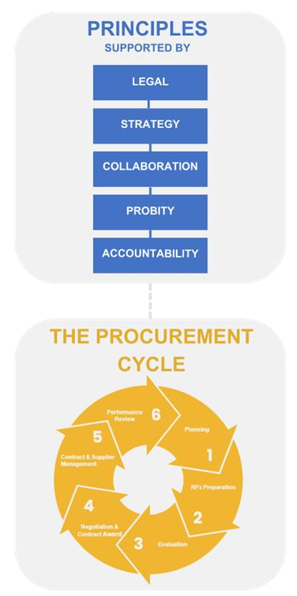

### 2. Principles

#### General principles

The procurement activities of councils should be governed by a set of best practice principles. These are based on the legislative requirements for councils to meet their strategic objectives and obtain value for money for their communities through their procurement processes. In this context, councils are bound by their statutory objectives to ensure:

* ongoing financial viability is assured;
* priority is given to achieving the best outcomes for their community that also address the needs of future generations and economic, social and environmental sustainability;
* collaboration with other councils and governments and statutory bodies is sought;
* council decisions, actions and information are transparent.[1]

The procurement policy developed and approved by each council should identify how the council will support its policy position via the procurement function.

#### Best practice principles in procurement

For optimal outcomes, these fundamental best practice principles should be applied to every procurement, irrespective of value and complexity:

* value for money;
* open and fair competition;
* accountability;
* risk management; and,
* probity and transparency.

##### Value for money

The Victorian Auditor General’s Office defines value for money as *“the optimum combination of quality, quantity, risk, timeliness and cost on a whole-of-contract and whole-of-asset-life basis.”[2]*

The Victorian Government Procurement Board defines the concept of ‘value for money’[3] as taking into account both monetary costs and non-cost factors (that promote/support the strategic direction of a council) including, but not limited to:

* advancing the council’s priorities;
* fitness for purpose;
* quality;
* service and support;
* whole-of-life costs and transaction costs associated with acquiring, using, holding, maintaining and disposing of goods, services or works; and,
* support for the strategic direction of a council, including environmental sustainability, local and social procurement, opportunities for Aboriginal and Torres Strait Islander businesses and circular economy (see *Section 2* *Other strategic items*).

##### Open and fair competition

All prospective suppliers must be treated (and be seen to be treated) fairly in an open and transparent manner with the same access to information about the procurement to enable them to provide prices/submissions on the same basis. Councils must adequately test the market in a consistent manner without any bias, or perception of bias, so that potential suppliers and the public have confidence in the outcome.

###### Accountability

Council officers are responsible for the actions and decisions they take in relation to procurement and for the resulting outcomes. Officers are answerable for such activities through established lines of accountability and delegation, and ultimately to the Chief Executive Officer (CEO). Officers must also ensure they provide adequate and reliable advice to the elected Council to allow it to make sound decisions on procurement matters.

*Section 7* specifically deals with accountability.

###### Risk management

All procurement carries some level of risk. It is important for councils to recognise this risk and to develop appropriate strategies to deal with it.

*Section 8* specifically deals with managing risk.

###### Probity and transparency

In all commercial dealings, the highest standards of honesty must be observed. Councils must conduct their business in a fair, honest and open manner, demonstrating the highest levels of integrity consistent with the public interest.

*Section 6* specifically deals with probity.

#### Role of value for money in procurement

The *Victorian Local Government Act* outlines the fundamental best practice principles that should be applied to every procurement. As listed in *Section 1*, councils need to apply value for money related principles to their procurement functions.

A council’s overarching governance and supporting principles require, among other matters, that:

• priority is to be given to achieving the **best outcomes** for all services provided by a council;

##### • the key strategic pillars of economic, social and environmental sustainability are to be promoted;

* **collaboration** with other councils and governments and statutory bodies is to be sought;
* ongoing **financial viability** needs to be ensured; and,
* **innovation and continuous improvement** should be pursued in the provision of services for its community.[4]

Each council should be able to demonstrate and report to its community that it effectively and efficiently applies these value for money-related overarching governance and supporting principles.[5] A council should take these factors into account when developing the principles and objectives within its policy (see *Section 3, Policy*) for more details.

#### Other Strategic Items

##### Role of sustainability in procurement

Sustainable procurement can be defined as *‘…a process whereby organisations meet their needs for goods, works and utilities in a way that achieves value for money on a whole life basis in terms of generating benefits not only to the organisation, but also to society and the economy, whilst minimising damage to the environment.’*[6]

Use of sustainable procurement practices helps councils meet their needs for goods, services, and works, not solely based on the principles set out in *Section 2 Best practice principles in procurement*, but more widely by maximising long-term net benefits for their communities, including future generations.7

Councils that embrace sustainable procurement incorporate extrinsic cost considerations into decisions alongside price and quality criteria, although in practice the sustainable impacts of a potential supplier’s approach are often assessed as a form of quality consideration. These considerations are typically divided into environmental, economic and social (also known as the ‘triple bottom line’). Social procurement forms an adjunct to sustainable procurement.

The legal framework for social procurement, especially in relation to competition legislation, is considered in detail in the *Beyond Value for Money: Social Procurement for Victorian Local Government,* Second Edition, 2017, supported by the associated toolkit, which can be found on the Local Government Victoria website.[7]

The other elements of sustainable procurement to consider include:

* local procurement;
* opportunities for Aboriginal and Torres Strait Islander businesses; and,
* circular economy.

Specific examples of sustainable procurement practices include:

* strategic use of local suppliers to encourage economic development;
* minimising a council’s environmental footprint by purchasing goods and services with less harmful environmental impacts or engaging suppliers which demonstrate a commitment to further sustainable outcomes in a meaningful way; and,
* generating local employment amongst disadvantaged communities and promoting social inclusion and gender equity.

It is important when undertaking sustainable procurement that a council properly articulates the benefits to the community, including financial benefits, and that those benefits can be effectively measured.

Local procurement

A council’s strategic policy objective may include how the council can support economic development opportunities, jobs and the local economy via its policy.

One of the difficulties that councils face in local procurement relates to determining which suppliers or goods and services are ‘local’. The usual test of ‘local’ is that of business location or employment opportunities. However, the issue of business ownership frequently arises

where the economic benefit of the procurement does not remain in the local area.

A council needs to include its own definition of ‘local’ in its strategic plans for procurement.

Objectives which seek to minimise whole-of-life or life-cycle costs subject to quality requirements, and to also engage local businesses, are likely to be inconsistent when local businesses cannot offer minimum life-cycle costs. A council adopting objectives supporting local business should state clearly in its policy the extent to which it will favour local business against minimum life-cycle costs.

###### ILLUSTRATION

A council, through its policies and procedures, required all submissions to be assessed against a local content evaluation criterion, with a weighting of up to 15%.

An RFT was advertised for the reconstruction of a road and five responses were received.

The top two respondents, scored similarly across all criteria, except for the local content criterion. One respondent was a local supplier and scored maximum points for the local content criterion. The other respondent was from outside of the municipality and scored a smaller proportion of the available points for the same criteria. The application of the local content criteria for this RFT, resulted in the contract being awarded to the local supplier.

Opportunities for Aboriginal and Torres Strait Islander businesses

Councils are recognising the importance of increasing the economic growth of Aboriginal and Torres Strait Islander (ATSI) businesses and are committing to ensuring they are providing opportunities for them to participate in their procurement processes.

Circular economy

The *Circular Economy (Waste Reduction and Recycling) Act 2021* obliges councils to provide their communities with residual waste and recycling services.[8] To complement the *2021 Act*, the Victorian government has developed a 10-year policy and action plan for waste and recycling which outlines Victoria’s circular economy goals.10

In Australia, our use of resources generally exists in what can be called a linear economy, where we take resources to make into products that we then use and dispose of.

The circular economy is an alternative to the traditional linear model, where the goal is to prolong the useful life of resources then continually repurpose them at the end of each useful life. In other words, a circular economy seeks to eliminate waste and to keep resources in a continually flowing loop.

Councils are likely to have strategic policy objectives around circular economy that need to be considered when procuring.

###### ILLUSTRATION

A council has introduced several new product streams into its recycling collection program. One of these products, soft plastics, is used extensively both domestically and commercially and has been a significant waste contributor.

The solutions now exist to recycle soft plastics into products used in road construction.

This council has committed to buying back and reusing the materials for its roads program.

## 3. Procurement and the Local Government Act - Legal framework

### General principles

The intent of the legislation applying to Victorian local government procurement is to ensure that councils meet their strategic objectives and ensure their communities achieve value for money through open and fair competition, applying high standards of probity, transparency, accountability and managed risks.

This requires that councils take steps to ensure that goods, services and works are procured at a competitive rate and in a transparent manner. It is important that councils continually test intended contracts against this primary standard.

The *Act* requires councils to have a procurement policy which should provide the basis for the council to undertake a competitive process to seek value for money in accordance with their own council's policy. There is also a transparency requirement regarding the development, publishing and review of a council’s policy.

These aspects are all essential to any best practice strategy and to statutory compliance.

If deemed necessary based on a set of legislated parameters, the *Act* empowers the Minister to direct a c[ouncil](http://classic.austlii.edu.au/au/legis/vic/consol_act/lga2020182/s3.html#council) to amend, discontinue, replace or report on its governance processes and policies.

### Requirement for a procurement policy

Section 108 of the *Act* requires councils to prepare and adopt a procurement policy. This has a number of mandatory requirements where each council can determine their own needs and risk profile as detailed in this section.

It is open to a council to undertake a community engagement process before adopting or amending a policy. A council’s own Community Engagement Policy will explain whether community engagement is a necessary step in the adoption or amendment process.

Publishing the council’s policy assists in informing suppliers about a council’s processes, increases confidence in the council’s procurement activities and thereby improves the relationship between the council and their current and prospective suppliers. Publication can minimise negative perceptions and complaints, enhancing transparency and accountability in local government business.

Section 109 of the *Act* requires a council to comply with its policy prior to entering into any contracts for goods or services or the carrying out of works.

### Legal aspects

The *Act* envisages the policy specifying the principles, processes and procedures that will apply to all purchases of goods, services and works by the council.[9] Given this, a *high-level* policy which contained only the council’s procurement principles would not comply with the legislation.

A copy of the current approved policy should be available on the council website.

The policy must be reviewed at least once during each four-year term and may be amended as necessary. Best practice would be served if this review is consultative of stakeholders and is approved by the council’s management group and agreed to prior to presentation to the elected council for approval.

### Policy content

The required components of a procurement policy are as follows:

**Principles:** the fundamental norms, rules, or values that represent what is desirable and of value to a council and its community. Principles are more basic than policy, process or procedures, and should govern all three.

The principles outlined in these guidelines (see *Section 2 Best practice principles in procurement*) are defined as value for money, openness and fairness in dealing with all suppliers, accountability, risk management, probity and transparency.

**Processes:** activities that use resources to transform inputs into outputs. A process therefore describes what is to be done. In these guidelines processes are activities such as the preparation of specifications and RFx evaluations.

In procurement a process also consists of:

* roles and responsibilities of the officer assigned to undertake the procurement activity; and,
* appropriate resources to support individuals in doing their jobs.

**Procedures:** ways in which procurement tasks are accomplished. It can be a sequence of steps that include preparation, conduct and completion of a task. A procedure describes how a process is to be achieved.

The procedures will explain how to undertake administrative tasks, risk management processes, internal control frameworks and performance measurements.

Specifications, contracts and records are not procedures in themselves as they do not describe how to do anything, rather they describe the outputs resulting from carrying out procedures or tasks.

**Items mandated by the *Act* include**:

* contract value threshold where a council must conduct a public RFx process;
* description of criteria to be used for evaluation in determining value for money;
* description of how a council will seek collaboration with other councils and public bodies in procuring goods or services;
* identification of the conditions where a council does not need to comply with its public tender or EOI threshold; and,
* outlining of the process to be undertaken when conducting a public RFx process.

**Common elements which should be found in a council’s policies include**:

* a council’s strategic objective(s) for procurement;
* identification and control of associated risk, including the development of containment strategies to mitigate loss/liability and contingency planning to respond to risks that may emerge;
* definition of the internal controls in place for procurement – integrated with each of the procurement functions;
* adopted mechanisms for procuring goods, services, and works;
* probity, for example, the conduct of council business in an honest, proper, fair, and ethical manner;
* council policy on sustainable procurement; and,
* breaches, exemptions and how these will be handled and reported.

The preferable method of incorporating statements of procedure and process in the policy is by reference to the relevant document. This allows processes and procedures to be continually improved without the need to amend the policy for each change.

#### Best practice policies

The policy requirements apply to all purchases of goods, services or the carrying out of works – irrespective of the value of such purchases.

A council should develop policies which are particular to their own requirements and should be aligned to the council’s overall vision and service objectives, and, be consistent with council delegations and with the adopted *Staff (and Councillor) Code of Conduct*.[10]

Councils should also assess their policy against the *Victorian Charter of Human Rights and Responsibilities Act 2006* and confirm its compliance with it. Within the context of human rights, some councils seek to promote objectives in regard to diversity and equity. The procurement of particular council services including human services, may require that suppliers exercise the same standards as the council in areas of employment equality and the treatment of clients in their contracts.

Policies may reflect local circumstances such as sustainable procurement objectives to support local or ATSI businesses or other economic development goals; to achieve particular social procurement objectives or to achieve environmental objectives (see *Section 2 Role of sustainability in procurement*).

Importantly, the evaluation criteria which is included in council contract documentation and RFx processes must include all factors to be taken into account when evaluating a submission. Particular attention should be given to ensuring the following aspects are adequately covered within a policy:

* structure is aligned with a council’s usual policy format, subject to ensuring that it complies with the requirement to include the principles, processes and procedures that apply to all purchases of goods, services and works by the council;
* structure follows a logical flow; and,
* content is consistent with these guidelines.

### Requirement for public RFx

#### Thresholds

Each council can set its own procurement thresholds within its policy. This includes the threshold at where a public RFx process must be conducted. This threshold can be set as a regional threshold or per specific needs of individual councils.

#### Aggregation

In order to be efficient, effective, and achieve value for money, councils should practise aggregation. This was well expressed in the Victorian Auditor-General’s Office report on *Tendering and Contracting in Local Government,* February 2010, at page xiii:

*“…where significant amounts are spent in aggregate on one supplier, or for one service, over time ...it is possible to achieve greater savings by leveraging this aggregate spend, rather than treating each discrete arrangement as a separate procurement exercise, whether undertaken competitively or not.”*

#### Length of contracts

There is no specific time limit applicable to the length of a contract which is subject to public RFx thresholds, unless specifically defined within a council’s policy. The council should firstly determine the optimum period for the contract based on value for money and the efficiency and effectiveness of the procurement, and then assess the value of the contract.

The council should then determine whether the public RFx threshold has been reached over the potential life of the contract.

The primary objective in any procurement process is to get value for money on a whole-of-life (or life-cycle) basis. The optimum length of a contract period in order to secure value for money can vary considerably depending on a range of factors, including:

* the extent of supply side competition – council may approach the market more regularly if pricing is competitive, or the market landscape is likely to change and vice versa;
* a contract term sufficient to make the cost of the procurement process worthwhile and maximise competition;
* the cost of equipment which the supplier or council must amortise over the term of the contract in order to submit an economic price; and,
* the potential for changes to systems, processes and supply chains to impact on service delivery and costs.

Therefore, the process should consider the following:

**STEP 1:** Form a procurement structure (as to the definition of goods, services or works required and optimum term, including extension options) in order to ensure compliance with requirement to *prioritise the achievement*  *of the best outcomes for their communities* and to ensure *transparency*.1

**STEP 2:** Ensure the proposed procurement adequately balances *cost and quality* requirements.1

**STEP 3:** Assess the value of the intended procurement against the procurement thresholds of the council’s own policy.1

**STEP 4:** Determine whether a competitive process by public RFx, or another method, is required.

**STEP 5**: Determine appropriate length of time with reference to technology improvements.

**Avoiding inefficient or ineffective contract structures**

If it is not an efficient or effective action to combine two or more services or works to

form one contract, due for example to **ILLUSTRATION**

impracticalities, then a council should not

One council bought three vehicles on the

create an artificial contract which does not same day from the same supplier but as

promote value for money.

separate contracts. The council **Measures which intentionally avoid** approached three suppliers and asked **procurement thresholds** them to price each of the three vehicles

Measures which intentionally seek to avoid individually rather than seeking the requirement to comply with council’s submissions for the potential purchase of policy – e.g., contract splitting, placing two or more as a means of encouraging multiple orders, seeking multiple quotations better value. This is poor practice.

with a single supplier or engaging in effect The contract values of the vehicles were a single supplier under different guises – $64,259, $73,996 and $71,259 totalling will breach the policy where procurement $209 951; this may exceed a council’s threshold values would otherwise be public RFx threshold.

reached. Councils must act with good faith in this regard.

#### Appointment of a panel of suppliers

One of the valid outcomes of a procurement or RFx process is the appointment of a panel of suppliers to promote security of supply. This is most likely to be the case where a council requires a range of services to be performed. The subsequent use of RFQ processes on a jobby-job basis further promotes competition and value for money.

Typical examples include the appointment of a range of trade services to undertake maintenance works or a range of contractors prepared to undertake projects such as refurbishment of buildings or facilities (for example, kindergartens, sports pavilions or public toilets).

#### No submissions received

Council policy should provide guidance where a council does not receive or rejects any submissions because they did not meet the council’s specifications outlined in the RFx document, and/or did not provide value for money to the council.

**ILLUSTRATIONS**

1. A council proposes to enter into a contract for a supply of quarry products with an initial contract period of three years and an option for an additional two years. The projected value of the contract for the full five-year period must be considered against the dollar thresholds prescribed under council’s policy.
2. A council proposes purchasing fuel using a fuel card. The council must consider the total value of the expenditure under a proposed contract with the fuel provider. The issuing of individual purchase orders or use of debit/credit/company cards does not avoid the requirements of the council’s policy.
3. A council proposes conducting an RFx for grass cutting and divides the area of the municipality into three zones (to reduce the risk of a single supplier failing to deliver). The council anticipates the total value of contracts for all zones will exceed the public RFx threshold amounts (although prices for individual zones may not) and that, despite the risk aspect, one supplier may be successful in being awarded all contracts. In these circumstances a public RFx process is advisable or council risks having to recommence the procurement process with a public RFx if it wishes to award a contract to one supplier for all three zones.
4. A council conducts a public RFx for construction of a sporting pavilion, the value of which exceeds the public RFx threshold amount. The lodged submissions all exceed the council budget and council decides to complete the project using its own resources. A council is obliged to ensure that it obtains value for money in a transparent and accountable manner and its policy could make allowances for such circumstances.
5. A council is spending $70,000 on stationery items each year. The council determines that the optimum period for obtaining value for money is three years (based on factors including the cost of the RFx process). The indicative value of the contract is $210,000 which exceeds a council public RFx threshold of $200,000. The council needs to ensure that it meets its policy by conducting a public RFx process.
6. A council buys trucks using a third-party agent – one at a time, in separate contracts, over a short period and each at a value below the councils public RFx threshold. The council is spending $500,000 each year on trucks in these separate purchases. The council must be able to demonstrate that this method of procurement is achieving value for money in a manner which is transparent and accountable.

#### Use of a public RFx for procurements below the public RFx threshold

A council may allow provision in their policy to undertake a public RFx where the value of goods, services or works *does not*reach the public RFx threshold sums. These may be situations where a public RFx is preferred or prudent, managing risk considerations are paramount, or there is a desire for greater transparency of the procurement. A council’s policy should outline where the council may undertake an RFx process even though the expected spend is under the public RFx threshold amount.

#### Assessing the value of a contract

The value of all contracts for the purposes of compliance with the council’s policy, unless explicitly stated otherwise, includes:

* costs for the full term of the contract, including any options for either party to extend the contract;
* applicable goods and services tax (GST);
* anticipated contingency allowances or variations; and,
* all other known, anticipated and reasonably foreseeable costs.

In certain circumstances, for example, where the contract price is nominal, it will be the market value of the goods, services or works which must be considered for the purpose of compliance with the council’s policy.[11] That is, it is the **value** of the contract rather than its **price** which applies.

In determining the value of a proposed contract, due diligence[12] should be exercised to ensure that realistic assessments are made of all factors which may impact on the value of the contract -including all aspects of the proposed contract which are reasonably foreseeable. This has particular application to those procurements which involve schedules of rates or unit prices requiring projections of usage rates and volumes in order to derive the total value of the proposed contract.

The assessment of a contract’s likely value must be made before entering into it. Therefore, councils need to have in place a means of aggregating their expenditure on goods, services and works well in advance of the procurement. Best practice is served if a council uses standard products and services codes, such as the National Procurement Network (NPN) category taxonomy, UNSPSC (United Nations Standard Products and Service Code)[13] or a code of its own design, within budgeting processesin order to assess future intended procurement aggregates.

Councils should use their budgeting process, supported by a committal accounting system, to report by supplier identity in order to avoid commitments which would otherwise be aggregated to in excess of the public RFx threshold for any one supplier. The objective is to identify the opportunity to aggregate spends before they are committed. Where a council only monitors expenditure in hindsight it risks exceeding the public RFx threshold.

Best practice requires that if doubt exists as to the likely value of an intended contract, then a public RFx process should be undertaken. This has the advantage of increasing the prospect that the goods or services are purchased or obtained at a competitive rate and in a transparent manner.

#### Goods, services and works

**ILLUSTRATION**

Multiple council departments are using the same consultant for the same type of service without each other’s knowledge. There is a risk of exceeding the public RFx thresholds of the council’s policy. The council should monitor its expenditure by supplier to ensure it does not breach its public RFx threshold limits.

The procurement threshold amounts applicable under a council’s policy may be different and distinguish between the purchase of goods and services and contracts for the carrying out of works.

The terms *goods, services and the carrying out of works* are not defined in the legislation, therefore, they take on their ordinary meaning and in the context of these guidelines the terms should be considered to mean:

* **Goods:** movable personal property, especially merchandise used in trade or commerce and requiring carriage from one place to another. The word ‘goods’ is very general and of quite indefinite import.[14]
* **Services:** the act of helping or doing work for another… work done in this way… assistance or benefit given to someone… the provision of what is necessary for the installation and maintenance of a machine etc. or operation.[15]
* **Carrying out of works:** the operations of building or repair (roadworks).[16]

The thresholds do not apply to services which a council elects to conduct using employed officers as these are not contracts for goods, services or works and are not subject to the council’s policy. The method for the delivery of all services and carrying out of works is reserved to the council and the public RFx process only applies to those circumstances where external resources are sought and the public RFx threshold is reached.

Whilst other legislation contains definitions of goods, services and works these other definitions will not bear any relevance to the interpretation of the same term in a different Act of Parliament, unless otherwise provided.

#### Advertising of procurement opportunities

Depending upon the procurement activity being undertaken, it may be prudent to issue a public notice or advertise councils’ requirements.

Most councils use electronic tender systems for public RFx threshold activity. If the reach of this method of supplier engagement may not extend to the potential respondents, then additional avenues should be considered. This may include advertisement in newspapers or industry news feeds, social media such as LinkedIn or Facebook, advertising on the council’s website or any other method which may result in the best possible outcome for the council.

Obtaining a competitive price and transparency would be best served by ensuring that the period of notice is sufficient to enable suppliers to adequately respond. This period will vary according to the nature of the contract and the length of time it will take respondents to prepare adequate submissions.

The *Act* does not prescribe certain undertakings to be required, however the method of how councils will conduct procurement activities must be included in their policy.

### Breaches of the policy

A council’s policy should set out what constitutes a breach, and the actions needed to be taken. A breach may occur when:

* a contract valued above the council’s public RFx threshold is entered into willingly without first conducting a formal RFx process as required under the policy;
* a public RFx process is undertaken but the contract subsequently entered into is materially different[17] from the specifications;
* an existing contract valued above the council’s public RFx threshold is extended without provision in the contract and without first undertaking a further RFx process unless there is provision in the policy to continue the requirement whilst conducting an RFx process; and,
* a contract valued above the council’s public RFx threshold is entered into without first going through a public RFx process or without complying with any exemptions as described under the policy.

It is essential that councils have in place systems and processes to avoid such breaches, and the mechanism to report as required within their own policy. Compliance with policy will be tested by bodies such as internal auditors, Victorian Auditor General’s Office (VAGO), Local Government Inspector or the Independent Broad-based Anti-corruption Commission (IBAC).

### Effect of non-compliance

Section 109(1) of the *Act* provides that a council *must* comply with its procurement policy *before* entering into a contract for the purchase of goods or services or the carrying out of works. There is no case law that provides any guidance as to the status of a contract entered into in breach of a council’s procurement policy. Clearly a council acts unlawfully if it breaches its procurement policy but the issue is whether a contract remains valid and enforceable.

Although decided with reference to different legislation, cases such as *Tonkin v CoomaMonaro Shire Council[18]* and *Swan Foreshore Protection Association Inc v City of Melville21* suggest that non-compliance with a procurement policy will *not* affect the validity or enforceability of a contract. At least this is so where the other party contracting was ‘innocent’ and unaware of the non-compliance.

If a failure to comply with a procurement policy tainted the validity or enforceability of a contract, third parties dealing in good faith with councils would be disadvantaged. Their contracts with councils would be at risk of being upset or rendered ineffective through no fault of their own.

So, despite the absence of case law concerning section 109 of the *Act*, it is likely that a failure to follow a procurement policy will not affect contracts that are entered into. A council that has not followed its procurement policy will, however, be vulnerable to someone with the appropriate legal standing seeking a Declaration from a Court that the council has acted unlawfully. There could be significant reputational implications as well.

### Reporting of non-compliance

A council is also obliged to report a non-compliance with its policy. The obligation is to be found in the *Local Government (Planning and Reporting) Regulations 2020* (SR No 117 of 2020, regulation 10 (c)(ii)).

Council must report the following within their annual reports:

* a list of contracts entered into above the contract value at which the council must undertake a public RFx process under its policy; and,
* a list of contracts entered into above the contract value at which the council must undertake a public RFx process under its policy - but for which the council did not undertake a public RFx process and did not meet the conditions for the to purchase goods or services without undertaking a public RFx process.

### Specific matters related to thresholds

#### Use of agents

It is common practice for councils to use the services of a third-party agent (also variously called buying groups, buying companies, aggregators and local government group purchasing schemes).

Councils can use third party agencies for procurements with details as to how and when this may be applied detailed in their policy. The use of agents should aim to gain value for money through economies of scale and ensuring that resources are used efficiently and effectively with transparency and accountability.

#### Common law aspects

The use of third-party agents takes its power from the common law ability of a council to appoint agents to act for it (see *Section 3 Agency arrangements*).

A council can act through an agent in procurement, however, it must retain control of the exercise and performance of its statutory powers and duties.

#### Action required of councils

The third-party agent RFx process should adequately address all the best practice principles in procurement outlined in *Section 2*. However, in using the services of a third-party agent, a council should take the following actions to comply with its statutory duties and powers:[19]

* make an initial decision to purchase goods, services or works, including, where applicable, reviewing and settling on contract specifications, conditions of contract and other contract documentation before a public RFx is conducted;
* ensure that probity is in place for the procurement, including obtaining and reviewing the relevant procurement related policies, processes and procedures of the agent;

* make the decision to appoint an agent;
* make a decision to either accept one of the submissions or reject all submissions, including reviewing all the submissions received, where applicable, and the evaluation and selecting one of the suppliers or a panel of suppliers subject to obtaining value for money and not simply a panel of convenient suppliers,[20] and;
* exercise discretion in accepting one of the submissions and not merely rely on the work undertaken by an agent.

There is an important distinction between contracts which are conducted by agents, including MAV and Procurement Australia, on behalf of a council(s) and a contract such as those on the Construction Supplier Register (CSR) contracts, State Purchase Contracts (SPC) and Whole of Victorian Government Contracts (WoVGs) which are available to councils.

Where a council uses an agent, the council must ensure that the agent complies with the same requirements that council must meet. The agent is only acting on the council’s

Where a proposed procurement reaches the public RFx threshold a council cannot access a third-party conducted contract if it has not formalised delegated approval to do so. Above all, a council must determine that the procurement represents ‘value for money’ to their community through undertaking their own analysis of the benefits of the contract on offer.

Where a council appoints an agent to conduct a public RFx process, the council must ensure that it has the necessary processes and checks and balances in place so that it will be in a position to be satisfied as to the integrity of the procurement process. The use of third-party agents must be rigorous and not constitute an exercise of convenience simply to fulfil the requirement of a policy to conduct a public RFx process.

#### Sole supplier

Situations arise where there may only be a single supplier of a good or service who is capable of carrying out work. Often, however, the ability to tap a competitive market will vary between councils especially in regional and rural areas. The only transparent means of demonstrating that multiple suppliers do not exist is to test the market. If that action demonstrates that there is only one supplier then a council is free to enter into a contract with that supplier (mindful of its obligation to obtain value for money).

#### Insurance

A contract of insurance is not necessarily a contract for services. But given the importance of achieving value for money outcomes there could be merit in treating contracts for insurance as falling within the scope of procurement principles.

Where the value of a contract (that is, the premium over the life of the contract) for insurance cover is estimated to reach the threshold amount (inclusive of GST), councils could undertake a public RFx process.

However, the exceptions to this requirement are statutory compulsory monopoly insurance schemes such as WorkCover insurances.

Where insurance cover is procured through an insurance broker, a council is, in fact, entering into two separate contracts:

* the contract with the insurance broker, the value represented by the brokerage fee; and,
* the contract with the insurance underwriter, the value of which is represented by the insurance premium and all associated statutory charges.

As both the above contracts would be treated as contracts for services, both may be subject to the policy but each may attract a distinct procurement approach.

#### Leases and licences

The following definitions can be applied to a range of leases, licenses, loans, and other council undertakings.

A **finance lease** is generally one where the lessor effectively transfers to the lessee substantially all the risks and benefits incidental to the lease, but where legal ownership of the goods may, or may not, be transferred **to the lessee**.

An **operating lease** is where the lessor leases the asset, generally a vehicle or plant and equipment, to the lessee generally for a fixed monthly amount, and also assumes the residual value risk of the vehicle.

Notwithstanding the general non-application of the council’s policy, in these situations the council must consider the requirements to ensure value for money and transparency.

A council may want to provide (within the policy), a separate section or reference to leases.

**Software licences** are contracts for services. By making available a product to a council, the owner of the software licence is providing a service. Often this service would also extend to troubleshooting problems on behalf of the licensee, providing software updates and otherwise assisting the licensee to utilise the software. The fact that a software licence may amount to a limited grant of rights does not change the fact that its provision will amount to a service. The council’s policy will apply to these acquisitions.

Where a council establishes electronic systems and is subsequently (after the initial contract period) renewing software licences (or upgrading systems), the council’s policy should provide guidance on the procurement requirements of such arrangements.

A **property lease** or a **licence to occupy** is not viewed as the purchase of a service, as the rent or licence fee being paid to the council is in return for the right to possess or use and manage the subject property. It is therefore not part of these guidelines.

#### Loans

Loans are considered to be contracts of loan and not contracts for goods, services or the carrying out of works. Councils may have other policies dealing with these matters and may not necessarily include this within its policy.

Notwithstanding, councils should consider both the value for money and transparency requirements when raising loan funds. Placing a public notice is one means of achieving these requirements. Some councils have achieved significant savings by promoting competition between lenders.

Further, councils should be aware of the requirements associated with the power to borrow under section 104 of the *Act*.

#### Purchase of land

The purchase of land contract[21] is not considered to be a contract for goods, services or the carrying out of works and therefore do not attract the requirements of section 108 of the *Act*. Councils may have other policies dealing with these matters and may not necessarily include this within its policy.

#### Contracts for sale of goods by council

Contracts for the **sale** of goods by the council (for example, recyclables under waste contracts) are not contracts for the **purchase** of goods or services or for the carrying out of works by the council. It is not proposed that the sale of goods form part of council’s policy. Councils should, in entering these contracts, be mindful that they are still required to achieve the best outcome for their community25 and should obtain proper value for goods sold.

#### Grants

Where council expenditure is funded from state or federal government grants the requirement to comply with the council’s policy remains unless there are grant conditions which provide alternative arrangements. This may arise where the council’s role is that of ‘fund manager’ and passes on funds from another level of government or other body.

#### Developer Contribution Plans

A council can waive a developer contribution pursuant to section 46P(2) of the *Planning and Environment Act 1987*[22] and require the developer to undertake works-in-kind in lieu of a cash contribution. Such an arrangement does not amount to a contract so does not trigger the council’s policy unless the policy specifically refers to such situations, for example, where the council enters into a contract with the developer to undertake further works on its behalf, which would be subject to compliance with the policy.

#### Major policy decisions during an election period

Councils are prohibited from making certain prescribed decisions during an election period.[23] This includes a decision to enter into a contract the total value of which commits the council to expenditure exceeding one per cent of the council's income from general rates, municipal charges and service rates and charges in the preceding financial year.[24]

A decision which does not follow this requirement is deemed to be invalid.29 Councils are liable to pay compensation as a result of acting on a major decision made in contravention of the legislation.

### Exemptions to requirement for a public RFx process

The council policy should provide guidance as to for the specific circumstances where a council may enter into a contract without first undertaking a public RFx or other process. These circumstances generally relate to:

* where the council has resolved that the contract must be entered into because of an **emergency;**

* where the contract is entered into **with a council acting as the agent** for a group of councils and the council has otherwise complied with the *Act*; and,
* the contract is **a type of contract that has been exempted** from this requirement by the council and stated within the council’s policy.

Novated contracts will also often be exempt from the need to be market tested.

Guidance on each of these exemptions follows.

#### Emergencies

A council policy should outline what constitutes an emergency and how the council may undertake acquiring the goods or services required. A council should prescribe those situations that it may enter into a contract - the value of which reaches the public RFx threshold amount, for the provision of goods, services or works without first putting that contract to a public RFx process - if the council or CEO resolves or determines that the contract must be entered into because of an emergency. These should be reported publicly in the interests of transparency.

Councils should consider delegating to the CEO the power to declare that a contract must be entered into because of an emergency and thus avoid delays in responding to it.

*The Act* does not define what constitutes an emergency situation. However, for the purposes of these guidelines the usual meaning should be taken to be a *sudden or unexpected occurrence requiring immediate action.*

The use of this emergency provision, should be limited to situations where a real emergency has arisen including:

* the occurrence of a natural disaster such as flooding, bushfire or epidemic which may require the immediate procurement of goods, services or works to provide relief;
* the occurrence of an event such as flooding or fire at a council property which may require the immediate procurement of goods, services or works to ensure business continuity;
* the unforeseen cessation of trading of a core service provider due to bankruptcy and a need to appoint a replacement service provider on the grounds of public safety; and,
* any other situation which is liable to constitute a risk to life or property including a disruption to a service that could risk life or property.

Emergency in the procurement context is viewed at three levels:

* Level 1 Immediate Response – Reactive procurement action taken immediately before, during and in the first period after an emergency to reduce the effects and

consequences of the emergency on people, their livelihoods, wellbeing and property; on the environment; and to meet basic human needs

* Level 2 Disaster Relief – Emergency procurement for the provision of assistance to meet the essential needs of individuals, families and the wider community during and in the immediate aftermath of an emergency
* Level 3 Post-Disaster Recovery – Accelerated procurement to assist the council and the community to achieve a proper and effective level of functioning.

It is preferable for a council to take all reasonable steps/actions to avoid the use its policy’s emergency provisions to enter into a contract. When a situation ceases to be unforeseen or no longer requires action to protect lives or property then the basis for use of this power also ceases.

In the context of achieving value for money and demonstrating transparency and accountability, contracts entered into under the emergency provisions must be limited in scope to that which is necessary to deal with the emergency. The period for any contract should only be sufficient to enable the council to conduct a public RFx or other process for a new contract or replacement service provider. The emergency provisions cannot be relied upon for extended works and services after the need for an emergency response has passed. Councils should take steps to assess best options prior to an emergency occurring, particularly where the risks of such an event are cyclic.

The use of the emergency provisions may be open to challenge where a council’s use of the power is inappropriate, for example, where no emergency actually existed, or where the council had taken into account irrelevant considerations or had acted for improper purposes in resolving that a contract must be entered into because of an emergency.

#### Agency arrangements

Councils’ policies should allow for them to form groups for the procurement of goods, services or works **with one member of the group, acting as an agent for the other councils**, undertaking a single competitive process.

Each of the members of this group is able to enter into a contract with the preferred service provider identified though this competitive process. Alternatively, the members of the group may choose to enter into a contract with the council which conducted the public RFx process. The practice of one council acting as an agent for a group of councils is not common.

The more common practice is for the services of a third-party agent (also variously called buying groups, buying companies, aggregators and local government group purchasing schemes) to be used by councils (see *Section 3 Use of agents*).

The ability to use agents does not prevent a group of councils jointly undertaking a procurement process without appointing an agent. However, each participating council must be involved in:

* the initial decision to undertake the procurement;
* preparation of, and agreement to, the specifications;
* ensuring probity for the procurement (see *Section 6 Probity*); and,
* deciding which submissions to accept or reject.

##### ILLUSTRATION

An RFT process was conducted by the five members of the Central Highlands Regional Procurement Excellence Network for bituminous road reseals.

Each council had two representatives involved in each phase of the contract. All parties confirmed a strategic procurement plan, procurement probity plan, a procurement conduct plan and an evaluation plan. All councils were involved in the development of contract documentation and specifications They all evaluated submissions and selected the successful respondent.

This project reflects the level of decision-making in each phase of a collaborative procurement which should be undertaken when groups of councils combine for procurement.

#### Novated contracts

A novation of contract occurs when one contract ends and simultaneously another contract is formed. For example, a council may have contracted with A but A has sold their business to B.

The council may agree to a novation of contract from A to B, so that the council’s contract with A comes to an end and a new contract between the council and B is formed.

A council’s policy should give effect to an exemption from the requirement for a public RFx or other process[25] for novated contracts providing:

* the initial contract was entered into in compliance with its procurement policy; and,
* the council has undertaken due diligence in respect to the new party to the contract.

### Competition compliance

Compliance with competition legislation is generally regarded as a specialist area. A council’s procurement policies and practices must comply with the *Competition and Consumer Act 2010 (Competition and Consumer Act)* and other fair-trading legislation applicable to its operations.

The competition provisions in the *Competition and Consumer Act* only apply where a council carries on a business either directly or by a company in which it has a controlling interest. Certain activities must be treated by councils as a business (for example, abattoirs). The test for other activities is whether, and to what extent, an activity is, or is likely to be, subject to competition by other providers.

* Breaches of applicable provisions of the *Competition and Consumer Act* can give rise to criminal and civil penalties. A council and its officers can be liable for their respective involvement in breaches. Councils should have a best practice compliance program covering: restrictive trade practices, including price fixing and exclusory provisions resulting in third line forcing;
* market sharing, including allocation of customers, anti-competitive agreements, exclusive dealing and misuse of market power;

* communication and promotion, including misleading or deceptive conduct, false claims and unsubstantiated predictions;
* unconscionable and unfair business practices (including contracts that do not contain unfair terms); and,
* service, quality and safety.

Best practice is served when a review of compliance with competition legislation is linked with an annual service review process (or review of the council’s policy).

Councils operating services which compete with the private sector should implement a full compliance program. Councils which assess their trade practices risks to be low may be able to link trade practice education and training to the more general procurement training.

From the perspective of supplier compliance, in order to minimise the risk of collusive practices among respondents, some councils require the completion of a statutory declaration as part of the RFx submission. This is considered best practice.

### National competition policy

Councils must ensure that when evaluating/analysing submissions by corporatised government entities, or other significant government businesses, that RFx processes must conform to the requirements of the Victorian Government’s competitive neutrality policy.[26] The principle underlying competitive neutrality is that government businesses should not enjoy any net competitive advantage simply by virtue of their public sector ownership.

### 4. Strategy and organisation

#### General principles

Each council will have its own set of policy and strategic objectives with activities aligning with its strategic direction. Procurement plays a key role in councils achieving strategic objectives, highlighting the need for procurement decisions and structure to be aligned to them.

The strategy and organisational structure adopted for each council’s procurement will be particular to its needs and resources. The important aspect of the strategy and structure is that consideration has been given to the optimisation of the efficient and effective use of resources and to ensure transparency and accountability.

The strategy should be documented in order to provide direction to all stakeholders.

#### Strategic procurement in the organisation

Over time, the role of the buying function has moved from a back-end purchasing activity focused primarily on reactive, transactional processing of requisitions and acquisition price for each procurement, to a strategic function.

However, the term ‘strategic procurement’[27] is variously applied to several different concepts including:

* a coordinated approach by an organisation to influence supply markets to support the business objectives;
* the purchase of high value, high risk, important and complex goods, services or works, often a multi-faceted project;
* long-range plans for ensuring timely supply of goods and/or services that are critical to a firm’s ability to meet its core business objectives; and,
* the process used to take a project from its early planning phase through to completion.

Depending on which of these concepts is adopted there will be a number of outcomes from a process of strategic procurement. These outcomes may take the form of:

* a strategy document formalising the council approach to influencing supply markets, focused on core business objectives and/or organisational coordination; and,
* a procurement plan for the implementation of a significant (high value or high risk) procurement (or a planning-to-completion project-based plan) as described in *Section 8 Procurement plan*.

The features of a strategic approach to procurement include:

* a centre-led organisational structure aligned with the council’s vision and values;
* organisational commitment to a coordinated and cooperative approach – often involving a team for a significant procurement;
* early involvement in the planning phase by the procurement function or team;
* understanding by procurement practitioners of product/service categories and the relative spend on each, together with the particular needs of the council functions which are being serviced;
* gathering of market intelligence and encouragement of new suppliers entering the market;
* use of performance-based specifications to encourage maximum innovation, where appropriate;
* openness with suppliers as a basis for conducting negotiations – with a focus not just on prices but on achieving other council objectives;
* optimising the allocation of risk between the parties; and,
* use of systems to monitor the progress of procurement and measure the outcomes.

The strategic elements adopted in any one procurement should be appropriate to its complexity.

The essence of strategic procurement is that it should be aligned with, and contribute to, council’s long-term strategy. It should be consistent with the Council Plan and the ten-year Financial Plan.[28]

Strategic procurement places an emphasis on:

* conducting detailed analysis of a council’s spending pattern;
* ensuring procurement effort corresponds with risk and expected return;
* optimising the procurement process to reflect market conditions; and,
* including continuous improvement and value for money in contractual arrangements with suppliers.

This emphasis is best supported with:

* sound training and development of those undertaking procurement functions; and,
* a focus on accountability to achieve value for money for all officers involved.

#### Organisational model/staffing structures

The Local Government Victoria Procurement Excellence Program identified three generalised organisational models for undertaking procurement. These were:

* **centralised:** a single central group undertaking all procurement;
* **decentralised:** dispersed procurement undertaken within individual departments; and,
* **centre-led:** a blend of localised and centralised procurement models.

**Centralised model:** a centralised model averages council spending and drives standard policy, process and technology decisions as well as implementation from a central point. While offering greater spending leverage and operational efficiencies, these structures often result in higher incidences of unapproved spending and process circumvention. The centralised model may have higher staffing costs and be less flexible and responsive to operational needs.

**Decentralised model:** a decentralised model empowers departments with autonomy and control over supply, process and technology decisions, as well as procurement execution. This structure improves satisfaction at the departmental level but fails to leverage council spending. It is usually costly to operate and leads to inconsistent supply cost and performance across the council.

The Victorian Auditor-General’s Office found the lack of central oversight in five councils that were audited resulted in inadequate and inconsistent practice, including insufficient monitoring of both expenditure levels and adherence to probity standards, and an insufficient review of effectiveness.[29]

**Centre-led structure:** a centre-led model allows procurement action to take place in the department whilst policy, strategy, technology, best practice and networking are led by a centralised unit.

In practice, there will be variations of these models within individual councils. For example, some councils will:

* require procurements above a specified amount to be managed centrally, and,
* operate a centralised model for part of the organisation – such as internal operations – and a decentralised model for other parts, such as works and parks.

Organisational size and resourcing levels will play a significant role in how structures are designed and implemented.

Although a centre-led model is favoured by most councils, each council should undertake an assessment to determine the structure most appropriate to its needs. Periodic review of the structure should be undertaken.

Position descriptions developed for the procurement function should align to each council’s procurement objectives and be structured in accordance with the *Victorian Local Authorities Award 2020*. These statements should be endorsed at senior management level to ensure the roles they define are embraced by all stakeholders.

There will officers who are directly involved in procurement because they are in the procurement team or indirectly because they are on a panel. It is important that appropriate procurement training and development is provided to all officers undertaking a procurement role. The level of training and understanding is further documented below, and councils should ensure that officers undertaking a procurement or panel member role have the appropriate skills to undertake these tasks.

#### Leadership

As with many council programs, the success of the organisational model for procurement rests on the extent to which it is embraced and implemented by a council’s senior management.

Leadership of procurement means having an understanding of the objectives of the council’s policy and procedures, advocating for their implementation, instilling a culture of compliance and best practice from a risk management perspective, and leading by example.

#### Procurement steering group

One option for councils is the formation of a procurement steering group. This is an excellent means of ensuring adequate focus on the procurement function and of achieving change within the organisational procurement culture.

A procurement steering group would be mandated to provide coordination, leadership and guidance for the procurement function. This group would include at least one director/senior manager and key stakeholders in the council’s procurement operations.

#### Project teams

Where a procurement is of sufficient scale, complexity or has significant inherent risks, consideration should be given to forming a project team to drive the RFx process (or the overall project where procurement forms part of a larger project). A well-planned project team is likely to improve decision-making, reduce risks and assist transparency. However, an assessment would need to be made as to whether the value of a project team would justify the cost of resourcing it and the likely additional time involved in decision-making.

#### Delegations

One of the key mechanisms for ensuring the efficiency of the procurement process is the implementation of delegations which allow for efficient decision-making at the appropriate level of the council. Councils have legislative capacity to delegate most functions, powers and duties to the CEO under an instrument of delegation.[30]

The CEO can also delegate functions, powers and duties of their office under an instrument of delegation to other council officers.[31]

Delegation relating to functions, power and duties should be distinguished from authorisations which would, for example, allow officers to approve procurements at values below certain procurement thresholds. They might take the form of authorisations contained in a council’s policy or in a separate written instrument authorising officers in specified positions to undertake procurement at stated levels of value.

Delegations should be consistent with a

council’s policy and **ILLUSTRATION** should specify who One council’s policy outlines the following high level (officer’s position, rather delegations structure for procurement approvals:

than a named officer) • CEO to award contracts up to $1,500,000 has the delegated power

to purchase and at what • Directors to award contracts up to $500,000 level of value those • Service unit managers to award contracts up to $100,000 delegations apply. This council also outlines contract variation approval

delegations within its policy.

All instruments of delegation should be

properly made and documented. It is important when determining delegations that it be granted with clear instructions on how it is to be exercised.

Delegations from the council must be reviewed within 12 months after a council general

election.[32]

Officers who are holding delegations should be provided with training on the exercise of their delegations. Such training can form part of broader governance training.

Legal implications result from the appointment of a delegate of the council. The individual delegate is the Council for the purpose of the delegated power, duty or function and a decision made under delegation is binding on the council. Comprehensive conflict of interest rules apply to a delegate of the council. (see *Section 6 Identification and management of conflicts of interest*.)

A delegate must:

* be unbiased and act in good faith; and,
* take into account relevant considerations and extenuating circumstances and ignore irrelevant considerations.

It is usually appropriate for a delegation to be recorded and reported on a regular basis so the delegator can monitor the use of the delegated power. A record should be kept of:

* what decision was made;
* who made the decision; and,
* when the decision was made.

Most procurement systems, whether manual or electronic, will be likely to satisfy these record keeping requirements. A simple periodic report from an electronic system to the delegator (the council or the CEO) can facilitate appropriate monitoring of the delegation. Manual systems will require greater effort to enable the delegator to monitor the exercise of the delegation.

The council can ‘call in’ a procurement matter which is the subject of a delegation to officers and reach its own decision on the matter (subject to compliance with matters such as consistency with evaluation criteria).

Delegations can only be made to council officers (or a delegated committee). A council cannot make delegations to non-council staff[33] (for example, to a consultant or embedded contractor[34]) to undertake responsibilities such as the evaluation of tenders, the selection of contractors, decisions regarding contract variations where budget funds are not specifically available or approval of invoices.

However, a council can appoint contract staff as agents. This would, for example, allow council to appoint a contract staff member to: undertake the preparation of specifications and contract documentation; respond to RFx queries; supervise another contract; approve minor variations where funds have been provided in the council’s budget; certify satisfactory completion of works (to enable a delegated council officer to approve the payment of invoices); or prepare and issue correspondence including works instructions, all subject to the provisions of the contract.

Agency appointments in these circumstances should be in writing and should define any restrictions on the functions of the agency. Where council is using an agent, they must retain control of the procurement exercise including statutory duties and powers (see also *Section 3 Use of agents*).

**Training and skill development to build capacity.**

Many of the shortcomings identified by investigations[35] of procurement in councils are due to lack of knowledge and skills of officers or the deficient application of procurement practices. Development of knowledge and skills is therefore critical to effective procurement and compliance of councils.

There are several learning pathways in procurement and contract management ranging from foundation learning, vocational education and training (VET) to higher education qualifications. By accessing the national network of registered training organisations (RTOs), councils can select the training best suited to the role requirements and career aspirations of their officers, especially where councils do not have in-house expertise in training.

Councils should consider use of the Australian Qualifications Framework (AQF) which is a unified system of national qualifications in schools, vocational education and training providers (TAFEs and private) and the higher education sector (mainly universities) to identify and define the knowledge and skill needs of their officers. The knowledge and skills gained by officers should be assessed and formalised.

There is a wide range of knowledge and skills needed to support effective procurement processes. These include:

* policy and procedure development and implementation;
* policy and procedure awareness;
* probity planning and implementation;
* procurement planning;
* risk identification and management;
* needs definition and specification preparation;
* RFx evaluation and reporting;
* negotiation;
* contract management/project management; and,
* performance monitoring and reporting.

Some training can be delivered in association with other council training. For example:

* training in conflict of interest, confidentiality and other aspects of probity could be delivered as part of council’s governance training (which could also cover the staff code of conduct, council gifts and hospitality policy);
* risk management training for procurement could be combined with similar training at an organisational level;
* budget and spend tracking for contract management could be delivered as part of general finance system training;
* generic training in negotiation skills could be appropriate for some officers;
* policy development training could benefit from being combined with other strategic training activities; and,
* induction training for new officers could provide core guidance on each of the council’s key policies and practices.

Levels of training and development required by officers should be determined by the organisational structure/model and based on what’s most appropriate to the council’s needs (see *Section 5 Organisational model/staffing structures*).

Ongoing development and training should also be a consideration, particularly when changes in government legislation occur.

Training could be effectively provided across a group of councils where resources for individual council training are limited (see Training in collaboration below).

Training and accreditation standards equally apply to elected councillors where they engage in procurement functions (see *Section 11 Evaluation panels*).

Training can extend beyond council officers to include suppliers. Supplier capability development can inform businesses on the processes and requirements involved in supplying goods and services to local government organisations (see *Section 5 Supplier education*).

#### Training in probity

One of the key measures a council should adopt to achieve a strong application of procurement probity standards is in skilling officers to identify conflicts of interest and apply probity principles.

When considering the composition of an evaluation panel, a member of the panel (not necessarily the chairperson) should be skilled in the development and implementation of probity plans and the engagement of probity auditors/advisors. Such skills training should be competency-based and include a formal assessment of skills gained and accredited.

All officers involved in procurement should be skilled in probity fundamentals and their application (see *Section 6 Probity fundamentals*). Best practice in evaluation panel membership should include one member who is formally accredited.

These principles apply equally to a third-party agent appointed by a council, as do the requirements of the best practice standards as outlined in *Section 2 Best practice principles in procurement*.

The council should also consider the opportunity and role in training and upskilling the market and potentially suppliers in the probity fundamentals and standards of council.

#### Training in collaboration

Collaboration within local government is now a requirement under the current *Act*, therefore it is imperative that council officers and elected officials are trained on how to appropriately collaborate with other councils and other third parties to drive efficiencies.

Training in collaboration can be delivered in a range of formats, however, best practice would be to train councils in regional groupings or as a collective of councils. This will ensure leveraging shared opportunities and will assist in identifying opportunities to drive efficiencies and value for money.

#### Supplier education

Supplier education about a council’s procurement process is very important in value creation because it is likely to improve supplier participation and increase competition in procurement activities.

Opportunities for supplier education should include a range of options including (i) programmed and advertised supplier presentations and (ii) information and/or contemporary eLearning videos available through council’s website.

Education topics may include information about:

* how to participate in procurement activities;
* eProcurement pre-registration options (if possible) and ways to seek exposure to council;
* the council’s procurement thresholds and processes;
* the importance of procurement process compliance, including:
  + responding in accordance with the process rules and by any stated closing date and time;
  + answering all questions and associated RFx schedules in a clear and concise manner; o signing documents if and where required; and,
* the council’s evaluation and award process.

### 5. Collaboration framework

#### General principles

Enhancing collaboration in procurement among councils was identified as a key recommendation within the *Local Government Procurement Strategy* (Local Government Victoria, September 2008).[36] The report outlined substantial potential savings achievable across the sector if councils increase their collaborative procurement efforts.

The new Act has elevated collaborative procurement from an aspiration to a legislative obligation.Councils, due their similar procurement profile and the non-competing nature. are uniquely positioned for collaboration.

The principles of collaborative procurement align with best practice principles of procurement detailed in *Section 2*, with aims to:

* achieve value for money outcomes;
* foster open and fair competition;
* enhance council accountability;
* mitigate risks for councils; and,
* maintain probity and transparency.

All council collaborative procurement activities should adhere to these principles to maximise collaborative benefit and deliver the best outcomes for communities.

#### Requirement for collaboration

An overarching principle in the *Act* is the requirement for councils to seek “*collaboration with other councils, other levels of government and statutory bodies”.[37]*

Furthermore, sections 108 and 109 of *the Act* mandate councils to address collaboration within their procurement framework and activities.

Section 108 stipulates that councils, in preparing and adopting their policy, must include “*a description of how the council will seek collaboration with other councils and public bodies in the procurement of goods or services*”.

Section 109 adds that “*the Chief Executive Officer must ensure that any report to the Council that recommends entering into a procurement agreement includes information in relation to any opportunities for collaboration with other councils or public bodies which may be available*”.

These sections of *the Act* highlight the importance placed on councils to work collaboratively to optimise resources, enhance efficiency, and deliver value for money outcomes for their communities. It is important that councils establish a framework for the inclusion of collaboration across their procurement activities.

This section of the Guidelines offers a structured framework for Victorian councils to facilitate collaborative procurement. This framework enables councils to maximise the benefits of collaboration while complying with legislation and incorporating better practice.

#### What is collaboration

In the context of local government, collaboration is the process of working together with one or more councils, government entities or statutory bodies to achieve common objectives.[38]

Collaborative procurement specifically involves procurement activities that engage two or more councils, government entities or statutory bodies to achieve better procurement outcomes.

These outcomes may encompass:

* cost savings;
* process efficiencies;
* greater economies of scale;
* improved product or service quality;
* increased supplier competition;
* enhanced shared expertise;
* reduced risk; and,
* sustainable procurement outcomes.

While this Guideline primarily focuses on collaborative procurement, councils have a wide range of collaborative options, from sharing information and knowledge with other councils, government entities, or statutory bodies to participating in a contract that addresses the needs of two or more of these entities.

In Victoria, there are networks, such as regional procurement excellence networks (RPENs), facilitated by Local Government Victoria, that empower council procurement leaders to collaborate formally on procurement and general business practices.

Special interest groups (SIGs) and sector reference groups (facilitated by LGPro and MAV) also offer opportunities for council procurement specialists to exchange ideas, network, stay informed about current trends and contribute to sector-wide procurement development.

Councils should leverage these networks for collaboration opportunities outside of and within their own organisations. Collaboration within a council should not be overlooked, as activities such as bundling of like projects into one procurement activity can increase competition, save council resources and reduce RFx costs for potential respondents.

Collaborative procurement can be complex and councils should be aware of common challenges including:

* lack of firm commitment from collaborative procurement partners;
* differing requirements and priorities;
* unclear roles and responsibilities;
* inadequate resource allocation;
* disparate returns for effort expended;
* neglecting stakeholder concerns during the process; and,
* unrealistic procurement timeframes.

#### Policy provisions

A council procurement policy must address its approach to collaborative procurement and should:

* detail the *Act’s* requirements for collaborative procurement;
* describe the council’s method for determining whether a procurement will involve a collaborative procurement arrangement;
* include provisions for councils to access third party contracts (MAV, Procurement Australia, state purchase contracts, Victorian whole-of-government contracts);
* emphasise links to council procurement networks (e.g. RPENs, SIG and sector reference groups); and,
* provide a concise overview of key collaborative procurement process requirements.

To further enable collaboration, councils, through their policy, may broaden their commitment to procurement within their region by expanding their definition of local procurement.

#### Strategy for collaboration

To implement collaborative procurement effectively, councils need a clear strategy that aligns with their organisational objectives, procurement framework and policy while addressing stakeholder needs including:

* identifying, assessing and prioritising collaborative procurement opportunities;
* selecting appropriate collaborative procurement partners;
* establishing a governance structure for collaborative procurement;
* clarifying roles and responsibilities for collaborative procurement;
* confirming procurement and contracting model options for collaborative procurement projects;
* linking collaborative procurement activities to the council's policy and practices; and,
* monitoring and reviewing the collaborative procurement outcomes and performance.

##### Opportunity analysis

Effective and strategic collaborative procurement initiatives commence with structured opportunity analysis that involves the identification, assessment and prioritising of opportunities for collaborative procurement.

Any opportunity analysis program should consider contracts established at a national, state, regional, sub-regional or cross-regional level and continue to explore internal collaborative procurement opportunities.

The baseline strategy involves identifying, assessing and prioritising opportunities for leveraging third-party contracts. These contracts may be agreements with entities such as the Municipal Association Victoria, Procurement Australia, state purchase contracts and Victorian whole-of-government contracts.

Councils should commit to executing the prioritised opportunities as soon as practical with the relevant third-party.

A comprehensive collaborative procurement opportunity analysis program should:

* Identify opportunities, through:
  + establishment of a working group tasked with identifying potential opportunities; o analysis of the council’s spending profile; o documentation of all identified opportunities; o engagement with subject matter experts and other key internal and external stakeholders to capture any further opportunities that may exist; and,
  + mapping of potential collaborative procurement partners.
* Assess opportunities, through:
  + developing and implementing a consistent assessment process that evaluates opportunities at all phases of the procurement and contracting process;
  + evaluating opportunities based on factors such as value and other potential benefits as well as the level of difficulty in delivering on collaborative procurement objectives; o addressing national, state, regional, sub-regional and cross-regional opportunities; and,
  + considering associated risks and other factors such as resourcing.
* Prioritise opportunities, through:
  + developing a prioritised collaborative procurement program based on value and potential benefits to be derived and the level of difficulty in delivering on the collaborative procurement objectives;
  + targeting opportunities that represent the highest overall potential value and benefits and the lowest level of difficulty in delivering on the collaborative procurement objectives for early implementation;
  + engaging with potential collaborative procurement partners to jointly review and select opportunities for further development; and,
  + documenting and communicating the plan to all key stakeholders.

Adequate allocation of council resources, both financial and human, are essential for successful implementation.

The collaborative procurement opportunity analysis program should not be static and councils should periodically review and update it to ensure it adapts to the evolving needs of the council.

To further enhance better practice in collaborative procurement, councils should maintain comprehensive documentation of identified collaborative procurement projects within a procurement activity plan.

When an opportunity analysis program is conducted within a regional or sub-regional group, councils should document the outcomes within an activity plan.

#### Governance structure

Critical to the success of collaborative procurement projects are effective governance structures and mechanisms to ensure a high standard of openness, fairness, accountability, risk management, probity and transparency. The following components should be implemented:

* **Formal agreements** – to detail the terms and conditions governing the procurement partners’ collaboration. The agreement should encompass project objectives, risks and scope as well as the respective commitments and obligations, roles and responsibilities of the partners. These agreements should be signed at the CEO level and provided to the lead council.

**Working groups** – including representation from all partners, to play a pivotal role in overseeing and guiding the project.

* **Communication program** - to facilitate regular information sharing and feedback among partners and other relevant stakeholders.
* **Process documentation** – to clearly articulate the process and assist in facilitating successful procurement outcomes. These documents should include plans that are based on the core elements of the procurement plan detailed in *Section 9*. These plans should include:
  + details of collaborative procurement partners, including contacts and their respective roles;
  + information on current contracts, including end dates; o an overview of the selected procurement and contracting model; o provisions for addressing risk management and mitigation issues related to the collaborative procurement;
  + acknowledgement of ACCC authorisation, where applicable; o requirements for collaborative procurement partner contract transitions; and, o specifics on the communication program.

##### Procurement leadership

Councils have a wide range of options when determining how to effectively lead and facilitate collaborative procurement projects. The most commonly adopted models are::

* **Lead council** – a single council is appointed to lead the project. This council generally takes on the responsibility for managing the RFx and utilises their own council internal resources, systems and processes for this purpose.
* **External lead** – councils may decide to engage an external consultant to lead the project. The external lead brings independence and expertise to the project leadership role.
* **Third party agents** – councils have the ability to engage the services of a third party agent to lead the project. These agents have requisite experience and expertise in establishing collaborative contracts for multiple organisations.

When selecting the most appropriate procurement leadership model councils should consider factors, including but limited to:

* timelines for project completion;
* availability of resources and budget; and,
* the expertise required to oversee the project.

Councils need to determine the leadership model to be adopted during the early stages of a project.

To provide further support to the appointed procurement lead and ensure a high standard of openness, fairness, accountability, risk management, probity and transparency, it is recommended that an independent probity advisor should be engaged for collaborative procurement projects.

##### Council responsibilities

The success of collaborative procurement projects is reliant on the commitment of all collaborative procurement partners. Each partner should be individually responsible for: committing the necessary resources, both human and financial, to the project; actively participating during all phases of the project, completing required actions promptly and effectively;

* considering all partners in decision making activities; and,
* supporting their nominated project representative(s) and the procurement lead for the project.

#### Procurement and contracting models

The broad nature of collaborative procurement means there is a wide variety of contracting and procurement models available for councils, all of which will address their legislative requirements..

Councils should consider three primary procurement and contracting model options which are:

##### Collaborative market engagement model

This model has the following attributes:

* a collaborative RFx event between collaborative procurement partners; • individual but generally consistent specification and contract documents;
* individual collaborative procurement partners who each then: o separately evaluates the submissions provided for them o manages their own contract negotiation and award processes o completes their own contract signing process with the successful supplier(s).

The benefits attainable from this model are primarily around RFx process efficiencies for both partners and respondents. After the go to market phase, the RFx process is managed individually by the partners.

##### Collaborative RFx process model

This model has the following attributes:

* a collaborative RFx event between partners;
* common specification and contract documents;
* individual collaborative procurement partners who each then:

o either separately or collaboratively evaluates the submissions; o collaboratively delivers the contract negotiation and award processes; and, o completes their own contract signing process with the successful supplier(s).

This represents the most commonly adopted model across councils and maximises the benefits of collaborative procurement available from the planning to negotiation and contract award phases of the procurement cycle. Following the completion of negotiation and contract award, the partners typically manage the supplier and contract management phase individually.

Councils can unlock additional benefits through a coordinated approach to supplier management through the contract and supplier management phase of the procurement cycle.

##### Collaborative contract model

This model has the following attributes:

a collaborative RFx event between partners; common specification and contract documents;

• individual collaborative procurement partners who each then:

o collaboratively evaluates the submissions; o collaboratively delivers the contract negotiation and award processes; and, o signs one overarching contract with the successful supplier(s).

This model provides the opportunity to realise the benefits associated with collaborative procurement.

For all models, councils should always agree on using agreed RFx conditions and schedule documentation. This minimises the work required from suppliers, as they only need to respond to a single set of RFx conditions and schedule documentation.

When selecting their model, councils should take into account the nature of the collaborative procurement project, the specific goods or services being procured and the capacity and number of collaborative procurement partners involved.

*Section 13* of this guideline outlines the expectations of contract managers within local government in the case of contracts resulting from collaborative procurement. Contract managers may need to consider partners’ needs during the supplier and contract management phase of the procurement cycle.

When the performance review phase of the procurement cycle has been reached, collaborative procurement partners should be included in activities undertaken during this phase.

#### Associated legislation

Councils need to consider compliance to trade practices requirements throughout the course of a collaborative procurement project. *Section 3* provides further information.

For collaborative procurement projects, councils specifically need to ensure compliance with the *Competition and Consumer Act*[39] provisions around anti-competitive conduct.

For certain collaborative procurement projects, councils may be obligated to seek authorisation to procure from the Australian Competition and Consumer Commission (ACCC), the Commonwealth authority that enforces the *Competition and Consumer Act 2010*.[40]

It is worth noting that the ACCC shall only grant authorisation if it is satisfied, under all circumstances, that the conduct: *would result or be likely to result in a benefit to the public, and the public benefit would outweigh the detriment to the public that would likely to result*.[41]

#### Better practice in collaborative procurement

To ensure they are striving to achieve better outcomes for their communities, councils should implement a better practice framework for collaborative procurement including:

* incorporation of collaborative procurement within the council’s policy, ensuring alignment with the *Act* and clearly defined the council’s objectives for collaborative procurement;
* commitment to participate in collaborative procurement networks;
* a collaborative procurement strategy that identifies, assess and prioritises opportunities,

with outcomes documented in a procurement activity plan; robust governance structures incorporating formal agreements among collaborative procurement partners, the formation of working groups, the implementation of a communications program and documented collaborative procurement processes;

* clarity on collaborative procurement project leadership and council commitments;
* application of the most appropriate procurement and contacting models for collaborative procurement projects;
* review of the performance of all collaborative procurement projects; and,
* compliance to all legislative requirements.

See the procurement cycle *Sections 9-14* for operational collaborative procurement better practice.

### 6. Probity

#### General principles

In the context of a procurement process, probity is a defensible process which is able to withstand internal and external scrutiny – one which achieves both accountability and transparency, providing respondents with fair and equitable treatment. Probity is about ensuring the procedural integrity of the procurement process.

When councils (or their agents) approach the market to procure goods, services or the carrying out of works, they have a responsibility to obtain value for money. This must be achieved by acting in an unbiased and ethical manner. The community expects business in the public sector to be conducted ethically, displaying honesty, integrity, diligence, fairness, trust and respect when dealing with others. The law often imposes a standard of ‘good faith’ in contract matters, which can be discharged if parties to a contract act honestly and reasonably.

This section of the guidelines is concerned primarily with the behaviour of council officers and their agents, and third parties such as consultants. It highlights associated ethical issues, ensuring the proper conduct of procurement services to:

* facilitate the achievement of value for money;
* reduce the risk to a council of being exposed to legal action and financial loss;
* provide potential suppliers with confidence about fair treatment, with consequential improvements in competition and performance; and,
* guard against collusion and fraud.

#### Good governance

The foundation of sound probity lies within a council’s governance culture and practice. Good governance is essentially getting the governance processes right – in the best interest of the

community.

It is a council’s responsibility to provide an environment that is conducive to good governance through:

* creating a vision for the council;
* developing and fostering an organisational culture which is conducive to good governance;
* establishing processes for defining and implementing clarity of roles;
* fostering an effective relationship between the councillors and the administration;
* developing effective decision-making processes that reflect transparency and accountability;
* establishing robust and transparent financial management;
* establishing and maintaining an effective approach to the identification, assessment, monitoring and management of risks;
* setting up effective delegations;
* segregating duties;
* creating systems that support accountability;
* putting in place an active performance management system;
* establishing internal structures that provide for independent review of processes and decision-making; and,
* embedding consultation appropriate to the scope and potential impact of each process or decision.

A council with good governance and sufficient standards and practices in place will succeed more easily in achieving probity in its procurement processes.

#### Probity fundamentals

The key probity fundamentals for meeting the legislative requirements to use resources efficiently and reflect transparency and accountability[42] are:

* compliance with the legal and policy framework applying to procurement decisions;
* use of an appropriately competitive process;
* fairness and impartiality;
* consistency and transparency of process;
* identification and management of conflicts of interest; and,
* appropriate security and confidentiality arrangements.[43]

These principles apply equally to a third-party agent appointed by a council, as do all the requirements of the best practice standards as outlined in *Section 2 Best practice principles in procurement*.

#### Compliance with the legal and policy framework

A council needs to comply with the framework set out in part 5, division 2 of *the Act*. The legal framework and the policy framework are set out in *Section 3* of this guideline.

#### Use of an appropriately competitive process

In most cases, probity is improved where a competitive process is used to test the market. The principle of fairness applies to all procurement activities.

Dependent upon the council’s policy requirement and the value of the proposed procurement, a competitive process may consist of a variety of RFx processes as detailed in *Section 10*. RFx processes should be targeted to maximise the opportunity to obtain value for money.

In the interests of obtaining the broadest range of submissions possible, consideration should also be given to providing information on the council’s website about how businesses, especially small and medium enterprises, can access and win local government work.

**ILLUSTRATION**

One council provides encouragement to local business on its website with the

following introduction:

**Doing business with council**

We spend over $

2

50

million annually on goods, works and services.

We aim to:

•

achieve value for money for ratepayers

;

•

conduct activities in a fair and ethical manner

; and,

•

support local business

.

support skills and training of suppliers.

A council should be careful not to erect barriers to competitive processes which may include fees for tender documents and/or supplier pre-qualification. Any fees for a pre-qualification arrangement must be clearly identified within the tender documents allowing prospective respondents to make provision for these costs within their submission.

eProcurement systems must ensure prospective respondents have ready access to RFx documentation and clear instructions on how to provide a submission.

Each council should have a documented supplier code of conduct which is publicly available, and suppliers should be required to comply with the supplier code of conduct when they participate in procurement activities. This is considered best practice.

Councils can consider using this supplier code of conduct which can be found on the Victorian Government Purchasing Board’s website www.buyingfor.vic.gov.au.

It is important that a council directly controls interaction with its suppliers with consideration given to.

* meetings with suppliers to be by appointment only;
* meetings with suppliers to be attended by more than one council officer; and,
* suppliers wanting to demonstrate a new product to be required to send details of that product to a generic email address accessible by more than one council officer.

##### ILLUSTRATION

Many councils provide advice on their website to prospective suppliers regarding eProcurement. These instructions provide clear steps for downloading RFx documents, using electronic forums for questions and uploading responses. One example can be found on the [Latrobe City Council website.](https://www.latrobe.vic.gov.au/Council/Accounts_and_Tenders/Tenders_and_Procurement)

#### Fairness and impartiality

Potential suppliers often invest considerable time, effort and resources in preparing and submitting offers to councils. In return they are entitled to expect fair treatment at every stage of the procurement process.

Potential suppliers should all be provided with the same information and procedures put in place to ensure that each submission is given fair and equal consideration.

The risk associated with processes that are not fair and impartial is that they may limit the number of respondents in the future and jeopardise a council’s opportunity to obtain competitive prices and hence value for money (see also *Section 11 RFx evaluations*).

Equal access to information in the same form, and at the same time, for all potential suppliers is essential to fairness and likely to be in the long-term interest of the council. Procedures for controlling and monitoring the flow of information should be established before a procurement process commences.

A further aspect of fairness relates to the fair payment of suppliers and councils should consider including an appropriate fair payment clause in its contracts such as:

* payment of debts within 30 days;
* penalty interest for late payments;
* requirement for the supplier to give notice of late payment in order to receive penalty interest; and,
* suspension of the 30-day payment period in the event of a dispute.

When using Victorian State Government contracts, it is a condition of use that a council apply the ‘fair payments policy’.[44]

For payments made to suppliers carrying out construction work or supplying related goods and services under a construction contract, councils need to adhere to the requirements of the *Building and Construction Industry Security of Payment Act 2002*.

#### Consistency and transparency of process

A consistent and transparent RFx evaluation process builds the confidence of potential suppliers in the council.

All prospective supplier submissions need to be evaluated in a systematic manner against clearly predetermined and endorsed evaluation criteria including weightings.

Where an RFx is sought, documentation should include the evaluation criteria. Where criteria are weighted, the weighting should be decided and documented before the closing time/date for receipt of the RFx. Weightings need not be disclosed to the respondent, although this action may build confidence in the council and the process. Councils should be alert when conducting an RFx where respondents bias their submissions according to any disclosed weighting.

Importantly, evaluation criteria must include all factors which a council proposes to take into account when evaluating a submission. Hence, if sustainable procurement objectives and similar initiatives are to be considered they must form part of the disclosed evaluation criteria.

Where certain RFx requirements are mandatory these must be identified. These generally relate to risk management factors including insurance, financial viability and occupational

health and safety. They are generally assessed in terms of pass or fail and are the first criteria to be assessed.

Transparency also has implications for accessing council information on policies. Councils are required to publicly disclose their policy (see *Section 3 Legal aspects*).

Best practice is served when councils also make their contract register publicly available, - minimising information which is withheld from the public - and thereby increasing the confidence of the public and potential respondents in the integrity of the RFx process. A register should contain the following about contracts that have been awarded:

* the contract number;
* title of the contract;
* type of contract (for example, works or goods);
* name of the successful supplier (and ABN); • total value of the awarded contract; and,
* length of the contract.

The register should be available online – an increasingly accepted practice with governments across Australia. Examples of this type of disclosure can be found on many local government websites. The underlying principle is that the public have a right to access government information.

Only trade secrets and genuinely confidential business information which would expose the supplier to unreasonable disadvantage should not be disclosed.

The RFx documentation should specify that certain information will be publicly available. Consent to make available such information should be made binding on prospective respondents. Respondents should further be advised that disclosure may occur under the *Freedom of Information Act 1982* or as required by the Victorian Auditor-General’s Office (VAGO), the Victorian Ombudsman or the Independent Broad-based Anti-corruption Commission (IBAC).

Further aspects to transparency and maintaining a good relationship with respondents include:

* providing feedback to respondents who lodge unsuccessful and successful submissions; and,
* effectively handling respondents’ grievances..

By keeping lines of communication open and unbiased, councils should be able to develop and maintain a good relationship with respondents and suppliers, thereby reducing the likelihood of complaints.

##### Feedback

It is best practice for councils to provide feedback to respondents as a matter of routine. This is integral to an accountable and transparent procurement process and supports the goal of a fair, open and ethical relationship with suppliers.

Councils should promptly inform respondents of the decisions on the award of a contract or the respondent’s elimination from expression of interest selection.

Providing feedback can pre-empt expressions of concern and may save councils from protracted exchanges with aggrieved respondents. A single dispute can engage more resources than a routine feedback process.

Providing feedback should be built into the council’s procurement procedures. By providing well-structured feedback and debriefing for respondents who lodge unsuccessful submissions, councils can educate the market on their procurement process and expectations. This, in turn, may help improve the standard of submissions in the future.

##### Grievances

A complaint or grievance is a negative expression generally of resentment or fault-finding and is distinct from an enquiry or request for information.

Where a complaint is received, open communication will assist in resolving it to the satisfaction of the respondent or supplier.

It is best practice to:

* set up fair, equitable and non-discriminatory complaints handling procedures that are well understood by all parties involved in a procurement process; and,
* effectively handle any complaints received in relation to a procurement process.

A council needs to adhere to their own complaints policy as required under *the Act*[45].

It should consider appointing officers who are independent of a matter to investigate complaints.

Grievance handling should be integrated into any corporate ‘public request/complaint’ policies

and procedures.

#### Identification and management of conflicts of interest [46]

The prescriptive nature of legislation covering conflict of interest in Victorian local government requires careful consideration as it has particular implications for council officers, councillors, members of delegated committees and contractors/consultants.

The importance of this aspect of procurement cannot be over-emphasised, as significant penalties and consequences may follow a breach.

In simple terms, a member of council officers with power of delegation,[47] advising council, a delegated committee or a meeting of council or a delegated committee,53 must disclose when they have a general or material conflict of interest as specified in the legislation.

##### Identifying a conflict of interest

There are two steps in the process of identifying a conflict of interest.

First, there must be a general or material interest. Often this is a financial interest, but it can also be another type of interest, such as a special advantage to a family member or a responsibility to another organisation.

Second, the interest must intersect or overlap with a person’s official public duty. This may

involve a decision to be made by a council officer who has been delegated a council power or one who is advising council, including preparation of an evaluation report for a procurement.

###### ILLUSTRATION

The Victorian IBAC *Special report on corruption risks associated with procurement in local government* (September 2019), is focused around two council IBAC investigations – Operations Dorset and Royston.

At the core of these investigations is the non-adherence of the council officers involved to council conflict of interest policies.

The report highlights several case studies across these two investigations that involve a failure by council officers to declare conflicts of interest and reinforces the potential for conflicts of interest to result in corrupt conduct.

##### Council officers holding a delegation

In a procurement matter where an officer holds a delegation in relation to procurement and has a conflict of interest, **that member must not exercise their delegation** and must disclose the interest. The procurement matter should be dealt with by another qualified officer with the appropriate delegation.

##### Council officers advising council or a delegated committee

Where an officer provides advice or service to the council or a delegated committee (or provides advice to a meeting of council or a delegated committee) and has a conflict of interest in the matter, they **must disclose that conflict**. This could include any member of an evaluation panel. It would also include preparing a report on a procurement matter (for example, recommending acceptance of a tender).

Officers are considered to be providing advice to a meeting of council when they:

* sign a report;
* prepare part of a report (even when someone else’s name appears on the report); and,
* provide information for inclusion in a report.

Officers who present verbal advice to a meeting of council or a delegated committee should disclose any general or material conflict of interest. They must also disclose any conflict of interest to the meeting when they make a presentation to council or a delegated committee.

If a procurement related evaluation report (or any other advice) is to be considered by the council (or a delegated committee) and the officer in the circumstance identified above has a general or material interest of the type specified in the legislation, then that officer has a conflict of interest which must be disclosed in line with councils’ governance rules as required by the *Act*.[48]

Although the *Act* only requires conflicts of interest to be disclosed in defined circumstances, it is good practice to make an interest known to other members by signing a declaration prior to

the market sourcing and to revisit the disclosure post closure for each evaluation panel member where there might be a perception of unduly influencing an outcome.

##### Secondary employment arrangements

Officers who have approved arrangements for undertaking, or are engaged in, secondary employment must have particular regard to the associated exposure to conflicting interests.

##### Contractors and consultants providing advice

Officers engaging contractors should ensure they are aware of the need to disclose a conflict of interest and maintain confidentiality. Best practice suggests this should be formalised as part of the process of engaging contractors and consultants who will be giving advice. A specification for consulting and similar services should provide for what is to occur if a conflict of interest is present when a service or advice is provided to council or a delegated committee.

A contractor or consultant who has a conflict of interest in a matter, to which the advice or report relates, should, at a minimum, be required to disclose it when providing the advice/report and before the advice/report is considered by a meeting of council or a delegated committee.

##### Acceptance of gifts and hospitality

Caution is also required regarding gifts and hospitality. Care should be exercised in regards to:

* avoiding a breach of the *Act* resulting from a conflict of interest due to receipt of an applicable gift (see *Section 7 Gifts and hospitality*);
* being familiar with and applying council policy on these matters (see *Section 7 Policies to facilitate accountability*);
* being particularly alert to the consequences of accepting a gift from a potential supplier which may be a crime in itself.[49]

##### Codes of conduct

Whilst the *Act* confines conflicts of interest in respect to council officers holding a delegation(s) or advising the council or a delegated committee, many councils use broader definitions of conflict of interest within their Staff Code of Conduct.

###### ILLUSTRATION

One council’s Staff Code of Conduct provides:

*A ‘conflict of interest’ is a situation where a conflict arises between public duty and*  *private/personal interest. It refers to circumstances where a staff member could be influenced, or could be reasonably perceived to influence or be influenced, by a private or personal interest when performing the official functions/duties of their role.*

Officers involved in an RFx process at a council with a broad definition of conflict of interest would be obliged to disclose a conflict of interest which arises between public duty and private/personal interest in order to comply with the Staff Code of Conduct. This may be broader than the requirements of the *Act*.

Similarly, councillors involved in procurement matters are bound by Councillor Code of Conduct provisions. These will require a councillor to avoid conflicts between their public duties as a councillor and their private interests and obligations. There are provisions for a hearing by a Councillor Conduct Panel in respect to alleged breaches of those provisions. (However, see *Section 11 Evaluation panels*.)

Codes of conduct should include provision for standards of behaviour in relationships between suppliers and council officers (see *Section 6 Consistency and transparency of process*).

##### Evaluation panels

It is considered best practice when all participants proposed to be appointed to an evaluation panel (however formed) are required to complete a declaration stating they do not have any conflict of interest prior to commencing any activity in regard to a proposed procurement.

###### ILLUSTRATION

A council’s conflict of interest declaration for RFx evaluation purposes may take the following form: **To: Chief Executive Officer** Re: Contract No.

I declare that I DO NOT have a conflict of interest, either general or material, in the evaluation of submissions pursuant to sections 126-131 of the *Local Government Act 2020*.

I further declare that, if I become aware that I have a conflict of interest during the evaluation of submissions, I will immediately disclose my conflict of interest in accordance with the relevant legislative provision.

I also declare that I have no financial interest in or association with any respondent or other person named in any submission as providing goods or services to a respondent. I further declare that, if I become aware of any such interest or association during the evaluation of submissions, I will immediately bring such interest or association to the attention of council’s Chief Executive Officer.

Name:

Signature:

Date:

This declaration is distinct from obligations which officers and councillors must disclose conflicts of interest under section 130 of the *Act* and contractors have to disclose conflicts of interest under contracts.

It is beyond the scope of these guidelines to include detailed guidance on all aspects of conflict of interest, However, all persons involved in procurement should familiarise themselves with the legislative provisions in relation to it. They should also consult the guide on conflict of interest published by Local Government Victoria.[50] Further, each council should conduct specific training on the implications of conflict of interest provisions for all officers engaged in procurement (see below Training in probity).

#### Appropriate security and confidentiality arrangements

Procedures adopted for receiving and managing RFx and supplier information should ensure the security and confidentiality of all information including intellectual property and proprietary information of the respondents as well as the integrity of the procurement process. The test of security is that RFx documentation must not be disseminated beyond members of the evaluation panel.

Appropriate security and confidentiality measures commence with preparation of the RFx documentation. The documentation should remain confidential until released to the marketplace in order to maintain fair competition.

From that point forward in the procurement process discussions and documentation should remain secure and confidential, particularly through the council/committee agenda preparation phase, at least until a decision on an RFx is made public, including:

* minutes of all meetings;
* RFx briefing attendance forms;[51]
* evaluation panel appointment (and acceptances);
* conflict of interest declarations;
* confidentiality deeds/declarations;
* evaluation criteria weightings;
* RFx submissions including attachments and any supplementary information;
* evaluation panel discussions and assessments, including all scoring;
* questions to respondents and the answers;
* referee questions and answers;
* respondent shortlists;
* preferred respondent negotiations; and,
* evaluation report (at least until released under council resolution or policy).

In many cases councils will hold these documents in electronic form and appropriate electronic security access should be put in place. Each member of an evaluation panel should also complete a deed of confidentiality.

##### ILLUSTRATION

A confidentiality agreement executed by the authorised representative of the respondent could take the following form:

**CONFIDENTIALITY AGREEMENT**

Contract Number: XXXXXXXXXXXX

**RFx Respondent Confidentiality** I hereby undertake to agree to:

1. maintain the confidentiality of the information to which I will have access and take reasonable precautions to prevent its unauthorised dissemination or use;
2. not use any confidential information for purposes other than those necessary to perform my function and shall not allow any other person access to the confidential information;
3. accept that this confidentiality agreement is binding;
4. treat as secret and confidential all confidential information to which I have access or which is disclosed to me;
5. not engage in any conduct which might be considered anti-competitive in the preparation of my submission;
6. not copy or reproduce the confidential information (in whole or in part) without the approval of the XXXXX city/shire council and will take all necessary precautions to prevent unauthorised access to or copying of the confidential information by any other person; and,
7. upon request, return any information supplied to myself.

Nothing in this agreement precludes me from disclosing any confidential information:

* + if required under a binding order of a government agency or procedure for discovery proceedings;
  + if required under any law or administrative guidelines, directive, request or policy having the force of law;
  + which is in the public domain; and,
  + with the prior written consent of the council’s CEO.

Name:

Signature:

A version of a confidentiality agreement can be found on the Victorian Government Purchasing Board’s website *www.buyingfor.vic.gov.au.*

Where a council is providing respondents with confidential information as part of the RFx, the respondent should equally be bound to confidentiality. Contract documentation should provide that information used in the development of the submission by the respondent, in whatever form provided by the council or converted by the respondent, must (at the council’s request) be returned to council following advice of the outcome of the RFx process.

Information which is confidential pursuant to section 125 of the *Act* must not be released by councillors (or members of a delegated committee) and includes:

* council business information, being information that would prejudice the council's position in commercial negotiations if prematurely released;
* private commercial information, being information provided by a business, commercial or financial undertaking that: o relates to trade secrets; o if released, would unreasonably expose the business, commercial or financial undertaking to disadvantage; and,
* confidential meeting information, being the records of meetings closed to the public.[52]

#### In-house teams and embedded contractors

Councils must exercise particular diligence with confidentiality and security of information where:

* they operate in-house teams that compete with external contractors; and,
* contractors are engaged under a contract which involves performing office-based work that has proximity or potential access to otherwise confidential information.

Councils must ensure that in-house teams do not have access to any RFx information which would advantage them over external respondents.

Corresponding attention needs to be given to ensuring that in-house teams, as council officers, are adequately skilled in identifying and disclosing conflicts of interest and other probity matters (see *Section 6 Training in probity*).

#### Reviewing probity standards

When applying probity standards councils should consider the summary framework used by the Victorian Auditor-General to review the setting and application of probity standards including.[53]

* adequacy of policies o policies identify acceptable probity standards; and, o policies provide sufficient guidance on applying probity standards.
* application o RFx submissions treated equally;
  + adequate controls for the management and security of RFx documentation; o conflicts of interest (and confidentiality) adequately managed during the RFx process; and,

* + evaluation reports contain sufficient detail to support recommendations to award a contract(s).
* oversight and training o council officers trained in probity standards; and, o adequate arrangements to monitor adherence to probity standards.

When a council undertakes a review of its policy it should also consider other aspects of the RFx process by applying the above tests of probity standards. Ideally a council should develop a comprehensive checklist which it applies at the time of each review.

#### Probity plans, probity auditors (and/or advisors) and reports

##### Probity plans

A probity plan is a document that sets out the steps to be taken and the processes to be implemented to ensure an RFx is conducted fairly and ethically.

Formal probity plans (and procurement conduct plans) should be developed and implemented in one of two circumstances:

* where the value of a proposed contract exceeds a specific value over its life determined by council; and,
* where a proposed contract is in the council’s view particularly complex, of a high risk or controversial nature, and requiring a high level of public confidence.

The benchmark value at which a proposed contract should be subject to a probity plan is $10

million.[54]

Although this is a matter for individual councils, a judgement must be made between the direct cost of developing and implementing a formal probity plan and the potentially considerable cost (both financial and to public confidence) of resolving problems that may arise from not adopting a probity plan approach. Ultimately, a policy position on this decision should form part of a council’s procurement policy.

A probity plan should cover the following matters:

* identification of the contract;
* objectives of the probity processes;
* statement on the proposed application of probity principles;
* roles and responsibilities of each participant in the evaluation process and probity auditing;
* specification of what probity auditing will occur;
* probity tasks, documents and timelines;
* measures for ensuring confidentiality and security;
* communication protocol with respondents (to ensure that no one submission obtains an unfair advantage over others); and,
* record keeping requirements.

##### Probity auditor or advisor

A probity plan generally involves the appointment of a probity auditor or advisor61 to provide

advice on issues which may arise, together with advice on strategies to overcome potential problems.

A probity auditor’s role is more generally confined to reviewing RFx processes and documentation and reporting to council or the CEO after the end of the process.

Where a probity auditor or advisor is appointed, this should occur before the RFx specifications and documentation are completed. Care is required in their selection to ensure they are independent and retain the necessary skills.[55]

The probity auditor or advisor takes no part in the decision-making process of the evaluation panel, but the probity advisor will assist the panel on probity matters.

##### Probity report

A probity auditor’s report of the audit at its conclusion should incorporate the following contents:

* definition of the scope of the audit;
* statement that the probity auditor has been able to fulfil their project brief in order to express an opinion on the RFx process;
* brief description of the probity framework (for example, plans, policies, guidelines etc.) against which the review has been conducted;
* statement about whether or not the audit was conducted according to the probity framework;
* list of any qualifications or limitations on the probity auditor’s opinion on the process; and,
* findings in the form of an expression of opinion about whether – in all material respects and based on the probity framework – the process was undertaken according to the legislation and council policy.

In the case of procurements where the complexity, risk or value are high, consideration should be given to ensuring the role of probity auditor is separated from the role of a probity advisor.[56]

The role of each of these appointments is well described in The Victorian Government

Purchasing Board’s *Probity in procurement – Goods and service procurement guide.*[57]

#### Training in probity

One of the key measures a council should adopt in order to achieve a strong application of probity standards is the skilling of officers involved in procurement to identify conflicts of interest and apply probity principles.

All officers involved in procurement should be skilled in probity fundamentals and their application.

Chairpersons of evaluation panels should also be skilled in the development and implementation of probity plans and the engagement of probity auditors/advisors.

Such skills training should be competency-based and include a formal assessment of skills

gained. Only probity trained persons should chair evaluation panels.

### 7. Accountability

#### General principles

Accountability in this section covers all aspects of the planning, initiation, processing, approval and review of procurement transactions, and ultimately holding officers responsible for the validity, correctness and appropriateness of their actions. Accountability must be based on a strong policy framework which sets the parameters for the integrity of the system.

Accountability means that council officers are responsible for the actions and decisions they take in relation to procurement and for the resulting outcomes. Officers are answerable for such activities through the established lines of accountability ultimately to the CEO.

The test of accountability is that an independent third party must be able to clearly see that fair, reasonable and transparent process has been followed. Record keeping is paramount as every step of the process must be properly documented. There must be a sufficient audit trail to account for all procurement actions and decisions.

Importantly, under the *Act*, the Chief Municipal Inspector is granted wide ranging powers to investigate potential offences or breaches of the *Act*, misconduct and public interest complaints relating to the conduct of a councillor or council officers. [58]

A council needs to have in place a number of instruments, processes and policies to ensure accountability regardless of the method of procurement. These should cover:

* processes to allow officers to identify and declare conflicts of interest;
* council Staff Code of Conduct (and a Councillor Code of Conduct);
* policies and procedures on fraud, gifts and hospitality and purchasing cards;
* sound regime of internal controls including Instruments of Delegation;
* effective internal audit functions; and,
* systems for providing feedback and managing grievances on procurement matters.

Matters relating to conflict of interest and Staff Codes of Conduct are covered elsewhere in this guidance (see *Section 5 Codes of conduct).*

Matters relating to feedback and managing grievances are also covered elsewhere in this guidance (see *Section 5 Consistency and transparency of process*).

#### Policies to facilitate accountability

There are a number of key policies which council should have in place to support accountability in procurement. These include, but are not limited to:

* fraud (sometimes called ‘fraud and corruption control’ or similar titles); • gifts and hospitality; and,
* use of purchasing cards.

##### Fraud policy

Fraud is the crime of obtaining a financial advantage by deception which involves some form

of material loss to the entity defrauded.[59]

A council must implement a fraud policy which creates a holistic framework to prevent the risk of fraud and strengthen organisational integrity.

It should address the three conditions which are generally present when fraud occurs:

* incentive or pressure that provides a reason to commit fraud;
* opportunity for fraud to be perpetrated (for example, the absence of controls, ineffective controls, or the ability of management to override controls); and,
* an attitude that enables individuals to rationalise the fraud.

A fraud policy should cover the following aspects:

* prevention;
* deterrence;
* detection; and,
* investigation.

Councils are required to have in place whistle blower (or public interest disclosure) policies and processes in order to facilitate disclosures of improper conduct by councillors and council officers. A council should not tolerate improper conduct or reprisals against those who disclose fraudulent behaviour.

Officers should feel confident to report matters where they have concern regarding improper conduct that constitutes one of the following:

* corrupt conduct;
* a substantial mismanagement of public resources; • a substantial risk to public health or safety; and,
* a substantial risk to the environment.

##### Gifts and hospitality

Council officers should, in the course of their employment, act impartially, including by avoiding conflicts of interest. The *Act* provides that officers who receive a disclosable gift will have a material conflict of interest[60] (see also section 5 Identification and management of conflicts of interest).

Particular care should be taken with gifts offered by suppliers and potential suppliers, including gifts to family members and unusual or exceptional invitations from any party with an interest in an RFx. [61]

A council must have a policy detailing its requirements with regard to gifts and hospitality (many councils have separate policies applicable to officers and to councillors) covering:

* solicitation of gifts or hospitality for private purposes;
* acceptance of a gift or hospitality; • gifts of token value;

* ownership of gifts where accepted; and,
* disciplinary consequences of policy breaches.

A program should be in place to communicate expected standards of behaviour to officers in a way they can easily understand.

##### Purchasing cards

Usage of a corporate purchasing card (credit or debit) is an effective way to acquire goods and services where it is not economical or practicable to issue purchase orders. Councils using this method of purchase should have in place a policy and procurement process which covers:

* identification of officers who are authorised to use cards (consistent with formal council instrument of delegation);
* expense thresholds for card use;
* restrictions on use (including ATM withdrawals) and on personal gain;
* use agreement statements for card holders;
* review, verification and reconciliation of card purchases;
* audit trail for purchases by card;
* security and maintenance of cards; and,
* sanctions for misuse or fraudulent use of cards.

#### Robust internal controls

Councils need to develop and maintain robust internal control systems to ensure sound financial management and effective and efficient service delivery. They comprise systematic measures (such as reviews, checks and balances, methods and procedures) set up by a council to:

* conduct operations in an orderly and efficient manner;
* safeguard assets and resources;
* deter and detect errors, fraud and theft;
* ensure accuracy and completeness of accounting data;
* produce reliable and timely financial and management information; and,
* ensure adherence to other policies and plans.

The foundations of a robust internal control platform are found in areas including:

* organisation structure;
* policy; and,
* financial management policies such as those on fraud prevention.

The key internal control activities which have application to procurement are set out below.

##### Segregation and rotation of duties

This requires that different officers be assigned responsibility for different elements of related activities, particularly those involving authorisation, custody or record keeping. With proper segregation, no single person has complete control over all procurement activities.

It is best practice is to have different people for each of:

* drafting and approving RFx specifications;
* raising and approving purchase orders;
* receipting goods;
* approving related invoices;
* reviewing and reconciling financial records; and,
* performing inventory counts.

The importance of the segregation of duties is well illustrated in the Victorian Independent Broad-based Anti-corruption Commission (IBAC) *special report on corruption risks associated with procurement in local government* (September 2019).

Controls should also ensure that officers rotate duties in positions more susceptible to fraud and that officers undertake regular periods of annual leave.

All officers undertaking approval, review and approval processes must familiarise themselves with the matters which they are considering and make an informed assessment.

##### Accountability and authorisation

Transactions and activities should be conducted in accordance with a council’s policy and other financial policies.

Best practice demands that:

* all procurement activities comply with approved policy;
* procurements are authorised by the correct officers with the relevant delegated authority;
* contract variations are approved within applicable limits and by the authorised council officer;
* signature and password authorisations are updated routinely; and,
* invoices are paid in a timely manner.

##### Adequate documentation and controls

Providing evidence to substantiate the validity of transactions and ensure that a clearly documented audit trail exists for procurements is necessary.

Best practice includes:

* maintaining copies of all RFx evaluation records;
* requiring adequate substantiation for contract payments, especially variations;
* reviewing supplier invoices for accuracy (comparing charges to purchase orders);
* verifying that the goods and services purchased have been received; and,
* performing monthly reconciliations of operating ledgers to ensure accuracy and timeliness of expenses.

##### Physical controls

Ensuring control over assets and records is necessary in order to protect the assets.

Best practice includes:

* securing goods received in a restricted area;
* restricting inventory access to appropriate staff;
* locking away goods and materials, and providing a key or combination to as few people as possible; and,
* movement of goods in and out of storage recorded in an integrated inventory management system.

##### Independent checks

Councils should have in place a routine program for monitoring performance through random internal checks and an internal audit program These should be conducted by persons knowledgeable in the function but independent of their operation.

#### Internal audit

The use of an internal audit is the key means of providing assurance of adequate controls and mitigating the risks inherent in the council’s procurement processes (see *Section 6 Robust internal controls*).

It is common practice for councils to contract-in the required resources for internal audit compliance functions. Other councils may have an in-house internal audit function as part of their governance structure. The type of assurance function needs to be geared to the legal and regulatory risks of the council.

Internal audits should be viewed as an opportunity to value-add to the procurement function. A well-constructed internal audit process can value-add by:

* cutting revenue leakages, reducing costs, increasing efficiencies and minimising the diminution of asset losses;
* promoting acceptance of, and reinforcing value adding, to works and services; • raising the level of assurance (confidence) in governance across a council; and, • better informing decision-making through improved financial reporting.

Under the *Act*, councils are also required to establish an Audit and Risk Committee (ARC) overseeing corporate governance including financial and performance reporting, risk management, internal and external audit and internal control.[62]

It is best practice for councils to ensure that the risk management framework and reporting mechanisms give adequate coverage of procurement processes and risks as well as the council policy in the ARC charter provision.

#### 8. The Procurement Cycle

The following sections contain guidance on the key phases of the operational procurement cycle - planning, RFx preparation, evaluation, negotiation and contract award, contract and supplier management, and performance review. This diagram summarises the process cycle for the procurement of goods and services and the carrying out of works used in these guidelines.

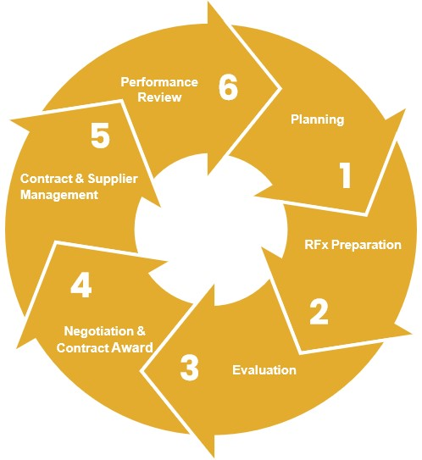

One of the keys to a successful procurement outcome is to prepare a timetable of steps in the process and to adhere to that timetable.

The goal is to ensure that decisions are made in a timely manner and provide certainty to all stakeholders including potential suppliers. Timely decision making will also avoid increased costs associated with delays, both for the council and for potential suppliers.

Councils should support their procurement cycle with a cohesive set of checklists, templates and proformas in the form of a procurement manual.

The preferable location for this manual is online for ease of access and maintenance rather than in a lengthy hardcopy document. A key aspect of this material is its structure. Given the volume of material that supports procurement, it should be structured in a logical manner to ensure it is useful and accessible.

#### 9. Planning

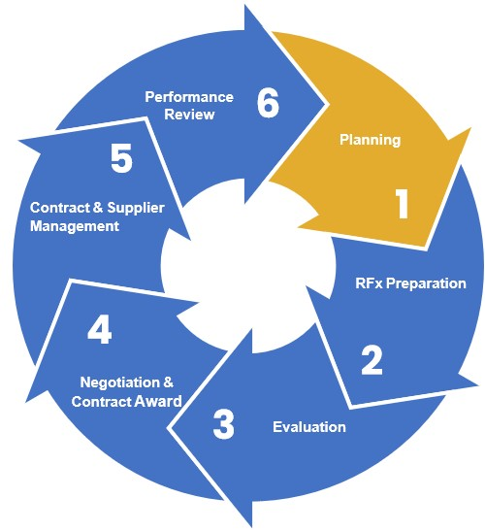

This section covers activities from the identification of the need for a procurement through to the development of RFx documentation.

The objectives of the planning phase of the procurement cycle are to ensure that the:

* procurement adequately achieves the council’s business needs with consideration given to council’s strategic objectives;
* proper internal and market analysis is undertaken resulting in a procurement that adequately reflects market capability and capacity;
* procurement strategy is clearly articulated through a risk management lens; and,
* appropriate authorisation to procure is attained.

##### Business need/requirement

It is critical to understand the council’s business need/requirement as this will define if it is categorised as a niche market or open market. This can be assessed against the council’s level of need i.e. mandatory, need and want - vs - short term or medium/long term business need.

Identifying council’s business need clearly in the specification helps all parties focus on the aim of the contract/project. It supports both effective contract management and the assessment of future contract variations to ensure it aligns with the council’s objectives to:

* ensure the goods, services or works being procured meet the council’s needs;
* ensure both the legislative requirements and council’s procurement related policies, procedures, guidelines are followed and a successful value for money outcome is achieved; and,
* manage the risks associated with the procurement.

The approach to each of these objectives, and the steps necessary to implement them, will depend on the scale of the procurement. Most of the guidance which follows applies to significant procurements in terms of value, complexity and/or risk.

**Factors that influence procurement planning** These include:

* the nature of the goods, services or works being procured – for example, capital projects requiring a design response may include a protracted period during which potential suppliers are required to move through a staged RFx process;
* the complexity of the procurement – for example, where multiple parties are involved in negotiating aspects, such as financing and risk-sharing arrangements;
* whether the need for the goods, services or works being procured is critical to council service delivery – for example, waste management services;
* whether there are time constraints on the delivery of the goods, services or works which mean the procurement needs to take place quickly;
* the level of risk associated with the procurement – for example, a project that presents a high risk to the public requires more detailed documentation than the procurement of general stationery items;
* the cost of subsequent purchases relying on the successful outcome of the current procurement – for example, a council may engage an architect to design a childcare centre and specify the functionality requirements. An RFx may later be called separately for construction of the facility; and,
* the maturity or size of the market – for example, the market for a particular expert service may be small and specialised, thereby limiting the number of potential suppliers.

A council will need to take these factors into account when tailoring its approach to define business needs and commencing the development of the specification phase.

###### Contribution to council objectives

Prior to preparing a specification of needs, it is essential to identify the need in the context of the proposed procurement’s contribution to the achievement of council objectives.

In the context of the legislative requirement for councils to achieve the best outcomes for their communities, there is also an element of justification in assessing the need.[63]

The process of identifying need for significant value procurements involves:

* confirming the origins of the business need which can derive from circumstances such as a council decision based on the Council Plan, council budgets or simply the need to continue to provide existing services. Consultation with stakeholders to identify and substantiate the need is important at this stage;
* identifying the goods, services or works to be procured;
* analysing the supply market to determine if the goods, services and works proposed to be procured are available – to gain a thorough understanding of the range or scope and pricing/costs of goods, services or works that may meet the business need, and to identify a range of viable procurement options; and,
* preparing a realistic, evidence-based assessment of the costs, benefits and risks associated with each procurement option. A business case should clearly identify any assumptions made and provide clear evidence of the basis for these assumptions.

The effort devoted to the process of identifying need, and particularly the extent of any business case, will depend on the complexity, value and risk of the procurement.[64] A significant project will generally call for a business plan.

Alternatively, completion of a procurement plan will address most of the requirements.

###### Collaborative procurement in practice

In accordance with the legislative requirements outlined in the Act, collaborative procurement is now a mandatory consideration for councils. Councils are required to address collaborative procurement across their entire procurement portfolio.

Section 5 of this document provides councils with framework considerations and requirements for implementing better practice collaborative procurement.

For councils embarking on a collaborative procurement process, the *Procurement Cycle* section of the guidelines includes specific advice around the actions required when delivering a collaborative project. This guidance is in the form of checklists, positioned at the end of each section, which outline the specific tasks essential for their successful execution.

It is important to note that the checklist encompasses the full spectrum of actions required for a major collaborative procurement project. However, the requirements may vary based on the scale and scope of the procurement.

###### Procurement analytics

Procurement analytics is the process of collecting and analysing procurement data to assist important council decision-making. It allows users to quickly and easily filter through large volumes of purchasing data, with the ability to see areas of improvement and new opportunities.

Additionally, it provides councils important insights into the procurement process and identifying purchasing trends.

There are many forms of procurement analytics available; some may provide historical data from actual purchases while others are advanced programs that can predict and create budgets for future purchases.

Types of procurement analytics[65]

Diagnostic Analytics

This procurement data is analysed to know why something has happened in the past.

Descriptive Analytics

This data describes what has happened in the past.

Predictive Analytics

This is where trends and patterns in data are used to forecast the future performance of procurement.

Prescriptive Analytics

This analytics shows actionable insights and possible future procurement performance scenarios. It can help you define specific steps to achieve purchasing goals and mitigate risks and disruptions.

###### Scope and specification

The *scope* is a summary of the extent and limitations of the goods, services or works required. The scope may cover the supply or service requirement including, for example, whether any installation works are to be undertaken, details of training or documentation, anticipated quantities, the period of the contract, and any exclusions the supplier is not required to do or provide which might otherwise be considered normally included.

A *specification* details the requirements of the goods, services or works. It is the basis of all submissions and therefore the foundation of the deliverables for a contract. It becomes an essential contract management document which is used to ensure the contracted supplier provides what is specified. It must therefore be clear and accurately define what is expected from a supplier regarding the outputs, solutions, outcomes, or the functional and performance requirements.

For the purpose of these guidelines, both scope and specification documents are referred to as “specification”.

Specifications must be clear and unambiguous so that potential suppliers can effectively address council need and accurately price their submission. Clear and defined specifications can also avoid claims for variations from the contracted supplier during the contract management process.

When procuring goods, services and undertaking works of a highly technical nature or which utilise specialist products, it is advisable to use industry standard specifications. This includes the *Australian Standards*, where these are available (and subject to licensing) or the services of a specialist to develop specifications. An example of frequently used industry standard technical specifications is those for roadworks which are made available by VicRoads for use by councils.

When developing specifications for outsourcing service delivery, councils should:

* consider the requirements of service users and other stakeholders;
* encourage innovative or cooperative approaches to delivering goods, services and works; and,
* ensure clarity as to the goods, service or works required.

If referencing industry standard requirements, ensure these do not contradict council’s specification requirements. To avoid this, consider if a document order of precedence list needs to be included within either the specification document or contract document.

###### Intellectual property

Care should be taken where intellectual property is concerned in the definition of procurement requirements. Intellectual property includes things such as any expression of ideas, designs, images, original writing and unique signs which have been specially created. The owner has exclusive rights and may be able to charge a fee if anyone uses the intellectual property they have created.

Contravention of property rights could be direct or even indirect – for example, linking to a website which carries images or words, or even sending writing, pictures or materials in a quote.

A council should respect intellectual property in all RFx matters. A contract should not involve the use of another’s intellectual property unless permission has been obtained and any fees paid.

If intellectual property is created as part of a council contract, there should be clear documentation establishing the ownership of such property arising from the contract – for example, per Standards Australia, Contract Standards and Licensing, to:

* Secure the right permissions to use standards;
* Find and buy contract templates; and,
* Access standards content or extracts

##### Market analysis

The key objective of market analysis is to identify the preferred and most relevant approach to the market given the requirements of the procurement.

Consider the following impacts, whilst being careful to maintain probity:

* current supply market’s capability and capacity;
* geography;
* restricting trends and developments;
* pricing; and,
* customers.

This can be supported by completing a SWOT (strengths, weaknesses, opportunities and threats) analysis.

##### Developing the strategy and procurement plan

###### Procurement plan

An appropriately detailed procurement plan should be developed at the outset and should be scalable depending on the level of risk, complexity and value. The plan may include but is not limited to:

* project summary;
* scope of the requirement;
* estimated value/financial considerations;
* strategic analysis – business case including key objectives, business needs, critical success factors, current/ proposed spend (volume/trends) and demand profile;
* policy matters affecting the procurement activity (for example, sustainable procurement, local and social procurement, circular economy, environmental sustainability, Aboriginal and Torres Strait Islander and collaborative procurement options etc.);
* market analysis;
* user/stakeholder expectations;
* evaluation criteria, methodology and evaluation panel members;
* contract KPIs;
* procurement methodology/options (for example, pre-invitation submissions, public market approach and information briefings);
* procurement timeframe;
* RFx management;
* risk management and mitigation issues;
* reporting and monitoring arrangements;
* transitional issues (in/out);
* asset management and disposal arrangements;
* probity requirements; and,
* procurement plan signoffs.

###### Managing risk

All procurements embody a degree of risk that can never be completely eliminated. However, risks can be identified, and many can be mitigated.

Risks can range from the failure of a supplier to deliver a minor requisition through to the breakdown or delay of a major project. Effective risk management requires containment strategies and contingency planning to mitigate and respond to risks that may emerge.

The council must also be aware of its statutory obligation to manage its financial risks by prudently having regard to economic circumstances.[66]

All risk management considerations and actions should be consistent with the council’s risk management policy. This policy should, in turn, be consistent with AS/NZS ISO 31000:2009 Risk Management – Principles and Guidelines (which supersedes AS/NZS 4360:2004) and provides a generic framework for establishing the context, identifying, analysing, evaluating, treating, monitoring and communicating risk.

High value procurements, and those of lesser value but of a complex nature, should be subject to a risk management plan. This plan considers risks at all stages of the procurement cycle. Council policy should set the trigger point at which a risk management plan is required.

A risk management plan would address the following:

Establish the context

The goals, objectives, strategies, scope and parameters of the procurement activity will be detailed.

Identify risks

The ‘what, why and how’ things can arise in the procurement will be identified, providing a basis for further analysis.

Analyse risks

The existing controls will be determined and the risks in the procurement will be analysed, in terms of consequence and likelihood in the context of those controls. The analysis will consider the range of potential consequences and how likely those consequences are to occur. Consequence and likelihood may be combined to produce an estimated level of risk.

Evaluate risks

The estimated levels of risk to the procurement will be compared against pre-established criteria. This will enable risks to be ranked to identify management priorities. If the levels of risk established are low, then risks may fall into an acceptable category and treatment may not be required.

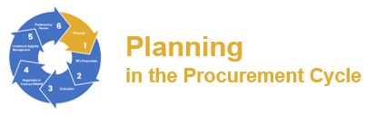

Treat risks

Medium and low priority risks may be accepted and monitored. For other procurement risks, a specific action plan will be developed and implemented in accordance with the available funding.

Monitor and review

Performance of the risk management system will be monitored and reviewed to take account of any changes which might affect it.

Communicate and consult

Communication and consultation with internal and external stakeholders will occur as appropriate at each stage of the risk management process and concerning the procurement process as a whole.

One significant mechanism for addressing risk is contingency planning.

Many councils have contingency plans in place for their major and/or critical services or functions (for example, loss of telecommunications, loss of power etc.). These contingency plans together with a council risk register not only identify potential risks but also set out plans for addressing the occurrence of major incidents.

Conversely, the role of the procurement function when a contingency plan is activated is critical - needing to respond to the urgent need for goods, service and works.

A council should also incorporate the relevant and current risk management standards in the specifications it develops for various goods, services and works.

A council must also consider the balance between apportioning risk to a supplier(s) and the cost. If all risks on all contracts are assigned to suppliers, then it is likely that a premium will be paid by the council. Council should determine what risk it is prepared to accept in a contract and ensure this is reflected in the price it pays.

##### Resourcing the RFx process

Consideration needs to be given to ensuring that appropriate resources, including adequate knowledge and skills, are available to ensure a successful and compliant procurement outcome.



##### Authority and funding to procure

One primary prerequisite for every procurement is to ensure that adequate authority is in place.

Before proceeding to procure any goods, services or works the relevant officers should confirm they have the authorisation, delegation or council direction necessary to undertake the procurement.

This authority will be exercised either on the procurement plan or via purchase order, depending on each council’s procedures.

Authorisations should also cover the approval of contract variations. Consideration should be given to setting a maximum value for variations as a percentage of the total value of the contract, before the need for approval is escalated to a senior level.

The assessed value of each procurement should be verified against the council’s budget, a funding resolution of the council and/or the council’s financial system to ensure adequate funds are available to meet the liability created by the procurement.

For high-risk high value contracts, a clear governance structure that lists each individual role and responsibility during the procurement and subsequent contract management process is recommended. These roles should be assigned to current employees or contractors with the correct skillset and financial delegations to effectively manage the contract.

Considering resourcing at this stage can be essential to a contract’s success. Relative to the size of the contract, adequate resources, both in terms of adequate time commitment and expertise, are important to ensuring all objectives of the procurement are met.

##### Supply cycle

An anticipated schedule for the procurement and supply cycle is fundamental to a successful outcome.

Decisions need to be made in a timely manner and provide certainty to all stakeholders including potential suppliers. Timely decision-making will also avoid direct and indirect impacts, including costs associated with delays, both to the council and to potential suppliers.

Councils should, in conjunction with their procurement policy, support their procurement and supply cycle with comprehensive documentation for managing all requirements throughout the process - for example, procurement framework, procurement plan, procurement procedures manual, and contract and supplier management framework.



##### Request for tender and quote minimum timelines

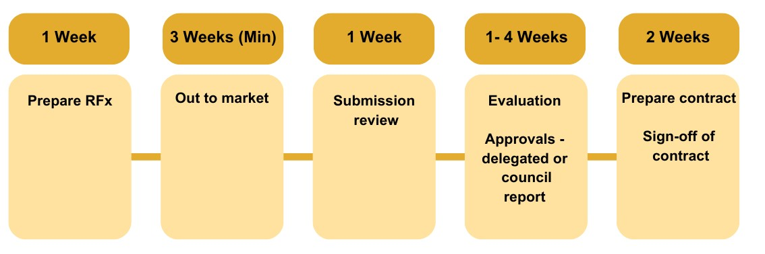

##### Expression of interest minimum timelines

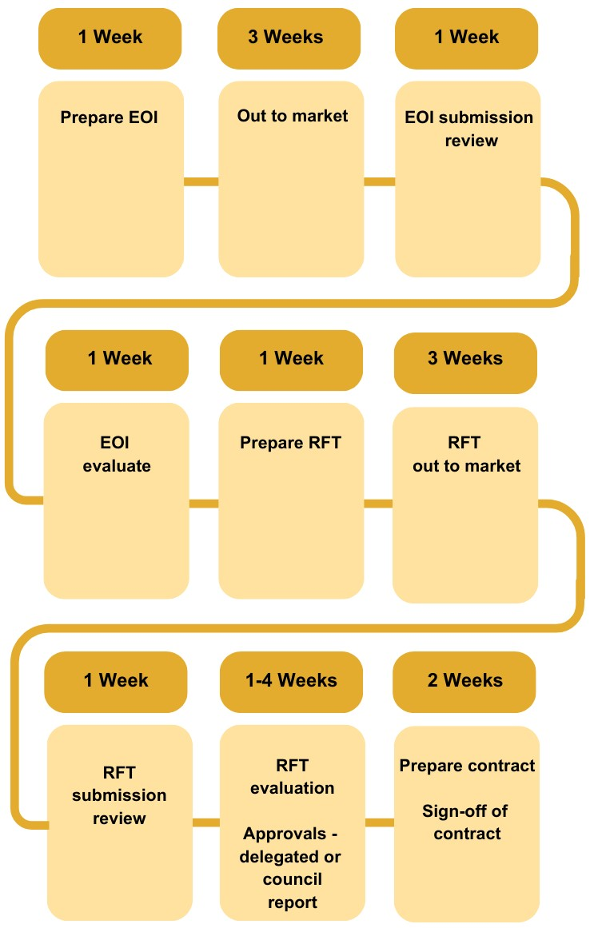



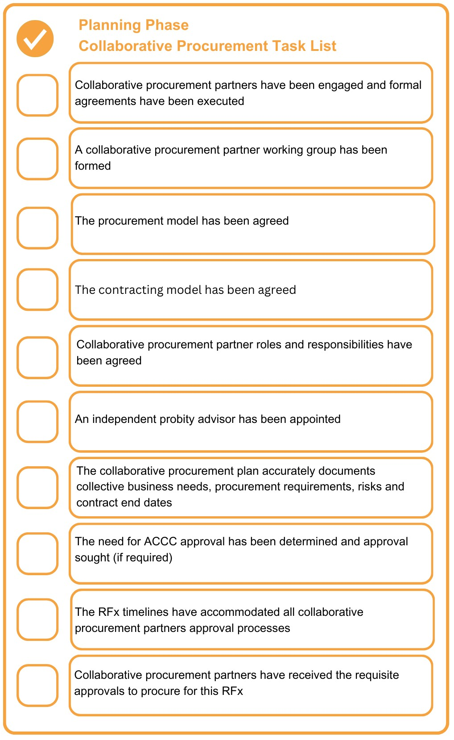

#### 10. RFx preparation

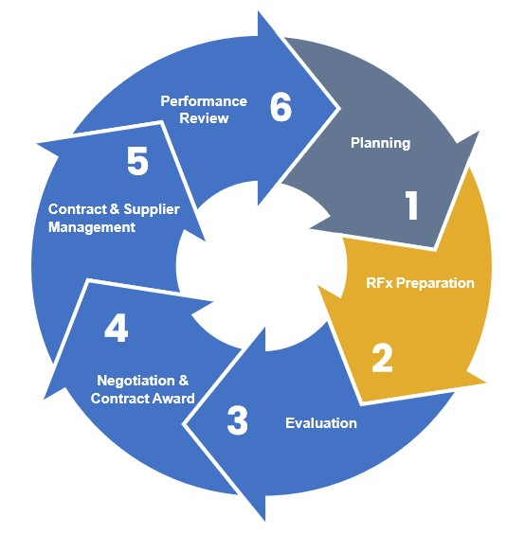

This section covers activities from the drafting of RFx documentation through to the RFx closing time.

The objectives of the RFx preparation phase of the procurement cycle are to ensure that the:

* drafted RFx documentation reflects the agreed procurement strategy;
* specification documentation provides the requisite level of detail to elicit a competitive response from the market and generate a value for money outcome; and,
* established RFx process is efficient and effective for both council and potential respondents.

##### Pre-RFx market testing

Prior to issue of an RFx, supply market analysis can provide an understanding of the availability, range and pricing of the required goods or services and assist in identifying alternative options.

Analysis will also allow a council to develop an understanding of the range of suppliers in the market, the factors driving supply conditions and how they may affect the procurement. This is important for developing specifications and in determining the strategy to encourage optimal market participation and thereby achieve value for money.

This process is more likely to be needed for new or atypical, rather than routine, procurements, although team members will generally also monitor the supply market for routine procurements.

Conduct early market engagement through an expression of interest or request for information process to:

* foster innovation and collaboration;
* refine the council’s requirements;
* understand the market dynamics, supply chains and trends;
* assess the broad scope for achieving evaluation criteria objectives;
* identify and manage issue and risks;
* inform subsequent RFx activities; and,
* understand likely costs (via a request for information process only).

This early market engagement is useful to inform and prepare your council and the market for the subsequent RFx process. Do not use it for supplier selection.

##### Developing RFx documentation including detailed specification

This should be reliant on the individual council’s procurement thresholds and level of requirements set out in the policy. The level of documentation, including the specification detail, should reflect the procurement value and risk. Subsequently the engagement method i.e., purchase order or formal contract, including the terms and conditions, should be tailored to suit the procurement type. The higher the value and risk of the procurement, the more comprehensive level of documentation and protection is generally required.

The tender document generally comprises of the below sections:

* RFx conditions;
* contract conditions;
* specification; and,
* RFx schedules.

##### Supplier selection to participate in RFx

Determining the best procurement approach will guide the suppliers selected to participate in the RFx process. Procurement methods include request for information (RFI), request for quotation (RFQ), request for tender (RFT), request for proposal (RFP) or expression of interest (EOI).

It is expected that councils have a suite of templates tailored to the procurement type and these are consistent where possible, to support completion by respondents.

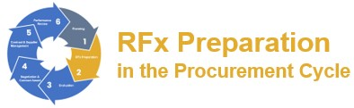

Selecting the best method will depend on a number of factors, including:

* value for money;
* capability;
* credibility;
* risk; and,
* availability of goods, services or works.

Refer to council policy to understand specific requirements and to understand value for money considerations.

###### Determining the procurement method

Councils have open to them a range of options for fulfilling their procurement needs. Choosing between these options will initially be determined by the value and risk of the procurement relative to the council’s policy.

If the value of a procurement does not reach the public RFx threshold, the procurement can be achieved through:

* purchase orders;
* purchase cards;
* RFx; and/or,
* under a third party agent contract e.g. other councils via collaborative procurement, MAV, Procurement Australia, state purchase contract, Victorian whole-of-government contract

Consequently, if the procurement involves a high level of risk, the method of procurement should be escalated to establishing a formal contract. For example, if a low value purchase has the potential to negatively impact the community and council’s public image/reputation, then establishing a formal contract can assist council in managing the risk, e.g. through insurances and additional terms and conditions the supplier is required to comply with.

A council should be aware of the cost of each procurement transaction to ensure that it does not outweigh the savings from the competitive RFx process. The use of purchase cards is one means of containing these costs.

Where the value of a procurement reaches the public RFx thresholds, a council must undertake a public RFx process such as:

* request for information (RFI) as a preliminary step to calling tenders;
* request for expression of interest (EOI) as a preliminary step to calling tenders;
* request for proposal (RFP);
* request for tender (RFT); and/or,
* a third party agent contract e.g. other councils via collaborative procurement, MAV,

Procurement Australia, state purchase contract, Victorian whole-of-government contract.

Other options include:

* a third party agent tender (purchasing schemes) where a council is eligible, or
* sole or single source supplier through councils' formal exemption process

The choice of one of these options will depend on a number of factors, including:

* policy provisions;
* value for money;
* risk; and,
* council’s objectives and preferences.

As systems develop councils are likely to make increasing use of online eProcurement systems such as electronic auctions (eAuctions, reverse auctions, etc) where the roles of buyers and sellers in a typical auction are reversed and the sellers compete to obtain business.

###### Request for tender

Request for tender is the primary method for seeking competitive submissions from prospective suppliers where public RFx threshold values are reached.

Where a decision is made that a public RFx process is to be undertaken, then a council needs to ensure it has in place the necessary documentation in addition to the specification.

The composition of the documentation will vary between councils but there are a number of primary components such as:

* introduction/overview;
* invitation to tender (some councils use this as a way to market their needs to potential respondents);
* conditions of tendering (the rules for tendering, including evaluation criteria);
* form of tender and pricing schedules or tables;
* proposed contract;
* tender schedules;
* conditions of contract (and sometimes special conditions); and,
* specification for the goods, services or work sought which may or may not include drawings and technical definitions of need.

RFx documentation is most important. Poor, faulty, or inadequate documents will increase the risk to success and discourage respondents.

###### Request for selective RFx (by invitation)

Selective RFx is the mechanism for inviting submissions from select suppliers as per council policy.

If this decision is taken a council needs to ensure it has the necessary documentation in addition to the specification in place.

The composition of the documentation will vary between councils but there are a number of primary components such as:

* introduction/overview;
* invitation to selected RFx (some councils use this as a way to market their needs to potential suppliers);
* RFx conditions (the rules for the RFx, including evaluation criteria);
* RFx form and pricing schedules or tables;
* proposed contract;
* RFx schedules;
* conditions of contract (and sometimes special conditions); and,
* specification for the goods, services or work sought which may or may not include drawings and technical definitions of need.

RFx documentation is most important. Poor, faulty, or inadequate documents will increase the risk to the success of the procurement and discourage respondents.

###### Request for expression of interest

An expression of interest is a two-step process and does not replace the need for a request for tender process.

It simply precedes the request for tender process and generally seeks to constrain the number, and focus the quality and detail of submissions received and/or ascertain potential suppliers in the marketplace. An expression of interest process is generally structured with the following components:

* overview of requirements;
* invitation to submit an expression of interest;
* criteria for evaluating expressions of interest (primarily capability and capacity); and,
* form of expression of interest submissions (respondents form).

An expression of interest should be used in circumstances such as where:

* there are likely to be many respondents, conducting a request for tender process will be costly, or, the procurement is complex and council does not wish to impose the costs of preparing full submissions on a large number of potential respondents; and/or,
* there is uncertainty as to the interest of suppliers or their capacity to offer the potential products or services or to undertake the proposed works.

RFx processes, including expressions of interests, should not be used to compensate for a lack of understanding as to a council’s needs.

###### Requests for information - RFI

If a council is uncertain as to what goods, services and works it requires, it should undertake a simple request for information. This may be undertaken for reasons which include establishing:

* available technologies, products or services in the marketplace that meet council needs;
* whether proposed terms and conditions or deliverable expectations are acceptable in the marketplace; and,
* whether proposed budgets are adequate to meet non-standard procurement needs – inadequate budgets should not become apparent only after an RFx is opened.

In short, a council should use a request for information process rather than a request for tender or expression of interest to improve its understanding of its own needs, availability and likely costs.



##### Issuing RFX documentation

###### Utilising eProcurement systems

In accordance with the above documentation and supplier selection, issuing RFx documents should be supported by using an eProcurement system to reinforce procurement principles.

Electronic procurement or eProcurement, as it's more commonly known – is an online platform used to procure the goods, services and works needed to operate, and may include:

* procurement planning;
* RFx processing;
* recording submissions;
* evaluating submissions; • supplier pre-qualification; and,
* contract execution.

EProcurement systems centralise and automate interactions between stakeholders (such as end users, the procurement department, suppliers, etc.) to improve the performance of the procurement process, management, and, strategy.

They can transform and influence the procurement process through:

* increasing efficiency;
* supporting transparency;
* monitoring compliance;
* optimising processes and increasing productivity;
* achieving cost savings through improved visibility and value;
* improving supplier relationships; • preventing duplicate spending; and,
* leveraging volume buying.

Council should assure itself as to the security of such systems, especially where they are effectively controlled by a third party.

The documented protocols for securing submissions which are followed by a third party agent should be held by council and be periodically tested by council as to the effectiveness of the security.

###### RFx schedules

The key components of the RFx documentation are the schedules which are prepared to enable the respondent to respond to the RFx and to provide council with the information it requires in a preferred form. This information will be used as the basis for evaluating submissions.

A list of schedules should cover, but is not limited to:

* respondents’ details/legal structure;
* statement of conformance/compliance/alternative submission;
* collusive tendering – statutory declaration;
* conflict of interest/confidentiality declaration;
* compliance with the Victorian Government Code of Practice for the Building and Construction Industry (where applicable);
* receipt of addenda;
* occupational health and safety;
* WorkCover, contract works insurance, public liability, professional development, product liability and motor vehicle insurances as a minimum;
* industrial relations history;
* quality management/system;
* RFx summary;
* financial assessment/statement of threatened or pending litigation;
* capability, capacity, resources to be engaged in the performance of the contract;
* register of subcontractors and suppliers;
* past and current contract commitments;
* experience and business references;
* delivery methodology and project/implementation plan;
* performance management;
* sustainable procurement commitments including environmental, social, local and Aboriginal and Torres Strait Islander business procurement; • pricing schedule; and,
* other information.



The schedules included in any one contract will vary. For example, where a contract is solely for goods then the ‘schedule for labour resources to be employed in the performance of the contract’ may not be required.

The content of some schedules will also vary according to the type of procurement. For example, an insurance requirement for professional indemnity and motor vehicle insurance does not apply to all contracts.

###### Assembling and checking of RFx documentation

Once all RFx documentation is prepared, it should be assembled in a sequence that facilitates respondents’ submissions.

A council should conduct a thorough review of all RFx documentation before issuing it to the marketplace. The goal should be to avoid the need to issue addenda to the RFx documentation for missing or erroneous matters which reflects poorly on the council and discourages respondents to submit. It is often valuable to have all the documentation independently checked within a council.

Issued documents should be fit-for-purpose. Councils should be alert to the risks of ‘boilerplate’ documentation and forming contracts with a ‘cut and paste’ approach. Many contracts require individual approaches to different aspects of the contract documentation, especially where standard template documentation is used and data has to be populated to the template.

###### RFx documentation authorisation

RFx documentation should be subject to approval by a relevant delegate, preferably at least third tier, within each council. This sign-off should confirm that the RFx documentation reflects the council’s needs and authorises the placement of a public notice for the RFx.

###### Issuing a public notice or advertising the RFx

The council policy will state when a council needs to conduct a public RFx process. For guidance on the issuing of a public notice and advertising the RFx, refer to *Section 3 Advertising of procurement opportunities*.

###### Prequalification of respondents

One means of reducing the cost of sourcing to a council (and their suppliers) where there are high volumes of procurements, is to pre-qualify potential respondents using a supplier prequalification management system. This could be an internal or third-party system where potential respondents can satisfy the basic RFx conformance and mandatory requirements on an annual or periodical basis.

Savings are gained by councils from not having to repeatedly assess the compliance of respondents in areas of occupational health and safety, insurance (for example, public liability, professional indemnity, worker compensation, motor vehicle) quality management, environmental management system etc.



Similarly, savings can accrue to businesses in not having to demonstrate compliance for every RFx to which they respond.

The pre-qualification process should cover criteria such as:

* company profile, including the financial stability of the organisation;
* confirmation of the insurance policies and level of cover held;
* compliance with occupational health and safety requirements;
* financial capacity of the supplier to fulfil its obligations under a contract;
* management, quality and environmental management systems; and,
* company experience including past and current contracts.

Many councils use third party website providers to manage their RFx registration and RFx issue processes. Some are also using these providers for the lodgement of RFx submissions.

A council should be careful to ensure that pre-qualification does not act as a barrier to new or smaller businesses. Barriers exist when additional and/or uneconomic costs are incurred by respondents in complying with council requirements or where the requirements of prequalification are excessive.

Prohibitive or unrealistic requirements for insurance cover or risk management requirements are examples. The issue is the level of risk a council should accept for itself. Councils must balance their responsibility to achieve prudent risk management with the cost of doing so, which is reflected in submission prices.

###### RFx briefings and site inspections whilst out to the market

A decision about whether to conduct briefings/site inspections is a matter of judgement as to the value of such a gathering and its timing. For a complex, unusual or sensitive RFx, the opportunity to attend briefing/site inspections prior to RFx close can help promote an effective approach to market exercise. These briefings can be either mandatory or non-mandatory.

Briefings/site inspections have a number of advantages, including:

* allowing council to reinforce its primary requirements and the essence of the contract;
* permitting suppliers to clarify any uncertainties;
* allowing potential respondents to assess their capacity to fulfil the contract; and,
* fostering relationships with suppliers.

Whilst a standard condition of an RFx requires respondents to familiarise themselves with the sites and circumstances of providing a service or works, sometimes a formal site inspection is valuable.



###### Forum questions and addenda

Forum questions, addenda and correspondence must be addressed through the eProcurement system.

Questions of a private or commercially sensitive nature asked by registered suppliers during the RFx period, are to be responded to via the original eProcurement system private response option.

Consistency is critical in all communications with registered suppliers on amendments to the original RFx. All respondents should be provided with all questions and answers, excluding those of a sensitive or private nature, and have adequate time to respond in their submission. A cut-off date for questions should be applied by a council and should be set to take into account aspects of the RFx submissions sought.

All communication must be via the eProcurement system. No canvassing of people outside the nominated person in the RFx should occur and this should be reinforced within the council’s RFx conditions.

###### Lodgement and close of submissions

A council must ensure the processes by which an RFx is submitted addresses probity, auditability, and accountability. Submission lodgement instructions in the RFx documentation must be clear to all potential respondents.

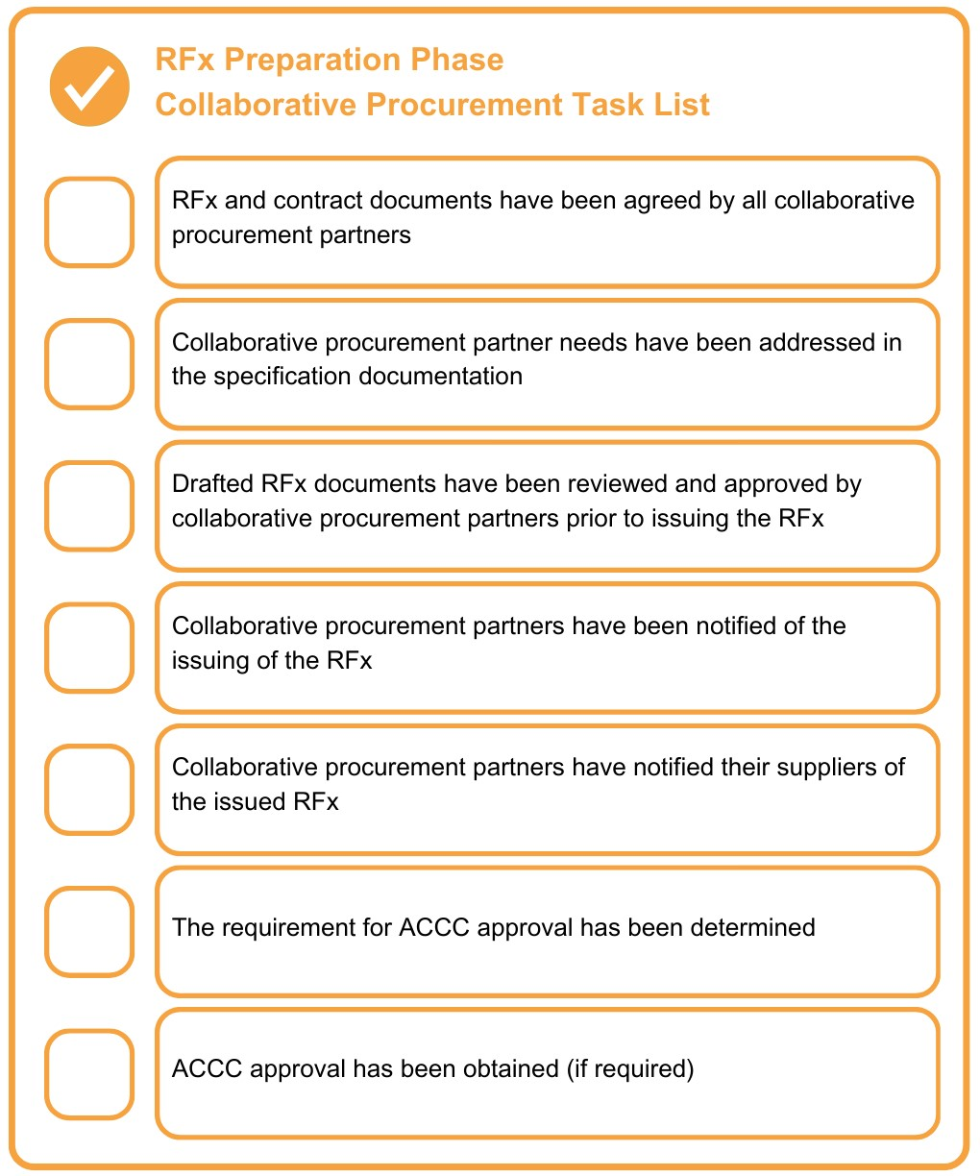

#### 11. Evaluation

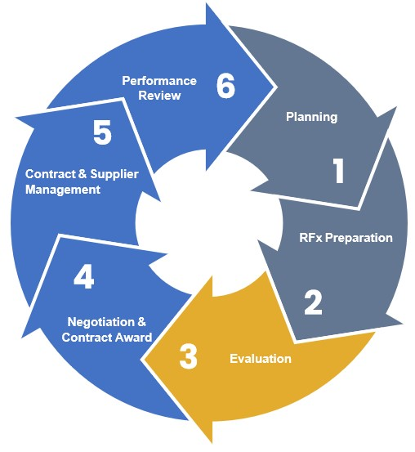

This section covers activities from the close of RFx through to the respondent shortlisting phase.

The objectives of the evaluation phase of the procurement cycle are to ensure that:

* the selected respondent can deliver a value for money solution;
* the selected respondent is capable and has the capacity of providing the goods or services being sought or the carrying out of works specified; and,
* the procurement process is transparent, fair, robust, and that decisions are justified, adequately documented, and stand up to scrutiny.

##### Probity principles

As detailed in *Section 6 Probity*, a robust and justifiable process should be followed to ensure probity principles are supported throughout the evaluation process, Considerations include:

* adhering faithfully to the approach to market conditions including applying the evaluation criteria set out therein;
* providing a fair comparison between the responses and conducting the process in accordance with approved evaluation methodology and criteria;
* detailing the information requested in the RFx documentation including any mandatory requirements. Failure to do so will deem the submission non-conforming;
* identifying the evaluation panel hierarchy, what information the panel members have access to and how evaluation criteria should be assessed and scored; and,
* Providing clarity for all parties within the process on their roles and responsibilities, signed conflict of interest / confidentiality declarations and the requirements when scoring.

##### No RFx submissions or rejection of all submissions

If a council undertakes a compliant public RFx process and does not receive any submissions or rejects all submissions, it may seek an alternative means of delivering the goods, services or works required under the RFx without changing the requirements (including undertaking the service or works itself).

If a council seeks to appoint another respondent (under what is sometimes called a selective RFx) who did not submit when submissions were originally called it must ensure that:

* the grounds for rejecting the submission(s) received are on the basis they did not meet council’s requirements outlined in the RFx document, and/or did not provide value for money to council;
* it is highly unlikely that another competitor would make a submission if the council were to go back to the market for the goods, services and/or works;
* the terms on which council intends to engage the supplier are the same as the specifications in the original RFx documentation; and
* engaging the supplier will provide value for money to council.

If a council amends the specification or intent of its requirements for goods, services or works so that it is materially different, this will constitute a new contract. Council should then undertake a new public RFx process.

##### Ownership of submissions

Upon submission, all RFx documentation and other information submitted by the respondent as part of or in support of an RFx should become property of council.

The respondent should retain copyright and other intellectual property rights contained in its submission. However, each respondent by provision of its submission, is deemed to have granted an irrevocable royalty-free licence to council to reproduce, in whole or part, its submission for the purposes of enabling the council, or such persons or bodies as the council reasonably considers necessary, to evaluate, clarify or vary the submission or to negotiate any resulting contract.

Respondents to an RFx process do not acquire rights to the intellectual property in the RFx documents and must not reproduce any of the RFx documents without the written permission of the council other than for use strictly for the purpose of preparing an RFx submission.

Respondents agree that, if the council accepts the submission, they will consent to the council publishing (on its website or otherwise) all contract information (including the successful respondent’s name, the contract value, and start and end date of recurring contracts).

##### Confidentiality

Each respondent or other recipient of the RFx must keep it, and any information provided by council in connection with it, confidential. This includes any information marked as confidential or which the respondent/recipient knows or ought reasonably to know is confidential or should be treated as such.

All submissions received by the council must be held in confidence. The respondent acknowledges that council may disclose any information in the submission to its professional advisors or if required by law (including, but not limited to, as required under the *Freedom of Information Act 1982* *(Vic)*), or government policy.

##### Acceptance of submissions

Unless otherwise stated in the RFx, submissions may be submitted for all or part of the council’s requirements and may be accepted by council either wholly or in part. The council is not bound to accept the lowest price, or indeed any submission (and may reject any or all submissions).

Respondents should be informed in writing of the outcome of their submission at the conclusion of the RFx process. The council has the right to not accept a submission (or any part of it) and is under no obligation to give reasons for not accepting a submission. The council may, at its absolute discretion, invite unsuccessful respondents to a de-brief meeting on the outcome of the RFx.

The respondent must declare and detail any non-compliances to the RFx in its submission including any contract departures and RFx assumptions. These must address any material conditions or positions in relation to the conditions of contract and/or specification.

If any submission is accepted by council, it should be conditional until both parties sign a contract for the goods, services or works, based on the conditions of contract (subject to negotiation of any amendments to those conditions requested by the respondent in their submission).

##### Submission validity period

Typically, submissions should remain valid and open for acceptance for 90 days from the RFx closing time unless extended by mutual agreement between council and the respondent(s) in writing.

##### Submission mistakes/errors

Although not considered best practice, a council may, at its discretion, permit a respondent to correct an unintentional mistake or anomaly in its submission after the RFx closing time.

Such a variation may be made either:

* at the request of the council; or,
* with the consent of the council at the request of the respondent, but only if, in the circumstances, it appears reasonable to council to allow the respondent to provide correction.

If a submission is varied in accordance with this clause, and it is deemed necessary in the interests of fairness, the council should notify in writing each other respondent whose submission circumstances have the same or similar characteristics as the varied submission and provide those respondents with the opportunity of varying their submissions in a similar way.

Alternatively, an incomplete submission may be disqualified or assessed solely on the information received with the submission. A correction should not be permitted if the council reasonably considers that the correction would materially alter the submission.

##### Clarification of a submission

The evaluation panel reserves the right to seek clarification on any RFx submission. The council may disqualify the submission if the respondent fails to supply satisfactory clarification.

The council is under no obligation to seek clarification and should always reserve the right to disregard any clarification that it considers to be unsolicited or otherwise impermissible.

##### Identity of the respondent

The identity of the respondent is fundamental to the council. The respondent (and the party to any ensuing contract with council) will be the company, person or entity (or in each case, multiple for joint submissions) named as the respondent in the submission.

The council may reject any submission that is not from or does not disclose a solvent legal entity capable of entering into a contract. The respondent must provide its Australian Business Number (ABN), or, if it does not have an ABN, the reason for not having one.

##### RFx evaluation panels

Evaluation panels must be formed to evaluate submissions for all RFx processes. All persons forming the evaluation panel should be nominated in the procurement plan and involved in the actual RFx assessment. The process should be robust and under no circumstances should the submissions be considered by a single person panel.

Evaluation panels must adhere faithfully to the RFx conditions including applying the evaluation criteria set out in them.

There may also be circumstances where it is advantageous to form small evaluation panels to evaluate RFQ’s. For example, where a series of RFQ’s is sought for a range of trade services the assessment of these may benefit from an evaluation panel assessment.

For procurement facilitated RFx processes, the procurement plan should list the appointment of the chairperson and each evaluation panel member and then be approved by the relevant director (or equivalent). When nominating panel members, the aim is to create a balanced and independent panel. These appointments should include standard instructions on the role and responsibilities of and/or terms of reference for evaluation panel members. A procurement team representative is typically nominated as chairperson.

The membership of an evaluation panel should be appropriate to the operational and technical aspects of the RFx and preferably represent stakeholders as well as those officers who will be responsible for managing the eventual contract. Where technical expertise is required, this may involve including one or more external persons. Contracts for waste are typical examples where external expertise in the assessment of submissions can be advantageous.

The inclusion of a panel member who is independent of the organisational unit managing the contract should be considered where it is central to, or will improve, the objectivity of the panel.

An evaluation panel should be formed before an RFx is issued. Conflict of interest and confidentiality requirements should be satisfied at this time. The panel should review the RFx documentation before it is issued and confirm it will achieve the objectives of the proposed contract.

As part of the review the panel must confirm that the evaluation criteria will allow the meaningful assessment of the submissions. Weightings should be assigned to each of the scored evaluation criteria (as distinct from the conformity and mandatory requirements) and may be reflected in the RFx documentation. This is an important probity issue and avoids the possibility of weightings being adjusted (consciously or unconsciously) to favour any respondent after submissions close.

The number of persons on a panel is dependent on the value or risk of the RFx. A benchmark size for a panel is three voting members and a chairperson for an RFx process up to $1 million in value and potentially a larger panel for higher value RFx processes.

In a best practice context, evaluation panel members should undertake training, be assessed as having the knowledge and skills required, particularly in RFx evaluation, and be accredited if appointed to a panel. The chairperson of a panel at least should be trained in probity matters. *(*See *Section 5 Training and skill development to build capacity).*

A council’s rules or terms of reference around the formation, composition and operation of evaluation panels should be documented. These should be distributed to evaluation panel members at the time they are appointed.

If councillors are involved in procurement processes/decisions, they will need to take particular care in identifying and disclosing conflicts of interest, in order to comply with the *Act*. The application of conflict-of-interest provisions to councillors are broader than for staff. Any councillor involved in procurement should consult the relevant guide or take advice.

###### Evaluation panel members

For procurement facilitated RFx processes, evaluation panel members should be nominated by the project manager or service lead during the planning stage and signed off in the procurement plan. External members can be nominated on to the panel and may be paid for their time.

Project managers should consult with the evaluation panel members prior to nomination, to confirm acceptance of appointment to the panel. Not all evaluation panel members need to score; subject matter experts can provide their knowledge to all the panel to help in the assessment, particularly when technical expertise is required. If an officer is just observing, they are still required to sign a conflict-of-interest/confidentiality declaration.

For high risk or complex RFXs, a probity advisor is strongly recommended.

##### Role of evaluation panel members

###### Roles and responsibilities of the evaluation panel

The roles and responsibilities of the evaluation panel members (excluding non-voting panel members) are to:

* treat submissions and potential respondents in a fair and even-handed way, providing respondents with the same information and avoiding preferential treatment, consistent with the approved RFx process and the evaluation criteria;
* ensure all responses are evaluated on the same basis, and scoring and associated comments are consistent with the evaluation scoring matrix (if applicable);
* ensure all submission information, both paper and electronic, is always kept securely with access only for authorised people;
* disclose any conflicts of interest arising during the RFx process and adhere to relevant policies;
* actively contribute to the evaluation of the submissions according to the evaluation criteria by providing comments and scoring;
* appropriately and adequately test and verify the claims made by respondents in relation to the evaluation criteria;
* recommend the preferred respondent(s), based on the outcome of the evaluation process;
* ensure no discussion should be held with any respondent about the evaluation process in relation to any aspect of the RFx process without the prior approval of the chairperson, or at their direction;
* exercise caution while routine business meetings and social activities continue as usual, and not discuss the evaluation, selection procedures, or contents of the RFx process. Where any party in an unrelated business meeting or social situation seeks to raise issues in respect of the RFx process, the person should indicate that it is not appropriate to discuss such matters;
* ensure respondents are advised to deal directly with the selected chairperson or nominated contact, for matters relating to the RFx process. Refusal to enter discussions of this nature is required;
* refer matters concerning probity and communication with respondents or potential respondents during the RFx process to the procurement/probity advisor; and,
* consider and recommend variations to the original RFx documentation that may arise during the RFx process.

###### Roles and responsibilities of the chairperson

The chairperson will be the primary contact for the RFx process and is required to abide by the roles and responsibilities of the evaluation panel members listed above, but has additional responsibilities, including to:

* chair the evaluation panel and to take responsibility for the conduct of the team ensuring compliance with the evaluation processes;
* make evaluation panel members aware of their roles and responsibilities during the RFx process;
* coordinate any contact with respondents during the RFx process;
* ensure that all respondents have access to the same information and that commercialin-confidence information is only available to those who need it. Significant clarification or further detail is to be provided to all respondents equally;
* ensure all evaluation panel members have assessed submissions consistent with the evaluation scoring matrix;
* maintain records throughout the process which should provide enough information to enable independent review if requested;
* coordinate the closing and registering of submissions; and,
* notify successful and unsuccessful respondent(s).

###### Roles and responsibilities of the procurement / probity advisor

The procurement/probity advisor should not have voting rights as part of the evaluation panel. They should play an independent advisory role, including to:

* provide timely and accurate advice on key aspects of the RFx process ensuring adherence to stated methodologies;
* attend key evaluation panel meetings;
* be an observer in dealings with respondents and the evaluation panel at presentations and interviews;
* be available to answer questions and provide advice to the evaluation panel and other internal stakeholders if required; and,
* prepare and present a probity report that formally summarises their observations of the RFx process.

The procurement/probity advisor should aim to empower the evaluation panel on the agreed RFx processes to ensure efficiency of process during these phases and to provide legacy knowledge for future RFx processes.

###### Roles and responsibilities of the non-voting panel members

The roles and responsibilities of the non-voting panel members (excluding procurement/probity advisor) are to:

* treat submissions and potential respondents in a fair and even-handed way, providing respondents with the same information and avoiding preferential treatment, consistent with the approved RFx process and the evaluation criteria;
* ensure all submissions are evaluated on the same basis;
* ensure all submission information, both paper and electronic, is to be kept securely at all times with access only for authorised people;
* disclose any conflicts of interest arising during the RFx process and adhere to relevant policies;
* actively contribute when required/requested to the evaluation of responses in a timely fashion;
* ensure respondents are advised to deal directly with the chairperson for matters relating to the RFx process. Refusal to enter discussions of this nature is required; and,
* refer matters concerning probity and communication with respondents or potential respondents during the RFx process to the procurement/probity advisor.

##### RFx evaluations

The process for evaluating RFx submissions will depend on the size, complexity, and associated risks of each procurement. This will range from a simple assessment of a number of submissions on a straightforward procurement, through to a comprehensive evaluation involving briefings, technical reports, a probity plan, probity advisor/auditor, detailed financial assessments, and possibly industrial relations negotiations.

A council must ensure that sufficient detail and analysis is undertaken and recorded during the RFx evaluation to justify the awarding of contracts. The objective is to create an audit trail and a set of supporting documentation to justify the evaluation process and final decision.

The evaluation process should provide a fair comparison between the submissions and be conducted in accordance with the approved evaluation methodology and criteria. The same evaluation method should be applied to each submission. Submissions must be evaluated in a systematic and consistent manner using the evaluation scoring matrix (if applicable).

A council should be alert to the possible creation of a ‘process contract’[67] wherein an RFx may also give rise to a legally binding agreement called by the courts a ‘tender process contract’. Courts have found that where an RFx is issued and a conforming submission is received, that a tender process contract will arise from it and will contain an implied term requiring it to ‘deal fairly’ with all the respondents in assessing their submissions and awarding the main contract. If a council deviates materially from its evaluation process set out in the RFx documentation it may be challenged on this basis.

The failure to keep a respondent fully advised of matters such as changes to RFx requirements (for example during the RFx process) may amount to misleading or deceptive conduct and therefore a breach of Section 18 of Australian Consumer Law, which form part of the *Competition and Consumer Act*.

##### Evaluation of in-house submissions

Where submissions from ‘in-house’ teams are to be evaluated then a council should:

* ensure the highest standards of probity in all matters associated with the submission (see *Section 6 In-house teams and embedded contractors*);
* consider appointing at least one evaluation panel member who is independent of the council; and,
* apply the principles of Competitive Neutrality (see *Section 3 National competition policy*).

##### Requests for further information

When submissions are initially assessed by the evaluation panel and information deficiencies are identified in respondents’ submissions, the evaluation panel (via the chairperson) can request respondents to submit the information which has been omitted if it is not material. However, if the deficiencies *are* material, it is open to the panel to decide that the submission is non-compliant. A consistent approach must be taken with all submissions.

An oversight or non-material omission (such as an unsigned schedule) can be resolved with a request for further information or rectification of the omission. Any material omission (such as an absence of detail or pricing information) should, on probity grounds, be considered fatal to the submission.

All requests for and receipt of further information should be carefully controlled through a single point of contact nominated by the evaluation panel.

Care should be exercised in seeking further information. If a supplier undertakes ‘works’ – for example detailed plans – it may be able to recover costs irrespective of whether it is awarded the contract.[68]

##### Respondent interviews and presentations

Evaluation panels may decide that it is beneficial to interview respondents, generally those which have been short-listed, to clarify parts of their submission. The objective is to address issues arising from each submission and/or to improve the panel’s understanding of the ability of the respondent to deliver on their submission. Interviews should be fully documented and scheduled and conducted by the chairperson.

Interviews may also be designed to allow respondents to make presentations to the panel where it is appropriate to the RFx circumstances. Respondents should be provided with an agenda and the detail of questions to be asked prior to the interview. Where presentations are to be made, a clear brief of what the panel is seeking should be included in the presentation.

##### Evaluation criteria

The evaluation criteria will have been determined as part of the preparation of the RFx documentation, specifically located within the procurement plan.

There is no one correct system for setting evaluation criteria and a wide range of classifications may be used for them.

In some circumstances, electronic evaluation tools may be useful in comparing complex supplier submissions, with different strengths and weaknesses, to procurement requirements. In eProcurement systems, submission evaluation tools are generally integrated with sourcing packages.

Generally, there are three evaluation criteria categories:

###### Mandatory requirements

These are measured by the content of the response to the council’s RFx (schedules). A submission which does not meet any one of the mandatory requirements is generally deemed non-compliant.[69] Mandatory factors are thus measured in terms of pass or fail, or compliant or non-compliant.

###### Conformance requirements

These are the general requirements for documentation and certification as part of the submission. A submission which does not meet any one of the conformance requirements of is generally deemed to be non-compliant and may be excluded without further consideration.

###### Comparative evaluation criteria (which are scored and weighted)

These are factors covering the resources of, and ability of, the respondent to fulfil the contract. In evaluating submissions, councils should give regard to:

* specific evaluation criteria;
* overall value for money assessed on a ‘whole of life’ basis in the submissions (including transitioning-in, the contract term and the transitioning-out phases of the relationship between the council and the respondent), with a view to long-term sustainability of the value for money proposition and with a focus on ensuring value for money outcomes are promoted and protected following the conclusion of any contract that may result from any RFx; and,
* compliance with the evaluation criteria identified as mandatory criteria.

Submissions will be assessed against the evaluation criteria, using a weighted scoring process based on information provided with the RFx.

###### Scored evaluation criteria

The objective of the scoring process against evaluation criteria is to obtain optimum value for money. It is important to note that value for money does not necessarily mean selecting the lowest price.

Most assessed criteria fall into one of four categories:

* capacity;
* capability;
* value/price;
* sustainable procurement - local and social procurement, circular economy, environmental sustainability, Aboriginal and Torres Strait Islander; and,
* financial sustainability.

**Capacity** measures resources which the respondent has available to it and can devote to undertake the works under contract. These may include labour (professional, trade or manual), material, plant and equipment, staff structure, availability of officers with expertise and support staff and subcontractors.

Capacity is measured by an assessment of the respondent’s resources detailed in their submission and possibly some testing of those submissions.

**Capability** measures the ability of the respondent to complete the works under contract.

This may include:

* the respondent’s knowledge and skills;
* past history of timely project completion to the required quality;
* systems for monitoring and managing projects, organisational systems and processes including ability to manage relations and resolve issues and disputes;
* appreciation of the RFx requirements, where applicable;
* systems of governance; and, the methodology (including innovation) the respondent proposes to use to complete the RFx requirements.
* systems for managing environmental aspects to the RFx, if these are relevant.

Capability is measured by the submission and supported by reference checks from previous contracts undertaken by the respondent.

If the evaluation panel is sourcing references for a respondent, a reference check template should be used to support consistency. Completed references should be distributed to the evaluation panel.

**Price(s)** measures the price – either lump sum or unit rates – submitted by the respondent. Price may factor into other considerations such as sustainable procurement where these form part of the evaluation criteria. Prices may be adjusted to reflect these factors in accordance with the RFx conditions.

There are a number of formats for assessing prices. One common formula is:



Where, ‘submission price’ is the price of the submission being evaluated. Other formulas will produce a narrower or wider range of score outcomes.

**Sustainable procurement** measures a respondent’s ability to contribute to the council’s objectives aroundlocal and social procurement, circular economy, environmental sustainability and/or Aboriginal and Torres Strait Islander business engagement.

For details on sustainable procurement, please refer to *Section 2 Role of sustainability in procurement*.

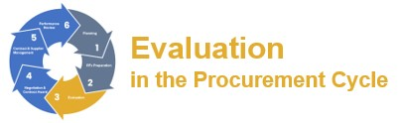

**Financial sustainability** ensures consideration is given to the council’s financial position, rate capping and other environmental and financial challenges, as well as the financial capacity of the respondents to provide the goods, services or works.

Councils may request financial information from the respondent, which may include (but is not limited to):

* financial statements for last three years, such as a balance sheet, profit and loss statement, statement of cash flows, notes to the financial statements, independent auditors report (or an accountant’s report);
* names and contact numbers of major suppliers and/or major subcontractors; and,
* details of any additional information that will assist in an understanding of the financial position.

Councils may engage a third-party supplier to undertake independent financial assessments as part of an RFx process for the purpose of determining a respondent’s financial sustainability and their associated commercial risk to the council.

##### RFx evaluation panel scoring

###### One-stage evaluation process

Evaluation process

The evaluation panel must assess RFx submissions on a systematic basis using the evaluation criteria which has been established and included in the advertised RFx documentation. The weighted attribute method of evaluation is to be applied.

Panel members may choose to score independently or by consensus, however scoring independently is considered best practice.

Evaluations can be recorded using either an eProcurement system or by using a spreadsheet. Weighted attribute method

Each evaluation criteria should to be ‘weighted’ out of 100% with the total sum of all weightings (for all criteria) to equal 100%.

All evaluation criteria are to be weighted and listed according to their importance.

Evaluation criteria can also include pass/fail scoring e.g. compliance with insurances.



Point scores

For the evaluation, each of the evaluation criteria categories or sub-categories is to be given a point score in the range of 0-10 in accordance with the following:

|  |
| --- |
| **10** Excellent – top five percent  **9** Very Good – top ten percent  **8** Very Good – in the top quarter |
| **7** Good - well above average  **6** Good - slightly better than average |
| **5** Average  **4** Acceptable – slightly below average |
| **3** Success not assured  **2** Marginally adequate |
| **1** Success unlikely  **0** Unacceptable |

Scoring

The financial criteria are scored (out of 10) ‘mathematically’; i.e.



Each non-financial evaluation criteria are scored out of ten.

**Two-stage evaluation process:**

The following outlines the two-stage RFx evaluation process.

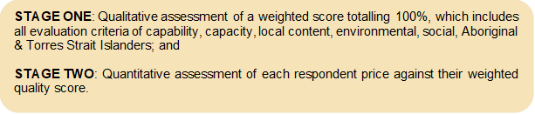



This evaluation model also removes the need for price/value to be included within the 100% weighting.

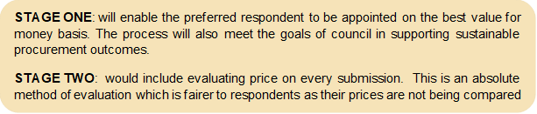

Whole-of-life costs

When assessing a significant RFx, a council should consider the ‘whole-of-life’ cost of the goods, services or works it is procuring. A council must assess at what value of a procurement it is desirable to calculate the whole-of-life cost and use the result in scoring the submission price.

Sometimes, the acquisition cost of a procurement is only a proportion of the total cost of ownership. Much of the total cost lies in operating and maintaining the product over its life. This makes it important to base a procurement decision not only on the acquisition price but also on the costs of using the product.

When assessing the whole-of-life cost, a council entity should differentiate between one-off costs and recurring costs. One-off costs are ‘sunk’ once the acquisition is made and are generally predictable. Recurring costs, on the other hand, continue to be incurred throughout the life of the procurement, and can increase with time if it is liable to wear and tear – resulting in increased maintenance costs.

Essentially, there are three types of costs, which together make up the total cost of a purchase. These are:

* initial purchase price;
* purchase administration costs; and,
* development and maintenance costs.

A more comprehensive breakdown however would cover:

* pre-acquisition costs;
* acquisition costs;
* changeover costs;
* operating costs;
* maintenance costs; • downtime costs; and,
* end of life costs.



Within each of these costs there is another breakdown of costs which can be applied. For example, pre-acquisition costs might cover:

* investigation of the marketplace;
* specification and design;
* budget allocation;
* preparation and issuing of RFx invitations;
* cost of RFx evaluation;
* cost of letting contract; and,
* preparation for receipt of the procurement.

A comprehensive whole-of-life cost should be undertaken for major projects or where the cost structures of competing offers vary materially.

Weighting of evaluation criteria

Weighting of evaluation criteria should occur to reflect the relative importance of different criteria and in turn a council’s objectives for each contract:

* weighting of evaluation criteria should be undertaken by the evaluation panel before submissions close;
* weightings in each RFx should reflect a council’s objectives for the RFx;
* a logical approach is to assign weighting proportions at a high level initially;
* percentage-based weighting proportions make for easier calculations; and,
* weightings need not be disclosed to the respondent although this action may build confidence in the RFx process (see *Section 6 Consistency and transparency of process*). Consistency of scoring against evaluation criteria between evaluation panel members is essential and a system of rating should be adopted to facilitate consistency.

The council should adopt an appropriate evaluation scoring model and reference it in its policy – however titled or structured. Refer the following example.

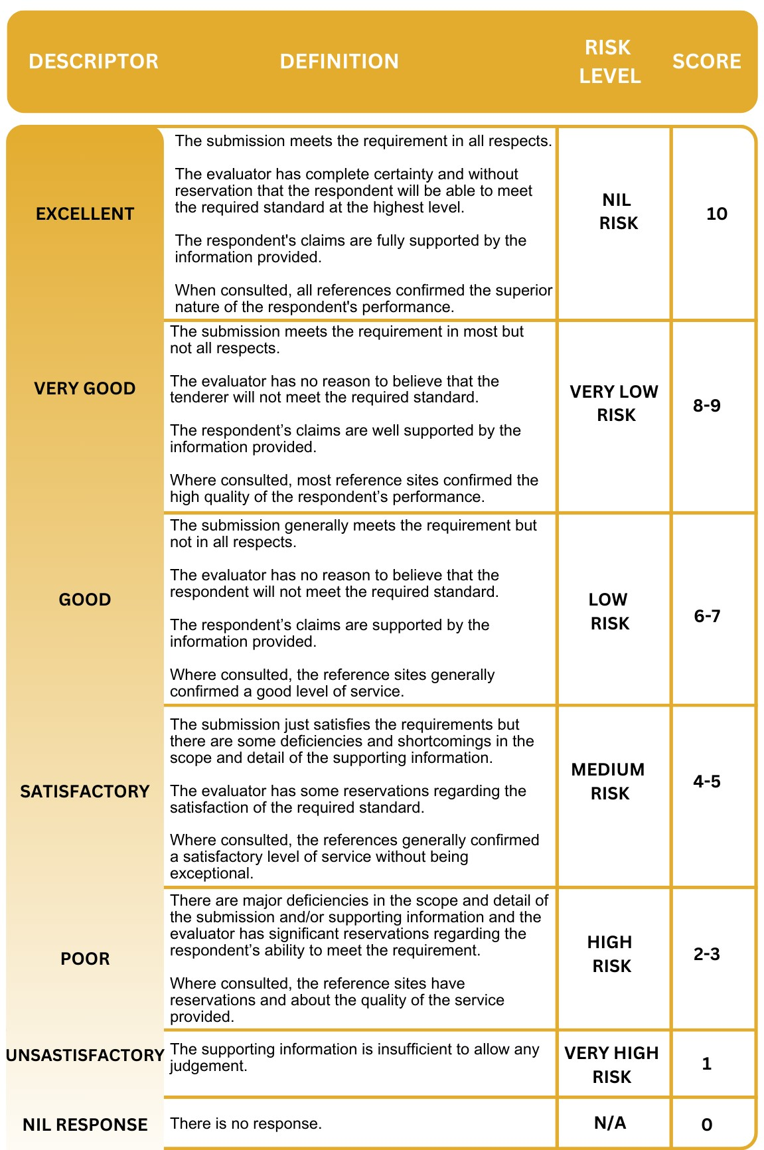



##### Alternative submission or non-conforming submissions

Councils may consider including definitions on alternative and non-conforming submissions within the RFx conditions, so they is clear to respondents. Examples below are:

* alternative submission – means a submission that proposes some variation to the specification which the respondent proposes for the council to consider as an alternative to council’s specification; and,
* non-conforming submission - means a response that proposes variations to the general conditions of contract included as part of this RFx.

Councils should reserve the right to consider an alternative or non-conforming submission but are not obliged to do so.

###### Alternative submissions

If a respondent elects to submit an alternative submission, the respondent must also:

* submit a copy of the clearly identified alternative submission in a marked-up form, which identifies all departures from the conforming submission;
* submit a marked up copy of the conditions of contract clearly identifying amendments proposed by the respondent and the rationale for that amendment.
* ensure that, in order to be considered for evaluation, the submission:
* is clearly identified as an “alternative submission”;
* fully describes its advantages, disadvantages, limitations and capabilities;
* is fully costed;
* permits ready comparison of the alternative submission with complying submissions; and,
* expressly states where it does not comply with the terms of the RFx.

Respondents submitting alternative submissions are strongly encouraged to also submit a conforming submission, to ensure their submission will be considered notwithstanding council’s decision to reject the alternative submission.

###### Non-conforming submissions

A council will sometimes receive submissions which offer one or more alternatives for delivery of the service or works where these are not sought in the RFx documentation. These are considered to be non-conforming submissions.

A council should always be open to innovative submissions as they may offer excellent opportunities for improvements to service delivery or works outcomes and are consistent with the legislative objectives for councils to achieve continual improvement.

RFx documentation where innovative solutions are sought should specifically invite nonconforming submissions which council can consider along with all other submissions.

Councils may consider including these requirements within the RFx conditions.



Council will not accept requests for amendments to the conditions of contract after the RFx closing time. Submissions are assessed based on whether they are conforming or nonconforming and accepting amendments after RFx closing time may compromise the integrity of council’s evaluation process.

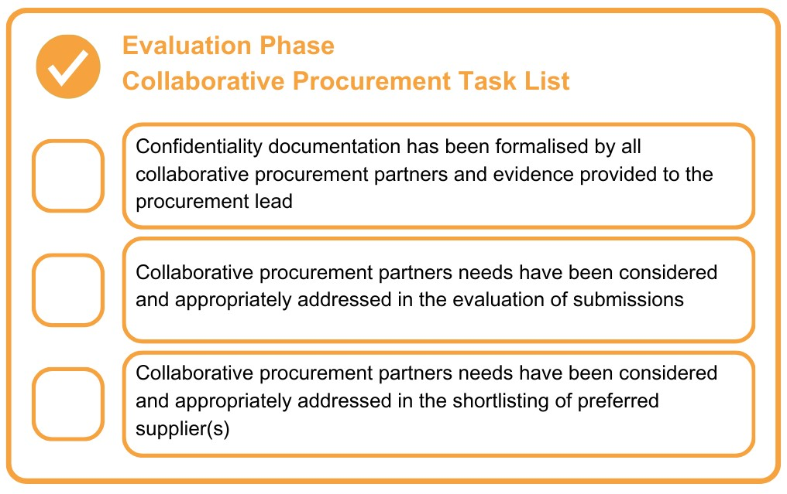

#### 12. Negotiation and Contract Award

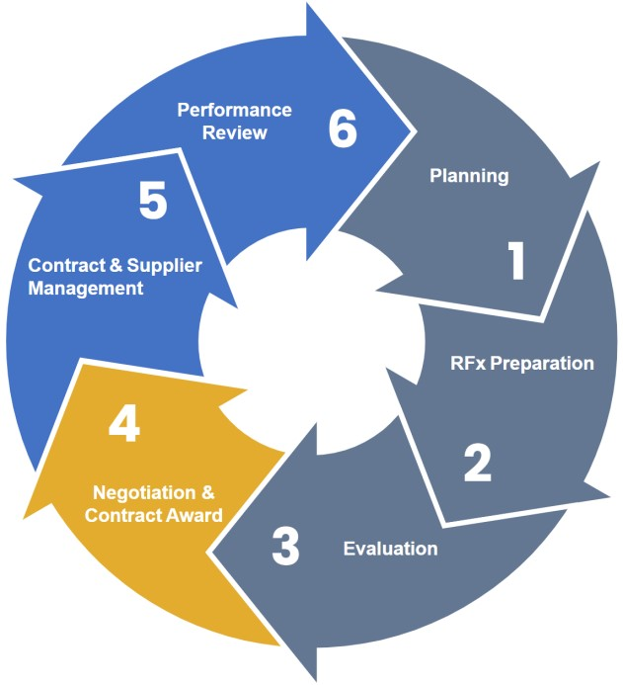

This section covers activities from the shortlisting of respondents through to the awarding of a contract.

The objectives of the negotiation and contract award phase of the procurement cycle are to ensure that:

* negotiations with shortlisted respondents are transparent, fair, robust, and that decisions are justified, adequately documented and stand up to scrutiny;
* the evaluation report that captures the evaluation panel contract award recommendation adequately reflects the RFx process undertaken;
* successful and unsuccessful respondents are notified of the RFx outcome; and,
* the final contract, executed by both parties, accurately documents the agreed goods, services or works to be delivered by the contracted supplier.

##### Post-RFX negotiations

The goal of the RFx evaluation process is to select the submission(s) which will best meet the council’s objectives. This may require council to conduct negotiations with the respondent/s.

The objective of post-RFx negotiations is to obtain the optimal solution and commercial arrangements and not merely the lowest price. By the end of the negotiation/clarification process, the council and the supplier must have the same expectations about the obligations of each party and how the contract will operate. All substantive issues must be agreed, and the contract documentation amended to reflect the agreement. To maintain the contract document order of precedence, it is recommended that these types of changes be included within the special conditions section within the contract.

If a council proposes, or seeks the option, to conduct negotiations, then its RFx documentation must specify that it reserves the right to negotiate with one or more preferred respondents. The conduct of negotiations should be consistent with the probity and/or procurement plan and subject to that plan the negotiations should follow these steps:

**Preferred respondent:** the evaluation panel should select a preferred respondent or shortlist the respondents that most closely meet the requirements of the contract and will best deliver the objectives for the contract.

The shortlist must be defensible, based on the evaluation criteria. There must be a clear break between the shortlist and other respondents, such that given the evaluation outcomes, even if the non-shortlisted respondents were given an opportunity to participate in the negotiation process, they would be unlikely to subsequently be shortlisted from an overall value for money perspective. If they can bridge the gap, they should be granted the opportunity to respond to the same negotiations as the preferred respondent(s).

**Negotiating team:** the evaluation panel or, at the chairperson’s discretion, some members of the evaluation panel, should meet with the preferred respondent together with the chairperson. Persons with expertise in negotiation may be included. No less than two persons representing the council should participate in order to ensure the contents and intent of any discussion can be confirmed by a second person. Participants on behalf of the council should have the necessary skills and experience in negotiation and non-panel members should be subject to the same conflict of interest/confidentiality declaration requirements as evaluation panel members.

**Advice to preferred or shortlisted respondents:** each should be advised that they are the panel’s preferred respondents(s) but that this does not constitute an acceptance of the submission, but rather an invitation to negotiate and/or that there are certain aspects of the submission which are unacceptable or deficient. The purpose of the negotiation is to achieve operational refinements or enhancements. This may include the price. However, care should be exercised that negotiations do not become an opportunity to trade off one respondent’s prices against another’s in order to obtain lower prices.

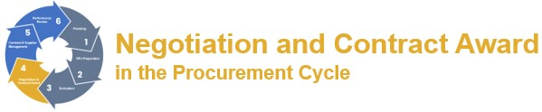

**Maintenance of intent and scope:** negotiations which change the scope or intent of the contract, creating a material difference, risk breaching the council’s policy. An RFx which has been poorly scoped must not be ‘downsized’ in negotiation to meet, for example, a budget allowance. The resulting RFx may be one to which smaller respondents could have provided submissions if they were aware of the realistic scope. There is also a risk of breaching Australian Consumer Law and, therefore, the *Competition and Consumer Act 2010* (Cwlth), in that the original RFx may be found to be misleading or deceptive conduct.

**Unacceptable aspects:** the unacceptable aspects of the submission should be detailed, and the respondent should be invited to consider those and advise in writing as to their willingness to address the inadequacies or deficiencies. Matters that could be negotiated include additional value adding options, specific contract management arrangements, accountable personnel for various contract stages or commitments, further intellectual property transfer opportunities, warrantees etc. Post-RFx negotiations can clarify matters and can be an effective risk management tool.

**Meetings and records:** all meetings and other discussions should be led by the chairperson of the evaluation panel and recorded (and confirmed) in writing. Complete records of meetings are necessary to form an audit trail and to document the integrity of the process. A condition of meetings should be that they are treated as commercial-in-confidence by all parties.

**Ethics and fairness:** post-RFx negotiations must be ethical and meet the standards of procedural fairness.

**Unsuccessful negotiations:** if negotiations are unsuccessful, the preferred respondent or shortlisted respondents should be advised.

**Reporting:** the result of post-RFx negotiations should be reported in the evaluation report.

**Cost/benefit:** the cost of embarking on negotiations should be weighed against the value of the possible advantages to be gained at the outset.

Councils undertaking negotiations should consider the Victorian Government Purchasing

Board’s publication *Negotiate – goods and services procurement guide*.[70]

##### Best and final offer

One option for a council to consider is to invite a best and final offer from each shortlisted respondent. This allows shortlisted respondents to submit their best and last technical and priced offer based on the RFx requirements. It is particularly useful when two or more submissions are difficult to separate following the evaluation.

A best and final offer may replace the need for negotiations with respondents.

In its RFx documentation, the council should reserve the right to conduct negotiations with a preferred respondent and for shortlisted respondents to be invited to submit a best and final offer.

The council should also clarify that it *may* rely on the information submitted in the initial submission *without* inviting best and final offers, and that respondents must therefore submit their best and final offer in the first instance.

In the a best a final offer scenario, the council would write to each respondent citing the areas where their submission was deficient and ask them to re-submit a submission that improves those areas. The key is that the revised submission can only change areas nominated by council.

A consideration with both post-RFx negotiations and a best and final offer is that they increase the risk that a council will move away from the original specification and thereby risk creating a contract which is ‘materially different’ to that which was the subject of the public RFx process.

Councils may consider including these requirements within the RFx conditions.

##### Council’s rights post-RFx closing time

In certain circumstances, council may need to do one or any combination of the following after the RFx closing time:

* cease to proceed with the process outlined in the RFx;
* accept all or part of a submission at the price(s) submitted unless the RFx states specifically to the contrary;
* reject any submission;
* accept one or more submissions;
* disqualify any submission that does not include all the information requested or is not in the format required;
* accept an alternative submission or non-conforming submission; and,
* obtain further information from the respondent for the purposes of clarification or explanation of its submission. This includes holding interviews with some or all respondents, including any personnel nominated by the respondent in their submission.

All submissions lodged will become the property of council and on no account will they be returned to respondents.

Councils may consider including these requirements within the RFx conditions.



##### Evaluation report

The key output of the RFx evaluation process is the evaluation report.

An evaluation report should, as a minimum contain:

* identification and brief description of the contract;
* background and scope of the contract;
* names of the evaluation panel members;
* conflict of interest declaration outcomes and record of confidentiality agreements;
* procurement methods – RFx process used;
* the council’s budget estimate of the cost of the RFx and the date the estimate was prepared against respondent’s final price;
* date of RFx public notice and closing time;
* summary of submissions received – respondent’s name and price;
* conformance requirements;
* mandatory evaluation criteria and results (identify pre-qualified respondents);
* evaluation criteria, weightings and scoring (ranked);
* risks associated with the preferred respondent;
* social implications;
* environmental implications;
* risk management implications;
* transition matters; and,
* recommended respondents(s) and justification.

##### Awarding the contract

Prior to the award of any contract, a full check of all pre-requisites should be conducted. A recommendation from the evaluation panel should then be put to the officer who has delegated authority to accept the submission or to the council.

The evaluation report prepared for a council meeting should comprise the following components: a public summary of the evaluation panel recommendation for contract award, the process undertaken, the final price arrived at, and a confidential attachment containing scoring methodology, pricing and detailed comments on the recommendation as well as any anticipated contingency.

It is open to the officer who has delegated authority, or to the council, not to accept the recommendation. However, in doing so, that party should be made aware of the potential ramifications of a ‘process contract’ breach.

Any decision which is inconsistent with the RFx evaluation panel’s recommendation should include the reasons for making an alternative decision. Such a decision must be compatible with the evaluation criteria published in the RFx documentation.

##### Advice to respondents and public announcements

Both successful and unsuccessful respondents should be advised of the outcome of their submission. Best practice is for the chairperson of the evaluation panel, or representative appointed by the chairperson, to speak with each unsuccessful respondent explain how they could improve their submissions to increase the prospect of being successful in future.

A direct personal approach to unsuccessful respondents may well avoid subsequent grievances and more importantly may improve the quality of submissions received in response to future RFx processes.

Once the contract has been accepted and awarded, an email including the contract management plan, if applicable, should be sent to the project manager.

##### Contract documentation

###### Completion of contract documentation

The contract should be executed by each of the parties prior to any goods/services being provided or works commencing. The contract documentation assembled for execution must represent the contract as intended. If there are changes as a result of negotiations these must be incorporated in the executed documentation. If these vary from the RFx conditions, amendments must be made to ensure consistency.

Some councils seek to accelerate the commencement of goods, services or works by the issuing of a letter of intent. *Letters of intent are problematic.* They will only rarely be considered a binding contract and should therefore not be used. It is preferable to prepare the contract documentation promptly, rather than use a letter of intent.

###### Execution of contracts

The careful execution of the contract documentation is vital to the validity of the contract.

An electronic signing process is preferable to expedite the contract signing process.

It is preferable to have the successful respondent sign first. This provides some assurance to the council that execution of the documents will not be overlooked.

The signatories of the respondent should be checked against ABN/ACN searches, to ensure signing is in accordance with the *Corporations Act 2001 (section 127(1))* where applicable.

The signatories to a contract on behalf of the council will depend on the authorities that are in place and are found in the council’s instrument of delegations.

###### RFx performance security and retention monies

Councils should hold a security deposit for significant value contracts.

The basic principle is that the council, as the contract principal, holds security for the purpose of ensuring the due and proper performance of the contract. The security deposit is released by the council to the contracted supplier either once the work is complete or, if the contract provides and where the sum is substantial, at certain stages of the contract.

Councils should ensure any security is in the form of an unconditional bank guarantee given by an approved financial institution with no expiration date. The contract should fix a date by which the deposit must be lodged. Many conditions of a contract provide that it is a substantial breach for a supplier to fail to lodge the security.

Some works contracts provide for retention monies where a specified percentage from progress payments is withheld until the amount of retention equals the total amount of security deposit (e.g. 5% of the contract sum – the supplier shall provide two unconditional and irrevocable bank guarantees, each bank guarantee shall be 2.5% of the contract sum with discharge at practical completion and final completion).

A council should consider the risks associated with allowing retention monies and whether a proportion of upfront security should be required in order to mitigate risks. A council should also consider whether a potential supplier has sufficient cashflow to allow retention monies to be deducted from progress payment without causing financial duress (see *Section 6 Fairness and impartiality with regard to timely payments to suppliers*).

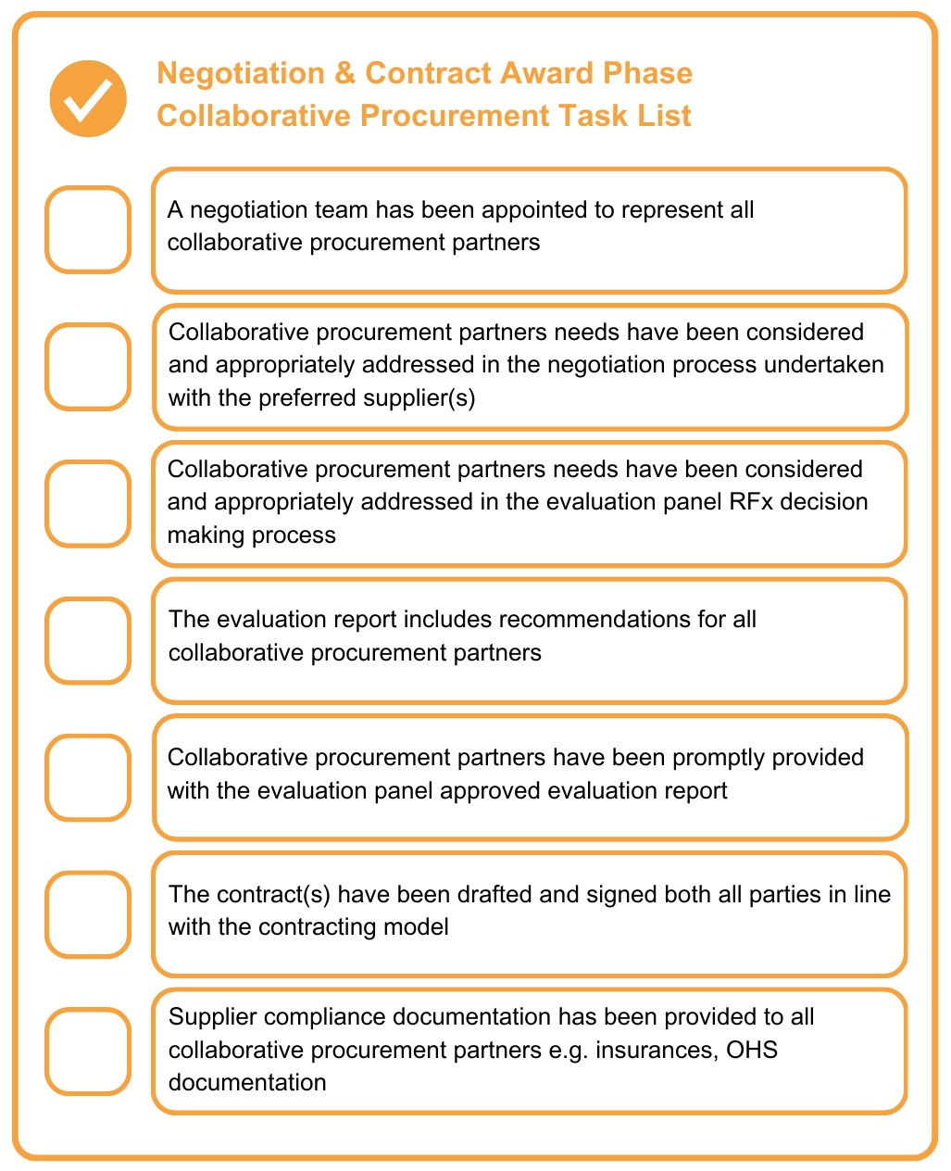

#### 13. Contract and Supplier Management

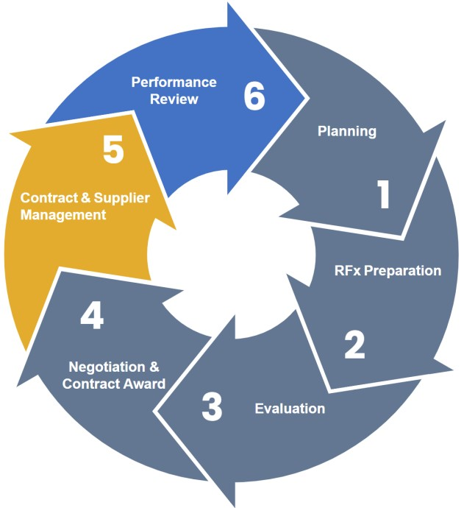

This section covers activities after the awarding of a contract through to the conclusion of the contract.

##### Introduction

The processes for managing a procurement will range from a simple process of ensuring that ordered goods are delivered through to the management of a complex contract.

Individual contracts may also form part of larger projects and be subject to various prerequisites. For example, a building contract may be dependent on the purchase of land.

A critical aspect of the contract and supplier management phase of the procurement cycle is that by this stage the rules of the contract are largely fixed. If due diligence has not been applied to correctly establish the contract, then changing the scope or intent of the contract at this point can prove difficult and expensive.

##### Objectives and scope

The aim of the contract and supplier management phase of the procurement cycle is to ensure that the goods and/or services are provided, or works are delivered, in accordance with the contract, all parties to a contract meet their respective obligations, including that:

* the appropriate level of contract management is applied to the contracted supplier based on the level of importance to council of the goods, services or works provided;
* suppliers are supported by the council in achieving the intended outcome; and,
* council contract managers understand the council’s expectations of their role during this phase of the procurement cycle.

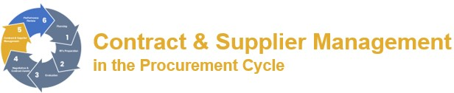

The scope of this section commences after the contract has been awarded and finishes when all retention works are completed, and the results of the contract are realised and/or assets are handed over.

The content of these guidelines is not a variation of, or substitute for, the terms of a contract which take precedence.

The following guidance largely applies to formal contracts, as distinct from lower value, lower risk purchases. This guidance touches on operational aspects of contract and supplier management and generally does not deal with the very wide range of technical and legal matters which can arise with the interpretation and implementation of contracts.

##### Contract classification

In order to determine the appropriate level of contract and supplier management required for a contract, it is important to establish how a contract is classified.

Based on the Victorian Government contract complexity model,[71] the following are the four key classifications of procurements using value and associated risk as a basis for this classification:

###### Transactional

These are generally **low value and low risk** procurements where preferred suppliers or council contracts are not available.

Transactional procurements generally require a minimal level of supplier and contract management.

###### Leveraged

These are generally **higher value and low risk** procurements for frequently used goods or services with many potential suppliers. Councils have the ability to drive further value from these procurements through their buying power either individually or via collaborative arrangements.

There is an expectation that the council will apply a base level of supplier and contract management to procurements classified as leveraged to ensure the value derived through the procurement process is realised.

###### Focused

These are generally **lower value and higher risk** procurements where there is a limited number of suppliers or where novel commercial arrangements are in place.

Councils should apply a reasonable level of supplier and contract management to procurements classified as focused to ensure the identified risks are adequately managed.

###### Strategic procurements

These are generally **high value and high-risk** procurements for critical council goods, services and works with competitive markets.

As stated above, the guidance in this section applies to larger council contracts. It is recommended that councils follow the guidance provided in this section for procurements classified as strategic.

##### Resourcing management of the contract

Relative to the size of the contract, adequate resourcing of contract and supplier management by council is essential to a contract’s success – both in terms of adequate time commitment and the expertise of the council contract manager.

As with other aspects of the procurement cycle, the council should ensure the roles and responsibilities of the staff engaged in contract management are clearly documented. Some of the expertise required includes:

* an understanding of the contract documentation – not only the specifications but also the conditions of contract and its meaning and practical application;
* an ability to manage the relationship with the supplier and their representatives;
* an appreciation and acceptance of the importance of ethical conduct in the management of contracts;
* adequate project management skills (especially scheduling, prioritization and time management); and,
* required level of delegation and authority.

These roles require either expertise or the appointee to be adequately supported by a person who does have such expertise. This has particular application to council officers that are only responsible for an occasional contract.

Some councils have implemented contract management software to assist in processing the wide range of issues which arise in contract management. Maximum benefit is derived by interfacing or integrating contract management software wherever possible with council’s other software.

###### Superintendent and/or superintendent representative (or council representative or contract supervisor)

Contracts should provide for the appointment of a superintendent[72] by the council who is obliged to:

* follow the provisions of the contract documents;
* interpret and administer the contract in accordance with the documents; and,
* act ethically and with due consideration for their intent.

If the contract document does not nominate the superintendent, then once an appointment is made the supplier should be advised. The superintendent’s role is to manage the interaction between the supplier and the principal[73] (i.e. the council).

The key roles of the superintendent under the contract should be set out in the conditions of contract. The superintendent is responsible for the day-to-day administration of the contract including:

* issuing directions to the supplier;
* negotiating disagreements;
* monitoring, recording and reporting; and,
* assessing claims made against the work undertaken and certifying payments.

Other roles of a superintendent include:

* assessing, referring and/or authorising contract variations;
* determining the quality of materials and workmanship, including professional standards;
* issuing notices and dealing with payment provisions;
* ascertaining losses or expenses by the supplier due to directions;
* assessing and determining any extensions of time applications; • determining and formally notifying the date of practical completion; and,
* determining completion and issuing the final certification.

In managing all these matters, a superintendent must be proactive in approaching and resolving all aspects of the contract.

Where councils have numerous contracts, the superintendent is often a senior person who does not have day-to-day involvement with the conduct of the contract. In such circumstances, it is common practice for the superintendent to appoint a superintendent’s representative.

This should be formalised in writing including any limitations on the authority of the appointment, which may include restrictions on:

* engaging in arbitration, litigation or mediation;
* approval of contract variations;
* handover of a completed project; and,
* issue of the final payment certificate to the supplier.

In these guidelines, the term superintendent should be taken to also cover the superintendent’s representative.

##### Contract management prerequisites

One of the first roles of the superintendent is to ensure all components of the contract are present to effectively oversee the contract. These will include:

* **contract documentation:** particularly the executed contract agreement, conditions of contract, specifications and letter of acceptance;
* **insurance requirements:** ensuring a copy of required insurance certificates of currency are held, and maintained current, by council;
* **bank guarantees:** to be secured from the supplier where they are provided for in the contract. These should be unconditional guarantees of the value stated in the contract;
* **approvals:** to be held for all planning matters, service authorities, etc.;
* **funding considerations:** such as that grant approvals are secured and grant conditions are established;
* **occupational health and safety (OHS):** ensuring that documentation and systems have been reviewed and confirmed; and,
* **risks:** that these have been assessed and any risk management plan which has been developed as part of the RFx process has been reviewed to identify, monitor and manage all risks over the life of the project contract.

If the contract superintendent has not been involved in the earlier RFx phases of a contract, then a formal transitioning should occur wherein the contract superintendent is fully briefed on the background of the contract and the expected outcomes.

##### Contract management manual

Given the complexities of contract management, a council should support its contract managers with the development of a contract management manual.

Depending on the size and complexity of each council, a contract management manual will vary from a simple written guide to an online manual with a full set of checklists and proformas. Ideally this will, in turn, be integrated with any council IT contract management system.

As with a procurement manual, a key aspect of a contract manual is its structure. Given the amount of material that supports contract management, it is essential the manual is structured in a logical manner to maximise its accessibility and usefulness. While not exhaustive, the following list outlines what could be included:

**RFx preparation and/or conduct documents:**

* development of appropriate RFx
* contract insurance requirements
* RFx document approval **RFx procedures:**
* advertising
* issue of documents
* pre-RFx meeting
* RFx enquiries
* tender box (or electronic lodgement)
* RFx opening procedures • late tender **Evaluation:**
* evaluation panel
* evaluation of RFx
* financial assessment

**Negotiation and contract award:**

* negotiation
* awarding of contract
* security of documentation

**Administration of the contract:**

* commencement of contract
* communication
* customer communication
* meetings
* issue resolution
* dispute resolution
* contract records
* variations to contracts
* performance monitoring, auditing and review
* payments
* contract extension
* default and cancellation
* contract completion.

##### Supplier relationships

One of the key ingredients in successful contract management is the establishment of productive relationships between the council and suppliers.

This relationship is generally governed by the provisions of the contract. However, the contract should not be so rigid that it precludes flexible, constructive management or the natural maturing of the relationship between council and the supplier.

The basis of an effective working relationship with a supplier can be enhanced by:

* establishing an agreed understanding of the contract with the supplier;
* understanding the background to the contract and any existing relationship with the supplier;
* establishing the necessary systems for monitoring and reporting, protocols for communication and record keeping arrangements; and,
* ensuring that any other stakeholders understand the rules of the working relationship.

###### Communication

The protocol for communication should include the frequency of meetings which may be defined in the contract documentation. These should be timed according to the needs of adequate supervision.

Formal meetings on contracts with longer terms should be conducted at pre-determined points. These meetings should review key timelines, critical deliverables and performance reporting priorities.

The outcome of all dealings with the supplier should be committed to writing (or email) and held on file.

###### Negotiation

Most disagreements between a council and its suppliers can be resolved through negotiation. The intent of negotiation during a contract is to reach a mutually acceptable solution where both sides consider they have gained the best possible result in the circumstances.

Successful negotiation will avert a formal dispute arising and is generally a preferable outcome in terms of both cost and progress of the contract. All negotiations should be conducted by two or more staff.

The outcome of any negotiated disagreement should be committed to writing and written acceptance by the supplier should be obtained.

###### Dispute resolution

At times a disagreement will not be resolved by negotiation and a dispute may arise. Depending on the scale and ramifications of the disagreement, consideration at this point should be given to seeking expert advice or assistance.

The process for resolution of a dispute will generally be governed by the terms of the conditions of contract. All parties are bound by these and councils should follow these processes carefully.

###### Mediation

Where a dispute arises between a small or medium business and a council, the business may contact the Victorian Small Business Commissioner (VSBC) for assistance in resolving the dispute.

The VSBC provides a quick, low cost and confidential mediation service to resolve these disputes. Mediation avoids the uncertainty, cost and disruption traditionally associated with litigation. Terms of settlement reached at mediation by agreement between the parties is binding on both parties.

Mediation is a quick, less formal, and less costly approach than arbitration. If mediation fails to resolve the dispute, arbitration may be undertaken.

###### Arbitration

The conditions of a contract will generally allow a dispute to be resolved by arbitration, with the aim of obtaining a final and enforceable result without substantial costs, delays, and the formalities of litigation. Notwithstanding, it is still an adversarial process with the possibility that neither party will be satisfied with the outcome, and it may be costly.

###### Litigation

Litigation is the act of pursuing a lawsuit or seeking redress through the courts. It can be expensive and time consuming and should only be undertaken when other avenues have failed. Litigation should be conducted through a council’s lawyers.

##### Occupational health and safety (OHS)

Councils should have collected and assessed the OHS regime of a supplier when evaluating their submission. This should ensure that the supplier’s OHS management system demonstrates compliance with all duties of an employer as specified in the *Occupational Health and Safety Act 2004* and *Occupational Health and Safety Regulations 2017*. A superintendent must equally ensure that the council’s own OHS responsibilities are met.

Councils undertaking to develop and manage buildings and civil construction projects should take particular note of the WorkSafe Victoria publication (*Health and safety in construction procurement: A handbook for the public sector 2017*).[74]

It is beyond the scope of these guidelines to provide guidance on all aspects of OHS. Depending on the size and complexity of the contract, the superintendent should continually be alert to identifying, monitoring and regularly auditing OHS requirements. The advice of council’s OHS officer should be sought where necessary.

##### Claims/variations and payments

The conditions of contract generally provide rules for payments under a contract. There are several factors that impact on contract payments, including:

* contract lump sum or rates;
* variations, including those due to latent conditions;
* provisional sums;
* rise and fall allowances;
* liquidated damages; and,
* extension of time and prolongation claims.

The *Building and Construction Industry Security of Payment Act 2002 and* will also impact certain payments (see below).

###### Contract variation

The conditions of contract will generally prescribe the circumstances in which a variation might arise (for example an instruction by the superintendent for the supplier to undertake additional work – known as ‘scope variations’ - or where the actions of the council leads to a claim for inefficiencies – known as ‘prolongation claims’). The method of calculating the value of variations should also be contained within the conditions of contract.

Contract documentation should be written to minimise the opportunity for conflict in determined variations. It should also ensure that council’s appointed superintendent can represent the interests of the council in matters of contract variations.

Councils need to exercise caution with contract variations where the:

* variation works were not envisaged in the original contract (they are inconsistent with the scope of that contract);
* value of the variation exceeds the public RFx threshold under the council’s policy; and,
* value of works which did not reach the threshold in the original contract (and was not subject to a public RFx process) increases and takes the total value over the public RFx threshold.

In these circumstances a council should assess whether it needs to undertake a further RFx process or seek an exemption via the provisions the council’s policy (see *Section 3 Exemptions to requirement for a public RFx process*).

###### Extension of time and prolongation claims

Where a council grants an application by the supplier for an extension of time, a claim may well follow from the supplier for compensation for any additional costs involved in the extension. The assessment of prolongation claims may prove difficult and requires expert advice.

###### Latent conditions

Latent conditions are physical conditions on the site or its surroundings, including artificial things but excluding the weather conditions at the site, which differ materially from the physical conditions that should reasonably have been anticipated by the supplier at the time of the RFx.

For example, latent conditions commonly include underground utilities such as telecommunications, electricity lines and sewerage systems and site conditions affected by contamination and water courses.

Where latent conditions are likely to arise, most contracts will provide for the supplier to be compensated provided it follows notification requirements within the contract.

It is the role of the superintendent to vet and test each claim for any variation.

###### Provisional sums

A provisional sum is a nominated amount of money, usually estimated by a quantity surveyor or engineer, where the exact scope and cost of specific work cannot be determined at the start of the contract. An example would be the excavation of rock on a building contract. Provisional sums are distinct from variations which are not known at the outset of the contract.

Provisional sums should only be provided for in contracts where it is not possible to determine the value of a component of works. They should not be used where it is possible to determine the value of the relevant component of works – either as a lump sum or as a rate.

Usually, a provisional sum included in a standard contract is not payable until a direction is given to the supplier to carry out that work or provide the item to which the provisional sum relates. Where the supplier carries out that work or provides that item, the price is determined by the superintendent. Any difference between the provisional sum stated in the contract and the amount determined by the superintendent is added to, or deducted from, the contract sum.

There are risks around provisional sums. If a council makes allowance for provisional sums in a contract it should ensure the rules around assessing the value of the work and payment for the provisional works are clearly set out in the conditions of contract.

For works contracts, councils sometimes include a contingency sum within the contract to accommodate potential future costs that may arise during a project.

###### Contract breaches

A breach of a contract is the failure by one of the parties to a contract to satisfactorily perform the service or action agreed to in the contract.

If a contract is breached there are several possible remedies. These include:

* informal remedies such as replacing defective goods;
* damages as payments to compensate the innocent party;
* termination in situations where one party refuses to carry out an obligation under the contract; and,
* specific performance where one party wants the other party to actually do what they undertook in the contract.

Councils are generally best advised to seek the least expensive and the less disruptive solution in case of contract breaches. Councils should always consider obtaining legal advice before acting in circumstances of a contract breach.

###### Liquidated damages

Liquidated damages are genuine covenanted (agreed) pre-estimates of damage where the supplier fails to perform or not remedy in a timely manner any non-compliance in the performance of the contract. They must be distinguished from penalties.

Legal advice is generally beneficial to ensure that liquidated damages provisions in a contract are enforceable.

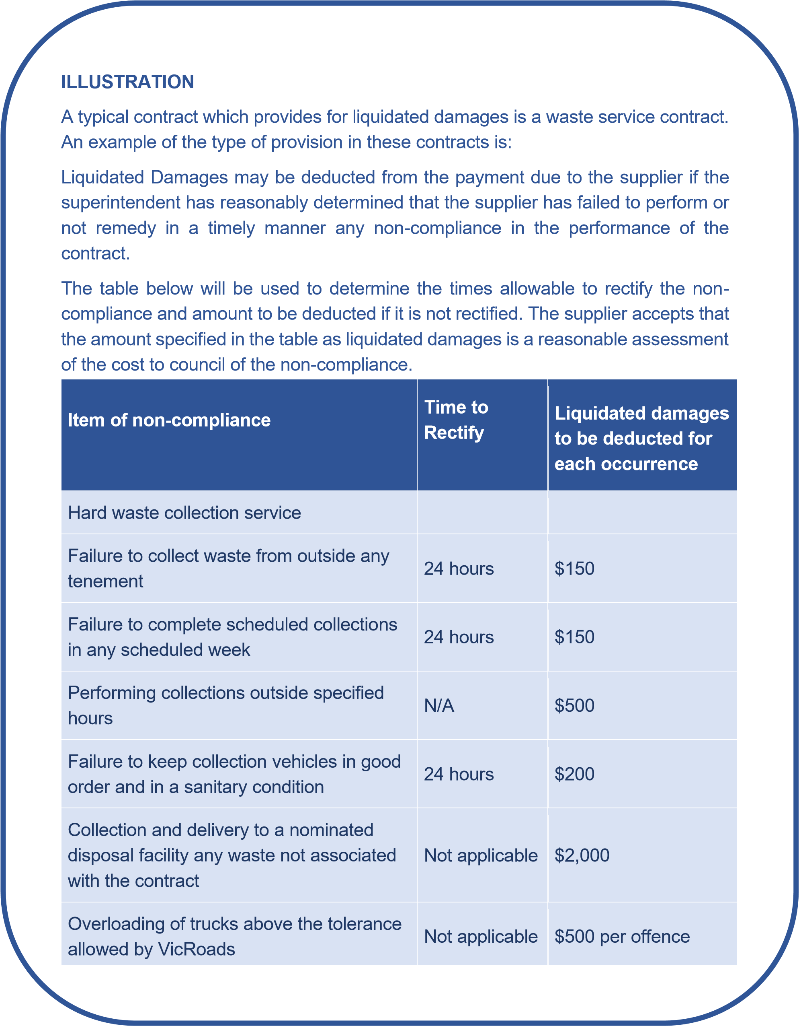

*Building and Construction Industry Security of Payment Act 2002*

A council must be alert to the provisions of the *Building and Construction Industry Security of Payment Act 2002* which help to ensure that any person who carries out construction work or supplies related goods and services under a construction contract gets paid. The *Act* is designed to increase cashflow and provide a fast, cheap, non-legalistic way of resolving payment for work done or materials or services supplied. In summary it:

* covers both verbal and written construction agreements;
* provides a statutory right to be paid for work done;
* establishes default payment terms where contract is silent bans ‘pay when paid’ clauses;[75]
* establishes a process for the fast recovery of payments; and,
* provides for the quick adjudication of payment disputes at a low cost to the parties.

###### Contract completion and asset handover

A contract is considered complete when all activity associated with it has been accomplished, all work is done, and all accounts have been paid.

One of the more useful tools at the end of a contract – especially if an asset such as a building in being handed over – is a checklist of all tasks which need to occur at this point, including:

* checking that permits and approval conditions have been satisfied;
* recording on asset registers;
* confirmation of completion and that contract records are complete – including handover to any internal asset manager;
* establishment of maintenance regime (including product warranties); and,
* acquitting any funding grants.

**Practical completion:** a term related to a construction project and describes the stage when:

* the work has been completed, all equipment installed, tested and found to be in running order;
* the project is deemed safe and fit for occupation to the satisfaction of the superintendent;
* the facility is fit-for-purpose, complies with service delivery performance requirements;
* the facility commissioning has been undertaken; and,
* operation and maintenance manuals, training and documentation have been provided.

A supplier will seek a certificate of practical completion once it believes works are complete and often a joint inspection will occur to establish (or otherwise) the supplier’s claim.

**Defects liability period:** the period stated in the contract that provides for the rectification of minor defects and/or omissions or items that fail to perform suitably, that may be outstanding or occur after practical completion.

**Final completion:** a term related to a construction project and describes the stage when:

* any minor defects and/or omissions or items that fail to perform suitably, that may be outstanding or occur after practical completion have been completed; and,
* the defects liability period has concluded.

A supplier will seek a certificate of final completion and final payment, if required, once the contract has reached this stage. The certificate of final completion represents the end of the contract.

**Transitioning:** some contracts will provide for the transitioning between different suppliers. This occurs particularly in contracts for ongoing services. Where transitioning is required, the contract should provide for the existing supplier to participate in a transition process and require particular standards of cooperation with both the council and the new supplier.

Suppliers may also be required to perform services for a short term after the contract term has expired. Care is needed to ensure that a new contract is not created in this process.

##### End of contract term/contract options

Before a contract term comes to an end, a council will need to determine the future direction of the service. If the contract provides for options of additional terms, council will need to elect (if the option is at council’s discretion) whether to take up those options and extend the contract. There is likely to be a period of time specified in a contract before which council must notify the supplier of its intent.

If a council extends a contract, it must do so in accordance with the provisions of the original contract. Parties to the contract must be of the view that the terms of the original contract provide sufficient certainty to ascertain the essential terms of the renewed agreement. However, if the terms are so uncertain, and any review conducted in accordance with the contract requires the parties to agree on all or any of the essential terms of the renewed contract, then they are putting in place a new contract. The council will then be subject to compliance with their policy. It matters not whether the new contract is different or identical to the existing contract following the renewal.

If a contract does not provide for additional terms, then the contract cannot be extended. A contract that runs past the end of its term constitutes a new contract. Likewise, if the public RFx thresholds set out under the council's policy are reached, the contract needs to be subject to a new public RFx process.

##### Record keeping

Thorough and sound record keeping/archiving at the end of a contract is important for a number of reasons, including to:

* substantiate the practices adopted during the procurement;
* support any post-contract matters or disputes; and,
* demonstrate OHS compliance and address any subsequent claims.

As with most aspects of records management, the structure and extent of records kept will depend on the value and complexity of the procurement. Procurement records, including contract management records, should be integrated with council’s recording management system – whether hardcopy or electronic.

Records should be kept in accordance with the *Public Records Act 1973* and the Public Records Office Victoria (PROV) Standards Framework.[76]

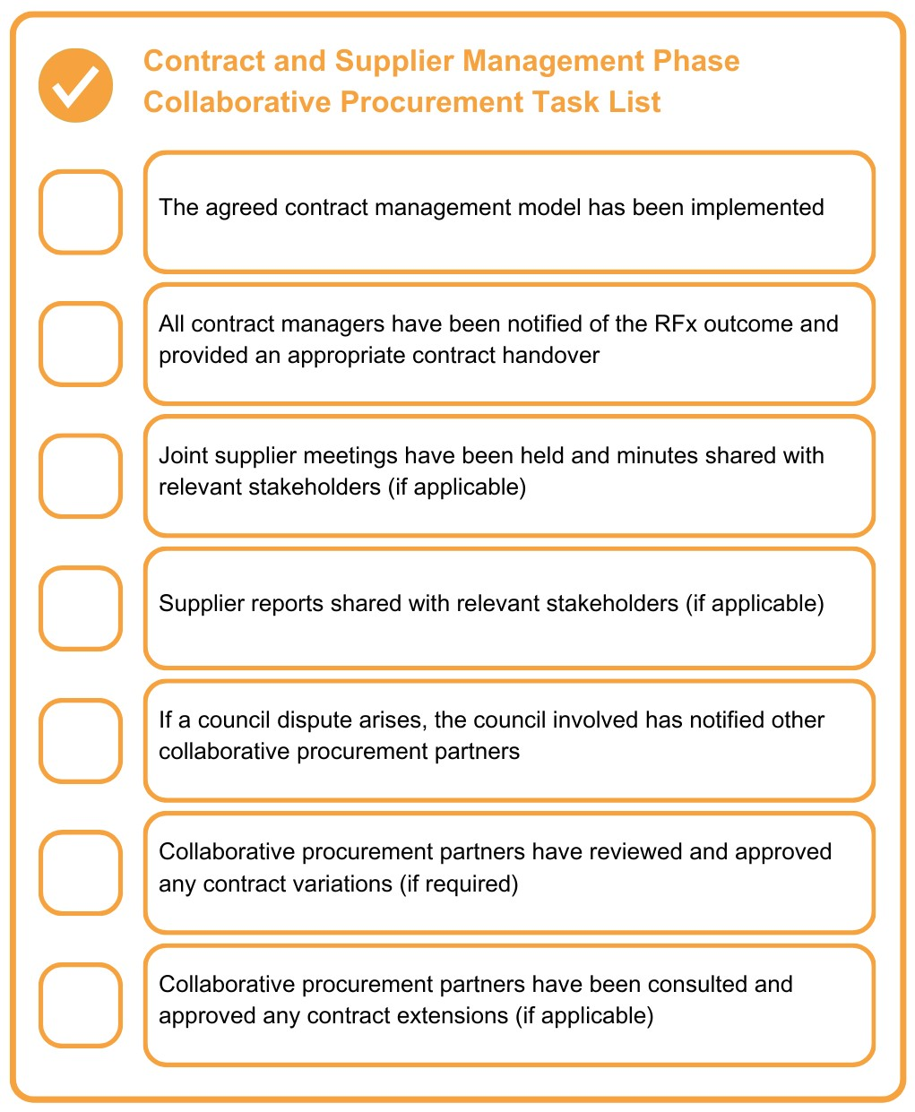

#### 14. Performance Review

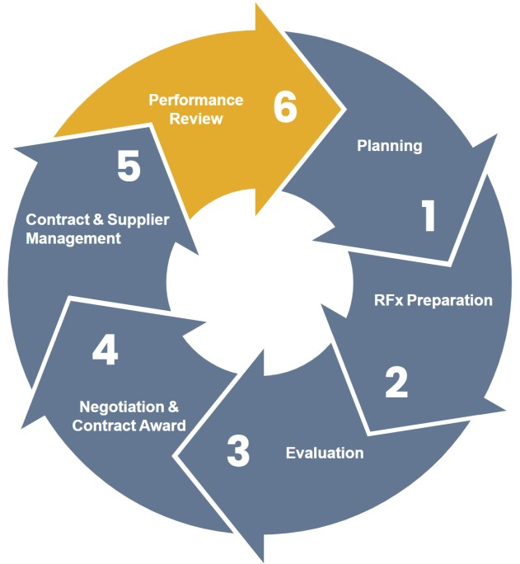

This section covers activities that should occur towards the conclusion of the contract delivery phase. This is to ensure that:

* the goods, services or works have been delivered in accordance with the contract and have achieved council’s intended outcome;
* the supplier’s performance has been assessed and adequately documented; and
* the council maximizes the opportunities that exist to improve future procurement processes and outcomes.

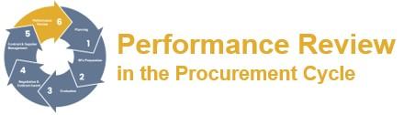

##### Evaluating procurement outcomes

Councils should develop a systematic and well documented process for evaluating procurement outcomes, in order to demonstrate that objectives are being achieved and provide a basis for the continual improvement of their procurement processes.

Procurement evaluation and reporting can provide a basis for effective control and stewardship of resources and demonstrate the value of the procurement function.

A key criterion for evaluating and reporting on procurement performance is that it is simple and concise. There are a wide range of measures which can be used to measure aspects of performance. These typically include:

* volume of orders/contracts;
* on-time delivery/completion;
* defect rates;
* cost of raising order/processing contracts; and,
* results of customer satisfaction questionnaires.

However, the recommended focus should be on an evaluation process which leads to the implementation of continual improvement to a council’s significant high value procurements.

There are three key procurement areas which should be evaluated:

* supplier performance;
* opportunities to improve processes; and,
* incorporation of process improvement.

##### Evaluating supplier performance

In a best practice context the following evaluations of supplier performance should occur:

* **prior to final payment or contract payment:** when evaluating performance of the supplier, the contract manager should determine the extent to which the requirements were met, whether any problems arose, the level of satisfaction with the procurement outcome, and whether the performance standards were met. The extent of any evaluation should vary with the value of the procurement.
* **end of procurement review or contract management review:** as part of this evaluation the contract manager must determine if established processes were followed and must record reasons for non-compliance with processes – to determine the need to revise practices.

This review can be undertaken at the time the last payment is made and can be a simple online questionnaire for the contract manager. The questionnaire results should be reviewed and audited by the senior officer responsible for procurement.



It is also important to include a review of the currency of contract documentation at the end of the procurement to ensure that any problems that may have occurred are identified and, where appropriate, improvements can be made in future contractual arrangements.

* **audit trail:** the contract manager should use a checklist at the time of the last contract payment to review documents relating to the procurement and ensure there is a sufficient audit trail.

##### Evaluating opportunities to improve processes

In a best practice context the following evaluation process improvements should occur:

* seek feedback from suppliers, users, suppliers and consultants to determine their satisfaction with the procurement/contract management processes, and seek suggestions for improvement; and,
* ensure that suggested improvements comply with legislation and policies.

##### Incorporating process improvements

In a best practice context the following implementations of improved process evaluation should occur:

* review and update manuals, plans and policies as necessary;
* train officers in revised processes; and,
* use change-management strategies to implement processes.

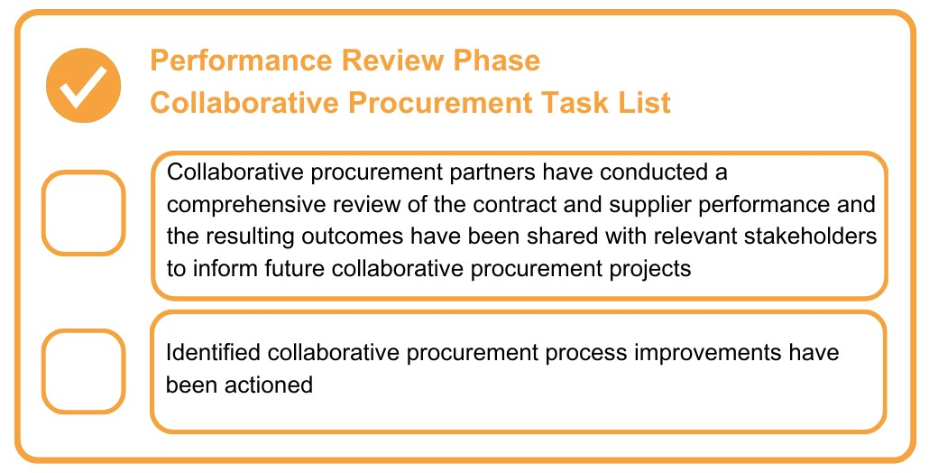

### Appendix A: Glossary

|  |  |
| --- | --- |
| **Term** | **Definition** |
| **the Act** | *Local Government Act 2020* (as amended). |
| **Addendum** | Additional information or corrections about an RFx, provided to all registered potential respondents after the initial advertising date. |
| **Circular economy** | An approach to the delivery of goods, services and works that ensures no waste is created at through their use of materials and products. The products and materials used in these goods, services and works are either recovered for reuse or have been designed to be fully recyclable when no longer required. |
| **Collaborative procurement** | Procurement activities that engage two or more councils, government entities or statutory bodies. |
| **Commercial in confidence** | Information that, if released, may prejudice the business dealings of a party (for example, discounts, rebates, profits, methodologies and process information). It is information provided for a specific purpose that is not to be used for any other purpose than set out in the initial document. |
| **Competitive neutrality** | A policy which aims to ensure that, where a government business is competing with the private sector, adjustments are made to remove any net advantage (or disadvantage) the government business has because it is owned by government. |
| **Conflict of interest** | In Victorian local government the law provides that a council officer holding a delegation or advising council or a delegated committee has a conflict of interest which they must disclose in writing when they have a general or material interest of the type specified in the legislation. |
| **Conflict of interest declaration** | A declaration signed by staff, councillors and consultants involved with an RFx process to indicate they do not have a conflict of interest. |
| **Conditions of contract** | The contractual terms that define the obligations and rights of the parties involved in the contract and form the basis of the contract awarded to the successful respondent. |

|  |  |
| --- | --- |
| **Confidentiality agreement** | A written legal document that is proof and record of the obligations agreed to between the parties; to protect the commercial interests of the council and/or the supplier. Often used interchangeably with the deed of confidentiality. |
| **Contract** | An agreement between two or more authorised persons on behalf of their organisations to perform or not perform a specific act/s enforceable in law. A contract may be verbal or written or inferred by conduct. |
| **Contract documents** | Documents construed together as an instrument of contract. They may include terms and conditions, specifications, drawings, RFx responses, delivery schedules and payment schedules. |
| **Contract management** | The process that ensures both parties to a contract fully meet their respective obligations as efficiently and effectively as possible, in order to deliver the business and operational objectives required from the contract and in particular, to provide value for money. |
| **Contract manager** | The person nominated by the council to manage the day-to-day matters of the contract. See also superintendent. |
| **Contractor** | Respondent (person, firm, etc.) whose submission has been accepted by the council with or without modification. |
| **Contract variation** | An addition or alteration to the goods and/or services under a contract that is within the general scope of the original contract. A contract variation can be documented between the parties with a letter or a deed of variation. |
| **Council officers** | Includes full-time and part-time council officers, and temporary employees, contractors and consultants while engaged by the council. |
| **Deed of confidentiality** | See confidentiality agreement. |
| **Delegate** | A person authorised by the council or Chief Executive Officer to make general or specified decisions constrained only by the instrument of delegation. Specifically, delegates commit and incur expenditure. The delegate is responsible for actions arising from their use of such power. |
| **Delegation** | A power handed down by the council or Chief Executive Officer in an instrument to enable a delegate to act on council’s behalf. |

|  |  |  |  |
| --- | --- | --- | --- |
| **Due diligence** | | The process of reviewing and analysing in detail the capacity of a responding organisation to meet future contract performance requirements. This may include a detailed assessment of the organisation’s financial stability, legal risks, technical capacity and infrastructure. | |
| **eProcurement** | | Refers to the use of electronic methods at any stage of the procurement process from identification of a requirement through to any to contract management and possibly procured asset management. Electronic tendering is the undertaking of the RFx process stage by electronic methods. | |
| **Expression of interest (EOI)** | | A response to an open approach to the market requesting submissions from respondents interested in participating in procurement. It is used to identify potential suppliers interested in, and capable of, delivering the required goods or services. Potential suppliers are asked to provide information on their capability to do the work. It is usually the first stage of a multi-stage RFx process. | |
| **Evaluation criteria** | | The criteria used to evaluate the compliance and/or relative ranking of RFx submissions. All evaluation criteria must be clearly stated in the RFx documentation. | |
| **General conditions of contract** | | Contractual terms which define the obligations and rights of the parties involved in the contract and form the basis of the contract awarded to the successful respondent. | |
| **Late tender** | | An RFx submission received after the specified closing time and date. | |
| **Negotiation** | | The bargaining process between two or more parties. Each party has its own viewpoints and objectives but seeks to reach an overall satisfactory arrangement. | |
| **Probity** | | In the context of an RFx process probity is a defensible process which is able to withstand internal and external scrutiny – one which achieves both accountability and transparency, providing respondents with fair and equitable treatment. | |
| **Probity advisor** | | A supplier with extensive experience and skills in procurement who may develop probity plans and other key documents and provide advice and training to officers on probity principles and guidelines. | |
| **Probity auditor** | | A supplier who provides the Chief Executive Officer with an independent and appropriate sign-off on probity requirements generally at the end of the RFx process. | |
| **Preferred respondent** | | Respondent who at the conclusion of the evaluation period has been selected to enter contract negotiations for the contract with the principal. | |
| **Principles** | | The fundamental norms, rules, or values that represent what is desirable and of value to a council and its community. Principles are more basic than policy, process or procedures, and should govern all three. | |
| **Processes** | | Activities that use resources to transform inputs into outputs. A process therefore describes what is to be done. | |
| **Procedures** | | Ways in which procurement tasks are accomplished. It can be a sequence of steps that include preparation, conduct and completion of a task. A procedure describes how a process is to be achieved. | |
| **Procurement** | | Procurement is the whole process of acquisition of external goods, services and works. It can include planning, design, standards determination, specification writing, preparation of RFx documentation, selection of suppliers, financing, contract administration, disposals, and other related functions. It also includes the organisational and governance frameworks that underpin the procurement function. | |
| **Purchase order** | | A form of contract, which is an official document used to authorise and record the purchase of goods or services by a buyer. It is the prime reference confirming the contractual situation between the buyer and supplier. | |

**Request for expressions** An invitation for persons to submit an EOI for the provision of the **of interest (EOI)** goods, services or works generally set out in the overview of requirements contained in the document. This invitation is not an offer or a contract. It identifies potential suppliers interested in, and capable of, delivering the required goods or services. Potential suppliers are asked to provide information on their capability to do the work. It is usually the first stage of a multi-stage RFx process.

See also ‘expression of interest’.

**Request for information** Formal request for information to gain a more detailed

**(RFI)** understanding of the supplier market and the range of solutions and technologies that may be available. It may be used to develop documentation for a future RFx process.

**Request for quotation** A written process of inviting submissions to supply goods and/or **(RFQ)** services involving simple documentation, a limited number of

|  |  |
| --- | --- |
|  | potential suppliers and generally of relatively lower values. |
| **Request for tender (RFT)** | A request for submissions against a set of clearly defined and specified requirements. Respondents are advised of all requirements involved, including the RFT conditions and proposed contract conditions. |
| **Respondent** | The party offering to enter into a legally binding contract with another party. |
| **RFx** | A collective term for procurement processes. These processes may include RFQ, RFT, RFP, EOI and RFI processes. |
| **RFx Conditions** | Rules governing the content and provision of submissions and the conduct of the RFx process. |
| **Small to medium enterprises (SMEs)** | Firms with less than 200 full-time equivalent employees (ABS). |
| **Specification** | The statement which clearly and accurately describes the essential requirements for goods, services or works. It may also include the procedures by which it will be determined that the requirements have been met and performance required under a contract. |
| **Social procurement** | The use of RFx processes and purchasing power to generate positive social outcomes in addition to the delivery of efficient goods, services and works. |
| **Strategic procurement plan (SPP)** | Refers to a detailed plan for a proposed RFx process. It outlines the procurement strategy for major contracts and draws a strategic connection between the higher-level project planning and implementation through procurement. |
| **Submission** | An offer by one party to enter into a legally binding contract with another party, often used interchangeably with quote, tender, response and offer. |
| **Superintendent** | The person appointed to the position nominated as the superintendent in a contract for the purpose of overseeing the council’s interests. |
| **Superintendent’s representative** | The person appointed by a contract superintendent to act on their behalf. |
| **Sustainability** | Activities that meet the needs of the present without compromising |
|  | the ability of future generations to meet their needs. |
| **Sustainable procurement** | A process whereby organisations meet their needs for goods, works and utilities in a way that achieves value for money on a whole life basis in terms of generating benefits not only to the organisation, but also to society and the economy, whilst minimising damage to the environment. Sustainable procurement includes  environmental, social, local and Aboriginal and Torres Strait Islander business procurement. |
| **Tender briefing** | A forum held where a council representative(s) briefs prospective respondents regarding an RFx process and responds to questions raised. |
| **Thresholds** | The value above which a procurement, unless exempt, is subject to the mandatory procurement procedures. |
| **Value for money** | The optimal combination of financial and non-financial factors through the lifecycle of the goods and services procured. This includes fitness for purpose, supplier capability, broader government objectives, total cost of ownership, timeliness, and risk. (VGPB). |

### Acknowledgements

MAV Procurement would like to acknowledge the following people for their contribution to the development of the Guidelines: Marnie Benny, Tony Caccaviello, David Cecala, Danielle Cox, Luke Crampton, Julia Cushing Marcus Daniel, Jason Farrugia, Nicole Kennedy, Fran Miller, Greg Painter, Molley Qi, Georgina Riddington, Samantha Rodriquez, Paul Sherwood, Kelly Stevens, Miranda Somers, and Julie Wiggins.

1. [Section 9 of the *Act*](https://www.legislation.vic.gov.au/in-force/acts/local-government-act-2020/019) 
2. [*VAGO Public Sector Procurement: Turning Principles into Practice, October 2007*](http://www.audit.vic.gov.au/sites/default/files/20071001-Public-Sector-Procurement-Turning-Principles-into-Practice.pdf) 
3. This aligns with the VGPB definition of value for money in th[e *Value for money – goods and services procurement guide, Buying for Victoria, 2023*](https://www.buyingfor.vic.gov.au/value-money-goods-and-services-guide) 
4. [Section 9 of the *Act*](https://www.legislation.vic.gov.au/in-force/acts/local-government-act-2020/019) 
5. [Section 9 of the *Act*](https://www.legislation.vic.gov.au/in-force/acts/local-government-act-2020/019) 
6. [*APCC 2007, Australian and New Zealand Government Framework for Sustainable Procurement*](https://static1.squarespace.com/static/6399096d4f946e597b746d34/t/63ec4de3356b8e4228e3a974/1676430820726/Australia+and+New+Zealand+Government+Framework+for+Sustainable+Procurement.pdf) [7 Section 9 of the *Act*](https://www.legislation.vic.gov.au/in-force/acts/local-government-act-2020/019) 
7. [*Beyond Value for Money: Social Procurement for Victorian Local Government Second Edition, Victorian Department of Environment, Land, Water and Planning 2019*](https://www.localgovernment.vic.gov.au/__data/assets/pdf_file/0017/165014/Beyond-Value-for-Money-Social-Procurement-for-Victorian-Local-Government-2nd-edition-update-4-April-2019.pdf) 
8. [9 *Section 60 of the Circular Economy (Waste Reduction and Recycling) Act 2021*](https://www.legislation.vic.gov.au/as-made/acts/circular-economy-waste-reduction-and-recycling-act-2021)

  
9. [Section 108 of the *Act*](https://www.legislation.vic.gov.au/in-force/acts/local-government-act-2020/019) 
10. [Section 49 of the *Act*](https://www.legislation.vic.gov.au/in-force/acts/local-government-act-2020/019) 
11. An example is where a subsidiary owned by council is supplying the goods or undertaking the service or works for a nominal payment.
12. Due diligence is the standard of care which a reasonable person should take.
13. [The UNSPSC system c](https://www.unspsc.org/)an be implemented using the detail of the codes at different levels. Most councils will not require the full number of levels of detail offered by the UNSPSC code structure.

   
14. Butterworth’s Concise Australian Legal Dictionary (2004, 3rd Ed) 191.
15. Australian Concise Oxford Dictionary (2004, 4th Ed) 1299
16. Australian Concise Oxford Dictionary (2004, 4th Ed) 1652
17. One test of whether a contract is ‘materially different’ is to compare the final position with what was originally provided for and make a judgement in both quantitative and qualitative terms as to whether these positions are essentially the same. As a rule of thumb, if the result of the comparison is greater than a 20% difference in price it is indicative of a material difference. A material difference is, however, capable of arising even when the price differential is 20% or less.
18. [[2006] NSWCA 50.](https://www.accc.gov.au/system/files/ACCC%20report%20card%20on%20franchising%20issues.pdf) 21  [[2018] WASC 211.](http://www.parliament.wa.gov.au/Parliament/commit.nsf/luInquiryPublicSubmissions/6C7E5F871F99E1284825849B007F7E12/$file/lo.lgi.249.190913.sub.Swan%20Foreshore%20Protection%20Association%20Incorporated.pdf)
19. These requirements follow the advice of the Victorian Government Solicitor’s Office which cites the decision in [*Morrison V Shire of Morwell* (1948 VLR 73),](https://victorianreports.com.au/judgment/1948-VLR-73) page 79, which held that *‘for the purposes of carrying out the duties the councils may employ agents, but, if it does so, it must retain control of the exercise of its statutory duties and powers.* 
20. The test a council must apply is to assure itself that it has sufficient information to make an informed decision.
21. [Section 112 of the *Act*](https://www.legislation.vic.gov.au/in-force/acts/local-government-act-2020/019) 25 [Section 9 of the *Act*](https://www.legislation.vic.gov.au/in-force/acts/local-government-act-2020/019) 
22. [Section 46P(2) of the *Planning and Environment Act 1987*](https://www.legislation.vic.gov.au/in-force/acts/planning-and-environment-act-1987/155) provides that *“The relevant collecting agency (council) may accept the provision of land, works, services or facilities by the applicant in part or full satisfaction of the amount of levy payable”*
23. [Section 69 of the *Act*](https://www.legislation.vic.gov.au/in-force/acts/local-government-act-2020/019) 
24. [Election period governance rules – section 69 (2)(b) of the *Act*](https://www.legislation.vic.gov.au/in-force/acts/local-government-act-2020/019) 29 [Section 69(4) of the *Act*](https://www.legislation.vic.gov.au/in-force/acts/local-government-act-2020/019) 
25. A novated contract is one where a party to an agreement is replaced with a new party. The new contract must be executed largely on the same terms and contracts as the existing contract.
26. [*Competitive Neutrality Policy*, *Victorian Department of Treasury and Finance 2012*](https://www.vic.gov.au/competitive-neutrality-policy) 
27. 32 The term ‘strategic sourcing’ is also used, generally interchangeably with ‘strategic procurement”.

   
28. 33 [Sections 90 and 91 of the *Act*](https://www.legislation.vic.gov.au/in-force/acts/local-government-act-2020/019) 
29. [*Tendering and Contracting in Local Government, Victorian Auditor-General’s Report, February 2010, Page 17.*](http://www.audit.vic.gov.au/sites/default/files/240210-Tendering-full-report.pdf) 
30. [Section 11 of the *Act*](https://www.legislation.vic.gov.au/in-force/acts/local-government-act-2020/019) 
31. [Section 47 of the *Act*](https://www.legislation.vic.gov.au/in-force/acts/local-government-act-2020/019) 
32. [Section 11 (7) of the *Act*](https://www.legislation.vic.gov.au/in-force/acts/local-government-act-2020/019) 
33. Reference should be made to the findings of the report o[n *Tendering and Contracting in Local Government, Victorian AuditorGeneral’s Report, February 2010*.](http://www.audit.vic.gov.au/sites/default/files/240210-Tendering-full-report.pdf) 
34. ‘Embedded contractor’ is used here in the context of external contractors who are appointed to undertake office-based functions. For example, a contractor managing design and construction projects.
35. These include investigations and reports by VAGO, Victorian Ombudsman and the Independent Broad-based Anticorruption Commission (IBAC).

   
36. [*Local Government Procurement Strategy (Local Government Victoria), September 2008*](https://www.mav.asn.au/__data/assets/pdf_file/0013/35221/Local-government-procurement-strategy.pdf) 
37. [Section 9 (2)(f) of the *Act*](https://www.legislation.vic.gov.au/in-force/acts/local-government-act-2020/019) 
38. [Cambridge English Dictionary](https://dictionary.cambridge.org/dictionary/english/collaboration) 
39. [Part IV of the Competition and Consumer Act 2010](https://www.legislation.gov.au/C2004A00109/latest/order-print-copy) 
40. [Section 88 of the Competition and Consumer Act 2010](https://www.legislation.gov.au/C2004A00109/latest/order-print-copy) 
41. [Sections 90 (7) and 90(8) of the Competition and Consumer Act 2010](https://www.legislation.gov.au/C2004A00109/latest/order-print-copy) 
42. [Section 4 of the *Act*](https://www.legislation.vic.gov.au/in-force/acts/local-government-act-2020/019) 
43. These key fundamentals are consistent with th[e *Value for money – goods and services procurement guide, Buying for*](https://www.buyingfor.vic.gov.au/value-money-goods-and-services-guide)

    [*Victoria, 2023*](https://www.buyingfor.vic.gov.au/value-money-goods-and-services-guide)

   
44. [*Victorian Government Fair Payments Policy*](https://djsir.vic.gov.au/__data/assets/pdf_file/0003/1955730/Victorian-Government-Fair-Payments-Policy.pdf) 
45. [Section 107 of the *Act*](https://www.legislation.vic.gov.au/in-force/acts/local-government-act-2020/019) 
46. All persons engaged in procurement activities should have a knowledge and understanding of [section 130 of the *Act*](https://www.legislation.vic.gov.au/in-force/acts/local-government-act-2020/019) on conflict of interest.
47. [Section 130(1)(e) of the *Act*](https://www.legislation.vic.gov.au/in-force/acts/local-government-act-2020/019) 53 [Section 130 (1) of the *Act*](https://www.legislation.vic.gov.au/in-force/acts/local-government-act-2020/019) 
48. [Section 130 (2) of the *Act*](https://www.legislation.vic.gov.au/in-force/acts/local-government-act-2020/019) 
49. [Section 179 of the *Crimes Act 1958.*](https://www.legislation.vic.gov.au/in-force/acts/crimes-act-1958/304)If a gift is given in exchange for favourable consideration, it may constitute a ‘secret commission’ unde[r section 176 of the *Crimes Act 1958*,](https://www.legislation.vic.gov.au/in-force/acts/crimes-act-1958/304) which is a criminal offence.
50. [*Public Interest - A conflict of interest guide for councillors, delegated committee members and council staff October 2020.*](http://www.localgovernment.vic.gov.au/__data/assets/pdf_file/0025/173635/Conflict-of-interest-guide-FINAL-October-2020.pdf)
51. Individual registration forms for each potential respondent representative attending briefings will ensure that the identity of competing respondents is not identified to one another.
52. [Section 3 Confidential information in the *Act*](https://www.legislation.vic.gov.au/in-force/acts/local-government-act-2020/019) 
53. [Tendering and Contracting *in Local Government, Victorian Auditor-General’s Report,* February 2010, Page 7.](http://www.audit.vic.gov.au/report/tendering-and-contracting-local-government) 
54. The $10 million threshold for development of a probity plan is consistent with th[e *State Department of Treasury and Finance, Managing Probity in Public Construction Procurement (Public Construction – Guidance 42), July 2018.*](http://www.dtf.vic.gov.au/practitioners-toolkit-guidance-public-construction-procurement/managing-probity-public-construction-procurement-public-construction-guidance-42) 61 Details on roles can be found in the [Commonwealth *Ethics and Probity in Procurement guidance.*](https://www.finance.gov.au/government/procurement/buying-australian-government/ethics-and-probity-procurement)
55. Failure to ensure the independence of a probity auditor was considered in the VAGO report on th[e *Tendering of Metropolitan Bus Contracts report, May 2015.*](http://www.audit.vic.gov.au/report/tendering-metropolitan-bus-contracts?section=31520--3-tendering-the-mmbf-&show-sections=1#31520--3-tendering-the-mmbf-)
56. The need for separate roles should be considered in light of the findings of VAGO in its report on th[e *Tendering of Metropolitan Bus Contracts report, May 2015.*](http://www.audit.vic.gov.au/report/tendering-metropolitan-bus-contracts?section=31520--3-tendering-the-mmbf-&show-sections=1#31520--3-tendering-the-mmbf-) 
57. [*Probity in procurement – goods and services procurement guide, September* 2023](http://www.buyingfor.vic.gov.au/probity-procurement-goods-and-services-procurement-guide#use-of-probity-practitioners) 
58. [Part 7, Division 4 of the *Act*](https://content.legislation.vic.gov.au/sites/default/files/2023-04/20-9aa019-authorised.pdf)

   
59. In September 2019 IBAC in Victoria reported on investigations which highlighted the procurement related corruption risks faced by Councils[. *Corruption risks associated with procurement in local government reports 2019.*](https://www.ibac.vic.gov.au/publications-and-resources/article/special-report-on-corruption-risks-associated-with-procurement-in-local-government)
60. *Disclosable gift* means one or more gifts with a total value of, or more than, the gift disclosure threshold (currently $500 or greater), or if an alternative amount is prescribed, received from a person or persons specified i[n subsection 128 (4) of the *Act* in](https://content.legislation.vic.gov.au/sites/default/files/2023-04/20-9aa019-authorised.pdf) the 5 years preceding the decision.
61. In October 2012 the NSW Independent Commission Against Corruption (ICAC) reported on investigations into allegations that employees of a number of state and local council authorities accepted a wide range of gifts from companies in return for placing orders and continuing business relationships with these companies.
62. [Part 2, Division 8 of the *Act*](https://www.legislation.vic.gov.au/in-force/acts/local-government-act-2020/019) 
63. [Section 9 (2) of the *Act*](https://www.legislation.vic.gov.au/in-force/acts/local-government-act-2020/019) 
64. Guidance can be found in the Victorian state government [*Creating a procurement business case – a goods and services procurement guide, Buying for Victoria, July 2023*](https://www.buyingfor.vic.gov.au/creating-procurement-business-case-goods-and-services-procurement-guide) 
65. [Chartered Institute of Procurement & Supply, Procurement Analytics](https://www.cips.org/intelligence-hub/procurement/big-data-in-procurement) 
66. [Section 101 (1)(b) of the *Act*](https://www.legislation.vic.gov.au/in-force/acts/local-government-act-2020/019) 
67. Se[e Ipex ITG Pty Ltd (in liq) v State of Victoria [2010] VSC 480 (29 October 2010)](https://www.coursesidekick.com/law/123866) which case indicates a noticeable trend for the existence of process contracts to be found by courts and [Hughes Aircraft Systems International v Air Services Australia (1997) 146 ALR 1.](https://mosaicprojects.com.au/PDF-Casewatch/1064_Hughes-v-Air_Services.pdf) The risk of a ‘process contract’ being found increases with the complexity of the tender. Also called a ‘Pre-Award Contract’.
68. [Sabemo Pty Ltd V North Sydney Municipal Council (1977) 2 NSWLR 880](https://nswlr.com.au/view/1977-2-NSWLR-880) 
69. [*Auditor-General’s report on East Gippsland Shire Council: Proposed sale of Lakes Entrance property, July 2005*.](http://www.audit.vic.gov.au/report/east-gippsland-shire-council-proposed-sale-lakes-entrance-property?section=)
70. See the Victorian state government [*Purchasing Board Negotiate - good and services procurement guide, Buying for Victoria, September 2023*](https://www.buyingfor.vic.gov.au/negotiate-goods-and-services-procurement-guide) 
71. The Victorian state governmen[t *Complexity and capability assessment - goods and services policy, Buying for Victoria, July 2023*](https://www.buyingfor.vic.gov.au/complexity-and-capability-assessment-goods-and-services-policy) 
72. References to superintendent or superintendent’s representative should be taken to refer to council representative or contract supervisor in the case of contracts for goods or services respectively.
73. The principal is a generic term used in a contract to refer to the party to the contract that engages the supplier to perform work or provide goods or services.

   
74. [*Health and safety in construction procurement: A handbook for the public sector, WorkSafe Victoria, 2017*](https://www.worksafe.vic.gov.au/resources/health-and-safety-construction-procurement-handbook-public-sector) 
75. A ‘pay when paid’ clause provides that payment to the subcontractor will be made within a certain period of time after the supplier has been paid by the owner, rather than within a period of time after the subcontractor has performed its work.

   
76. [*Public Records Act 1973 and the Public Records Office Victoria (PROV) Standards Framework*](https://prov.vic.gov.au/recordkeeping-government/standards-framework) 