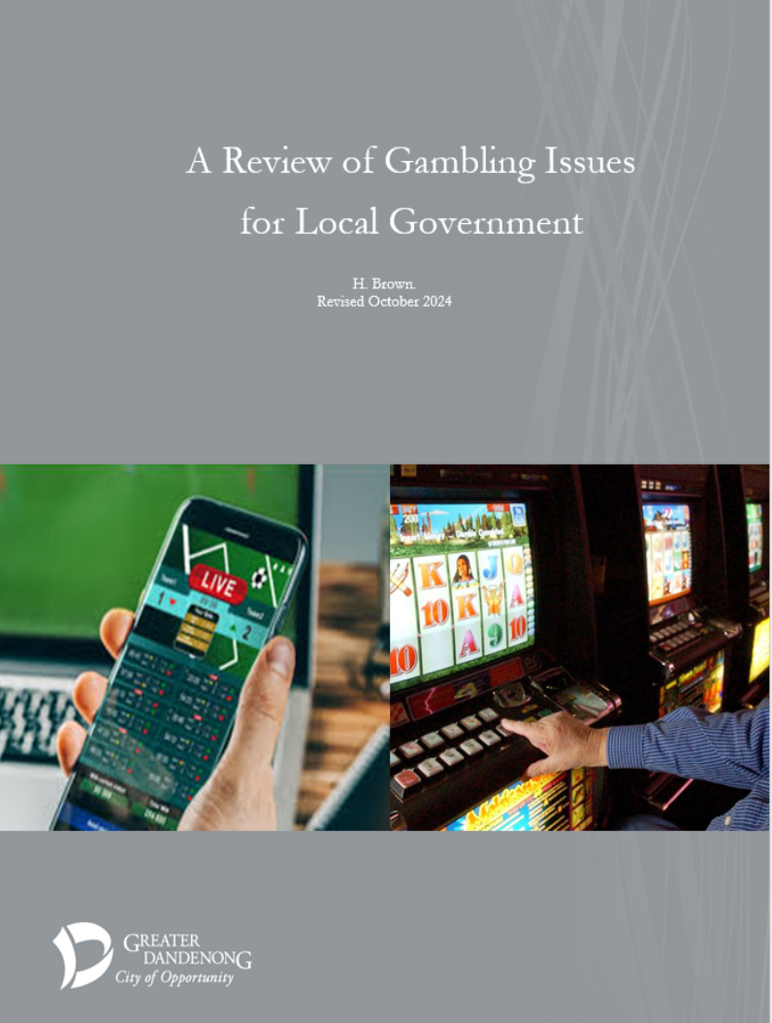

INDEX

PATTERNS OF GAMBLING AND GAMBLING PROBLEMS 1
Participation in Gambling 1
Participation in Gambling Types 1
Gambling Frequency 3
EGM Losses 4
Gambling Losses and Social Characteristics 5
Gambling Losses and Incomes 6
Trends in EGM and other gambling Losses 7
The EGM Gambling Industry and Distribution of Gambling Losses 9
EGM Losses and Disadvantaged Municipalities 9
EGM Density and Disadvantaged Municipalities 11

SPORTS AND ONLINE GAMBLING 12
Levels and Patterns of Sports and Online Gambling 12
Participation in Online-only Gambling-like Activities 13
Sports Betting 14
Personal Circumstances which Attract People to Sports and Online Gambling 15
The Convenience and Appeal of Online Gambling 16
Promotion of Sport and other Online Gambling 17
Exposure to Online Gambling among Children and Adolescents 18
Sports and Online Gambling-related Problems 18
Regulation of Online Gambling 19
Proposals to Limit the Harm Associated with Online and Sports Gambling 20

NATURE AND CAUSES OF GAMBLING PROBLEMS 22
The Nature of Gambling Problems 22
Causes of Gambling-related Problems 22
Venue Characteristics and Gambling-related Problems 25

THE PREVALENCE OF GAMBLING PROBLEMS 33
Prevalence of Severe Gambling Problems 33
Gambling Harm 34
Limitations of Surveys of the Prevalence of Gambling Harm 36
The Importance of Low- and Moderate-risk Gambling 39
Impact of Gambling Problems vs. the Prevalence of Problem Gambling 40

CHARACTERISTICS OF PEOPLE WITH GAMBLING PROBLEMS 41
Age 41
Social Disadvantage and Gaming Problems 43
Incomes 43
Education 44
Unemployment and Joblessness 45
Occupations 46
Indigenous People 46
Personal and Health Problems 46
Cultural Influences 47

EFFECTS OF GAMBLING PROBLEMS 49

BENEFITS ATTRIBUTED TO GAMBLING 53
Economic Effects of EGM Gambling 53
Community support Fund 53
Community Benefit Statements 54

Selected Sections of the Gambling Regulation Act (2003), relevant to Approvals Submissions 56

BIBLIOGRAPHY 60

NOTES ABOUT GAMBLING ISSUES
Participation in Gambling
The 2023 Victorian Population Gambling and Health Study found that approximately half (53%) of Victorian adults had gambled during the previous 12 months, including 51% of women and 56% of men.
This proportion had declined from 73% in 2008, including a halving in rates of participation in EGM gambling from 21.5% to 10.7%, during that period. Alone among the major forms of gambling, sports betting recorded a rise in participation, from 4% in 2008, to 5.1% by 2023.
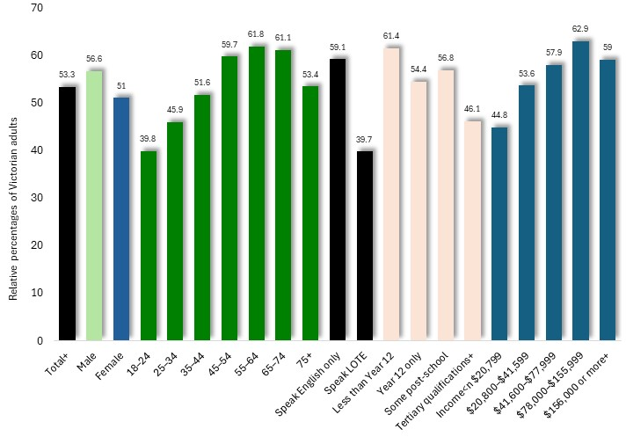
The prevalence of gambling recorded in the 2023 study, rose with age, from 40% of 18-24-year-olds, to its peak of 62% among people aged 65-74. Gambling participation was higher among people who speak English only in their homes, among those with more limited formal education and among people on higher incomes.

Per cent of adults who gambled in the previous 12 months, by characteristics: Victoria, 2023

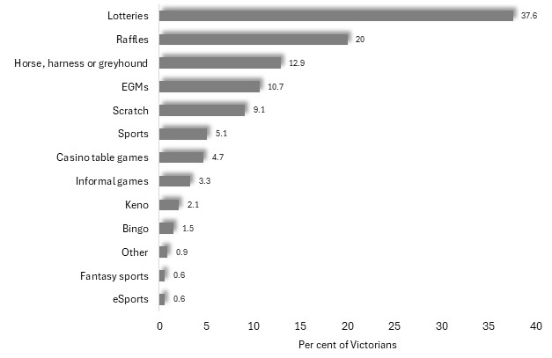
Participation in Gambling Types
The 2023 study determined that approximately a third of Victorian adults participated in lotteries and one fifth in raffles, while one in nine (10.7%) - including 11.9% of males and 9.6% of females - had participated in EGM gambling and about one in twenty (5.1%) in sports betting.

Per cent of adults who gambled in the previous 12 months, by type of gambling: Victoria, 2023
Rates of gambling participation among segments of the community vary widely among the various types of legal gambling. The diagrams presented below, illustrate these differences with odds ratios. For each variable shown here, such as sex, age, spoken language, educational attainment and income, one category is assigned the value '1', with the number assigned to other categories of that variable showing the rate of participation, relative to that category.
For example, in the diagram below, illustrating levels of participation in EGM gambling, the number 1 is assigned to males, with the number 0.9, assigned to females, showing that women are 90% as likely to participate in such gambling as men.
Note: these odds ratios may only be compared among categories of a particular variable, such as sex, age, income and so on. The odds ratios may not be compared between categories of different variables, for instance, between 26-34-year-olds and people with year 12 education.

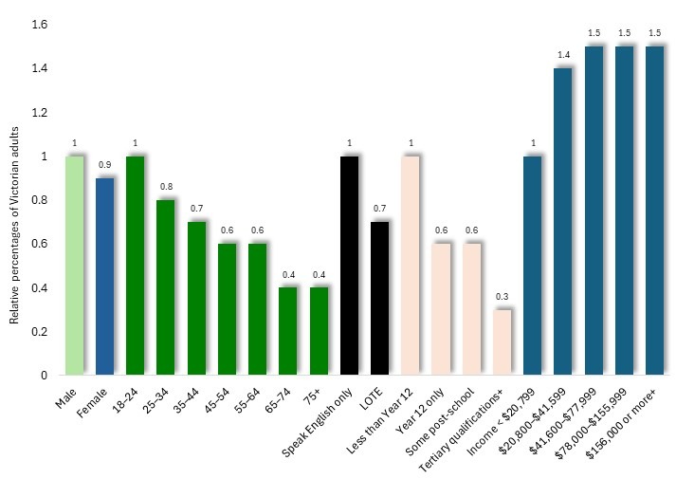
Participation in EGM gambling tends to be slightly higher among men, younger adults, English-only speakers and those with limited formal education, and rises with increasing income.

Odds Ratios, for participation in EGM gambling, by social characteristic: Victoria, 2023

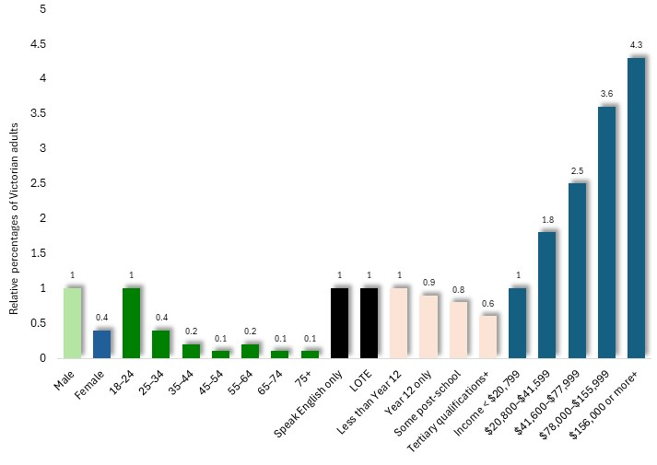
The proportion of Victorian adults who participate in Casino gambling is more than twice as high among males as among women, is highest among young people, somewhat higher among people with more limited formal education, and rises with increasing income.

Odds Ratios, for casino gambling, by social characteristic: Victoria, 2023

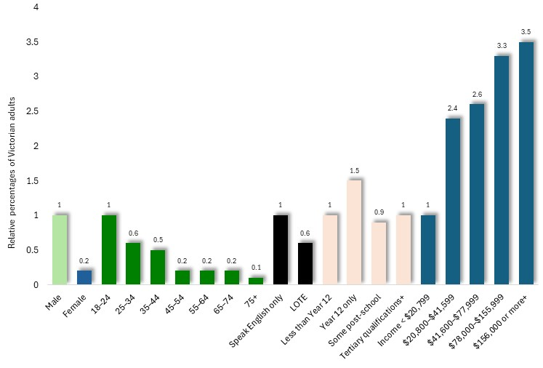
Participation in sports betting is five times higher among men than for women, highest among young people and those who speak English-only at home, and rises with increasing income.

Odds Ratios, for sports betting, by social characteristic: Victoria, 2023

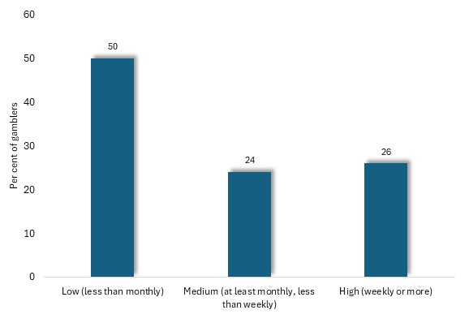
Gambling Frequency
The 2023 Victorian Population Gambling and Health Survey determined that half of Victorians who participate in gambling do so less than monthly, with about a quarter gambling at least monthly, but not weekly, and the balance participating at least every week.

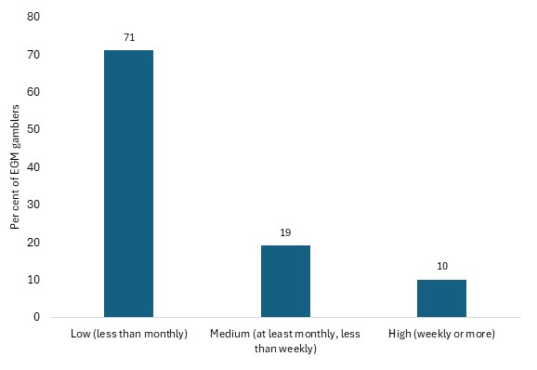
Per cent of gamblers, by frequency of gambling: all gambling, Victoria, 2023

Among EGM gamblers, 71% participate less often than monthly, with only one-tenth (representing about 1% of Victorian adults) participating weekly.

Per cent of gamblers, by frequency of gambling: EGM gambling, Victoria, 2023
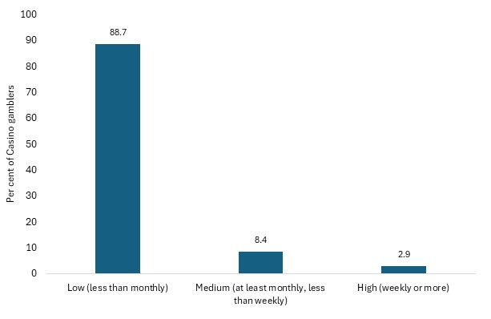

Similarly, among people who participate in Casino gambling, nearly nine-tenths do so less than monthly and only 2.9% as often as weekly.

Per cent of gamblers, by frequency of gambling: casino gambling, Victoria, 2023

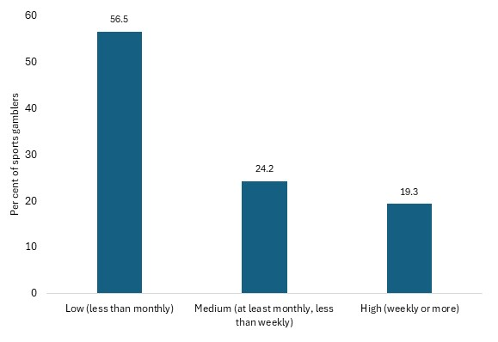
Sports betters gamble more frequently than EGM or casino gamblers, with over half participating less often than monthly, but nearly one-fifth participating at least every week.

Per cent of gamblers, by frequency of gambling: sports gambling, Victoria, 2023

EGM Losses
In 2024, the Victorian Gambling and Casino Control Commission (VGCCC) reported that there were 26,377 attached electronic gambling machines [EGMs or ‘pokies’] operating at 488 hotels and clubs throughout the State. In 2023/24, $3.03 billion was lost to these EGMs - equivalent to an average of $6.2 million per venue, $115,000 per machine, or $581 per adult – and representing 41% of all legal gambling losses in 2022/3 (Queensland Government Statisticians Office, 2024). These losses were equivalent to the cost of feeding 1,013,400 children for one year.
The 2023 Victorian Population Gambling and Health Survey informs us that approximately 10.7% of Victorian adults use gambling machines in a 12-month period. Dividing the total Victorian EGM losses in 2023/24 by the number of adults who gamble on EGMs, gives a figure for average EGM losses among such gamblers during that year, of $5,201.
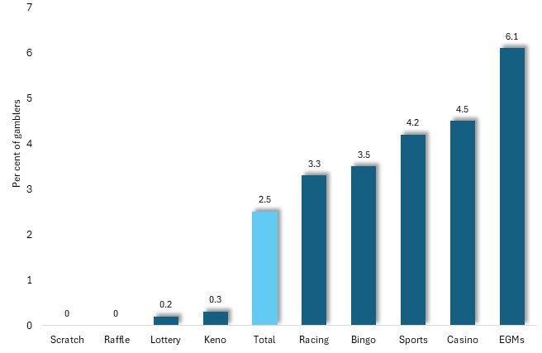
The survey also documented the proportion of gamblers who acknowledged losses of more than $10,000 in the previous 12 months, a figure which stood at 2.5% among gamblers in general. Among EGM gamblers though, this rose to 6.1% - the highest percentage among all gambling types. Among Casino gamblers, 4.5% lost over $10,000 in the previous year, while for sports gamblers the figure was 4.2%. By contrast, less than 1% of scratch, raffle, lottery and Keno gamblers recorded such losses.

Per cent of gamblers who lost over $10,000 in the previous 12 months to gambling, by type of gambling: Victoria, 2023

Gambling Losses and Social Characteristics
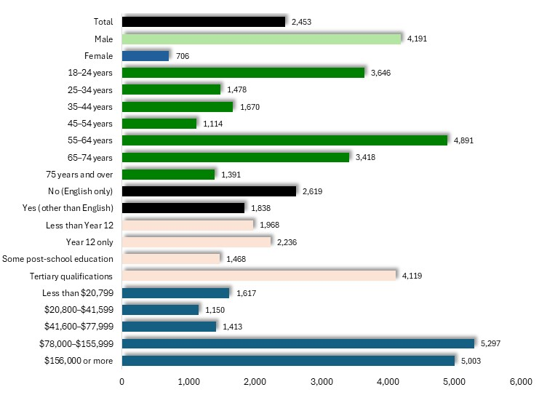
Average annual gambling losses acknowledged by participants in the 2023 Victorian Population Gambling and Health survey were over six times higher for males than for females, and highest among young people and those in their older age, among English speakers, those with tertiary qualifications and people on higher incomes.

Average acknowledged losses to all forms of gambling by gamblers, in the previous 12 months, by community characteristics: Victoria, 2023

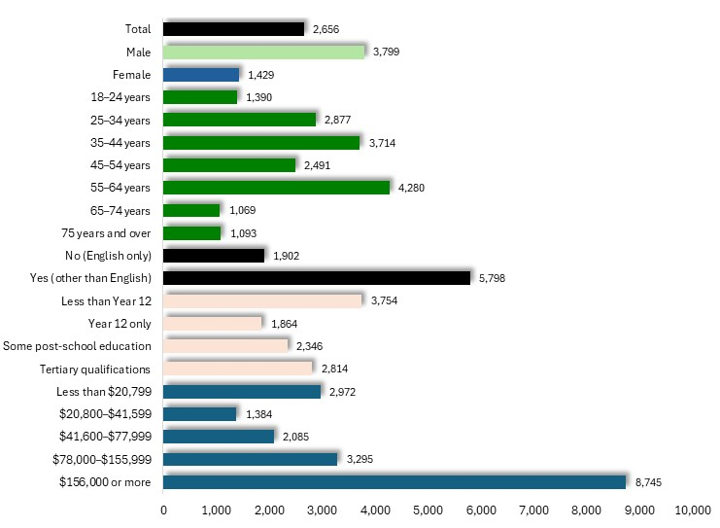
Though losses acknowledged by survey participants understated the true scale of EGM losses, the survey findings may still provide some suggestion of the relative levels of average EGM losses among various segments of the community. Among gamblers, losses were higher among non-English-speaking people, those with limited formal education and higher income earners.

Average acknowledged losses to all forms of gambling by EGM gamblers, in the previous 12 months, by community characteristics: Victoria, 202

Losses in the previous 12 months were highest among frequent gamblers. For example, among those who gamble at least weekly, the average acknowledged loss during the previous 12 months was $8,212, compared with $158 among those who participate less often than monthly. Similarly, among EGM gamblers, average losses among weekly gamblers stood at $5,344 compared with $312 among those who gambled less often than monthly.

Gambling Losses and Incomes
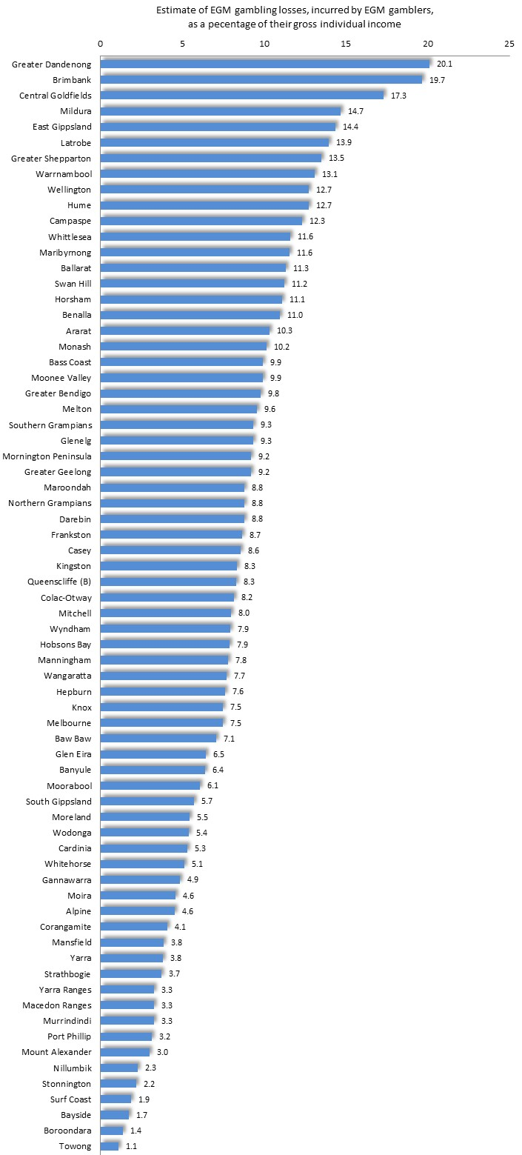
Where losses are measured in relation to household income, the disparity between gambling losses among the most and least affluent localities is still more marked.

Estimated Proportion of Gross Individual Income Lost to Gambling by EGM Gamblers, 2021/22: Metropolitan Municipalities

The relationship between EGM gambling losses, and income levels may be examined by concentrating upon those individuals who actually gamble on electronic gambling machines. Since 10.7% of adults in Victoria use EGMs in a given year, losses in each municipality in 2021/22 may be used to calculate the approximate level of average annual losses for EGM users.
To this end, annual EGM losses per adult were multiplied by 100/10.7, then divided by the median gross individual annual income for adults in each municipality (based on the findings of the 2021 Census), to give a reckoning of the proportion of average, gross adult income, lost by EGM gamblers in each of these municipalities. According to these estimates gamblers in Greater Dandenong lost an average of 20.1% of their gross income to EGMs in 2021/22, while their counterparts in highly affluent Boroondara lost just 1.4% of their incomes on EGM gambling.
Trends in EGM and other gambling Losses
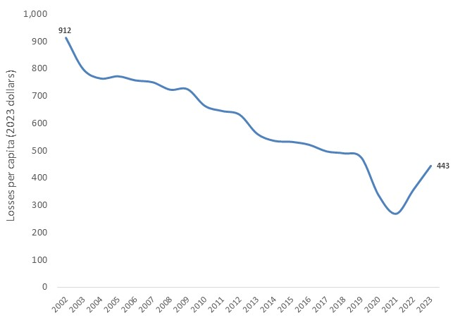
Losses to EGMs per capita in Victoria declined by 52% in real terms during the period 2002 (the peak of EGM losses) to 2023.

Losses per capita (2023 dollars): Gambling machine gambling, Victoria, 2002-2023

The percentage change in real losses per person, in the period 2000/01 to 2023/24, for each metropolitan municipality, are illustrated in the accompanying chart.

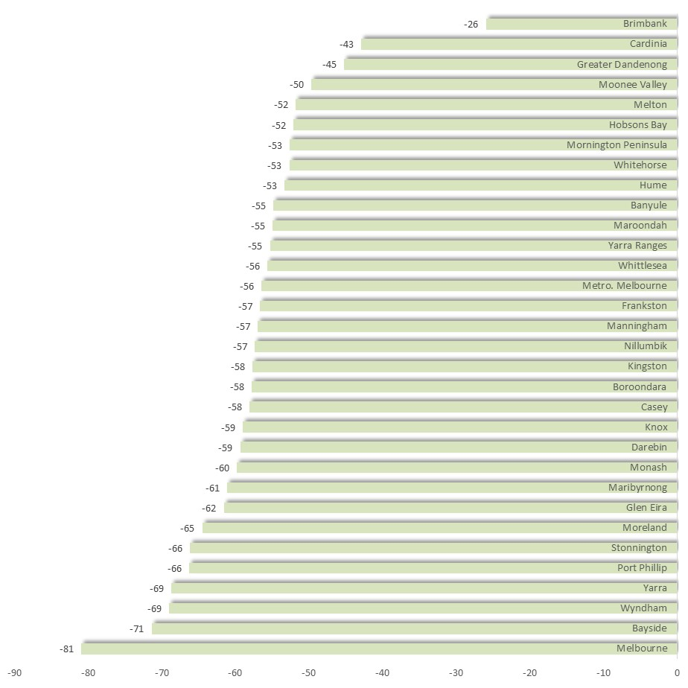

Change in losses per capita (2023 dollars) by metropolitan municipality: EGM gambling, Victoria, 2002-2023

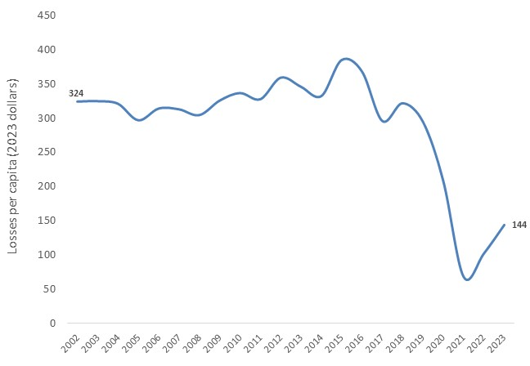
During the same period, casino losses declined by 56%,

Losses per capita (2023 dollars): Casino gambling, Victoria, 2002-2023

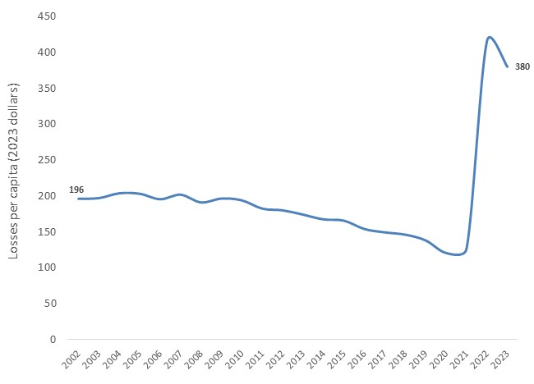

Meantime, losses at wagering (betting on sports and other events) nearly doubled, rising by 94%, in real terms.
Losses per capita (2023 dollars): Wagering, Victoria, 2002-2023

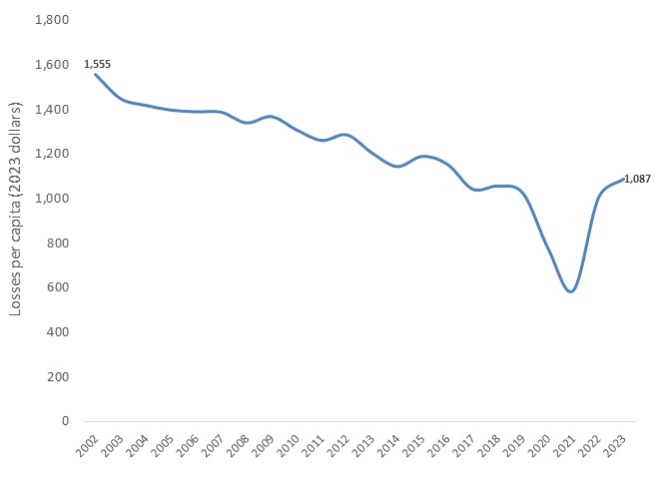

Overall losses to all forms of legal gambling per person, adjusted for inflation, declined by 30% during this period.

Losses per capita (2023 dollars): All legal gambling, Victoria, 2002-2023

The EGM Gambling Industry and Distribution of Gambling Losses

Under the Gambling Regulation Act 2003, a maximum of 30,000 electronic gambling machines (EGMs) may operate within Victoria: 2,628 within the Melbourne Casino, and 27,372 machines evenly divided among clubs and hotels throughout the state. Of those EGMs operating in hotels and clubs, a minimum of 5,474 must operate outside the Melbourne Statistical District, with the consequence that no more than 21,898 may operate within the metropolitan region. The Act further specifies that a maximum of 105 electronic gambling machines may be permitted within a single venue (Victorian Government, 2008).
The 488 venues with gambling machines outside the casino in 2024 were either hotels or clubs. Since all EGM gambling venues must hold a liquor license, if that license is cancelled, approval for EGM gambling at that venue is rescinded.
EGM gambling losses, or the revenue obtained from gambling machines, are distributed among the state and Federal Governments, was well as the clubs and hotels which serve as gambling venues. Hotels pay 8.3% of gambling revenue to the State Government Community Support Fund, which is allocated to problem gambling programs, drug education and treatment, youth programs, community advancement, sport and recreation, the arts, tourism and other purposes. Clubs on the other hand, are expected to contribute 8.3% of their gambling revenue to support the community, with its contribution documented in annual community benefit statements published by the VCGLR.
The Victorian Government 2023-24 Financial Report reports that $1.383 billion in gambling taxes were collected from losses incurred at electronic gambling machines, representing 46% of EGM losses that year, or $3.030 billion.

EGM Losses and Disadvantaged Municipalities
A variety of studies, reviewed further on, have found that gambling losses are largely sustained by those who can least afford them: people on lower incomes, in manual employment, those without paid work and people of limited educational attainments. Inversely, others in paid work, with more skilled occupations, higher incomes or educational attainments, by contrast, generally spend less on gambling.
This tendency is mirrored by differences in EGM gambling losses among various localities in Victoria, where the most disadvantaged communities tend to incur the highest gambling losses. In 2023/24 for instance, gambling losses among EGMs situated in Brimbank - metropolitan municipality with the lowest incomes recorded in the 2021 Census - stood at $1,172 per adult, the highest rate of losses in Victoria and eight times higher than the corresponding rate of $140 in Boroondara – among the most advantaged municipalities in the State. Thus, the residents of the community with the highest gambling losses in Victoria are among those least able to bear the financial burden.
The relationship between social disadvantage and gambling losses is illustrated in the accompanying diagram which, for each metropolitan municipality, matches annual EGM losses per 1,000 adults in 2021/22 (chosen to coincide with the most recent Census), to the median individual weekly income levels for 2021. Notably, the diagram shows the general tendency for higher rates of gambling losses to be incurred by the communities with the lower average income levels.
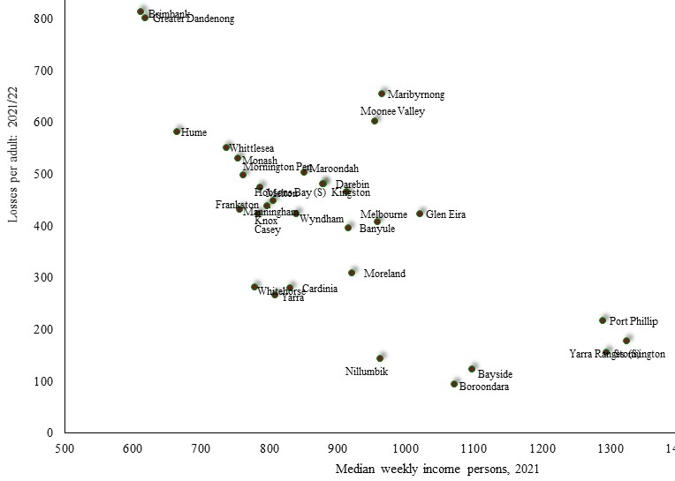
EGM Losses per adult 2021/22 and Median Individual Weekly Incomes 2021: metropolitan municipalities

The highest losses are featured among localities with lower incomes, such as Greater Dandenong, Brimbank and Hume, while rates are lower among the more affluent metropolitan municipalities such as Port Phillip, Stonnington and Yarra. A similar association may be seen in the relationship between EGM gambling losses per adult and the SEIFA Index of Relative Socio-economic Disadvantage, formal educational attainments and median incomes.
The map below depicts differences in estimated losses per adult, across metropolitan Melbourne.

Estimated EGM Losses per Adult: SA1 areas of metropolitan Melbourne, 2021/22
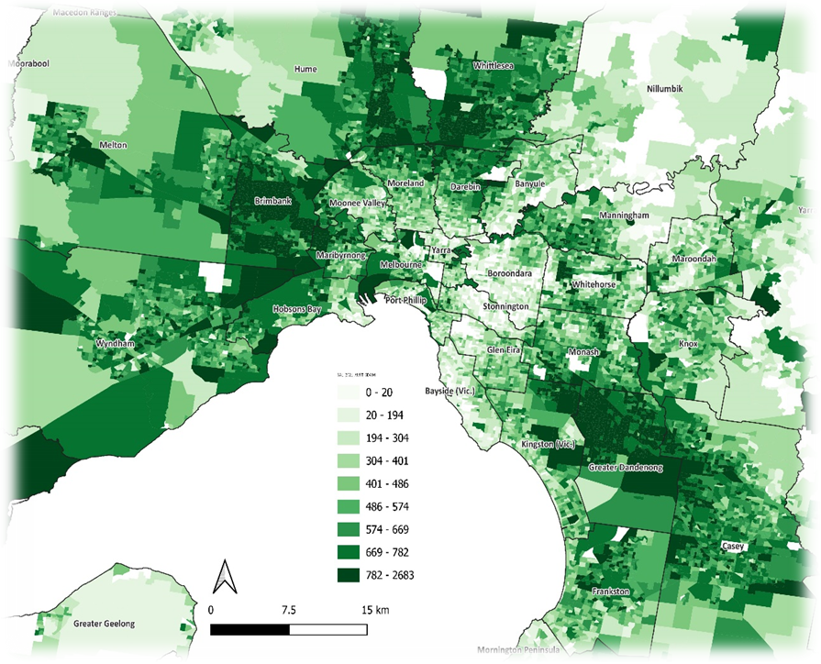

EGM Density and Disadvantaged Municipalities
As with EGM losses, the density of EGMs throughout Victoria [measured as the number per 1,000 adult residents] tends to be highest among the least affluent municipalities. For example, the average EGM density in the most disadvantaged four metropolitan localities [as measured by 2021 median personal incomes] in 2022 was 5.4 per 1,000 adults, compared with 3.1 among the least disadvantaged localities. In the case of Greater Dandenong, the density of EGMS stood at 7.2 per adult in 2022 – the highest concentration of gambling machines in metropolitan Melbourne and substantially in excess of the metropolitan average of 4.8.

Rate of EGM Losses and EGM Density: Most and Least Affluent Victorian Municipalities
Least affluent localities | EGMs/1,000 adults, 2022 | Losses/ adult, 2021/22 | Most affluent localities | EGMs/1,000 adults, 2022 | Losses/ adult, 2021/22
Whittlesea | 3.9 | 552 | Yarra | 3.3 | 267
Hume | 4.6 | 582 | Stonnington | 2.5 | 156
Brimbank | 6 | 815 | Port Phillip | 3.9 | 217
Greater Dandenong | 7.2 | 801 | Bayside | 2.5 | 128
Average | 5.4 | $688 | Average | 3.1 | $191

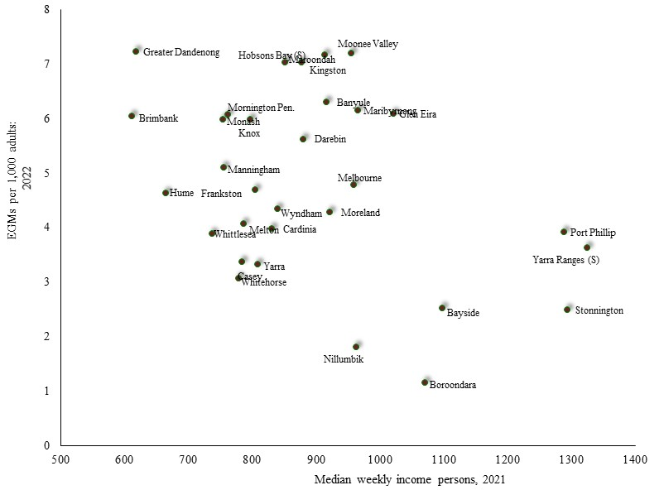
.
EGM Density 2022 by Median Individual Weekly Income 2021: metropolitan Municipalities

The association between EGM density (EGMs per 1,000 adult residents) in 2022, and 2021 median individual income, for each metropolitan municipality, is presented at left. The resulting pattern partly reflects that of EGM losses, shown earlier, with the highest numbers of EGMs per 1,000 adults among localities of lower income levels, such as Brimbank and Greater Dandenong, while lower densities are featured among more affluent localities such as Bayside, Port Phillip, Stonnington and Yarra.

Contemplating evidence of the higher densities of EGMs in less affluent localities, the Productivity Commission observed that high densities of EGMs in disadvantaged areas “…can serve to concentrate the social costs in communities that are less able to bear them.” (1999: 30) and accentuate the withdrawal of incomes from these communities.
Evidence linking levels of gambling opportunity, including the density of EGMs or EGM gambling venues, with levels of gambling and gambling-related problems, is surveyed further on, in the section ‘Access to Gambling Opportunities’.

II: SPORTS AND ONLINE GAMBLING:
Levels and Patterns of Sports and Online Gambling
Online gambling is conducted through the internet, using computers, tablets, smartphones or other devices. Gambling on sports is largely conducted online, with the result that recent rises in participation and expenditure on sports betting have largely unfolded in step with the burgeoning of online gambling.
By 2015, online gambling was the most rapidly growing form of gambling in Australia (Gainsbury, 2015), with Australian expenditure subsequently surging from $5.6 b. in 2019 to $9.6b. by 2022 - a rise of 72% in three years (House of Representatives Standing Committee on Social Policy and Legal Affairs, 2023).
Surveys show that the popularity of online gambling has risen commensurately. The House of Representatives Standing Committee on Social Policy and Legal Affairs (2023) relates that the prevalence of online gambling in Australia rose from 13% in 2010/11 to 31% by 2019. Within Victoria, the 2018/19 Victorian Population, Gambling and Health Study determined that 19.1% of adults had gambled online during the previous 12 months (Rockloff et al, 2020). And by 2023, the Victorian Population Gambling and Health Survey found that nearly a quarter (23%) of Victorian adults (up from 19% in 2018/19), and 44% of gamblers (up from 28% in that year), gambled online in the previous 12 months.
Among the most pronounced rises in online gambling in recent years is the proportion of sports betters who gambled online, which quadrupled from 22% in 2008 to 86% by 2023; and the proportion of racing gamblers who bet online, which rose eight-fold, from 6.8% to 55% in that period.
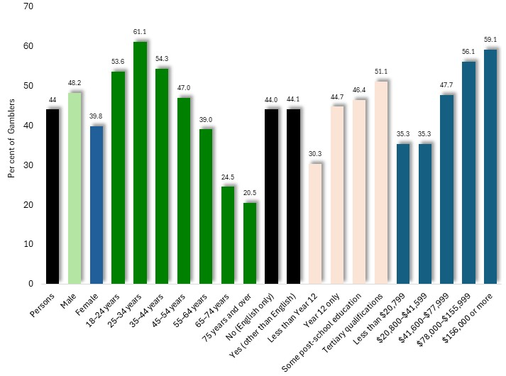
The 2023 inquiry found the proportion of gamblers who gambled online was similar for males and females, at approximately 48% and 40% respectively; declined gradually with age, from 61% of 25-34 year olds to 20.5% of people aged 75 or more; was similar for English and non-English speakers; was higher among people with tertiary qualifications, at 51%, compared with 30% of those with less than year 12 education; and was highest among high income earners, at 59% of those earning $156,000 or more p.a. compared with 35% of those on less than $20,799 p.a.

Per cent of gamblers who used online platforms to gamble in the previous 12 months, by characteristics: Victoria, 2023

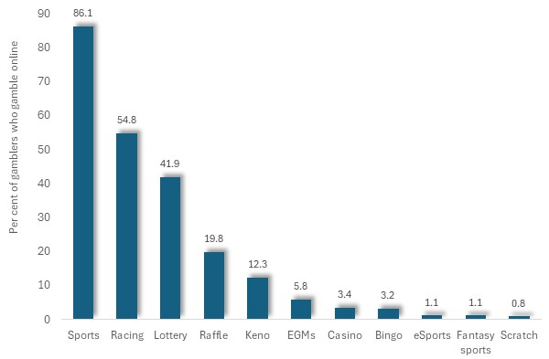
The accompanying chart shows the percentage of gamblers who gambled online at some time during the previous 12 months. Among them, over four-fifths of sports gamblers and more than half of those who gambled on racing, used online means to participate in these activities.

Per cent of gamblers who participated in gambling online during the previous 12 months, by type of gambling: Victoria, 2023

Participation in Online-only Gambling-like Activities
In addition, the 2023 Population Gambling and Health Survey determined that 2.7% of Victorian adults participated in online-only gambling-like activities including loot boxes, skins, fantasy sports and eSports betting. Levels of participation in these activities were seven times greater among males than females, and nearly 100 times more prevalent among young adults than among older people.
The pattern of participation in such online-only activities, with respect to such social characteristics, is reminiscent to that for online gambling, with the principal exception that levels of engagement differed little with income level.

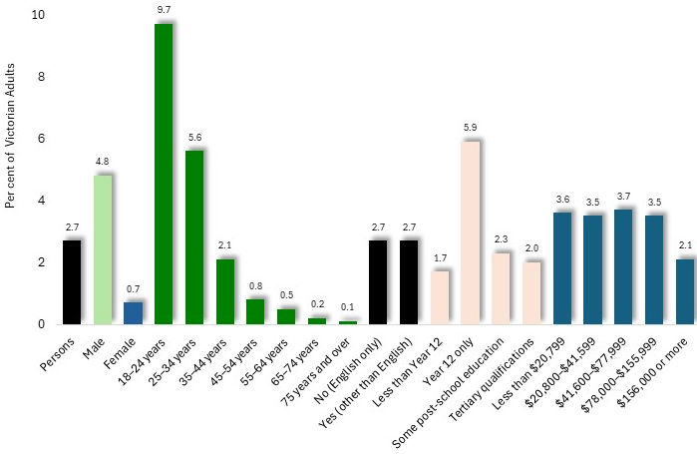

Per cent of adults who participated in online-only gambling-like activities in the previous 12 months, by characteristics: Victoria, 2023

Sports Betting
Forty-four per cent of Australian adults surveyed in 2022 had participated in sports or racing gambling during the previous 12 months (House of Representatives Standing Committee on Social Policy and Legal Affairs (2023). The 2023 Population Gambling and Health Study determined that approximately one in twenty Victorian adults had participated (5.1%) in sports betting during the previous 12 months.
Sports betting closely interacts with online gambling, for just as most sports betting is conducted online, a substantial proportion of online gambling relates to sports betting. A 2015 Australian survey determined that 59% of those who used the internet for gambling had participated in online sports betting (Winders and Derevensky, 2019), echoing other Australian findings (Parke and Parke, 2019) and global trends.
Gender
Local investigations confirm that participation in sports betting is highest among young people, and males in particular (Miller, 2017).
The 2023 Population Gambling and Health Study found that proportion of men who participate in sports betting is five times higher than for women. Sports betting participation was also highest among young adults, declining to a tenth of that level among people aged 75 years or more.
The reasons given for the higher level of participation in online and sports gambling among young men include their higher level of interest in sporting outcomes, and engagement with networks that are influenced by sports (Winders and Derevensky, 2019; Deaner et al, 2016), a more prevalent tendency to seek out intense or thrilling experiences (Rahamani and Lavasami, 2012; Cross et al, 2013), and exaggerated perceptions of the role of skill in determining gambling outcomes (Hing et al, 2014).
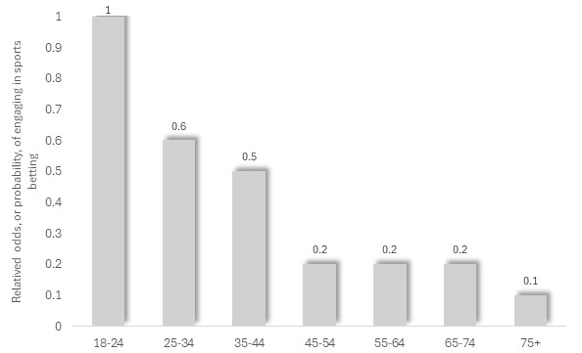
Age
The 2023 Victorian Population Gambling and Health Survey found that the proportion of Victorian adults who stated that they had participated in sports betting during the previous 12 months declined steeply with age, from its highest level among young people.

Odds Ratios, for sports betting, by age: Victoria, 2023

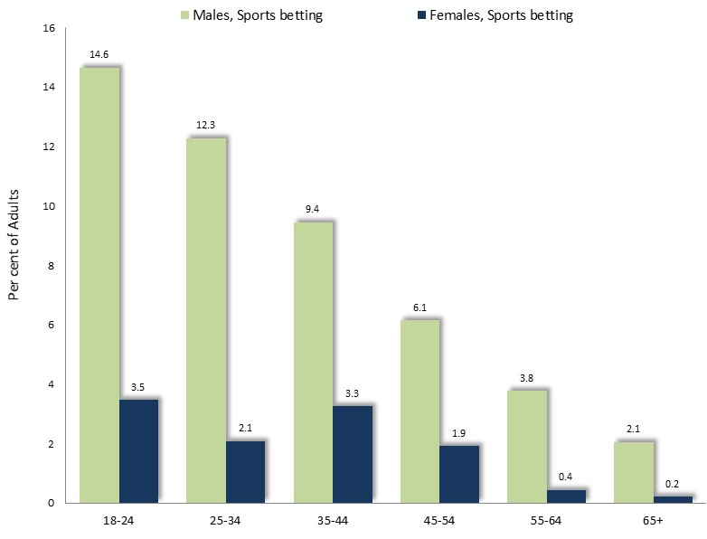
A 2015 Victorian study reported the same pattern, with 14.6% of 18-24-year-old males engaging in sports betting in the previous year – more than four times the corresponding proportion of women the same age, of 3.5%. A substantial, though declining, proportion of older men also participated, including 12.3% of 25-34 year-olds and 9.4% of those aged 35-44 (Hare, 2015) (chart, right).

Prevalence of sports betting by sex and age: Victorian adults, 2015
The same age profile of sports betters recurs in the findings of previous inquiries (Dowling et al, 2010; Delfabbro et al, 2009; Purdie et al, 2011).

Other Characteristics of Sports Betters
Aside from age and gender, the 2023 Victorian Population Gambling and Health Study revealed that people who spoke English only were about twice as likely to participate in sports betting, and those on the highest fifth of incomes about 3.5 times more likely to participate as the lowest fifth of income earners. Levels of participation did not differ markedly with education.
The HILDA survey found that sports betters were generally employed (85%), unmarried (55%), had an average, or above-average, education and income, and were renting (Siegff, 2017; Armstrong and Carroll, 2017; Palmer, undated). Further segments of the community who may be at risk of harm from sport or online gambling include Aboriginal and Torres Strait Islanders, members of CALD communities and young people (Gainsbury, 2015; House of Representatives Standing Committee on Social Policy and Legal Affairs, 2023; Wardle et al, 2007; Griffiths and Parke, 2002; Hing et al, 2015; McCormack et al, 2013).

Personal Circumstances which Attract People to Sports and Online Gambling
Growth in sports and online gambling may be attributed to a range of conditions, including the personal circumstances of those who participate in sports and other online gambling, as well as the convenience and marketing of such activities.
Among the circumstances highlighted in the research are gamblers' participation and interest in sport (Winders and Derevensky, 2019; Palmer, undated), the influence of their friends and family with a similar interest in sports and gambling (Pitt et al, 2017; Miller, 2017), and the effect of gambling in strengthening connections with peers (Nyemcsok et al, 2022), sometimes compounded by unrealistic confidence in their ability to foresee the outcomes of sporting events (Winders and Derevensky, 2019; Siegff, 2017, Nyemcsok et al, 2022).
Efforts to ease social isolation, boredom and stress, and to establish connections with friends, may also fuel sporting and online gambling (Co-As-It, undated). In a survey of 2,000 online gamblers during the pandemic, largely young men, most cited social isolation and boredom as conditions which enticed them to participate in sports and online gambling. One gambler commented that he became so bored that he would gamble "…just to get a thrill of it... with no knowledge of the sport..." (Silva, 2020).
Among young people in particular, sport and online gambling – as well as gambling problems – also appear to be associated with poor coping skills, mental health issues and impulsivity (Siegff, 2017). Regarding impulse control, Remo et al (2015) report attention deficit-hyperactivity disorder (ADHD) – notably, more prevalent among men, with a male-to-female ratio estimated from 3:1 to 9:1 (Australian Guidelines on Attention Deficit disorder, Royal Australian college of Physicians, 2009) – among 23% of people seeking gambling treatment. Sharpe and Jain (2000) explain that individuals with ADHD have limited control of impulses – as do many problem gamblers – and conversely, that the boredom, depression and low self-esteem which often accompany ADHD are alleviated by the 'stimulus and reward' of gambling.
Impulse control problems may not be particular to online or sports gambling though, as a high prevalence of such problems is reported among people with gambling problems more generally (Mestre-Bach et al, 2020; Ioannidis et al, 2019).
Other mental health concerns, including the alleviation of personal distresses, efforts to cope with past trauma, and the influence of drug use, may also promote engagement in sports and other online gambling (Hing et al, 2017). In addition, Siegff (2017) observes that for many young people, gambling may foster the appealing illusion of power, success and control.

The Convenience and Appeal of Online Gambling
Aside from the personal characteristics and social circumstances of individuals, the ready availability of online gambling, coupled with its promotion by gambling operators, exert a crucial influence upon levels of participation in such activities.
In its report on gambling regulation in Victoria, the Public Accounts and Estimates Committee (2023) observed that online gambling “…is accelerating in Victoria and can be particularly harmful to users because of its accessibility, normalisation and the aggressive marketing methods employed”, its “immersive design”, capacity to target individual users and potential for covert participation, and insufficient regulations, adding that children most vulnerable. These issues form the subject of this section.
Access to the Internet: Access to the internet has surged in the past two decades, with 86% of Victorian households having internet connections by 2016 (ABS, 2017), 80% of adolescents possessing a smartphone (Miller, 2017), and the proportion of the overall Australian population with a smartphone expected to reach 80% by 2025 (Granwal, 2020).
Meantime, the proportion of Australians who used the internet to gamble more than doubled in six-years, from 16% in 2012 to 34% by 2018, while the proportion who gambled on a smartphone rose four-fold during the same time, from 5.6% to 23% (Roy Morgan Research, 2019). Similar trends have been witnessed overseas, with a ten-fold escalation in world-wide mobile phone gambling expenditure reported in the five years to 2021 alone (Guillou-Landreat et al, 2021).
Advancement in Gambling Technology: The development of internet technology, coupled with a proliferation of gambling operators, presents gamblers with an opportunity to bet frequently, on a wide range of events, with a variety of engaging or immersive products, at any place or time of day (Siegff, 2017; Parke and Parke, 2019; Victorian Responsible Gambling Foundation, 2023), thereby intensifying their experience (Victorian Responsible Gambling Foundation, 2023) and making gambling a routine part of everyday life for some (Nyemcsok et al, 2022; Gainsbury, 2015). As a result, much gambling has shifted out of hotels and other social environments, to the seclusion and comfort of home (Palmer, undated; Gainsbury, 2015). The observations of one gambler are illustrative: "Whenever I'm bored, my finger automatically opens the app." (Silva, 2020).
Rapid, Continuous Gambling: In the wake of these technological developments, online betting allows outcomes to be determined swiftly, providing rapid reinforcement, while live betting, cash-out, instant depositing (enabling gamblers to bet their winnings), coupled the opportunity to repeatedly gamble on a succession of minor events, have all supplied gamblers with access to an intensive, continuous and impulsive experience (Parke and Parke, 2019). In addition, convenient electronic means to expend funds on gambling may temporarily obscure the financial implications of gambling losses for some gamblers (Victorian Responsible Gambling Foundation, 2023; Gainsbury, 2015). Such circumstances, commentators warn, elevate the risk of gambling harm (Winders and Derevensky, 2019).

Promotion of Sport and other Online Gambling
Further contributing to the rise of sport and other online gambling is its relentless and widespread promotion through free-to-air broadcasts, streaming services and social media, program content, product placements and other means (Kim et al, 2017; Victorian Responsible Gambling Foundation, 2023).
Exposure to this and other gambling promotion is almost inescapable: in 2021, 346,000 gambling adverts were broadcast on free-to-air TV, representing 39 ads per hour (Victorian Responsible Gambling Foundation, 2023). Moreover, its intensity has escalated in recent years, with expenditure on gambling promotion in Australia rising from $90 million in 2011, to $287 m in 2021. Of the latter sum, three-quarters was spent by wagering providers and corporate bookmakers; with TV adverts accounting for 54% (Victorian Responsible Gambling Foundation, 2023).
Commentators observe that gambling advertising has a particular impact upon those most susceptible to, or already experiencing, gambling problems (Guillou-Landreat et al, 2021). Young males are a primary target for sports and online gambling (Victorian Responsible Gambling Foundation, 2023) since they display the highest rates of participation in such activities (Winders and Derevensky, 2019; Miller, 2017). Notably they are also the most vulnerable to gambling problems. The 2023 Victorian Population Gambling and Health Study found that males were 2.5 times more likely to be problem gamblers than women, and young adults twice as likely than those in their late middle age.
Exposure of children and young people to gambling advertising is a subject of acute concern for some commentators. The 2017 Australian Secondary Students Alcohol and Drugs Survey found that 73% of its youthful respondents had seen gambling ads in the previous month (Victorian Responsible Gambling Foundation, 2023). Another investigation, featuring interviews with 54 Australian 11-17-year-olds found that most perceived that gambling advertising was prominent in sport (Pitt et al, 2022). Such advertising appears to exert an influence upon younger people: interviews with 48 Australian 8-16-year-olds determined that their interest in sports betting was largely shaped by marketing of gambling products (Pitt et al, 2017).
Gambling operators often link gambling with sport in their promotions, identifying their products with popular sporting values of loyalty and mateship, and seeking to foster sensations of excitement, victory and power (Deans et al, 2017; Miller, 2017). As Guillou-Landreat et al (2021) explain, the gambling industry has crafted ingenious ways of "controlling and capturing human emotions...through the creative use of touch, hearing and sight". In online gambling, inducements such as free credit or games, are frequently offered by gambling providers to lure people into online activity (Victorian Responsible Gambling Foundation, 2023).
In light of these circumstances, commentators caution that the ready availability of gambling products, their aggressive promotion, efforts to promote their link to sporting attributes, and the proliferation of gambling among peer groups for some young people, has made online gambling and its promotion a routine and unexceptional part of everyday life (Macniven et al, 2011; Siegff, 2017; Palmer, undated; Parke and Parke, 2019), thereby increasing the ease with which young people may be lured into such activities.
Similarly, the Victorian Responsible Gambling Foundation (2023) contends that gambling advertising may contribute to notions that frequent gambling is normal, prompt people to gamble increasing amounts of money, persuade people from some overseas backgrounds that gambling is a means to fit themselves into the Australian culture, and lure others to gamble as a way to foster a sense of belonging.
Exposure to Online Gambling among Children and Adolescents
Another circumstance which may accentuate the participation of young people in gambling is their experience of online ‘gambling-like’ activities during their childhood and adolescence. Commentators observe that sports betting often begins in adolescence or early adulthood (Winders and Derevensky, 2019; Dundie et al, 2011; Miller, 2017). Some therefore express concern at the impact of online poker and casino games where no money changes hands but which may introduce young people to the idea of online gambling (Palmer, undated).
Others caution that some adventure or role-playing games incorporate features where a player may trade non–monetary resources for an advantage (such as a weapon or special power) which is unseen until purchased – a form of gambling (Zendle et al, 2019). Such features of online games, directed to children and young people, may have the effect of fostering the impression that gambling is a normal and acceptable feature of life, while also generating fanciful expectations of the probability of winning (Victorian Responsible Gambling Foundation, 2023).
Accordingly, some commentators propose that the Commonwealth Government further place restrictions upon the exposure of children and adolescents to such online activities (Pitt et al, 2017), while others urge that parents set an example of restraint in their gambling behavior and take steps to obstruct children's access to such sites (Co-As-It, undated).

Sports and Online Gambling-related Problems
Sports and other online gambling activities are associated with a relatively high prevalence of gambling problems (Hakansson, 2020; Winders and Derevensky, 2019). The 2013 Population Gambling and Health Study assigned 6.7% of sports betters to the ‘problem gambling’ category.
In an investigation of broader gambling problems, Armstrong and Carroll (2017) report that 41% of regular sports betters experienced one or more gambling problems in 2015, noting that, at 23%, their prevalence of moderate to severe problems was nearly three times greater than that among other gamblers, of 8%. The House of Representatives Standing Committee on Social Policy and Legal Affairs (2023) recounts the findings of an investigation which concluded that about half (46%) of Australians who gambled in 2022 were at some risk of gambling harm in the past 12 months, with sports, racing and pokies gambling associated with the highest prevalence of risk.
In relation to online gambling, Gainsbury (2015) cites findings of a population survey which determined that the prevalence of problem gambling (that is, severe gambling problems) was 0.9% among non-internet gamblers and 2.7% among those who participated in online gambling.
As with gambling problems in general, behavioral patterns associated with harmful sports and online gambling include preoccupations with gambling, gambling increasing amounts of money, efforts to cease gambling, 'chasing' gambling losses, concealing losses from family and friends (Rasker, undated), with impacts which include personal distresses, financial difficulties, family conflict and violence, homelessness, crime and deceptive behaviour, work problems and others (Armstrong and Carroll, 2017).
Regulation of Online Gambling
Section 51 (v) of the Australian constitution states that the Commonwealth Government may make laws relating to “postal, telegraphic, telephonic, and other like services”. As a result, issues concerning access to online gambling opportunities fall chiefly within the jurisdiction of the Federal Government (Jackson, 2001; Horne, 2021).
One major effort to regulate online gambling was the Interactive Gambling Act 2001. In 2000, the Federal Government received a report from the National Office for the Information Economy, which determined that the government could legislate to ban domestic interactive gambling service providers which failed to adhere to prescribed standards (Jackson, 2001). The following year, the Government passed the Interactive Gambling Act 2001, which prohibited online casinos, in-play sports betting, sports betting services with no Australian license, the advertising of banned services and provision of credit for online sports betting (Australian Communications and Media authority, undatedA; Palmer, undated). Subsequent amendments tightened restrictions on non-Australian services and added a self-exclusion register. However, a 2012 Federal review of the Act concluded that its impact was limited, and that a rising number of Australians were accessing any of over 2,000 online gambling providers illegally operating in this country, attracting expenditure then estimated at $1 billion p.a. (Dept. Broadband, Communications and the Digital Economy, 2012). Authors of the review instead proposed that some currently banned online gambling providers be permitted to operate in Australia on condition that they promote lower-risk activities such as card games rather than slot machines and adhere to harm minimization and consumer protection measures.
By 2015, the federal government established the National Consumer Protection framework for Online Wagering in Australia, with collaboration from state governments, which prohibited credit being offered for online wagering, placed restrict tins on some inducements, established a voluntary opt out precommitment scheme, provided staff training in responsible service of online gambling and other measures.
In late 2024, the Federal Government amended the classification of computer games to impose a minim of an M (Mature, not recommended for children under 15 years of age) classification to games incorporating paid loot boxes and other elements of chance, and a classification of R for computer games which simulate gambling environments, such as casinos.

Proposals to Limit the Harm Associated with Online and Sports Gambling
Limiting Sports Gambling Advertising
Current rules about the promotion of sports gambling on TV and radio, published and enforced by the Australian Communications and Media Authority (undatedB), prohibit gambling advertisements during children's viewing hours (6-8:30 am and 4-7 pm) and in the course of play in broadcasts of sporting events on TV or radio, and forbid promotion of odds during, as well as 30 minutes prior to and after, a sports broadcast.
Some commentators propose that the Federal Government impose more stringent restraints upon advertising of sports betting during sports broadcasts (Macniven et al, 2011) and remove gambling advertisements from SBS (Alliance for Gambling Reform, 2021). Among the recommendations presented to the federal parliamentary inquiry into online gambling was a proposal to restrict advertising of online gambling, with a goal of its complete prohibition within a few years (House of Representatives Standing Committee on Social Policy and Legal Affairs, 2023). The committee though, instead recommended the development of a strategy and framework, research, data collection, public education, multi-lateral agreements and improved gambling treatment services.
In addition, the Australian Medical Association (2022) proposes steps to prohibit sponsorship – itself a form of advertising - of sports by gambling industry.
Others focus their attention upon measures to reduce the exposure of children to gambling advertising – a goal which receives strong support among the wider community, with one opinion poll finding that 71% of Australians favored a ban on gambling advertising (The Australia Institute, 2022). Lending its support to such measures, the Australian Medical Association (2022) affirms that: "Advertising and marketing which targets children, young people and vulnerable people experiencing harm from gambling is absolutely unacceptable".

Aspects of the Conduct of Online Gambling
Policing of Overseas Gambling Sites: In contrast to Australian government-regulated sites, many unregulated, overseas operators are disguised to look Australian and sometimes fail to pay winnings, disappear and retain customers' money, or continue withdrawing funds from customer's bank accounts without permission (NSW Responsible Gambling, undated). Accordingly, the House of Representatives Standing Committee on Social Policy and Legal Affairs (2023) endorsed measures to block overseas sites, accompanied by stronger sanctions for those who contravene gambling laws and strengthened international cooperation to police such laws.
Speed of Play in Online Gambling: Measures to curtail continuous betting in sports (Parke and Parke, 2019) or to reduce the speed of online gambling (Sewell, 2022).
Children and Gambling: Assignment of an R18+ rating to games which reproduce the experience of gambling, such as loot boxes (The Australia Institute, 2022), with R ratings introduced for gambling simulation in online games, and an M rating for loot boxes and other in-game purchases, in late 2024.
Online Gambling Inducements: Prohibition of online gambling inducements altogether is recommended by some (House of Representatives Standing Committee on Social Policy and Legal Affairs, 2023) while others propose the banning of inducements directed to gamblers who may be at risk or who have not used their account for a significant period (Victorian Responsible Gambling Foundation, 2023).
Pre-commitment Scheme: Consideration of the possibility of instituting a scheme where online gamblers could set a binding limit upon their losses, for a specified amount of time, thereby imposing restraints upon their gambling expenditure (House of Representatives Standing Committee on Social Policy and Legal Affairs, 2023).
Access to Credit for Online Gambling: A ban on use of credit cards and digital wallets for online gambling in Australia (Australian Finance Industry Association, cited in Victorian Responsible Gambling Foundation, 2023).
Public Education Campaigns
The House of Representatives Standing Committee on Social Policy and Legal Affairs (2023) proposed that the Federal government should establish a media campaign about online gambling directed to vulnerable segments of the community, including children and young people, CALD and Aboriginal people, featuring information about the risks of gambling, consumer protection tools and sources of assistance.
Programs to Address Sports and Online Gambling Among Young People
The Victorian Responsible Gambling Foundation conducts awareness-raising activities, community engagement and media campaigns to curtail the normalization of sports gambling among young people. Such programs, instructing people about the probability of winning when gambling, and dispelling popular misunderstandings about chance, are designed to instill a more realistic understanding of the likelihood of winning and thereby encourage people to moderate their gambling behavior.
Some research about the effectiveness of such programs indicates that most have little or no effect upon gambling behavior (Williams et al, 2007), the authors suggesting that, as with programs designed to moderate smoking or excessive alcohol consumption, knowledge of potentially harmful effects may be a necessary but not sufficient, condition to change harmful behavior. Williams et al (2007) also examined a range of evaluations of school programs, finding that in the relatively few instances where impact has been evaluated there has been little if any effect upon gambling behavior. They cite the example of a school-based program in Canada, where 1,600 students from several schools participated and 400 served as a comparison. Six months after the program, participants exhibited a clearer understanding of gambling, a resistance to such activities, and an actual decline in frequency of gambling behavior. However, no differences in problem gambling were recorded.
Similarly, a review commissioned by the Victorian Responsible Gambling Foundation though determined that such efforts essentially raised awareness among young people, which subsided over time and was “…not effective at changing attitudes and behaviors in the long run" (cited in Victorian Auditor General’s Office, 2021).
These results are paralleled by the findings of investigations of the impact of other programs which provide well-intended advice to young people. For example, in a review of the outcomes of safer driver education programs directed to young adults, Mayhew and Simpson (2019) reported little evidence that such efforts were effective in changing driving behavior. Lloyd et al (2009) documented similarly unfavorable outcomes among school-based drug education programs, which either lacked any longer-term evaluation of their impacts upon young people, or yielded few or no discernible benefits - with the exception of sustained, intensive, and comprehensive programs, whose attributes are not likely to be matched by any program in the field of gambling.
III: NATURE AND CAUSES OF GAMBLING PROBLEMS

Defining Gambling-related Problems
The term ‘pathological gambling’ was once widely used in the literature to characterizes severe gambling problems as persistent or chronic mental disorders, featuring a preoccupation with gambling, loss of control and persistence with gambling despite adverse consequences (Unnamed, 2005; AllPsych Online, 2008). The diagnosis of ‘pathological gambling’ was first introduced into the 3rd edition of the American Psychiatric Association Diagnostic and Statistical Manual [DSM III] in 1980, then revised in the mid-1990s. ‘Pathological gambling’, according to DSM IV, was considered to be present when 5 or more of its ten diagnostic criteria are present (American Psychiatric Association, 2008; AllPsych Online, 2009).
Lately though, attention has shifted from the state of the individual, to the effects of gambling upon the person, their family and broader community, with gambling-related problems viewed as a public health issue. With such considerations in mind, commentators often label severe gambling-related problems as 'problem gambling'.
Such an approach has several advantages, in not relying upon the proposition that gambling problems are a medical condition; in encompassing the larger group of people who experience gambling-related problems and their social context, rather than upon a lesser number deemed to be afflicted with a clinical addiction; and in focusing upon the effects of gambling problems rather than the individual, acknowledging the destructive implications of gambling-related problems and repudiating a victim-blaming approach.
A major shortcoming in the focus upon ‘problem gambling’ adopted by some researchers though, is its narrow emphasis on personal and behavioral impacts of gambling, as distinct from the wider conception of the personal, financial and material effects which ensue when a gambler persistently losses more money than they can comfortably afford, often termed ‘gambling problems’.

Causes of Gambling-related Problems
Causes of gambling problems are often complex and may involve individual factors, the nature of the gambling experience, and the accessibility and types of gambling opportunities.
Misconceptions and Deceptive Gambling Machine Design
Individual gambling behavior is also known to be influenced by irrational or superstitious conceptions about the probability of winning or the role of skill in gambling – notions that cause some gamblers to entertain unrealistic expectations of winning – as well as ineffective approaches to decision-making (Joukhador et al, cited in Moodie, 2007; Talbot, 2008). Such ideas may be fostered by aspects of gambling machine design, such as those which display the required symbols just above or below the pay line to convey the misleading impression of a near win (Select Committee of the Legislative Council on Gambling Licensing, 2008; Harrigan, 2007). As one interview respondent remarked in research conducted by AC Nielsen “Every machine comes so close to winning a major jackpot and you think, I’m just one off…” (2003: 45). Livingston explains that: “…poker machines are conditioning machines...” which employ principles of operant conditioning to teach people “…that if they keep playing the machine they will get a series of intermittent rewards” (2008: CA5). The Responsible Gambling Foundation (2015) cites the Productivity Commission, which in its 2010 report on the gambling industry asserted that “…problems experienced by gamblers are as much a consequence of the technology of the games and their accessibility, and the nature and conduct of venues, as they are a consequence of the traits of gamblers themselves.”
Frequency of Gambling
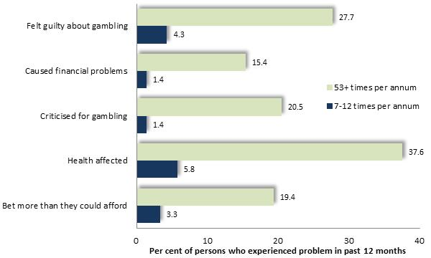
The 2008 Victorian Prevalence Survey compared the proportion of gamblers who experienced each of a selection of adverse effects of gambling, by frequency of EGM gambling. The prevalence of these consequences was up to fourteen times more prevalent among people who gambled at least weekly than among those who engaged in this activity 7-12 times per year. (accompanying diagram)

Adverse Effects of Gambling, by Frequency of Exposure to Gambling

Access to Gambling Opportunities
Evidence attests that accessibility to gambling – including gaming machine density – is associated with higher levels of gambling losses and problems. Some of these studies relate specifically to the density of gaming machines.
Storer, Abbott and Stubs (2009) examined findings of 34 gambling prevalence surveys, concluding that the number of problem gamblers rose with increased EGM density by between 0.6 and 1 per gambling machine, concluding that “The prevalence of problem gambling increases with increasing density of EGMs” (2009: 238). In addition, they observed that the prevalence of problem gambling reached its plateau only when gaming machine density attained a level well in excess of the existing densities. Rintoul et al (2012) examined the association between EGM gambling losses per adult and socioeconomic disadvantage (measured by the SEIFA Index) across Melbourne suburbs and EGM density, contending that “40% of the apparent effect of disadvantage was explained by the density of EGMs.” (2012: 1).
Other research relates to more general levels of gambling opportunity or access to gambling venues. The report ‘Risk Factors for Problem Gambling’ (2015) cites work by Valiliadis et al (2013) who determined that accessibility of gambling opportunities is associated with increasing gambling problems. Further research, recounted in ‘Problem Gambling in New Zealand: preliminary results from the New Zealand Health Survey’ (2012), found that people living close to gambling venues were more likely to experience gambling problems than others. ‘Risk Factors for Problem Gambling’ (2015) adduced the findings of Barratt (2014) who inquired into health-seeking patterns, reporting that increased access to gambling opportunities was accompanied by elevated levels of gambling-related harm.
Welte et al (2006) similarly concluded that proximity to gambling outlets was associated with an increased prevalence of problem gambling. Such a relationship between accessibility of gambling opportunities and the prevalence of gambling-related problems is affirmed and explained by various researchers and commentators. The Productivity Commission (2010: 14.6) found that “Accessibility stimulates demand, with the result that some gamblers are exposed to risk that were originally muted or absent”. In its earlier investigation of the gambling industry, the Productivity Commission observed that high densities of EGMs in disadvantaged areas “…can serve to concentrate the social costs in communities that are less able to bear them” (p: 30), a condition aggravated by the outflow of incomes from these communities as tax on gambling receipts.
The report ‘Destination Gambling’ (2008: 6) found that high accessibility makes “…gambling tempting for emotionally vulnerable problem gamblers” adding that “Where the presence of…gaming venues is increased, impulse behaviour will be more frequent”. Similarly, Lam and Mizarski (2009) contended that “Increasing opportunities to gamble would result in more individuals picking up the habit of gambling and potentially increase the incidence of problem gambling.” (pp. 273-4).
Harris and Griffiths (2017) recount evidence that increased gambling accessibility raises levels of participation and gambling-related problems, as “…those gambling at a level below or just below the limit for heavy or excessive gambling” increase their gambling intensity, thereby shifting “…those at risk into the problem gambling category, as well as converting those who gamble recreationally, problem-free, to at-risk gamblers.”
An illustration of the influence of gambling machines upon gambling-related problems has been provided by circumstances where EGMs have been removed or shut down. Williams et al (2007) cite the example of South Dakota where during the 1990s, its gambling machines were closed for three months due to a legal dispute. During this period, the number of gambling-related inquiries and clients at four treatment agencies declined from 79 each month, to 4 in three months. Similarly, the removal of EGMs in South Carolina in 2000 was followed by a halving of the number of gamblers anonymous groups within 90 days, with many remaining support groups reporting a marked decline in attendance.
As it would appear, a persuasive accumulation of research signifies that accessibility to gambling may increase the prevalence of gambling-related harm.
Considering the impact of high numbers of gambling machines, the Public Accounts and Estimates Committee (2023) recommended in its report on gambling regulation, that “The Victorian Government consider the impact of reducing the total number of electronic gaming machines.”

Venue Characteristics and Gambling-related Problems
Some industry advocates maintain that venue practices, including display of signage and brochures about responsible gambling and sources of assistance, staff training and other measures, may substantially alleviate the harm caused by gambling. Available evidence however, casts doubt upon this proposition. Rather, the general appeal, number and range of gaming machines, and long opening hours of many gaming venues may a far greater influence in attracting individuals who are susceptible to gambling-related problems.
Pleasant staff: The report ‘Problem Gambling from a Public Health Perspective’ (2009), found that proximity to home and ‘nice venue staff’ are among features of venues that hold appeal for some people with gambling problems. Klaus (2018) found that welcoming environment was designed to encourage gaming patrons to remain gambling as long as possible. Friendly and welcoming staff, a warm and comfortable environment, and a non-threatening atmosphere are alluring features of venues to many gamblers (Rintoul and Deblaquiere, 2019).
High numbers and choice of gaming machines hold attraction for some people with gambling-related problems. Hing and Haw (2010) report that both problem and regular gamblers who participated in their survey found access to their favorite gaming machines to be an attraction of gaming venues.
Bells and Whistles: Gambling machines are difficult to overlook, with Rintoul and Deblaquiere (2019) finding their ‘bells and whistles’ often reminded patrons of the gaming machines and prompted some to proceed to the gaming room. Lights and sounds are reported to be attractive to some gamblers under the influence of ice, heroin or other drugs, with the colors and sounds stimulating for some, or congenial to the trans-like state experienced by others (Rintoul and Deblaquiere, 2019). Neilsen (2003) concluded that the music and lights which accompany the operations of the gambling machines appear to exert an hypnotic impact upon some gamblers – particularly those with gambling-related problems. One gambler interviewed by AC Neilsen commented that “…I want to get in an air-conditioned room and have somebody bring me a drink and play pokies and look at the bells and whistles and lights, all the glamour of that sort of thing.” (2003: 45). Indeed, music, lights and other features of gaming machines were “…highly influential in encouraging gamblers to play longer” according to the authors of the report, with many beguiled by the experience of gambling losing track of time and events.
In addition, linked jackpots and bonus gaming machine features were found to be attractive to people experiencing gambling problems in a survey study conducted by Hing and Haw (2010).
Anonymity in larger venues: The Productivity Commission (2010) explored the attributes of larger venues, expressing the view that it may be easier for staff in small venues to identify people with problems and help them – with the implication that larger gaming venues diminish this prospect. Other research has presented testimony of people with gambling problems, of whom some have observed that they favour venues whose size or other features such as location away from their local neighborhood – may afford them some degree of anonymity (Neilsen, 2003). Hing and Haw (2010) report that some evidence indicates that more frequent and heavy gamblers tend to seek out privacy.
Size and Level of Activity in the Venue: Rockloff concluded that venues of larger size and high numbers of patrons contributed to increased levels of gambling activity and losses, as patrons were spurred by relatively high frequencies of wins ‘broadcast’ across the gaming room through the lights and sounds generated by gaming machines.
Meals and Free Tea and Coffee: Interviews with gamblers conducted by Rintoul and Deblaquiere (2019) revealed that free tea and coffee or snacks, meals and the bar, often lured patrons who then remain to participate in the gaming activities offered by the venue, some stating that they came to eat, then found themselves gambling unintentionally. Gaming venues, the authors concluded, provide a wide range of facilities to entice a ‘broad demographic’.
Late-night Operation of Gambling Venues
The long opening hours of some venues may contribute to the accessibility of gambling, especially to people at risk of gambling-related problems.
The report ‘Destination Gambling’ (2008) found that extended opening hours increase accessibility and that higher-risk gamblers often play at night – echoing a view offered by the Productivity Commission (2010) and Victorian Responsible Gambling Foundation report ‘Behavioral Indicators of Responsible Gambling Consumption (2016).
Rintoul and Deblaquiere (2019) report that some gamblers report that gaming venues were the only place open late at night, when they left their home. Research by Hing and Haw (2010) found that extended venue opening hours were appealing to people experiencing gambling problems.
Other research however, presents evidence which, while indicating that a high proportion of gaming room patrons in the early hours of the morning have gambling problems (Neilsen, 2003), does not show that most problem gambling occurs during these hours, particularly as levels of gaming patronage at early hours of the morning are generally far lower than at other times.
Other Venue Characteristics
Rockloff et al also recount findings from other investigators which indicate that machines with linked jackpots, free spins and double-or-nothing features are popular with problem gamblers. Their own research showed that attributes of venues that are appealing to problem gamblers include ‘close to home' (82% of high PGSI gamblers), the opportunity for social contact (56%) and availability of other activities (59%). Of gaming machines in particular their findings indicated that features such as a free spins or extra games (71%), jackpots (65%), and improved perceived chance of winning (76%) were among the attributes most alluring to problem gamblers.
Rockloff et al (2015) conducted an investigation in which 59 respondents were invited to rate various features of venues, as well as other EGM gambling platforms. Features attractive to gamblers including potential problem gamblers included close to home (82%), quality of service (82%), general atmosphere (56%), availability of other activities (59%), physical layout of the venue (53%), amount of EGMs (53%), clientele (53%), social (56%), availability of cheap food and drink (47%) with ‘size’ attracting 35% of the high PGSI segment of the sample (numbering 34 respondents). Overall, ‘size’ attracted the fourth lowest rating for importance in selection of a gaming environment out of 17 factors related to the characteristics of a venue. It is not made clear what characteristics ‘size’ encompasses, though based on general comments in the report about other gambling and venue attributes, some respondents who identified this as an important feature may have favored larger venues and others smaller or medium-sized venues.
Overall authors of the study concluded that “…the ideal environment for the average gambler consists of gambling at a club near home, with a group of friends, in a relatively quiet place with pleasant air-conditioning, with cheap food available and a safe place to play in, on a classic game with quality animations and small bet sizes, where you feel safe and secure and there is a wide variety of other games to play when you are done.” (Rockloff, 2015: 35)
Hing and Haw (2010) conducted interviews with gamblers to ascertain the characteristics of gaming venues which were most attractive to them. These appealing features included:
- Easy access
- Easy access to ATMs
- Allowing uninterrupted gambling
- Extended opening hours
- Glitzy venue
- Service - good
- Safe environment
- Seating comfortable
- Low denomination machines and bonus features
Many of these features are present at most gaming venues.
Staff Responses to Gambling Problems
Improved training for venue staff in the recognition of behavior suggestive of gambling problems, and in steps to intervene to offer support or deter such people from gambling, has been proposed as a means to reduce problem gambling. (Delfabbro et al, 2007).
However, staff interaction with gamblers maybe sparse and have limited effect, according to Victorian Responsible Gambling Foundation report ‘Behavioral Indicators of Responsible Gambling Consumption. Its authors found that signs of problem gambling in patrons are “…often ignored unless a patron is aggressive or disturbing other patrons” (Rintoul: 35).
Similar findings emerged from an investigation featuring discussions with gamblers and gambling venue staff and management, coupled with unannounced observations of EGM venues, found “…only isolated evidence of supportive interactions between staff and gamblers to address gambling harm”. Its authors added that “…venues often fail to respond to signs of gambling problems and instead encourage continued gambling in contradiction of their CoC [gambling codes of conduct] responsibilities” (Rintoul et al, 2017).
A further Australian study, involving interviews with 48 venue staff, reported wide variation in signs construed as evidence of gambling problems. Its authors reported that “…most contemplated intervening only if patrons’ behaviour is seen as a threat to themselves or others” (Hing et l, 2013: 1). None of the staff interviewed stated that they would intervene if they observed gaming patrons ‘trying inappropriate means to borrow money’, “being anti-social”, “irrational verbalizations or talking to a machine”, making multiple ATM withdrawals, telling staff that money intended for bills or food had been gambled, gambling a big win away, being inordinately attracted to a particular EGM, gambling large sums of money or waiting for venues to open. Only a small minority of the staff interviewed stated that they would intercede if a patron appeared distressed or crying, changed a large amount of money, heard friends or family telling them to stop gambling, or complained that a win had not covered their losses. Aggressive behaviour was the single indicator which most staff stated would prompt them to intervene in a patron’s gambling (Hing et l, 2013)
According to the female participants in a 2020 Australian investigation, venue staff overlooked patterns of behavior or gambling which pointed to gambling problems, such as their partners gambling a large sum, every day of the week, or making frequent cash withdrawals at the venue, and did not respond constructively even when they visited the venue to express concern about their partner’s gambling losses. The report notes that: “None of these participants reported that they or their partner were offered any assistance from a venue for the gambling problem, even when they or their partners visited the venue in distress about the gambling” (Hing et al, 2020: 9).
In a survey of 230 gamblers who were familiar with venue staff, 22 of them classified as problem gamblers, only one was identified as having ‘some problems’ by venue staff. Venue staff also identified 15 others as having ‘some problems’ of whom the gambling screen classified them as having no risk or a low risk (Ladoucier et al, 2017). The findings of the New South Wales Independent Gambling Authority show that venues may encourage prolific gamblers who lose substantial amounts of money.
Conversely, similar findings emerged from in-depth interviews, conducted in Melbourne by Rintoul et al (2017a) with gaming patrons with experience of gambling problems. Of the 36 gamblers who were asked about venue staff speaking with them in relation to their gambling, 32 had never experienced such an approach. This research was coupled with unannounced observations on 2-5 occasions, within each of 11 venues. In 34 hours of such observations, the investigators recorded numerous signs of probable gambling problems, including betting intensively, multiple cash withdrawals, gambling through mealtime and others. However, on no occasion were staff seen to approach to gaming patrons to encourage them to suspend their activities. Overall, the researchers reported “…an overall lack of staff interaction in the context of apparent gambling problems, staff encouraging gambling, a lack of intervention when gamblers were accessing cash, gamblers using multiple machines…”, observing “…only isolated evidence of supportive interactions between staff and gamblers to address gambling harm.”
Indeed, the 2023 Victorian Population Gambling and Health Study found that 1.9% of Victorian gamblers had been asked to take a break from their gambling, by venue staff, a figure which rose to 5.9% among people who gambled for 3 hours or more and 6.9% among problem gamblers. This finding appears to discredit the often-repeated claim by EGM venue operators that their staff closely scrutinize patrons for signs of problematic gambling and diligently intervene to curtail such behavior.
In addition to these specific considerations, the Victorian Auditor General’s Office (2021) found that venue staff training conducted by the VRGF, including training to recognition and intervention in instances of gambling problems, have not been evaluated to determine “…if the program is reducing harm” (p. 31).
Notably, ACNeilsen (2002) found that many gamblers are averse to interruption by staff in any case, responding with irritation if disturbed by staff feeling that such interruptions were an intrusion on their privacy, broke their concentration, might bring them bad luck or disturbed their pattern of play.

Knowledge of Services which Address Gambling Harm
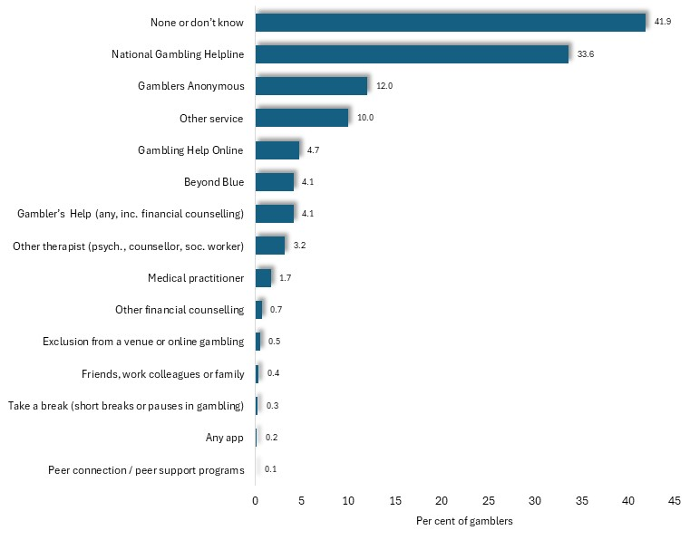
Few gaming patrons avail themselves of professional services to which staff may seek to refer in any case. The 2023 Victorian Population Gambling and Health Survey found that nearly half (49%) of Victorian adults overall, and 42% of gamblers, did not know of any gambling support services. Among gamblers, those services most widely cited were the national Gambling Helpline, known to 34%, and Gamblers Anonymous, known of by 12%.

Per cent of gamblers who were aware of support services, by type of service: Victoria, 2023

Help had been sought for gambling problems in the previous 12 months by 23% of people classified as problem gamblers and 2.8% categorized as moderate risk gamblers.
The Victorian Longitudinal Community Attitudes Survey found that, of regular gamblers in Victoria, just 2.4% had sought help with their gambling in the previous year. Among the 2.4% of regular gamblers:
- 2.4% had talked to someone in the venue about support services – representing approximately 1 in 2,000 regular gamblers, and
- 12% sought assistance from Gambler's Help, Gamblers Anonymous or Gambler’s Help lines in the previous year – equivalent to approximately 1 in 500 gamblers.
Moreover, among people who phone Gambler’s Help, few eventually engage with a local service, according to Gamblers Help data, with 368 of 3,909 people (or about 1%) who called the helpline actually engaging with a local service (cited in Victorian Auditor General, 2017).
Psychological Influences
The experience of individuals who are attracted to gambling as a way to alleviate boredom, social isolation, depression and other personal distresses, is well documented (Moodie, 2007; Ballon, 2006). Writing of homeless people in Australia, Talbot (2008) notes that for many, EGM gambling provides something to occupy their minds, while for others, the venue is a place to be among people. Echoing this finding, some gamblers interviewed in one study mentioned the role of gambling venues in “…providing contacts and a form of social connectedness.” (Thomas and Lewis, 2012: 10). Rintoul and Deblaquiere too remark that many problem gamblers are socially isolated and gamble to alleviate loneliness (2019). Similarly, ACNielsen (2003) found that some gamblers played when they felt down, to alleviate loneliness or to escape difficulties in their social, home or work lives.
Accordingly, many people experiencing mental health or drug-related problems may be susceptible to gambling problems (McCready et al, 2008), with a Melbourne study finding that people with gambling-related problems were far more likely than others to be depressed or to use alcohol or other drugs to excess (Science Alert, 2008).
Howe et al (2018) report that frequent gambling is associated with depression and people suffering from problems with gambling report higher levels of depression. In addition, Giovanni et al (2017) found that people with post-traumatic stress disorder are at an elevated risk of gambling problems. Similarly, a 2017 study commissioned by the Victorian Responsible Gambling Foundation found that 41% of people seeking treatment for mental illness gamble and 6% had a problem with their gambling – eight times higher than among the general population (Lubman et al, 2017).
Psychological conditions which predispose to impulsivity may exert an influence upon gambling behaviour, with one inquiry finding that 25% of gamblers who sought counselling for gambling problems had attention deficit disorder - nearly twice the corresponding prevalence in the general community of 14%. (Waluk et al, 2015). Other researchers have reported conditions such as a lesser tendency than others to delay gratification among people with gambling-related problems (Navos et al, 2017), personality disorders (Rucevic, 2016), and high levels of impulsivity and prevalence of ADHD (Black 2013). Echoing these findings, a longitudinal survey of 6,145 young adults found that those who experienced signs of ADHD, or higher than average impulsivity in childhood were more likely than others to report gambling problems, high levels of gambling losses and multiple types of gambling activity, than others (Clark et al, 2013). Studies also indicate that many people with gambling related problems gamble to alleviate depression, loneliness, boredom or anxiety, often seeking to distract themselves from their concerns or to escape reality altogether at a gaming venue (Neilsen, 2003).
An investigation conducted by Pitt et al (2020) documented increased susceptibility among people with intellectual disabilities to gambling harm, owing to their limited employment opportunities, lower incomes, social isolation, limited understanding of risk and probability, among other factors. The researchers found that some people with intellectual disability are attracted to gambling either in hopes of winning money, as a means to alleviate loneliness, and for a feeling of independence and participation in an adult activity.
Some researchers observe that many women are attracted to gambling as a means to escape isolation and serious personal problems, such as domestic violence (Healthy, Wealthy and Wise Women, undated). A 2020 inquiry into links between gambling problems and family violence, found that gambling venues were attractive, ‘safe spaces’ for women who participated in the study, owing to their long opening hours, accessibility, security, free food, courteous staff, child-minding facilities, opportunity for social contact with the staff and congenial atmosphere (Hing et al, 2020).
Adolescence itself may predispose some people to gambling related problems. Thomas and Lewis (2012) found that many enjoyed the excitement associated with the risk of gambling and the possibility of winning money, often as part of a social experience. Indeed, research reveals a higher prevalence of problem gambling among adolescents in Australia – in the range 2.4% to 16% (Miller, 2015), and the 2023 Population Gambling and Health Study, recorded a prevalence of problem gamblers, of 2.8% among 18-24-year-olds, compared with 1.7% among the general adult population.
Self-control and ‘Responsible Gambling’
Some people with severe gambling-related problems report a loss of awareness and control as they become immersed in the experience of gambling. Commonly, the result is a state of mind described as trance-like, in which perception of events, time and consequences become confused (Pinkerton, 2005). As a witness to a recent Senate inquiry from a problem gambling service told it: problem gamblers “…go into blackouts, they loose time and cannot remember their actions” (Senate Standing Committee on Community Affairs, 2008: 20).
Similarly, the Productivity Commission (2010) found that EGMs were the form of gambling most often associated with the psychological state of dissociation – where an individual ‘loses track of reality’, ‘played in a trance’, ‘lost track of time’ or ‘felt someone else was controlling their actions’, concluding that such states impair the ability of gamblers to “…reassess whether they wish to continue to gamble…” (2010: 4.14) a proposition which seemingly discounts the notion of ‘responsible gambling, which postulates that gamblers should merely exert rational control over their behavior, when gambling. As Dickerson observed: “…the data we collected showed the virtual impossibility of regular…EGM players gambling responsibly…” (cited in Breakeven Tasmania, 2008).
Cultural Factors
The 2023 Victorian Population Gambling and Health Study determined that people who speak languages other than English at home, showed lower rates of participation in gambling than those who speak English only, yet were more likely to be problem gamblers (at 2.4%) than those who speak English only (1.5%), and more often experienced gambling problems - at 19.3%, compared with 11.2% among those who spoke English only. A variety of circumstances relating to the cultural backgrounds of many migrants as well as the stresses and social isolation often associated with settlement may predispose some individuals to gambling problems.
Dickins, M. and Thomas A (2012) concluded that while CALD people overall appear less likely to gamble, those who do participate in such activities are more likely to experience gambling problems. Australian research, largely focused upon ethnic Chinese Australians, has identified some factors which may predispose some CALD groups to gambling problems, pointing to the popularity and acceptance of gambling as a cultural norm in Chinese culture (Feldman et al, 2014). Religious or spiritual beliefs in the influence of luck and its interaction with character exert a wide influence in Chinese culture, with a display of good luck purporting to demonstrate good character. Such notions are often coupled with unrealistic beliefs in personal ability to control outcomes of gambling (Dickins and Thomas, 2012; Feldman et al, 2014).
The appealing environment offered by casinos, in the relative absence of alternative, culturally-appropriate entertainment may also contribute to the prevalence of gambling among people of some cultures. For people of Chinese ethnicity in particular, casinos offer culturally sensitive and familiar entertainment – including Chinese New Year celebrations, evening activity reminiscent of their homeland and staff who speak non-English languages. In addition, some commentators maintain that the Casino provides inexpensive meals and drink in a safe environment with a glamorous and appealing décor, making it an attractive and prestigious location, particularly for recent settlers and those who have not adapted to Australian culture (Dickins and Thomas, 2012). Interviewees in a study by Feldman et al (2014) observed that for some Chinese, showing guests around the Casino is a way of affirming their affluence and garnering respect.
For some migrants with limited English fluency, an additional appeal of casinos and other gambling venues, may be the presence of bilingual staff or the opportunity to be among people without having to participate in conversation (Feldman et al, 2014).
For isolated migrants, including many older people, the Casino appeals as a place that is safe, accessible after dark, where they can be around other people and feel less lonely. In addition, those organizing excursions for older senior’s clubs are often unfamiliar with the range of alternative venues available, and may be attracted to the cheap meals offered by venues (Feldman et al, 2014)
Many international students, including those of Chinese ethnicity, experience high levels of stress, depression and social isolation, often coupled with prevalent irrational beliefs about gambling, which may foster an attraction to gambling and to venues such as the Casino (Feldman et al, 2014). It is reported that, in addition, freed from parental and other constraints, some international students tend to lose control of their finances (Feldman et al, 2014).
Gambling machines may also be a captivating novelty for some recent settlers, who may perceive them as a means to acquire more money (Rintoul and Deblaquiere, 2019). Abrupt exposure to various gambling opportunities may pique curiosity and trigger excessive involvement in gambling (Dickins and Thomas, 2012). In addition, stressors relating to settlement or experience in their country of origin may cause some migrants to be vulnerable to gambling problems (Dickins and Thomas, 2012). Feldman et al (2014) note that refuges and asylum seekers, in particular, often experience stress relating to challenges of adapting to Australian life, including social isolation, poverty and boredom, prompting some look to gambling to improve their financial position.
The stigma associated with gambling problems may induce some migrants to conceal issues from family and friends. In addition, professional counseling is unfamiliar to many, with most migrants preferring to deal with personal problems within their family (Dickins and Thomas, 2012)
The research findings recounted here are echoed in the conclusions reached by the Ethnic Communities Council of Victoria (ECCV). In December 2017, it published findings arising from its consultations with representatives of a variety of cultural communities, which concluded that recent settlers and some cultural communities were at heightened risk of gambling related harm, due to limited prior exposure to, and understanding of, gambling products; increased access to gambling in Australia; and lack of culturally sensitive support for people with gambling problems. The ECCV added that women, older people and students were most at risk of gambling-related problems.

IV: THE PREVALENCE OF GAMBLING PROBLEMS
Many people who gamble regularly experience difficulties in their personal, family or working lives as a result of financial stress caused by their gambling losses, or by the time spent gambling. Efforts to determine what proportion of the community experience gambling-related problems is discussed below.

Prevalence of ‘Problem Gambling’
Over the past few decades, surveys have been conducted to determine how widespread gambling-related problems are in the community, to document differences in prevalence among various segments of the community, and to trace any changes in the extent of gambling problems over time. With few exceptions, such estimates have been reached in the basis of the findings of random surveys of the adult population, which focus upon the identification of moderate and severe gambling-related problems.
The 2023 Victorian Population Gambling and Health Survey documented gambling problems, and the risk of problems, with the Problem Gambling Severity Index (PGSI), featuring nine questions about feelings concerning gambling, financial problems stemming from gambling losses, and responses of friends of family to their gambling. The 2023 study found that 8.5% of all Victorian adults, including 11.2% of males and 5.9% of females, reported patterns of behaviour or consequences of gambling which placed them in the categories of low risk (5.3%), moderate risk (2.3%) or problem gambling (0.9%).
Among the gambling population (that is, the 10.7% of Victorian adults who gamble in a 12 month period) 15.8% fell into this range, with 9.9% deemed at low risk of gambling problems, 4.2% at moderate risk and 1.7% classified as problem gamblers - the latter including 2.5% of males and 1% of females. (accompanying chart).

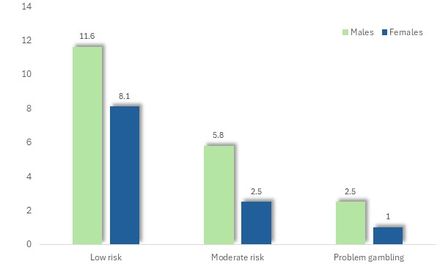
Per cent of gamblers classified as low-risk, moderate risk or as ‘problem gamblers’, by sex: Victoria, 2023

The prevalence of problem gambling was also highest among people who spoke languages other than English, those of lesser formal educational levels and people on lower incomes.

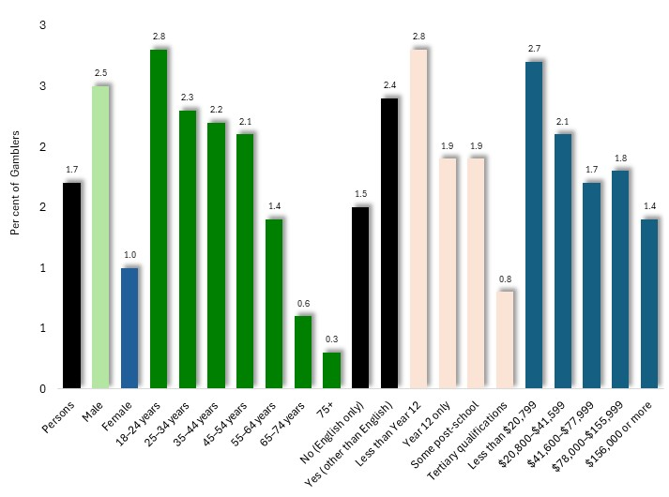

Per cent of gamblers who were classified as problem gamblers, by characteristic: Victoria, 20023

Similarly, an earlier, 2018/19 survey of over 10,000 Victorian adults, reported by Rockloff et al, (2020) determined that 9.8% of the population experienced gambling-related risk or problems, including 6.7% low-risk, 2.4% moderate-risk and 0.7% as problem gamblers. Among people who used EGMs in the previous year, 3.6% were identified as problem gamblers and 8.9% as moderate-risk gamblers.
The 2014 Victorian Gambling Prevalence Study found that approximately 0.81% of Victorian adults were problem gamblers, and that a total of 3.6% were either problem or moderate risk gamblers, and a 2011 survey of 1,500 Victorian adults, employing the Gambling Severity Index, concluded that 0.7% were problem gamblers and 2.4% ‘moderate-risk’ gamblers (Hare, 2011). Hare (2015) found that 8.9% of Victorian adults were low-risk and 3% moderate-risk gamblers, compared with 0.8% of adults who were identified in the survey as ‘problem gamblers’ (cited in Miller, 2017).
The proportion of gamblers who were classed as problem gamblers in the findings of the 2023 Victorian Population Gambling and health Survey, also varied with gambling activity, with problem gambling identified among 7.1% of EGM gamblers, 7.3% of those who gamble at the casino, 6.7% of sports betters and 3.7% of participants in racing gambling.
The Prevalence of Gambling Harm
The 2023 Victorian Population Gambling and health Survey also found that 6.9% of Victorian adults, or 13% of gamblers, had experienced at least one form of gambling harm during the previous 12 months, such as financial difficulties, personal distress, or relationship conflict. This represents a broader conception of the adverse impacts of gambling than the focus on psychological distresses used to define ‘problem gambling’.
The proportion of gamblers who had experienced such harm was highest among males, young adults, those who spoke languages other than English at home and people with year 12-only education. Little difference in the prevalence of gambling harm was observed by income level (accompanying chart).
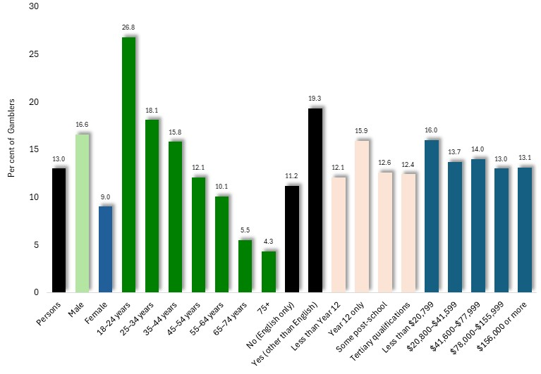

Per cent of gamblers who experienced any gambling harm, by characteristic: Victoria, 2023

As with ‘problem gambling’, the prevalence of gambling harm varied widely among gambling activities, ranging from 36% of people who gambled at the Casino, 35% of sports gamblers, 29% of those who gambled on EGMs, and 20% of racing gamblers.

EGM Losses and Problem Gambling
Gambling on EGMs is strongly associated with problem gambling (South Australian Centre for Economic Studies, 2005). The 2023 Victorian Population Gambling and Health Study found that 7.1% of Victorians who participated in EGM gambling were problem gamblers, and a further 12% were at moderate risk of such severe problems. An earlier study concluded that 28% of regular EGM gamblers experienced severe gambling-related problems – compared with 13% of regular Casino patrons, and 3% of those who regularly gamble on racing (McMillen and Marshall, 2004). Regarding the same issue, but focusing upon gambling losses, the Productivity Commission (2010: 5.1) concluded that problem gamblers account for 22-60% of total EGM losses, while moderate and problem gamblers in total account for between 42% and 75% of EGM losses – representing a mid-range of 58%.
Conversely, EGM gamblers represent a substantial proportion of people with gambling problems. The Victorian Longitudinal Community Attitudes Survey, found that EGMs are the favored form of gambling among 84% of problem gamblers, with horse racing preferred by just 8% (McMillen and Marshall, 2004). Indeed, Practical experience shows that EGMs are associated with relatively high rates of gambling harm, with EGM gamblers accounting for most people seeking assistance with gambling problems in Australia, the UK and New Zealand (Delfabbrio et al, 2020; Dowling et al, 2004; Abbott, 2006).
Further research indicates that EGMs have made the largest contribution to gambling problems in nearly all Western nations (Williams et al, 2007).
People who are experiencing gambling-related problems tend to exhibit different patterns of gambling activity on EGMs, to those with few or no such problems. A 2018/19 survey of over 10,000 Victorian adults, conducted by Rockloff et al, (2020) found that people experiencing gambling problem used EGMs more frequently, played for longer periods and accessed EFTPOS facilities at gaming venues more often. Overall, 9% of all EGM users played the pokies 25 times or more in a year, compared with 69% of problem gamblers. Moreover, 18.2% of Victorian non-problem gamblers spent 1 hour or more in a typical session, compared with 60.9% of problem gamblers. (non-problem gambler is one who is not a problem gambler, or low or moderate risk). Rockloff et al (2020) also found that 80% of problem gamblers used EFTPOS at least once in a typical session, compared with 10% of non-problem gamblers. And 57% of problem gamblers used EFTPOS at least 3 times in a typical session, compared with 2% of non-problem gamblers. Finally, the amount withdrawn in a typical session was $227 among problem gamblers and $70 among non-problem gamblers.
‘* * * *
As it may be seen, a variety of research shows that patterns of gambling behavior and losses vary across a broad continuum, from those who do not gamble at all, or do so infrequently, to others who gamble often, and may therefore sustain persistent and substantial losses, relative to their means. About one in ten adults gamble on EGMs, with 10.7% of the Victorian public gambling on EGMs at least annually, with the result that losses are concentrated among a relatively small proportion of gamblers. This in turn, leads to adverse consequences for the gambler and any dependents.

Limitations of Surveys of the Prevalence of Gambling Harm
While community surveys and other evidence furnish some suggestions about the prevalence and characteristics of problem gamblers, their findings should be interpreted with caution. Three major limitations of such surveys include:
- the apparent inaccuracy with which problem gamblers are distinguished from others
- inconsistency in measurement due to differences in questionnaires
- the criteria used for defining problem gambling and survey methods; and
- imprecise measurement arising from the difficulty of reaching conclusions about a small proportion of the population from the results of a sample survey.
Low Response Rates
Authors of the 2023 Victorian Population Gambling and Health Study observed that declining response rates, typically lower than 5% in Australian phone surveys, may reduce the representativeness through "...non-response errors, which refers to differences between those who are selected into a particular sample and those who end up completing the survey” (Suomi et al, 2024).
Inaccurate Responses
Researchers have long noted with concern, that many people with gambling-related problems are inclined to conceal their difficulties, abstaining from participation in surveys or giving answers which minimize their problems (Walker, 2008). As a result, the proportion of respondents with gambling problems may be underreported.
The 2023 Victorian Population Gambling and Health Study acknowledged the tendency for survey participants to under-report "...expenditure, frequency and negative consequences of gambling" due to a selective failure to recall such experiences or a reluctance to candidly report them (Suomi et al, 2024).
For example, in one of the early trials of a gambling questionnaire, among 384 students, 28 were interviewed and found to have gambling problems. Yet of this number, 13, or 45%, were not detected by the survey (Cullerton, 1989; Lesieur and Blume, 1993). Thus, the true rate of prevalence of gambling-related problems among this sample was nearly twice that recorded by the questionnaire. The most likely reason was that some individuals chose to conceal the extent of their gambling problems in their responses to a survey.
Relevantly, when the Productivity Commission asked 409 problem gamblers how they would have answered a phone survey on gambling, prior to seeking treatment, just 29% replied that they would have responded and given candid replies. If these results reflected the actual level of detection of severe gambling difficulties in sample surveys, then the proportion of Australian adults with gambling-related problems would be not 2.1%, as the authors of that report found, but three times higher, at over 6%.
A further reflection of the under-reporting of gambling losses may be seen in the findings of the 2003/4 Household Expenditure Survey, where Victorian respondents reported, on average, EGM losses of 64c per household (Australian Bureau of Statistics, 2008A) – equal to $63 million in total across Victoria - just 2.8% of actual EGM gambling losses, of $2,290 million that year (Victorian Casino and Gaming Authority, 2004) Not surprisingly, this source has been characterised as “notoriously unreliable” (South Australian Centre for Economic Studies, 2005: 197) as a source of gambling expenditure data.
With some respondents mistakenly identified as problem gamblers, and as many as two-thirds of those with severe gambling-related problems, and nine-tenths of losses, overlooked in sample surveys of the general population, the accuracy of the findings of such prevalence surveys may not be relied upon with confidence.
Inconsistent Survey Methods
The results of prevalence surveys may be further compromised by differences in the questionnaires used, the survey methods, the type of sample selected, and the cut-off point used to identify problem gamblers (Select Committee of the Legislative Council on Gambling Licensing, 2008; Doughney, 2007; Jonsson, 2007; Xenophon and the Australian Greens, 2008; Livingston, 2008). Such inconsistencies in the conduct and interpretation of surveys make it difficult to compare the findings of surveys conducted at varying times or among different communities. McMillen and Wenzel (2006) note that it would be preferable if governments settled upon a single, consistent method for measuring the prevalence of gambling-related problems.
Imprecise Measurement
A further limitation of prevalence surveys stems from the fact that, in selecting a sample of the population, chance alone may decide whether or not the sample actually contains the same proportion of people with severe gambling-related problems as the overall community which the sample is intended to represent. Typically, 5 to 20 out of every 1,000 people who participate in a community survey indicate that they have severe gambling problems. However, among samples drawn from the same population, such numbers are subject to chance variation - much as the number of heads in of a sequence of coin tosses may vary. When the prevalence of the characteristics being investigated is relatively low - as it is for gambling problems – chance exerts a relatively large influence upon the final result. Moreover, where many individuals selected to participate actually decline to do so - as in most population surveys - the range increases substantially, rendering the final result so imprecise as to be almost valueless.
A Narrow Focus
A further criticism of some surveys may be based not upon the way in which they measure gambling related problems but on what they measure. Surveys which focus upon the individual characteristics of ‘pathological’ or ‘problem’ gamblers, may overlook others who may experience gambling-related problems of a lesser intensity, as well as those adversely affected by the gambling of others. Addressing the shortcomings of such prevalence studies, Young observes that this research is conceptually and methodologically defective but tends to be supportive of, and favored by, the gambling industry (Young, 2012).
The narrow focus upon severe and addictive patters of gambling behaviour, coupled with the lack of precision, evident inaccuracy, and inconsistency of such surveys, raises questions about their validity. Speaking of efforts to measure the prevalence of gambling-related problems in Australia, Gary Banks, Chairman of the Productivity Commission lamented that “…despite all the surveys, we remain quite uncertain as to whether problem gambling has diminished in recent years.” (2007: 22).

Gambler’s Help Data as an Indicator of the Prevalence of Gambling Problems
Information concerning the number clients of Gambler’s Help provides little indication of the actual underlying levels of gambling-related problems in a community, since few people with severe gambling problems seek formal assistance in a given year.
The 2023 Victorian Population Gambling and Health Study concluded that help had been sought for gambling problems in the previous 12 months by 23% of people classified as problem gamblers and 2.8% categorised as moderate risk gamblers – with the result that differences in levels of attendance over time, or among municipalities, may not be interpreted with confidence.
An earlier inquiry by the Productivity Commission estimated that 10% of problem gamblers sought formal assistance in one year, while the 2010 Productivity Commission report on the gambling industry put the figure in the range 8-17%. Research indicates that most people with serious gambling-related problems only accept professional counselling when they have ‘hit rock bottom’ or a pressed to do so by family members or others (Neilsen, 2003).
In the course of its review of gambling regulation in Victoria, the Public Accounts and Estimates Committee (2023) determined that only 1–2% of those experiencing gambling harm have sought treatment from VRGF funded services, the only public services in Victoria.
Such small samples of problem gamblers may fluctuate due to changes in Gambler’s Help resources or the publicity given to their services, without reflecting any real change in the underlying prevalence of gambling problems. Therefore, one cannot prudently rely on such information for tracing changes in the prevalence of gambling-related problems over time, or measuring differences in their prevalence from one area to another.
The Importance of Low and Moderate-risk Gambling
The Productivity Commission cited with endorsement a selection of definitions of ‘problem gambling’ which each emphasise the presence of harm to the player, their family and/or the wider community, adding that such gambling problems form a continuum of harm, rather than being confined to the extreme end of the scale where ‘problem gambling’ is characterised. This perspective was echoed in a subsequent report by the Commission (2010), which concluded that harm caused by gambling affects not only problem gamblers, but those less severely affected by gambling. Authors of the report affirmed a preference for a ‘population health’ approach, in which all levels and types of harm are appraised in assessing the impact of gambling, rather than attention being confined to the “…the arbitrary group of harms that are clustered together in particular individuals.” (p. 5.7) – those labelled as ‘problem gambling’. Indeed, in examining the occurrence of the psychological condition of dissociation for example, the Commission concluded that people characterised as non-problem gamblers accounted for the majority of those who experienced this condition while gambling, noting that “…harm is experienced by many non-problem gamblers, with this group accounting for a greater share of the aggregated harm than problem gamblers” (2010: 4.24).
Rockloff et al, (2020) maintain that emphasis upon the small percentage (0.81% according to Hare, 2015) not only diverts attention from people who experience gambling harm but do not fit the clinical criteria for problem gambling, but also focuses attention upon the personal characteristics of the gambler rather than the noxious features of the gambling environment and products, while directing programs towards individuals instead of reform to the conduct and regulation of gambling. They concluded that of all gambling-related harm, problem gambling accounts for 20%, non-problem gambling for 22%, moderate-risk for 26% and low-risk gambling for 21%.
Like-minded, Browne et al (2016) investigated gambling-related harm from a public health viewpoint, gauging all harms caused by gambling, rather than focusing upon “…causes or symptoms of problem gambling” (2016: 36). They provided an estimate of the relative proportion of gambling-related harm, experienced by people of different gambling risk categories, with low-risk gamblers accounting for 50% of total harm from gambling – owing to their preponderance among gamblers - moderate risk gamblers for 34% of gambling harm, and problem gamblers for 15%. Similarly, the Victorian Responsible Gambling Foundation (2017) cites research funded by the VRGF which found that about half of gambling harm is related to low risk gambling and about 15% to problem gambling.
The publication ‘Using a Public Health Approach to the prevention of Gambling-related Harm’ (2015) concluded that “While the rate of harm is much lower among non-problem gamblers than those who meet the criteria for problem gambling, the absolute number of people experiencing some form of harm is significant.” (p. 10). Accordingly, the Victorian Responsible Gambling Foundation report ‘Social Costs of Gambling in Victoria’ ascribes a higher cost to low- and moderate-risk gambling, of $4.6 billion, than to the problem gambling, of $2.4 billion (Browne et al, 2017). A similar outlook is reflected in the findings of the report ‘Responsible Gambling Past, Present and Future’ (2016).
Other research indicates that low to high-risk gamblers account for a substantial proportion of EGM gamblers, which increases with rising gambling frequency. In Victorian Gambling Study: a longitudinal study of gambling and health in Victoria, Billi et al (2014), concluded that persons with mild to severe gambling risk accounted for 27% of people who used EGMs less often than once a month, a figure which rose to 38% of those who gambled 1-3 times each month and 61% of those who gambled at least once a week.

Impact of Gambling Problems vs. the Prevalence of Problem Gambling
A range of studies affirm that the proportion of the adult population who meet the criteria for ‘problem gamblers’ is in the order of 0.7% to 2%. The impression conveyed by these findings is that the extent of gambling-related problems is relatively modest. However, the findings of population surveys, which seek to determine the proportion of the population who conform to the formal definition of problem gamblers, tend to depreciate the extent of either gambling-related harm in the community and the proportion of the population and of gaming patrons, which are affected. Three points are recounted here to set this matter in its due perspective.
First, problem gamblers account for a significant proportion of gambling patrons. The Productivity Commission (2010: 5.25) stated that “While problem gamblers may account for only 0.7% of the population they may account for 10 to 40 times this among venue patrons at any one time”. Referring to the findings of a Victorian survey, the Commission concluded that between 27% and 76% of regular EGM players were problem gamblers or moderate-risk gamblers.
Second, even moderate-risk and problem gamblers account for a substantial proportion of gaming revenue. The Productivity Commission (2010: 5.1) concluded that problem gamblers account for 22-60% of total EGM losses, while moderate and problem gamblers in total account for between 42% and 75% of EGM losses – representing a mid-range of 58%.
Finally, as evidence recounted in the previous section shows, gambling problems do not relate only to problem gamblers in any case, but affect a wide range of gamblers to varying degrees, thereby further increasing the prevalence of problems among gambling patrons. The report ‘Using a Public Health Approach to the prevention of Gambling-related Harm’ (2015) concluded that “While the rate of harm is much lower among non-problem gamblers than those who meet the criteria for problem gambling, the absolute number of people experiencing some form of harm is significant.” (p. 10). The Productivity Commission was like-minded, recognizing that “…harm is experienced by many non-problem gamblers, with this group accounting for a greater share of the aggregated harm than problem gamblers” (2010: 4.24). These views are echoed in the report ‘Responsible Gambling Past, Present and Future’ (2016). This issue is discussed further on, under the heading ‘Low and moderate-risk gambling’.

V: CHARACTERISTICS OF PEOPLE WITH GAMBLING PROBLEMS
Surveys of the apparent level of gambling problems in the community have also provided some insight into some of the characteristics of people with gambling problems.
Sex
The 2023 Victorian Population Gambling and Health Survey found that similar proportion of women and men participate in gambling, including EGM gambling, and similar proportions participate in gambling online.
Men, however, were five times more likely to participate in sports gambling and more often engage in online-only gambling-like activities. Moreover, levels of gambling losses acknowledged by male gamblers are nearly five times higher than for women and their EGM losses are over twice those for women.
Gambling problems were found to be twice as common among male gamblers, is about twice that among women: 2.5% of men being classified as problem gamblers, compared with 1% of women; and 17% of men, compared with 9% of women, experience gambling problems.

 | Males | Females | Males: % higher or lower than females
Participation in gambling | 56.6 | 51 | 11
Participation in EGMs (odds ratio) | 1.0 | 0.9 | 11
Participation in sports g. (odds ratio) | 1.0 | 0.2 | 400
Participation in online gambling | 48.2 | 40 | 21
Participation in online-only | 4.8 | 0.7 | 586
Ave. G expenditure (gamblers) | $4,191 | $706 | 494
Ave. G expenditure (EGMs) | $3,799 | $1,429 | 166
Problem gambling - % gamblers | 2.5 | 1 | 150
Gambling problems - % gamblers | 16.6 | 9 | 84

Further investigations also indicate that gambling-related problems are more prevalent among men. The 2014 Victorian Gambling Prevalence Study found that 1% of males and 0.6% of females were problem gamblers and that 5.3% of males and 2.1% of females were problem or moderate risk gamblers (Responsible Gambling Foundation, 2015).
The 2011 survey of Victorians, commissioned by the Department of Justice also concluded that problem gambling was more prevalent among males (accounting for 0.95%) than among females (0.47%).
Similarly, the Household, Income and Labour Dynamics in Australia (HILDA) population survey, conducted among 17,000 Australian adults by the Australian Gambling Research Centre, found that both gambling expenditure and the prevalence of gambling-related problems were higher among males than females (Armstrong and Carroll, 2017). A study of the prevalence of gambling problems in South Australia found that 4.1% of men experienced severe or moderate gambling harm, compared with 1.8% of women (Woods et al, 2018). Rockloff et al, (2020) concluded that the prevalence of moderate risk or problem gambling was 4.4% among males and 2.9% among females.

Age
The 2023 Victorian Population Gambling and Health Survey found that while 18-24-year-olds were less likely to participate in gambling than older people (here, 55-64-year-olds), they were more likely to engage in EGM, sports, online and online-only gambling.
In relation to EGM gambling, Hare (2015) similarly found that their use was more widespread among older people, with 23% of Victorians of retirement age using gaming machines in the past 12 months, compared with 13% of those aged 25-54.
Though losses to gambling overall, and to EGMs, were lower among young gamblers, the 2023 Victorian Population Gambling and Health Survey found that the prevalence of problem gambling declined steeply with age, from 2.8% of 18-24-year-olds, to 0.3% of people aged 75 years or more. Similarly, gambling problems were experienced by 27% of young adults, aged 18-24, and by 44.3% of those aged 75 or more.
 | 18-24 | 55-64 | 18-24 y.o.: % higher or lower than 55-64 y.o.
Participation in gambling | 40.0 | 62 | -35
Participation in EGMs (odds ratio) | 1.0 | 0.6 | 67
Participation in sports g. (odds ratio) | 1.0 | 0.2 | 400
Participation in online gambling | 54.0 | 39 | 38
Participation in online-only | 9.7 | 0.5 | 1840
Ave. G expenditure (gamblers) | $3,646 | $4,891 | -25
Ave. G expenditure (EGMs) | $1,390 | $4,286 | -68
Problem gambling - % gamblers | 2.8 | 1.4 | 100
Gambling problems - % gamblers | 27.0 | 5.5 | 391

A 2018/19 survey, of over 10,000 Victorian adults, conducted by Rockloff et al (2020) found a prevalence of moderate risk or problem gambling of 5.9% among 18-24 year-olds compared with 2.1% among people aged 55-65. Based on a Victorian survey conducted at about the same time, Howe et al (2018) concluded that, while the proportion of people who were low and moderate risk gamblers was relatively uniform cross the age range, the proportion of people who were high-risk gamblers reached its peak among those aged 18–34-year-old before declining with increasing age.
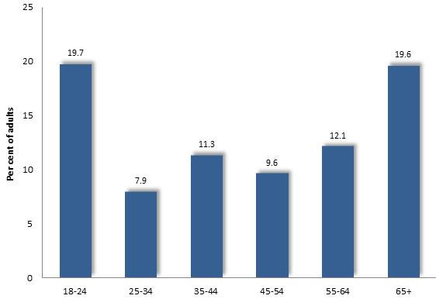
In relation to problem gambling, Hare’s 2014 investigation - ‘Study of Health and Gambling in Victoria’ - found that the proportion of Victorian adults who were problem, moderate-risk or mild-risk gamblers ranged from nearly 20% among both the youngest and oldest adults, to approximately 8% among those aged 25-34 years (Hare, 2015). Overall, 12.5% of Victorian adults fell within the range of problem to mild-risk gamblers, compared with 20% of people aged 65 years or more.

Percent of Adults who are at Risk of Gambling Harm, by Age: 2014 (Hare)

Social Disadvantage and Gaming Problems
Socioeconomic disadvantage is associated with a relatively higher propensity to gamble and susceptibility to gambling-related problems. At the same time, the gambling industry, responding to the opportunities which such conditions present, has tended to install more gaming machines in disadvantaged areas – which in turn, raises gaming losses in such localities. In this way, socioeconomic disadvantage and gaming machine accessibility interact to contribute to elevated gaming losses in disadvantaged areas.
The association between overall socioeconomic disadvantage and prevalence of gambling-related problems on the other is supported by two lines of reasoning, each corroborated by substantial evidence.
First, population surveys disclose that people in disadvantaged circumstances – as for instance, lower incomes, lesser educational attainments or joblessness – are more likely to experience gambling problems or be at risk of such difficulties, than others. Evidence of these links is reviewed further on. Accordingly, it follows that that socio-economically disadvantaged areas, where such individuals are represented in higher proportions than elsewhere, would experience a relatively high prevalence of gambling-related problems.
Second, further evidence directly establishes that disadvantaged areas experience higher rates of gaming expenditure than others. Indeed, gaming losses per adult in 2020/21 in Greater Dandenong – the least affluent municipality in Melbourne - were approximately seven times greater than those recorded in Boroondara – among the wealthiest localities in Melbourne (at $801 per adult, compared with $994 per adult in Boroondara). Similarly, an Australian study found that suburbs that were most disadvantaged exhibited the highest average EGM losses per adult – with losses in the most disadvantaged fifth of suburbs at $849 per adult, nearly three times higher than the corresponding rate of losses in the least disadvantaged fifth of suburbs, of $298. (Rintoul et al, 2017b).
Such high levels of gambling expenditure are, in turn, associated with an elevated prevalence of gambling problems. The document ‘Risk Factors for Problem Gambling’ (2015) cites research by Markham, Young and Doran who report that rates of gambling expenditure are positively associated with prevalence of gambling related harm, with a rise in expenditure per adult from $10 to 150 associated with an increase in prevalence of gambling harm from 9 to 18%. The ‘Report to Municipal Association of Victoria’ (2014) examined trends across regions, finding that high rates of gambling problems are associated with increased EGMs density and high expenditure. It follows that localities of socio-economic disadvantage, where levels of EGM expenditure are highest, would therefore also experience elevated rates of gambling-related problems.

Incomes
The 2023 Victorian Population Gambling and Health Survey found that people on the highest range of incomes (>$156,000) are more likely than those on lower incomes (<$12,600) to participate in gambling, including EGMs, sports and online, though less likely to engage in online-only activities.

 | lowest income | highest income | Low income: % higher or lower than highest
Participation in gambling | 45.0 | 59 | -24
Participation in EGMs (odds ratio) | 1.0 | 1.5 | -33
Participation in sports g. (odds ratio) | 1.0 | 3.5 | -71
Participation in online gambling | 35.0 | 59 | -41
Participation in online-only | 3.6 | 2.1 | 71
Ave. G expenditure (gamblers) | $1,617 | $5,003 | -68
Ave. G expenditure (EGMs) | $2,972 | $8,745 | -66
Problem gambling - % gamblers | 2.7 | 1.4 | 93
Gambling problems - % gamblers | 16.0 | 13 | 23

Though gambling losses overall, and on EGMs, are greater among higher income gamblers, the study found that the prevalence of problem gambling declined with increasing income, from 2.7$% of people in receipt of incomes less than $20,800 per annum, to 1.4% of people in on annual incomes exceeding $156,000. The prevalence of gambling problems though, was fairly uniform among people of different incomes.
A 2018/19 survey of over 10,000 Victorian adults, conducted by Rockloff et al, (2020) recorded a similar relationship between the prevalence of gambling problems and income levels, documenting a prevalence of moderate risk or problem gambling of 2.5% among people in receipt of annual incomes of $20,800 to $41,600, compared with 1.8% among those with an income exceeding $166,000.
The 2014 Victorian Gambling Prevalence Study also found that problem gambling was most widespread among people in receipt of low incomes – as well as among unemployed adults and other segments of the community (Responsible Gambling Foundation, 2015).
The report ‘Gambling Prevalence in South Australia 2012’, also found high rates of problem gambling among people with low annual personal incomes. Similarly, in a review of contemporary research, Miller (2015) concluded that low incomes and lower socio-economic status are associated with a higher prevalence of gambling. In its earlier study of gambling patterns in Australia, the National Institute of Economic Research concluded that losses were largely sustained by those who could least afford them: those on lower incomes or manual employment (NIER, 2000).
The authors of the report ‘Destination gambling’ (2008) offer a common-sense explanation of this pattern, observing that people in disadvantaged areas may experience greater harm from gambling than others due to their limited financial means, sources of financial support and employability, to compensate for any gambling losses.

Education
The prevalence of gambling and gambling-related problems is also higher among people with limited educational attainments, than others. The 2023 Victorian Population Gambling and Health Survey found that people with limited formal education (less than year 12) were most likely to participate in gambling overall and on EGMs, through less often engaged in online gambling; and they have a similar level of participation in sports gambling and in online-only gambling. Losses among gamblers of limited education are about half of those for people with a tertiary education - though higher for EGM gambling.

 | less than yr 12 | Tertiary | < Yr 12: % higher or lower than tertiary
Participation in gambling | 61.0 | 46 | 33
Participation in EGMs (odds ratio) | 1.0 | 0.3 | 233
Participation in sports g. (odds ratio) | 1.0 | 1 | 0
Participation in online gambling | 30.0 | 51 | -41
Participation in online-only | 1.7 | 2 | -15
Ave. G expenditure (gamblers) | $1,698 | $4,119 | -59
Ave. G expenditure (EGMs) | $3,754 | $2,814 | 33
Problem gambling - % gamblers | 2.8 | 0.8 | 250
Gambling problems - % gamblers | 12.1 | 12.4 | -2

The 2023 study documented a pronounced decline in the prevalence of problem gambling with increasing formal education, from 2.8% of people with less than year 12 education, to 0.8% of those with tertiary qualifications. The prevalence of gambling problems however, differed little with educational attainment.
A similar trend was documented in an investigation into gambling prevalence in South Australia (Office for Problem Gambling, 2013) which recorded a prevalence of problem gambling of 0.2% among those with university degrees and 0.9% - or over four times higher – among people with secondary education only.
The report ‘Risk Factors for Problem Gambling’ (2015) cites investigations by Wardle et al (2010), Young et al (2006) and Sporston et al (2012), all of which recorded relatively high rates of problem gambling among people of limited educational attainments. In addition, overseas surveys have concluded that people with gambling problems tend to be less well educated than those without gambling problems (Cunha, 2017; McCready et al, 2008).
Unemployment and Joblessness
Some research points to a higher prevalence of gambling problems among people who are unemployed, with the 2013 report 'Gambling Prevalence in South Australia 2012' ascertained that 11.2% of unemployed people were moderate-risk or problem gamblers, compared with 4% of those in full-time employment, 2.3% in part-time employment, 1.4% of people in home duties, 1.8% of retirees and 2.1% of students.
The HILDA survey also documented an association between joblessness and the prevalence of gambling problems, with unemployed Australians accounting for 3.1% of the sample, but 12% of problem gamblers. (Armstrong and Carroll, 2017). The survey also found that respondents whose main income was derived from welfare payments, were over-represented among those with severe gambling problems.
A South Australian population survey found that the prevalence of problem and moderate-risk gamblers was 5.4% among unemployed survey respondents, compared with 3.3% among those in full-time employment and 2.4% among those in part-time work (Woods et al, 2018).

Occupations
Other evidence indicates that people on lower incomes or in less skilled occupations tend to experience higher gambling losses (Wardle et al, 2007; Williams et al, 2007). The later report ‘Victorian Gambling Study: a longitudinal study of gambling and health in Victoria, 2008-2012, found that sales workers, machinery operators and drivers and labourers were substantially over-represented among problem gamblers in a population sample, while those employed as professionals, technicians and trades workers and clerical or administrative workers, were under-represented among those with serious gambling problems (Billi et al, 2014).

Prevalence of Problem Gambling by Occupational Category: Victoria, 2012
 | Per cent of Problem Gamblers | Per cent of Victorian Adults
Over-represented among problem gamblers
Sales workers | 30.9 | 6.1
Machinery operators and drivers | 14.9 | 4
Laborers | 18.3 | 5.4
Under-represented among problem gamblers
Professionals | 12.4 | 32.3
Technicians and trades | 2.8 | 17
Clerical and administrative | 1 | 12.3

Indigenous People
Research findings concerning the prevalence of gambling problems, indicates that their prevalence is substantially higher among Aboriginal people than the general population.
The 2014 Victorian Gambling Prevalence Study resulted found that approximately 8.7% of Indigenous people were problem gamblers, compared with 0.7% of the overall adult population. And 30% of Indigenous people were either at low or moderate risk of gambling problems, or problem gamblers, compared with 11% of other Victorian adults.
A 2018/19 Victorian survey featuring 10,600 Victorian respondents, found that people of Aboriginal and Torres Strait Islander descent were over four times more likely to have experienced ‘pathological’ gambling during their lifetimes, as the general population (at 5.8%, compared with 1.3%) (Rockloff et al, 2020).
Personal and Health Problems
The 2023 Victorian Population Gambling and Health Study found that problem gamblers tended to have poorer self-assessed heath, higher levels of psychological distress and risky drinking, and more often smoked, than non-gamblers. In particular, 34% of non-gamblers were ranked among the lowest quartile of general self-assessed wellbeing, compared with 86% of problem gamblers; 5.2% of non-gamblers were rated as experiencing psychological distress, compared with 43% of problem gamblers; 31% of non-gamblers were classified as risky drinkers, in contrast to 55% of problem gamblers, and 9.8% of non-gamblers smoke weekly, compared with 47% of problem gamblers.
Higher than average rates of personal distress and excessive alcohol or other drug use are reported among people with gambling-related problems (McMillen and Marshall, 2004). A 2008 survey of Tasmanian residents found that, among regular gamblers, the prevalence of heavy smoking (100+ per week) was 15%, compared with 6% among others, while 18% of regular gamblers engaged in heavy drinking compared with 7% of others (SA Centre for Economic Studies, 2008). A Melbourne study of 2,000 adults, conducted by the Problem Gambling Research and Treatment Centre at Monash and Melbourne Universities, determined that problem gamblers were 19 times more likely than non-problem gamblers to experience psychological difficulties; 4 times more likely to exhibit hazardous alcohol use; 2.4 times more often depressed; 6 times more likely to be divorced, and less inclined to feel valued as members of the community or able to call upon friends for assistance (Science Alert, 2008).
Cultural Influences
Cultural factors, as well as stresses related to settlement in Australia, may exert an influence upon gambling behaviour, and in some instances, predispose to gambling-related problems. It may be cautioned though, that existing difficulties in measuring the prevalence of gambling-related problems are accentuated when considering a segment of the community, defined by birthplace or cultural identity, who may account for a small fraction of population survey respondents. Moreover, it is difficult to form sound conclusions about a segment of the community as diverse as those born overseas – who, aside from this single characteristic are as diverse as those born in Australia. As a consequence, the prevalence of gambling-related problems among people of different birthplaces, language groups or ethnic identities, has never been determined with finality.
The 2023 Victorian Population Gambling and Health Survey found that people who speak English only have slightly higher rates of participation in gambling, EGMs and sports gambling than those who speak languages other than English at home. The level of engagement in online gambling and online-only activities is similar among the two groups.
 | English | LOTE | English only: % higher or lower than LOTE
Participation in gambling | 59.0 | 40 | 48
Participation in EGMs (odds ratio) | 1.0 | 0.7 | 43
Participation in sports g. (odds ratio) | 1.0 | 0.6 | 67
Participation in online gambling | 44.0 | 44 | 0
Participation in online-only | 2.7 | 2.7 | 0
Ave. G expenditure (gamblers) | $2,619 | $1,838 | 42
Ave. G expenditure (EGMs) | $1,902 | $5,798 | -67
Problem gambling - % gamblers | 1.5 | 2.4 | -38
Gambling problems - % gamblers | 11.2 | 19.3 | -42

Gamblers who speak languages other than English had lower rates of annual gambling losses - though they experienced higher rates of losses to EGM gambling ($5,798 vs $1,902). However, the study found that 2.4% of people who spoke languages other than English at home were problem gamblers, compared with 1.5% of those who spoke English only. Similarly, 19% of non-English speakers and 11% of those who spoke English only were experiencing gambling problems.
The 2014 Victorian Gambling Prevalence Study documented a similar trend, finding that 0.95% of non-English language speakers and 0.77% of English speakers were problem gamblers.
Similarly, Hare (2015), in her report ‘Study of Gambling and Health in Victoria’ determined that 5% of adults who spoke languages other than English in their homes were problem or moderate-risk gamblers, compared with 3.2% of English speakers.
Dickins and Thomas (2012) concluded that while CALD people overall appear less likely to gamble, those who do participate in such activities are more likely to experience gambling problems. CALD communities were also identified as among those at risk of gambling-related problems in the VRGF report Victorian Population Gambling and Health Study 2018-2019.
Other inquiries have shown that regardless of cultural background, for isolated migrants, or those with limited English fluency, the Casino and other gambling venues hold appeal as places that are safe, accessible after dark, and alleviate loneliness (Feldman et al, 2014). Further research indicates that stressors relating to settlement or experience in their country of origin expose some migrants to vulnerability to gambling problems (Dickins and Thomas, 2012; Feldman et al, 2014).

VI: EFFECTS OF GAMBLING PROBLEMS
Gambling losses are largely funded by reductions in expenditure on essential household goods, such as food and clothing, resulting in a diminished standard of living for the children and other dependents of many regular gamblers. While for some gamblers, accumulated losses may be significant, for others, on low or fixed incomes (Harrigan, 2007), even the sustained loss of modest amounts of money may have a substantial financial impact. Indeed, aside from those people who experience more severe financial problems as a result of gambling losses, a greater number of regular gamblers may persistently loose more money than they can comfortably afford, with the result that they and their families live less decently than otherwise.
Financial Difficulties
The South Australian Centre for Economic Studies (2005) found that, as the highest levels of gambling losses were incurred among people in the least affluent localities, most losses were funded not by savings, but by reduced spending on other goods. When asked how they would spend their extra funds if they did not gamble, 23% of a sample of people with gambling-related problems identified groceries and small household goods, and a similar proportion specified clothing and footwear. Just 20% stated that they would save these funds (South Australian Centre for Economic Studies, 2005). In a related investigation, financial harm experienced by all gamblers interviewed, with some going without meals or struggling to pay rent or mortgage (Rintoul and Deblaquiere, 2019).
Personal Stress
Investigations report a higher prevalence of personal distress, including depression and suicidal thoughts, and excessive alcohol or other drug use, among people with gambling-related problems (South Australian Centre for Economic Studies, 2005; Healthy, Wealthy and Wise Women, undated; SA Centre for Economic Studies, 2008).
A 2018 Swedish study found that the rate of suicide among people with gambling disorders was 15 times that of the general population. During the decade encompassed by this research, 19% of the approximately 2,000 gamblers under investigation had attempted suicide, 51% suffered from depression, 60% anxiety disorders and 41% substance-use disorders (Karlsson and Hakansson, 2018).
In its 2023 report, ‘Gambling and liquor regulation in Victoria’, the Public Accounts and Estimates Committee reported that the Coroners’ Court of Victoria had identified 184 gambling-related suicides between 2009 and 2016, the Committee adding that ‘…For many more Victorians, gambling would have been a contributing factor to their suicide.’
Family Stress and Violence
Available evidence indicates that the prevalence of family violence is higher in families which are experiencing gambling problems, than among others. Citing the findings of a review of international studies exploring the link between family violence and gambling, Dowling (2014) remarked: “…over half of people with gambling problems (56%) report perpetrating physical violence against their children. Dowling et al (2006) found high to low risk gamblers experienced a higher prevalence of family violence perpetration and victimization than others, thereby establishing an association between these two circumstances. An Australian study by Suomi et al (2014a) of people seeking treatment for gambling problems, found that 34% were experiencing family violence, either as a perpetrator and/or victim, while further research also disclosed that family violence was more prevalent in families where problem gambling was occurring (Suomi, 2014b). In a review of a selection of other Australian studies, Dowling found that one-third to one-half (34-53%) of people with gambling problems, or their family members, report some form of family violence in the previous 12 months." (Dowling, 2014).
Moreover, further investigations point to a causal link between gambling and family violence, with family violence sometimes contributing to gambling problems, and gambling in other instances contributing to family violence. For example, women’s health in the South-east (undated) concluded that family violence may contribute to gambling problems, citing a range of research which attests that some victims of family violence, largely women, may seek solace in the relative safety and comfort of gambling venues and in the experience of gambling itself, with gambling problems representing a consequence of family violence in such instances.
Further evidence affirms that gambling-related problems can lead to family dysfunction, conflict and violence (Australian Institute of Family Studies, 2014; Costello, 2008; Ferland et al, 2008), pointing to a direct causal relationship between gambling and family violence. Crane (2015) cites the CEO of a major Victorian welfare agency, who observed that “Problem gambling places great stress on relationships” with “family violence part of the mix with some problem gambling clients” adding that children often grievously affected by such aggression.
Commenting upon such family conditions, one investigator explained: “The family environments of people with gambling problems are characterized by high levels of anger and conflict as well as low levels of clear and effective communication, less independence, less engagement in intellectual and cultural activities, a lack of commitment and support, little direct expression of feelings, and less participation in social and recreational activities…Moreover, the children of people with gambling problems are exposed to a range of family stressors, including financial and emotional deprivation, physical isolation, inconsistent discipline, parental neglect/abuse and rejection, poor role modelling, family conflict, and reduced security and stability.” (Australian Gambling Research Centre, 2014).
Survey findings also shed light upon the role which gambling problems may play in causing and aggravating family violence. Muellemar et al (2012) investigated women admitted to emergency departments, finding that of those experiencing violence from their intimate partner and whose partner also had gambling problems, 64% perceived a connection between these two conditions (Suomi et al, 2013). Authors of the report noted that “…of the participants who were interviewed in depth, most reported that problematic gambling generally preceded the family violence (p. 1). The authors of the study concluded that gambling often leads to financial stress and mistrust, resulting in conflict and family violence.
Similarly, a New Zealand study of 254 people attending gambling treatment services, found that 50% had experienced physical, psychological, emotional, verbal or sexual abuse in the previous 12 months. Notably, among the 208 participants who took part in a further survey in the course of this research, 46% of those who had been victims of family violence expressed that view that the violence was a consequence of their partner’s gambling. (Bellringer et al, 2017).
Such findings are echoed by the results of research conducted by Suomi et al (2013) of 120 people seeking assistance as members of families with problem gamblers, which found that 53% reported family violence in the past 12 months, with 44% having been victims of such violence. Among a smaller sample of 32 of these survey participants who were interviewed as part of this investigation, most related that the family violence had followed the onset of gambling-related problems, Suomi et al reporting that “…problematic gambling generally preceded the family violence” (2013: 1). The authors of the study concluded that gambling often leads to financial stress and mistrust, resulting in conflict and family violence. Commenting on this study, Dowling remarked that while “…a commonly held view is that some people gamble as a mechanism to cope with being a victim of family violence…” the findings of this inquiry “…suggest that gambling problems precede both victimization and perpetration of family violence.” (Dowling, 2014: 4).
Dowling herself conducted a phone survey of 3,628 randomly selected Australian adults, finding that, after controlling for social variables as well as drug use, that “Problem gambling was associated with increased odds of becoming a victim of family violence”, adding “…but the reverse was so …with family violence increasing the odds of experiencing problem gambling.” (Dowling et al, undated). Reflecting upon this and other research, Prof. Dowling concluded that the causal relationship between family violence and gambling operates in both directions, depending upon the particular circumstances of each family - a finding consistent with the evidence reviewed here. In the Victorian Responsible Gambling Foundation report ‘Social Costs of Gambling in Victoria’ Browne et al (2017) similarly concluded that family violence may be caused by gambling.
In interviews with gamblers and effected family members conducted by (Rintoul and Deblaquiere, 2019) some reported that financial stress linked to gambling triggered conflict which occasionally resulted in family violence.
In light of the abundance of available evidence about this subject, the Public Accounts and Estimates Committee (2023) concluded that “A relationship between gambling and family violence has been established. Gambling can be both the impetus and the outcome of family violence.”, adding that “Gambling can “…precede and increase the chance of violence” and “…exacerbate the frequency and severity of violence.”
Work-related Difficulties
Distracted by a preoccupation with gambling, many people with gambling-related problems experience difficulties associated with their employment, leaving work early to gamble or missing work altogether, and sometimes ultimately losing their employment as a result of gambling (Dowling, 2004; Australian Medical Association, 2013)
The New South Wales Office of Liquor, Gaming and Racing reports that 25% of people with gambling problems report that gambling detracts from their paid employment (Wieczorek and Zhou, 2014). Loss of employment was among the adverse consequences mentioned by gamblers in research conducted by AC Nielsen (2003)
Crime and Deception
Deceptive or criminal actions carried out in response to gambling problems, are widely reported (Livingston, 2008; Commonwealth of Australia, 2008; Sakurai and Smith, 2003; Centre for Criminology and Criminal Justice, 2000; Crofts, 2002) with a survey of 8,000 randomly-selected New Zealand residents found that 0.3% had committed crimes in response to gambling difficulties during the previous 12 months (Lin et al, 2008).
In an inquiry consisting of interviews of gamblers, high levels of crime were reported at venues, including drug dealing, loan sharking, stolen goods, while some gamblers themselves, resorted to crime including theft, fraud, robbery unregulated sex work, and drug dealing, to make money (Rintoul and Deblaquiere, 2019). Similarly, in its 2023 review of gambling regulation in Victoria, the Public Accounts and Estimates Committee recounted evidence from the Australian Vietnamese Women’s Association that gambling problems may contribute to crime “…when a person who develops gambling problems commits a crime such as thievery and/or drug trafficking to repay the accumulated financial debt.”

VII: BENEFITS ATTRIBUTED TO GAMBLING
While the creation of employment by the gambling industry is often claimed as a benefit of EGM gambling, it would appear that gambling merely diverts expenditure and jobs from other sectors of employment. A further purported benefit of gambling – the expenditure of funds upon community projects from the Community Support Fund and by venues directly – represents a small return of funds lost to EGM gambling.

* * * *

Economic Effects of EGM Gambling
One of the benefits ascribed to EGM gambling is the employment generated in gambling venues (Select Committee of the Legislative Council on Gambling Licensing, 2008; Tabcorp, 2009), with the State Government observing that EGM gambling provides employment for thousands of people across Victoria (Department of Justice, 2006B, 2009). The VGCCC reports that in 2020/21, 23,483 people were employed in the gambling industry. However, much of the employment associated with gambling comes at an even greater cost to other sectors of the economy.
Investigations of the spending patterns of gambling show that funds lost to gambling machines are largely diverted from expenditure on goods and services, such as household items (South Australian Centre for Economic Studies, 2005), with the consequence that growth in the retail sector is lower than it would have been if EGMS had not been introduced. For example, gaming venues often detect from expenditure at local businesses as they divert expenditure from other goods and services (Rintoul and Deblaquiere, 2019).
Moreover, evidence indicates that expenditure on EGM gambling creates fewer jobs in gambling venues than those lost from other sectors of the economy. A 2006 study of Victorian and Western Australian gambling concluded that 3.2 jobs were created for every million of EGM gambling expenditure, compared with 8.3 jobs per million services from sales of beverage and 20.3 jobs for every million spent on meals and food (South Australian Centre for Economic Studies, 2005)..
Weighing the evidence concerning the economic effects of gambling, the Victorian Competition and Efficiency Commission cited with endorsement the conclusions of the Productivity Commission in its 2010 review of the gambling industry, that “… the long-run economy-wide impact of an expansion in gambling activity is likely to be neutral.” (2012: 77).

Community support Fund
Under Section 3.6.6 (2)(c) and 3.6.12(1)&(1A) of the Gambling Regulation Act (2003), a 8.33% tax is imposed upon gambling revenue from hotels, in addition to the 24% levied upon all hotel and club venues. The 8.33% tax passes to the Community Support Fund which is allocated to problem gambling programs; drug education and treatment; youth programs; community advancement; sport and recreation; arts and tourism; veterans support; and other purposes.
The manner in which Community Support Funds are distributed to communities has been challenged, with the 2006 Report on the Consultations for the Gambling Licenses Review remarking on a “lack of transparency” in allocation of funds to local communities (Kirby, 2006). Such considerations hold particular relevance for some in local government and community organizations who see the Community Support Fund as a means by which the burden of gambling losses upon local communities may be partially redressed, through grants for community projects. Some commentators from local government and the community sector have therefore urged that local communities be afforded greater influence upon the choice of local projects to be supported, and that those communities which incur the higher losses to gambling be given preference in the allocation of those funds.
However, it lends perspective to note that, at best, the benefits of the Community Support Fund may only partially redress the effects of gambling upon communities, since the entire fund represents only 4% of all EGM gambling losses.

Community Benefit Statements
The Gambling Regulation Act requires that clubs which are EGM gambling venues provide an annual audited ‘Community Benefit Statement’, of the funds which they have directed to “philanthropic… benevolent…sporting or recreational purposes” (Gazette S124 26 June 2003). This obligation is intended to show that clubs direct 8.3% of their gambling revenue to activities which benefit to the community. Clubs which are late in submitting Community Benefit Statements are required to pay 8.3% of their gambling revenue to the Community Support Fund until they do so; and where a shortfall is found to exist, the balance must be paid into that fund.
The requirement for these statements stems from the difference in the level of tax levied upon hotels and clubs. While hotels pay 33% of their gambling revenue to the state government - of which 8.3% is deducted to the Community Support Fund - clubs pay only 24.3% of their gambling revenue as tax, as it is expected that they will direct 8.3% of their gambling funds at least, to activities of benefit to the community. Community Benefits Statements are intended to verify that such funds have indeed been contributed to community projects.
However, the types of expenditure which may be claimed as community benefits have included running costs, such as employment expenses; fixed assets, such as furniture, TVs and fridges; and subsidized goods and services. A comparatively small amount of funds are directed to community support by club gambling venues. In 2022/23, Victorian clubs expended $16 million upon donations, gifts, sponsorships to the wider community, and to the support of ex-service personnel and their families – a sum representing only 1.6% of total club revenue from electronic gambling machines. The balance included employment costs, capital expenditure and subsidized services. In addition, RSL venues across Victoria typically provide less than 1% of their EGM gambling revenue on support for veterans and their families.
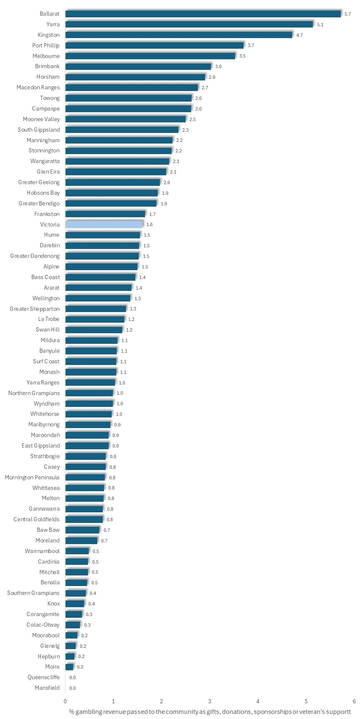
Per cent of losses/gambling revenue distributed by club gambling venues as Gifts, Donations, Sponsorships and Veteran's Support: Victorian municipalities, 2022/23

The chart at left illustrates the percentage of revenue from electronic gambling machines that was distributed to the wider community in 2022/3, as gifts, sponsorships, donations or veterans support, by clubs in each municipality.
Noting that the Community Benefits fund is intended to support each club venue’s ‘ wider local community’, the Public Accounts and Estimates Committee, in its 2023 report on gambling regulation in Victoria, recommended that the fund be audited to determine the actual level of funds which “…is being redirected into the community, as opposed to being spent on operational expenses and expenditure aimed at increasing clientele”, proposing that consideration be given to the establishment “a publicly-managed fund targeted towards reducing and preventing gambling harm.”

Selected Sections of the Gambling Regulation Act (2003), relevant to Approvals Submissions

1. Application for Approval of Premises
Application for approval of premises requires a planning permit be obtained, or applied for
3.3.4
(1) The owner of premises or a person authorized by the owner may apply to the Commission for the approval of the premises as suitable for gaming.
(3) The application must contain or be accompanied by—
(i) a copy of a permit issued under the Planning and Environment Act 1987 permitting the premises to be used for gaming on gaming machines; or
(iii) a copy of an application that has been made in accordance with the Planning and Environment Act 1987 for a permit that, if granted, would permit the premises to be used for gaming on gaming machines.

3.3.5 Notification of responsible authority
Within 14 days after applying, the applicant must send a copy of the application to the relevant responsible authority within the meaning of the Planning and Environment Act 1987.
(The ‘relevant responsibility is usually, though not invariably, the local council)

3.3.6 Responsible authority may make submission
(1) The relevant responsible authority may make a submission to the Commission on an application for approval of premises—
(a) addressing the economic and social impact of the proposal for approval on the wellbeing of the community of the municipal district in which the premises are located; and
(b) taking into account the impact of the proposal on surrounding municipal districts.
(2) A submission must be in the form approved by the Commission and must include the information specified in the form.
(3) A submission must be made within 60 days (or the longer period allowed by the Commission) after the responsible authority receives a copy of the application.

3.3.7 Matters to be considered in determining applications
(1) The Commission must not grant an application for approval of premises as suitable for gaming unless satisfied that—
(c) the net economic and social impact of approval will not be detrimental to the wellbeing of the community of the municipal district in which the premises are located.
(3) The Commission must also consider any submission made by the relevant responsible authority under section 3.3.6.

Responsible Authority may appeal decision on application for approval of premises, to VCAT
3.3.14 Tribunal review of approval
(1) An applicant for approval of premises may apply to the Tribunal for review of a decision of the Commission on the application.
(2) A responsible authority that made a submission under section 3.3.6 on an application for approval of premises may apply to the Tribunal for review of a decision of the Commission granting the approval.
(3) An application for review must be made within 28 days after the later of—
(a) the day on which the decision is made;
(b) if, under the Victorian Civil and Administrative Tribunal Act 1998, the applicant or responsible authority requests a statement of reasons for the decision, the day on which the statement of reasons is given to the applicant or responsible authority or the applicant or responsible authority is informed under section 46(5) of that Act that a statement of reasons will not be given.

2. Application to Vary Existing License Conditions (number of machines, 24 hour opening etc.)
Application for more machines, 24-hour gaming, or specification/variation of days & dates of 24-hour gambling, must include a social impact assessment
3.3.4
(4) If an application for approval of premises as suitable for gaming includes an application for approval of 24 hour gaming on the premises, the application must also be accompanied by a submission—
(a) on the net economic and social benefit that will accrue to the community of the municipal district in which the premises are located as a result of the premises being open for gaming for 24 hours; and
(b) taking into account the impact of the proposal for approval on surrounding municipal districts.

3.4.17
(1) The conditions of a venue operator's license, including—
(d) variation of the days or dates on which 24 hour gaming is permitted in an approved venue under the license - may be amended in accordance with this Division.
(2) A venue operator's license may be amended in accordance with this Division to add a condition specifying days or dates on which 24 hour gaming is permitted in an approved venue, when none currently takes place.

3.4.18
(1) A request by a venue operator for an amendment of license conditions—
(c) in the case of an amendment referred to in section 3.4.17(1)(d) or (2) or an amendment to increase the number of gaming machines permitted in an approved venue, must be accompanied by a submission—
(i) on the net economic and social benefit that will accrue to the community of the municipal district in which the approved venue is located as a result of the proposed amendment; and
(ii) taking into account the impact of the proposed amendment on surrounding municipal districts.

Local council must be notified of an application for more machines
(2) If an amendment proposed by a venue operator is to increase the number of gaming machines permitted in an approved venue, the venue operator must send to the municipal council of the municipal district in which the approved venue is located a copy of the proposed amendment within 14 days after the proposal is made.

Local council may make a submission to VCGLR on application for more machines
3.4.19 Submissions in response to proposed amendments
(1) Within 60 days (or the longer time allowed by the Commission) after receiving a copy of a request for an amendment referred to in section 3.4.18(2) a council may make a submission to the Commission—
(a) addressing the economic and social impact of the proposed amendment on the wellbeing of the community of the municipal district in which the approved venue is located; and
(b) taking into account the impact of the proposed amendment on surrounding municipal districts.

3. Caps on Gambling Machine Numbers
3.2.4 Regional limits on gaming machines
(1) The Minister may from time to time, by order published in the Government Gazette—
(a) determine regions in the State for the purposes of this Chapter; and
(b) in respect of each region, specify the criteria which the Commission must use to determine the maximum permissible number of gaming machines available for gaming in the region.
(2) Within 60 days after an order under subsection (1) is published in the Government Gazette, the Commission must, by instrument published in the Government Gazette, and in accordance with the specified criteria, determine the maximum permissible number of gaming machines available for gaming in a region determined and in force under sub-section (1)(a) but so that the total for the State does not exceed the State limit.
(7) Not later than 5 years after the publication of a determination under sub-section (2) and thereafter at intervals not exceeding 5 years, the
Commission must—
(a) review the regional limits; and
b) if a regional limit is no longer appropriate, determine, by instrument published in the Government Gazette, a new regional limit in accordance with the criteria specified under sub-section (1)(b) but so that the total for the State does not exceed the State limit.

BIBLIOGRAPHY
Aarsomen, D., Dias, S. and Butera, C. (2020). Transitioning in and out of Low and Moderate Gambling Risk Gambling: predictors and profiles. Victorian Responsible Gambling Foundation, Melbourne
Abbott, M., Hare, S., Jolley, D., Marshall, P., MacMillen, J., Villaneuva, E and Volberg, R. (2011) The Victorian Gambling Study: a longitudinal study of gambling and public health – wave two findings. Department of Justice, Melbourne.
Abbott, M. (2006). Do EGMs and problem gambling go together like a horse and carriage? Gambling Research, Vol. 18
ABS - Australian Bureau of Statistics. (2017). Households by whether Connected to the Internet: Victoria, 2016. Customized Tabulation, Census 2016. ABS, Canberra
AC Neilsen (2003). Evaluation of the Impact of the Three-hour Shutdown of Gaming Machines. Department of Gaming and Racing.
Alliance for Gambling Reform. (2021). Stand with us to End Gambling Ads. AGR, Melbourne. Accessed at: https://www.endgamblingads.org.au/
AllPsych Online (2009). The virtual psychology classroom. Accessed 23 February 2009 at: http://allpsych.com/disorders/dsm.html allpsych.com/disorders/impulse_control/gambling.html.
American Psychiatric Association (2008). Diagnostic and Statistical Manual of Mental Disorders Fourth Edition, Text Revision.
Anglican Diocese of Melbourne Social Responsibilities Committee (2008). Submission to the Senate Inquiry on the poker Machine Harm Reduction Tax. Inquiry into Poker Machine Harm Reduction Tax [Administration] Bill, Poker Machine Harm Minimization Bill and ATMs and Cash Facilities in Licensed Venues Bill. Commonwealth Government, Canberra.
Armstrong, A. and Carroll, M. (2017). Gambling Activity in Australia: Finding from wave 15 of the Household, Income and Labour Dynamics in Australia (HILDA) Survey. Australian Gambling Research Centre and Australian Institute of Family Studies, Melbourne
Armstrong, A. and Carroll, M. (2017). Sports Betting in Australia: a research summary. Australian Institute of Family Studies. Accessed at: https://aifs.gov.au/agrc/publications/sports-betting-australia
Arnott, C. (2011). Local Impacts of Electronic Gaming Machine Gambling in Moreland. The Social Research Centre, Melbourne.
Associated Press (2008). Norway Imposes strict gambling rules. Associated Press. Featured in Canadian Responsible Gambling Accessed 10 January 2009, at Accessed 10 January 2009, at www.responsiblegambling.org/staffsearch/library_news_results_details.cfm?inteID=11553.
Australian Broadcasting Commission (2008). Gambling Addictions a Root Cause of Homelessness: researcher. The World Today - Tuesday, 29 January, 2008 12:26:00. Accessed 13th February, 2009, at: www.abc.net.au/worldtoday/content/2008/s2148892.htm
Australian Bureau of Statistics (2000A). Household Expenditure Survey 1998-1999. ABS, Canberra.
Australian Bureau of Statistics (2000B). Australian Housing Survey, 1999. ABS, Canberra. Accessed 23 February, 2009 at:
Australian Bureau of Statistics (2007). Basic Community Profiles. ABS, Canberra.
Australian Bureau of Statistics (2008A). Household Expenditure Survey, Australia: Detailed Expenditure Items, 2003-04. Cat. No. 6535.0.55.001. Commonwealth Government, Canberra. Accessed 16 February, 2009 at: www.abs.gov.au/ausstats/abs@.nsf/mf/6535.0.55.001
Australian Bureau of Statistics (2008B). Regional Population Growth: 2006-2007, ABS, Cat. 3218.0 Accessed on January 12 at:
Australian Bureau of Statistics. (2017). Households by whether Connected to the Internet: Victoria, 2016. Customized Tabulation, Census 2016. ABS, Canberra
Australian Communications and Media authority. (undatedA). About the Interactive Gambling Act. Australian Government. Accessed at: https://www.acma.gov.au/about-interactive-gambling-act
Australian Communications and Media Authority. (undatedB). Rules for Gambling Ads. Accessed at: https://www.acma.gov.au/rules-gambling-ads
Australian Gambling Research Centre (2014). The impact of gambling problems on families - AGRC Discussion Paper No. 1 – November 2014
Australian Government. (undated). Interactive Gambling Amendment act 2017. Federal Register of Legislation. Accessed at: https://www.legislation.gov.au/Details/C2017A00085

Australian Institute of Family Studies (2014). The impact of gambling problems on families. AGRC Discussion Paper No. 1 – November 2014. Accessed at: https://aifs.gov.au/agrc/publications/impact-gambling-problems-families/what-are-impacts-gambling-problems-families on 12 June, 2018
Australian Medical Association (2013).Health Effects and Problem Gambling. AMA. Accessed at: https://ama.com.au/position-statement/health-effects-problem-gambling-2013
Australian Medical Association (2022). Submission to the House of Representatives Standing Committee on Social Policy and Legal Affairs.
Badji, S., Black, N. and Johnstone, D. (2020). Proximity to Gambling Venues, Gambling Behaviour and Related Harms. Victorian Responsible Gambling Foundation, Melbourne
Ballon, B. (2006). The case of the bleak blackjack bettor: Clinical depression and pathological gambling. Journal of Gambling Issues, Vol. 16, 2006. Accessed 19 December 2008 at: www.camh.net/egambling/issue16/issue16/jgi_16_ballon.html
Banks, G. (2007). Gambling in Australia: are we balancing the equation? Speech to the Australian Gaming Expo Conference. Accessed 2 January, 2009 at: www.pc.gov.au/speeches/cs20070819
Barratt, MJ, Livingston, M, Matthews, S & Clemens, S.L. (2014), ‘Gaming machine density is correlated with rates of help-seeking for problem gambling: a local area analysis in Victoria, Australia’, Journal of Gambling Issues, no. 29, pp. 1–21.
Bartley, H., Drake, H., Hetherington, B., and Maddern, C. (2017). Initial Implementation of Revised Victorian Responsible Service of Gaming Training: outcomes and lessons learned. Victorian Responsible Gambling Foundation and Office of Gambling and Liquor Regulation.

Bellringer, M. du Preez, K.P., Pearson, J., Garrett, N., Koziol- McLain, J., Wilson, D. and Abbott, M. (2017). Problem Gambling and Family Violence in Help-Seeking Populations: Co-occurrence, Impact and Coping. New Zealand Ministry of Health, 15 May 2017, accessed at: https://www.health.govt.nz/publication/problem-gambling-and-family-violence-help-seeking-populations-co-occurrence-impact-and-coping
Ben-Tovim, D..I., Esterman, A., Tolchard, B. and Battersby, M. (2001). The Victorian Gambling Screen. Victorian Casino and Gaming Authority, Melbourne.
Billi, R., Stone, C.A., Marden, P., Yeung, K. (2014). The Victorian Gambling Study: a longitudinal study of gambling and health in Victoria, 2008-2012. Victorian Responsible Gambling Foundation, Melbourne.
Black, D. (2013). Neuropsychological performance, impulsivity, symptoms of ADHD, and Cloninger's personality traits in pathological gambling. Addiction Research and Theory, Vol. 21, Issue 3, pp 216-226 Accessed at: https://www.tandfonline.com/doi/full/10.3109/16066359.2012.705399
Blashke, B. (2021). Tabcorp back to profit in FY2021 on lotteries, wagering increases. Inside Asian Gaming. 18 August, 2021. Accessed at: https://www.asgam.com/index.php/2021/08/18/tabcorp-back-to-profit-in-fy2021-on-lotteries-wagering-increases/
Bleidorn, W. (2015). Age and Gender Differences in Self-Esteem — A Cross-Cultural Window. Journal of Personality and Social Psychology. Dec 15, 2015. Accessed at: https://www.apa.org/news/press/releases/2016/01/self-esteem-gender
Breakeven Tasmania. (2008). The Break Even Program Addressing the Impacts of Poker Machines in Tasmania: Submission to the Senate Standing Committee on Community Affairs Inquiry into the Poker Machine Harm Reduction Tax (Administration) Bill 2008, the Poker Machine Harm Minimization Bill 2008 and the ATMS and Cash Facilities in Licensed Venues Bill November 2008. Accessed 20 February 2009 at: www.aph.gov.au/SENATE/COMMITTEE/CLAC_CTTE/poker_machine_harm_reduct/index.htm
Brown, H. (2018) Estimate of Breakdown of Gamblers in Venues at a point in time, by gender, age and gambling risk: 2014, Victoria. City of Greater Dandenong, Melbourne (Unpublished)
Browne, M, Greer, N, Armstrong, T, Doran, C, Kinchin, I, Langham, E & Rockloff, M (2017). The social cost of gambling to Victoria, Victorian Responsible Gambling Foundation, Melbourne.
Browne, M., Langham, E., Rawat, V., Greer, N., Li, E., Rose, J. and Best, T. (2016). Assessing gambling- related harm in Victoria: a public health perspective. Victoria Responsible Gambling Foundation, Melbourne
Caraniche (2005). Evaluation of Electronic Gaming Machine Harm Minimization Measures in Victoria, Final Report.
Castren, S., Basnet, S., Salahon, A., Pankakoiski, M. Rankainen, J., Alho, H. and Lati, T. (2013). Factors Associated with Disordered Gambling in Finland. Substance Abuse, Treatment and Policy. Vol. 18, no. 1, pp. 1-10
Centre for Criminology and Criminal Justice (2000). The Impact of Gambling and Crime Statistics. Victorian Casino and Gambling Authority, Melbourne
Centre for International Economics (2008). Gambling with Policy: the economic impacts of removing gaming machines from pubs and clubs. Centre for International Economics, Canberra.
Clark, C., Nower, L. and Walker, D.M. (2013). The relationship of ADHD symptoms to gambling behaviour in the USA: results from the National Longitudinal Study of Adolescent Health. International Gambling Studies, Vol 13, No. 1, ppp. 35-51
Co-As-It (undated). Risk Factors for Problem Gambling after COVID-19. Accessed at: https://www.coasit.org.au/risk-factors-for-problem-gambling-after-covid-19/
Commonwealth of Australia (2008). Submissions to the Senate Standing Committee on Community Affairs Inquiry into the Poker Machine Harm Reduction Tax (Administration) Bill 2008, the Poker Machine Harm Minimization Bill 2008 and the ATMS and Cash Facilities in Licensed Venues Bill November 2008. Commonwealth Government, Canberra.
Commonwealth of Australia (Department of Social Services) (2015). Review of Illegal Offshore Wagering
Cooke, A. (1999). Gender Differences and Self-esteem. Journal of Gender Specific Medicine. Vol. 2, No. 3, pp. 46-52 Accessed at: https://www.sciencedirect.com/science/article/pii/S1877042812017168
Costello, T. (2008). Rudd’s Crack at State Pokie Habit. Herald Sun, 1 April 1998. Accessed 18 January at: www.acl.org.au/national/browse.stw?article_id=20522

Crane, C. (2015). Problem gambling often linked with family violence, expert warns. Geelong Advertiser
Crofts, P. (2002). Gambling and Criminal Behaviour: An Analysis of Local and District Court Files. Casino Community Benefit Fund, Sydney
Cross, C.P., Cyrenne, D. and Brown, G.R. (2013). Sex differences in sensation-seeking: a meta-analysis. Science Reports. Vol. 3, pp. 2486. Accessed at: https://www.ncbi.nlm.nih.gov/pmc/articles/PMC3757272/
Cullerton, R.P. (1989). The Prevalence Rates of Pathological Gambling: A Look at Methods. Journal of Gambling Behavior, Vol. 5 (1), Spring, pp. 22-41, 1989.
Deaner, R., Balish, S. and Lombardo, M.P. (2016). Sex Differences in Sports Interest and Motivation: An Evolutionary Perspective. Evolutionary Behavioural Sciences. Vol. 10, No. 2, pp73-97
Deans, E. G. (2017). The role of peer influences on the normalisation of sports wagering: a qualitative study of Australian men. Deans, E., Thomas, S., Daube, M. and Derevensky, Journal of Addiction Research and Theory, Vol. 25, Issue 2, pp. 103-113 Accessed at: https://www.tandfonline.com/doi/full/10.1080/16066359.2016.1205042
Deans, E., Thomas, S., Derevensky, J. and Daube, M. (2017). The influence of marketing on the sports betting attitudes and consumption behaviors of young men: implications for harm reduction and prevention strategies. Harm Reduction Journal. Vol. 14, No. 5. Accessed at: https://harmreductionjournal.biomedcentral.com/articles/10.1186/s12954-017-0131-8
Delfabbro, P. (2011). Australasian Gambling Review. Independent gambling Authority, Adelaide
Delfabbro, P., Lambos, C., King, D. and Puglies, S. (2009). Knowledge and Beliefs about Gambling in Australian Secondary School Students and their Implications for Education Strategies. Journal of Gambling Studies, Vol. 25, No. 4, pp. 523-539
Delfabbro, P., Osborn, A., Nevile, M., Skelt, L. and McMillen, J (2007). Identifying Problem gambling in Gaming Venues. Gambling Research Australia, Nov. 2007, p. 16-20?
Delfabbro, P., Winefield, A.H. and Anderson, S. (2009). ‘Once a gambler – always a gambler? A longitudinal analysis of gambling patterns in young people making the transition from adolescence to adulthood’. International Gambling Studies. Vol. 9, No. 2, pp. 151–63.
Department of Justice (2006). New Regional Caps on Electronic Gambling Machines. Victorian Government, Melbourne.
Department of Justice (2006A). Taking Action on Problem Gambling. Government of Victoria, Melbourne
Department of Justice (2006B). Taking Action on Problem Gambling: Regional Caps. Government of Victoria, Melbourne.
Department of Justice (2008). Destination Gambling: evaluating the benefits for Victoria. Victorian Government, Melbourne.
Department of Justice (2008). Destination Gambling: evaluating the benefits for Victoria. Dept. Justice, Melbourne
Department of Justice (2009). Gaming Machine Arrangements 2012. Victorian Government, Melbourne.
Department of Justice (2009B). Problem Gambling from a Public Health Perspective. Victorian Government, Melbourne.
Department of Justice (2011). The Victorian Gambling Study: a longitudinal study of gambling and public health, Wave Two. Victorian Government, Melbourne.
Department of Justice (2011). Victorian Gambling Survey – Wave Two. Victorian Government, Melbourne. Accessed 21 July, 2011 at:
Department of Planning and Community Development (2008). Annual Report 2007/8. DPCD, Melbourne
Department of Sustainability and Environment (2006). Changes to the Gaming Provisions in Planning Schemes: advisory note. Dept Sustainability and Environment, Melbourne.
Dept. Broadband, Communications and the Digital Economy. (2012). Review of the Interactive Gaming Act 2001: Final Report. Australian Government. Accessed at: https://apo.org.au/sites/default/files/resource-files/2012-09/apo-nid311553.pdf
Delfabbrio P., King, D.L., Browne, M. and Dowling, N.A. (2020). Do EGMs have a Stronger Association with Problem Gambling than Racing and Casino Table Games? Evidence from a Decade of Australian Prevalence Studies. J Gambl Studies, 2020 Jun;36(2):499-511
Dickins, M. and Thomas A (2012). Gambling in culturally and linguistically diverse communities in Australia. Australian Gambling Research Centre. Institute of Family Studies.
Doughney, J. and Kelleher, T. (1999). Preliminary Local Area Gambling Research: Economic Effects. Victoria University, Melbourne.
Doughney, James. (2007). Lies, Damned Lies and Problem Gambling Prevalence Rates: the Example of Victoria, Australia. Victoria University, Melbourne.

Dowling N. (2014). Impact of Gambling Problems on Families. Australian Gambling Research Centre.
Dowling N., cited in J. Dowling (2014). ‘The Problem with Gambling’, The Age, November 16. Accessed at: http://www.theage.com.au/victoria/the-problem-with-gambling-20141125-11tqhc.html
Dowling, N. A., Carrie, E., Yousef, G. J., Merkouris, S. S., Suomi, E., Thomas, S. A, and Jackson, A., (2006). Problem Gambling and Family Violence: Findings from a population-representative study. Journal of Behavioural Addictions, Vol. 7, Issue 3, pp.
Dowling, N., Smith, D. and Thomas, T. (2004). Electronic gaming machines: are they the ‘crack-cocaine’ of gambling? Addiction. 10 December 2004

Dowling, N., Suomi, A. and Ewin, C (undated) Problem Gambling and Family violence: findings from a population representative community study.
Dowling, N.A., Jackson, A.C., Thomas, S.A. and Frydenberg, E. (2010). Children at risk of developing problem gambling. Gambling Research Australia, Melbourne.
Dundie, N., Matters, J., Hillman, K., Munty, M., Ozlinn, C., and Millwood, P. (2011). Gambling and Young People in Australia. Australian Council for Educational Research.
Eadington, W.R. (1989). Problem Gambling and Public Policy: Alternative in Dealing with Problem Gamblers and Commercial Gambling. In, H.J. Shaffer, S.A. Stein, B. Gambino, T.N. Cummings and R.L. Custer (eds.), Compulsive Gambling: Theory, Research and Practice. Lexington Books, Lexington.
Ethnic Communities Council of Victoria (2017). EECV paper on gambling harm prevention in culturally diverse communities. EECV, Melbourne.
Feldman.S., Radermacher, H., Andersion, C., and Dickins, M. (2014). A qualitative investigation of the experiences attitudes and beliefs about gambling in the Chinese and Tamil Communities in Victoria. Responsible Gambling Foundation, Melbourne.
Ferland, F., Fournier, P., Laouceur, R., Brochu, P., Bouchard, M. and Paquet, L. (2008). Consequences of Pathological Gambling on the Gambler and His Spouse. Journal of Gambling Issues, Vol. 22, Dec. 2008 Accessed 2 January, 2009 at: www.camh.net/egambling/issue22/04ferland-fournier.html
Focus Gaming News (2022). Norwegian gambling regulator proposes mandatory break for high-risk games, 6 August 2022
Freund, M., Noble, N., Hill, D, White, V., Evans, T., Oldmeadow, C. & Sanson-Fisher, L. (2019). The prevalence and correlates of gambling in secondary school students in Victoria, Australia, 2017, Victorian Responsible Gambling Foundation, Melbourne.
Gainsbury, S. M., King, D., Delfabbro, P., Hing, N., Russell, A., Blasczczynski, A., and Derevenskly, J. (2015). The Use of Social Media in Gambling. Gambling Research Australia. Melbourne
Gainsbury, S., King, D., Arabanel, B., Delfabrio, P. and Hing, N. (2015B). Consequences of Gamblers and Gambling in Digital Media. Victorian Responsible Gambling Foundation, Melbourne.
Gainsbury, S., Russell, A. Hing, N., Wood, R., Lubman, D. and Blaszczynski, A. (2013). How the Internet is Changing gambling: finding from an Australian Prevalence Survey. Journal of Gambling Studies, Vol 31, pp. 1-15.
Gainsbury, S., Russell, A., Hing, N., Wood, R., & Blaszczynski, A. (2013). The impact of Internet gambling on gambling problems: A comparison of moderate-risk and problem Internet and non-Internet gamblers. Psychology of Addictive Behaviors, 27(4),1092-1101.
Gainsbury, S.M. (2015). Online Gambling Addiction: the relationship between internet gambling and disordered gambling. Curr Addict Rep. Vol. 2, No. 2, pp. 185-1933
Gainsbury, S.M., Russell, A., Blaszczynski, A. and Hing, N. (2015). Greater involvement and diversity of Internet gambling as a risk factor for problem gambling. European Journal of Public Health, Vol. 25, No. 4, August 2015, pp. 723–728. Accessed at: https://academic.oup.com/eurpub/article/25/4/723/2399188
Gambling Regulation Act, 2003 [Version no. 005] Victorian Government, Melbourne.
Gerstein, D., Hoffmann, J., Larison, C., Engelman, L., Murphy, S., Palmer, A., Chuchro, L., Toce, M., Johnson, R., Buie, T. and Hill, M. (1999). Gambling Impact and Behavior Study. Christiansen/Cummings Associates, New York.
Gilding, M. and Le, R. (2016). Gambling and Drugs: the role of gambling among Vietnamese women incarcerated for drug crimes. Australian and New Zealand Journal of Criminology, Vol. 49 (1)
Giovanni M, Fabiola S, Mariangela C, Nicola P, Ilaria T, Gianluca S, Maurizio P and Giannantonio Massimo D, ‘Gambling Disorder and Suicide: An Overview of the Associated Co-Morbidity and Clinical Characteristics’, International Journal of High Risk Behaviour and Addiction,6(3), 2017, 6.
Granwal, L. (2020). Smartphone Penetration as Share of Population Australia 2017-2025. Statista Accessed at https://www.statista.com/statistics/467753/forecast-of-smartphone-users-in-australia/
Greenstock, L. (undated). Reducing Gambling requency with Culturally and Linguistically Diverse Communities. HealthWest, Melbourne.
Griffiths MD, Parke J. The social impact of internet gambling. Soc Sci Comput Rev. 2002;20(3):312–20.
Guillou-Landreat, M., Gallopel-Morvan, K., Lever, D. and Le Goff, D. and Le Reste, J. (2021). Gambling Marketing Strategies and the Internet: What Do We Know? A Systematic Review.
Hakansson, A. (2020). Impact of COVID-19 on Online Gambling – A General Population Survey During the Pandemic. Frontiers of Psychology. Vol. 25, Sept 2020. Accessed at: https://www.frontiersin.org/articles/10.3389/fpsyg.2020.568543/full
Halliburton, E. and O’Loughlin, L. (2015). Clayton CANVAS Summary Report: 1 July 2014-30 June 2015. Monash University and Victorian Responsible Gambling Foundation, Melbourne
Hancock, L. (2008). Testimony before the Senate Standing Committee on Community Affairs. Reference: Poker Machine Harm Reduction Tax [Administration] Bill, Poker Machine Harm Minimization Bill and ATMs and Cash Facilities in Licensed Venues Bill. Hansard. 11 September 2008:. Commonwealth Government, Canberra.
Hare (2009). Problem Gambling from a Public Health Perspective: a study of gambling in Victoria. Department of Justice, Melbourne
Hare, S. (2015). Study of Gambling and Health in Victoria, Australia. Victorian Responsible Gambling Foundation and Victorian Department of Justice and Regulation.
Harrigan, K. (2007). Slot machine structural characteristics: Distorted player views of payback percentages. Journal of Gambling Issues, Vol. 20, 2007. Accessed 25 November, 2008 at: www.camh.net/egambling/issue20/06harrigan.htm Accessed at 25 November, 2008
Harris, A. and Griffiths, M. (2017) A Critical Review of the Harm-Minimisation Tools Available for Electronic Gambling. Journal of Gambling Studies. March 2017, Volume 33 (1), pp 187–221 Accessed at: Hing, N., Russell, A. and Hronis, A. (2016). Behaviourhttps://link.springer.com/article/10.1007/s10899-016-9624-8 on 1/6/2017
Healthy Wealthy and Wise Women (Undated). Who Picks up the Tab? Issues and Dilemmas for services providing mainstream support to women affected by gambling in Melbourne: Western Metropolitan Region. Women’s Health in the South-east, Melbourne.
Hing N, Russell AMT, Gainsbury SM, Blaszczynski A. Characteristics and help-seeking behaviors of internet gamblers based on most problematic mode of gambling. J Med Internet Res. 2015;17(1):E13. doi:10.2196/jmir.3781.
Hing, N. and Haw, J. (2010). The Influence of Venue Characteristics on a Player’s Decision to Attend a Gambling Venue. Gambling Research Australia
Hing, N., O’Mullan, C., Nuske, E., Breen, H., Mainey, L., Taylor, A., and Rawat, V. (2020). The relationship between gambling and intimate partner violence against women (Research report, 21/2020). ANROWS, Sydney
Hing, N., Russel, A., Tolchard, B. and Nower, L. (2014). Comparative study of men and women gamblers in Victoria. Victorian Responsible Gambling Foundation, Melbourne. Accessed at: https://responsiblegambling.vic.gov.au/about-us/news-and-media/gender-gap-highlighted-new-gambling-study/
Hing, N., Russell, A. and Browne, M. (2017). Risk Factors for Gambling Problems on Online Electronic Gaming Machines, Race Betting and Sports Betting. Frontiers of Psychology. 15 May, 2017. Accessed at: https://www.frontiersin.org/articles/10.3389/fpsyg.2017.00779/full
Hing, N., Russell, A. and Hronis, A. (2016). Behavioural Indicators of Responsible Gambling Consumption. Victorian Responsible Gambling Foundation, Melbourne.
Horne, M. (2021). Online Public Presentation by M. Horne, Minister for Gambling at the Local Government Working Group on Gambling and Gaming. 17 November 2021. Victorian Local Governance Association
House of Representatives Standing Committee on Social Policy and Legal Affairs (2023). You Win Some, You Lose More: online gambling and its impacts on those experiencing gambling harm. Parliament of Australia, Canberra
Howe, P., Vargo-Soenz, A., Hulibertt, C. and Boldero, J. (2018). Gambling and Problem Gambling in Victoria. Victorian Responsible Gambling Foundation, Melbourne
Hunt, C. and Gonsalkorale, K. (2018). Conformity to masculine norms among treatment-seeking male problem gamblers. International Gambling Studies, DOI: 10.1080/14459795.2018.1429482
Ioannidis K., Hook R., Wickham K., Grant J.E. and Chamberlain S.R. (2019). Impulsivity in Gambling Disorder and problem gambling: a meta-analysis. Neuropsychopharmacology. 2019 Jul. Vol. 44, No. 8, pp. 1354-1361.
Jackson, K. (2001). Gambling Policy and Regulation. E-Brief: Online Only issued March 2001; updated September 2001. Parliament of Australia.
Jenkinson, R., Sakata, K., Khakhar, T., Tanjin, R. and Jatkar, U. (2020). Gambling in Australia during Covid. Australian Gambling Research Centre. Accessed at: https://aifs.gov.au/agrc/publications/gambling-australia-during-covid-19
Jonsson, J. (2007). An overview of prevalence surveys of problem and pathological gambling in the Nordic countries. Journal of Gambling Issues, Vol. 18, 2006. Accessed 24 November 2008 at Internet: www.camh.net/egambling/issue18/jonsson.html.
Karlsson A and Hakansson A, ‘Gambling disorder, increased mortality, suicidality and associated comorbidity: A longitudinal nationwide register study’, Journal of Behavioural Addictions, 2018.
Kim, H., Wohl, M., Gupta, R. and Derevensky, J. (2017). Why do young adults gamble online? A qualitative study of motivations to transition from social casino games to online gambling. Asian Journal of Gambling Issues and Public Health. Vol. 7, No. 6. Accessed at: https://ajgiph.springeropen.com/articles/10.1186/s40405-017-0025-4
Kim, H., Wohl, M., Gupta, R. and Derevensky, J. (2017). Why do young adults gamble online? A qualitative study of motivations to transition from social casino games to online gambling. Asian Journal of Gambling Issues and Public Health. Vol. 7, No. 6. Accessed at: https://ajgiph.springeropen.com/articles/10.1186/s40405-017-0025-4
Kirby, P. (2006). Gaming Machine License Arrangements Post-2012: Report by Peter Kirby on Public Consultations and Submissions. Office of Gaming and Racing, Victoria.
Koivola, A., Koiranen, I., Rasanen, P. and Keipi, T. (2020). Online Gambling Activity in Finland 2006–2016. In ‘Social Computing and Social Media. Participation, User Experience, Consumer Experience, and Applications of Social Computing’. 12th International Conference, SCSM 2020
Ladoucier, R., Shaffer, P., Blaszczynscki, A. and Shaffer, H. (2017). Responsible gambling: a synthesis of the empirical evidence. Addiction Research and Theory, Vol 25, Issue 3, 2017, pp. 225-235
Lin, E., Casswell, S. and You, R.Q. (2008). Assessment of the Social Impacts of Gambling in New Zealand. Centre for Social and Health Outcomes Research and Evaluation, Auckland.
Lindsay, S., Thomas, S., Lewis, S., Westberg, K., Moodie, R. and Jones, S. (2013). Eat, Drink and Gamble’: marketing messages about “risky” products in an Australian major sporting series. BMC Public Health, Vol. 13, No. 1, pp. 1-11
Liquor and Gambling NSW (2020). Biggest ever penalty for club linked to problem gambler’s death. 17 July 2020. Accessed at: https://www.liquorandgaming.nsw.gov.au/news-and-media/biggest-ever-penalty-for-club-linked-to-problem-gamblers-death
Livingston, C. (2008). Testimony before the Senate Standing Committee on Community Affairs. Reference: Poker Machine Harm Reduction Tax [Administration] Bill, Poker Machine Harm Minimization Bill and ATMs and Cash Facilities in Licensed Venues Bill. Hansard. 11 September 2008:. Commonwealth Government, Canberra.

Livingston, C. (2016). Areas with more poker machines have higher rates of domestic violence, study finds. The Conversation. Accessed at: http://www.abc.net.au/news/2016-10-21/poker-machines-and-high-rates-of-domestic-violence/7949798 on 12 June, 2018

Livingston, C., Rintoul, A. and Francis, L. (2014). What is the evidence for harm minimisation measures in gambling venues? Victorian Responsible Gambling Foundation, Melbourne. Accessed at: https://www.responsiblegambling.vic.gov.au/information-and-resources/research/giro-research-updates/december-2014/what-is-the-evidence-for-harm-minimisation-measures-in-gambling-venues on 25/4/2017
Livingston, C., Rintoul, A., de Lacy Vardon, C., Borland, R., Dietz, P., Jenkinson, R., Livingston, M., Reem, R., Smith, B., Stocve, M., Winter, R. and Hillk, P. (2019). Identifying Effective Policy Interventions to Prevent Gambling-related Harm. Victorian Responsible Gambling Foundation, Melbourne
Livingstone, C. and Fancis, L. (2015a). What is the Evidence to Support Reduction of Maximum Bets on Electronic Gambling Machines? Monash University, Melbourne.
Livingstone, C. and Fancis, L. (2015b). Discussion of the Likely Effects of Further Local Caps on EGM Numbers of Gambling Harm and the Prevalence of Problem Gambling. Monash University, Melbourne.
Livingstone, C., Kirseina, C. and Rintoul. A. (2012). Assessment of Poker Machine Expenditure and Community Benefit Claims in Selected Commonwealth Electoral Divisions. Monash University, Melbourne
Livingstone, C., Wooley, R. and Borrell, J. (2006). The Changing Electronic Gambling Machine (EGM) Industry and Technology. Australian Institute of Primary Care, Melbourne.
Lloyd, C., Joyce. R., Hurry, J. and Ashton, M. (2000). The Effectiveness of Primary School Drug Education. Drugs: Education, Prevention and Policy. Vol. 7, Issue 2.
Lubman D, Manning V, Dowling N, Rodda S, Lee S, Garde E, Merkouris S, and Volberg R, ‘Problem gambling in people seeking treatment for mental illness’, Victorian Responsible Gambling Foundation, July 2017, 2
Macklin, J. (2009) Ministerial Council on Gambling – Communiqué Brisbane 10/7/2009 (Press Release) Accessed: 24 August, 2009 at:
MacLean, C., Asnaani, A., Litz, B. and Hoffman, S. (2011). Gender Differences in Anxiety Disorders: Prevalence, Course of Illness, Comorbidity and Burden of Illness. Journal of Psychiatric Research, Vol. 48, No. 8, pp. 1027-1035
Macniven, R., Kelly, B. and King L. (2011). Unhealthy product sponsorship of Australian national and state sports organisations. Health Promot J Aust.
Markham, F. Doran, B. and Young, M. (2016). The Relationship between electronic gaming machine accessibility and police-recorded domestic violence: a spatio-temporal analysis of 654 postcodes in Victoria.. Australia, 2005-2014. Soc Sci Med. Aug 162:106-14. (Markham et al, 2016)
Markham, F., Young,. And Doran, B. (2014). Gambling Expenditure Predicts Harm: evidence from a venue-level study. Addiction, Vol. 199, pp. 1509-1516
Mason, K. (2008). Raising the Odds? Gambling behavior and neighborhood access to gambling venues in New Zealand. New Zealand Ministry of Health, Auckland. Accessed 4th December, 2008 at: http://www.moh.govt.nz/moh.nsf/pagesmh/7783/$File/raising-the-odds-may08.pdf
Mayhew, D.R. and Simpson, H.M. (2019). The Safety Value of Driver Education and Training. Injury Prevention. Vol. 8, No. 2
Mayo Clinic (undated). Depression in Women: understanding the gender gap. Mayo Clinic. Accessed at: https://www.mayoclinic.org/diseases-conditions/depression/in-depth/depression/art-20047725
McCormack A, Shorter GW, Griffiths MD. Characteristics and predictors of problem gambling on the Internet. Int J Ment Health Addict. 2013;11(6):634–57.
McCready, J., Mann, R., Zhao, J. and Eves, R. (2008). Correlates of Gambling-related problems among older adults in Ontario. Journal of Gambling Issues, Vol. 22, Dec. 2008 Accessed: 2 January, 2009 at: www.camh.net/egambling/issue22/02mccready-mann.htmll
McMillen, J. (2008). Letter to the Australian Senate Community Affairs Committee on the Poker Machine Harm Reduction Tax (Administration) Bill 2008. Inquiry into Poker Machine Harm Reduction Tax [Administration] Bill, Poker Machine Harm Minimization Bill and ATMs and Cash Facilities in Licensed Venues Bill. Commonwealth Government, Canberra.
McMillen, J. and Doman, J. (2004). Problem gambling and Gambling Machine Density: a socio-spatial analysis of three Victorian Localities. International Gambling Studies Vol. 66 No. 1 pp. 5-29.
McMillen, J. and Marshall, D. (2003). Victorian Longitudinal Community Attitudes Survey. Centre for Gambling Research. Canberra
McMillen, J. and Wenzel, M. (2006). Measuring Problem Gambling: Assessment of Three Prevalence Screens. International Journal of Gambling Studies, Vol. 6, No. 2 pp. 147-174
Mestre-Bach, G., Steward, T. and Granero, R. (2020). Dimensions of Impulsivity in Gambling Disorder. Science Reports. Vol. 10, No. 397 (2020).
Miller, H. (2015). Risk Factors for Problem Gambling: environment, geographic, social, cultural, demographic, socio-economic, family and household. Responsible Gambling Foundation, Melbourne

Miller, H. (2016). Responsible Gambling: past, present and future. Victorian Responsible Gambling Foundation, Melbourne
Miller, H. (2017). Gen Bet: Has Gambling Gatecrashed our Teens? Victorian Responsible Gambling Foundation, Melbourne.
Miller, H. (2017). Hidden Harm: low-risk and moderate-risk gambling. Responsible Gambling Foundation, Melbourne.
Milner, L., Hing, N., Vitartas, P. & Lamont, M. (2013). Embedded gambling promotion in Australian football broadcasts: an exploratory study. Communication, Politics & Culture, 46 (2), 177 -198.
Moodie, C. (2007). An exploratory investigation into the erroneous cognitions of pathological and social fruit machine gamblers. Journal of Gambling Issues, Vol. 19, 2007. Accessed 25 November 2008 at: www.camh.net/egambling/issue19/pdfs/moodie.pdf.
Moody, G. (1995). The Roots, Significance, Value and Legislation of Gambling. Journal of Gambling Studies, Vol. 11 (1), Spring, pp. 35-59, 1995.
Muellemann, R.L., DenOtter, T., Wadman, M.C., Trant, T. P, and Anderson, J. (2002). Problem Gambling in the Partner of the Emerfgency Department Patient as a Risk Factor for Intimate Partner Violence. The Journal of Emergency Medicine Vol. 23, Vol. 2 pp. 307-312
National Institute of Economic and Industry Research (2000). The Economic Impact of Gambling. NIEIR, Melbourne.
Navas, J., Billieux, J., Perandrés-Gómez, A., López-Torrecillas, F., Cándido , A., and Perales, J. (2017). Impulsivity traits and gambling cognitions associated with gambling preferences and clinical status. Addiction Research and Theory, Vol. 17, Issue 1, pp 102-124
Neilsen (2003). Evaluation of the Impact of the Three-hour Shutdown of Gaming Machines. Department of Gaming and Racing.

New Zealand Ministry of Health (2012). Problem Gambling in New Zealand: Preliminary Results from the New Zealand Health Survey. New Zealand Ministry of Health, Aukland
Nightingale, T. (2013). Melbourne University researchers shocked by level of violence inflicted on relatives of gamblers. ABC News. Accessed on 30/9/2013 at: http://www.abc.net.au/news/2013-09-05/relatives-of-gamblers-suffering-violence/4938030
NSW Responsible Gambling (undated). Gambling on overseas websites.
Nyemcsok, C., Pitt, H., Kremer, P. and Thomas, S.L. (2022). Young men’s perceptions about the risks associated with sports betting: a critical qualitative inquiry. BMC. Vol. 22
O’Sullivan, P. (2009). Address to Victorian Commission For Gambling Regulation Responsible Gambling Industry Information Session. Melbourne Park, Melbourne, 28 May, 2009
Office for Problem Gambling (2013). Gambling Prevalence in South Australia, Adelaide
Office of Gaming and Racing (2005). Regional Electronic Gaming Machine Caps Review Panel: consultation paper. Department of Justice, Melbourne.
Office of the Premier (2006). Record Funding for Problem Gambling as Government Announces New Gaming Machine Limits. Press release 12 October, 2006. Victorian Government, Melbourne
Ohtsuka, K and Ohtsuka, T. (2010). Vietnamese Australians Gamblers View on Luck and Winning. Asian Journal of Gambling Issues and Public Health 1(1) pp. 34-36
Palmer, C. (undated). Sports betting research: literature review. University of Tasmania. Accessed at: https://www.communities.tas.gov.au/__data/assets/pdf_file/0025/43945/Sports_Betting_Literature_Review.pdf
Parke, A. and Parke, J. (2019). Transformation of Sports Betting into a Rapid and Continuous Gambling Activity: a Grounded Theoretical Investigation of Problem Sports Betting in Online Settings. International Journal of Mental Health and Addiction. Vol. 17, pp. 1340–1359
Petry, N. M., Stinson, F. S. and Grant, B. F. (2005). Co-morbidity of DSM-IV Pathological Gambling and other Psychiatric Disorders: Results from the National Epidemiological Survey on Alcohol and Related Conditions. Journal of Clinical Psychiatry. Vol. 66, pp. 564-574.
Pinkerton, S. (2005). Letter to the editor. September 29, 2005 Journal of Gambling Issues, Vol. 16, 2006. Accessed 25 November, 2008 at: www.camh.net/egambling/issue16/issue16/jgi_16_pinkerton.html
Pitt, H., Thomas, S., Bestman, A., Daube, M. and Derevensky, J. (2017). Factors that influence children’s gambling attitudes and consumption intentions: lessons for gambling harm prevention research, policies and advocacy strategies. Harm Reduction Journal, Vol. 14, No. 11.
Pitt, H., Thomas, S., Watson, J. and Balondin, S. (2020). People with Intellectual Disability and their Lived Experience of Gambling. Victorian Responsible Gambling Foundation, Melbourne
Pitt, H., Thomas, S.L., Randle, M., Cowlishaw, S., Arnot, G., Kairouz, S. and Daube, M. (2022). Young People in Australia discuss Strategies for Preventing the Normalization of Gambling and Reducing Gambling Harm. BMC Public Health. Vol. 22, No. 956
Public Accounts and Estimates Committee (2023). Gambling and liquor regulation in Victoria: a follow up of three Auditor-General reports. Parliament of Victoria, Melbourne
Productivity Commission (1999). Australia’s Gambling Industries. Commonwealth Government, Canberra.
Productivity Commission (2010). Gambling 2010: inquiry report. Commonwealth Government, Canberra
Purdie, N., Matters, G., Hillman, K., Murphy, M., Ozolins, C. and Millwood, P. (2011). Gambling and young people in Australia. Gambling Research Australia, Melbourne
Queensland Government (2012). Queensland Household Gambling Survey 2011-12.
Queensland Government Statisticians Office (2020), Australian Gambling Statistics, 1990–91 to 2017–18 , 33rd edition. Accessed at: www.qgso.qld.gov.au/products/reports/aus-gambling-stats/
Queensland Government Statistician's Office. (2021). Australian gambling statistics, 36th edition. Queensland Treasury. Accessed at: http://www.qgso.qld.gov.au/products/reports/aus-gambling-stats/
Quirk, J. (2021). Why more young men have gambling Problems. Askmen
Ramani, S. and Lavasani, M. (2012). Gender Differences in Five Factor Model of Personality and Sensation Seeking. Procedia - Social and Behavioral Sciences. Vol. 46, 2012, pp. 2906-2911
Rasker, R. (2021). How to tell if you're addicted to sports bet apps. ABC Everyday. 20 Sept., 2021. Accessed at: https://www.abc.net.au/everyday/signs-of-sports-bet-app-addiction/100466558
Remo, L., Remond, J.J. and Coefec, A. (2015). Gambling and ADHD in a Population of French Students. Journal of Gambling Issues. Vol. 31, pp. 1261-1272.
Report to the Ministers for Social Services and the Minister for Communication and the Arts by Lead Reviewer, the Hon. Barry O’Farrell. Canberra.
Responsible Gambling Foundation (2015). Using a Public Health Approach in the Prevention of Gambling-related harm. Responsible Gambling Foundation 2015, Melbourne
Responsible Gambling Foundation (2016). Study of Gambling and Health in Victoria 2016. Responsible Gambling Foundation, Melbourne. Accessed at http://www.responsiblegambling.vic.gov.au/information-and-resources/research/foundation-research-program/research-programs-and-activities/study-of-gambling-and-health-in-victoria on 23/2/2017
Reynolds, G. W. (2008). Testimony before the Senate Standing Committee on Community Affairs. Reference: Poker Machine Harm Reduction Tax [Administration] Bill, Poker Machine Harm Minimization Bill and ATMs and Cash Facilities in Licensed Venues Bill. Hansard. 11 September 2008:. Commonwealth Government, Canberra.
Rintoul, A. (2019). Modernising harm prevention for gambling in Australia: International lessons for public health policy and improved regulation of gambling, Winston Churchill Memorial Trust of Australia, 2019
Rintoul, A. and Deblaquiere, J. (2019). Gambling in Suburban Australia. Institute of Family Studies, Melbourne.

Rintoul, A. C., Linvinstone, C., Mellor, A. P. and Jolley, D. (2012). Modelling Vulnerability to Gambling-related Harm: how disadvantage predicts gambling losses. Addiction Research and Theory, Early Online. pp. 1-10
Rintoul, A., Deblaquiere, J. and Thomas, A. (2017a). Responsible Gambling Codes of Conduct: lack of harm minimization in the context of venue self-regulation. Addiction Research and Theory, Volume 25, 2017 - Issue 6. Accessed at: www.tandfonline.com/doi/full/10.1080/16066359.2017.1314465, on 27 May, 2019
Rintoul, A., Livingstone, C., Mellor, A. and Jolley, D. (2017b). Modelling vulnerability to gambling related harm: How disadvantage predicts gambling losses. Addiction Research and Theory, Vol 21, Issue 4, pp. 329-338 Accessed at: https://www.tandfonline.com/doi/full/10.3109/16066359.2012.727507
Rockloff, M, Browne, M, Hing, N, Thorne, H, Russell, A, Greer, N, Tran, K, Brook, K. and Sproston, K. (2020). Victorian Population Gambling and Health Study 2018–2019. Victorian Responsible Gambling Foundation, Melbourne.
Rockloff, M. (2010). The impact of an audience and venue size on poker machine gambling. Office of Gaming and Racing, Victorial Government Dept. of Justice, Melbourne.
Rockloff, M., Thorne, H., Goodwin, B., Moskovsky, N. Lagnham, E., Browne, M., Donaldson, P, Li, E. and Rose, J. (2015). EGM Environments that contribute to excess consumption and harm. Victorian Responsible Gambling Foundation. Melbourne
Rodda, S and Cowis, M. (2005). Evaluation of EGM Harm Minimization Measures in Victoria: Final Report. Victorian Gambling Research Panel, Melbourne.
Roy Morgan Research (2006). Australians want Local Councils to Decide where Poker Machines Go. Accessed November 25, 2008 at: www.roymorgan.com/news/polls/2006/4067/
Roy Morgan Research. (2019). Mobile Betting Drives Growth in Online Wagering. Roy Morgan. Accessed at: http://www.roymorgan.com/findings/7624-mobile-betting-users-march-2018-201806172313
Royal Australian college of Physicians (2009). Australian Guidelines on Attention Deficit disorder
Ručević, S. (2016). Gambling among Croatian young people: an exploratory study of the relationship between psychopathic traits, risk-taking tendencies and gambling-related problems. International Gambling Studies, Vol. 16, pp. 231-245
Rush, B., Veldhuizen, S. and Adlaf, E. (2008). Mapping the prevalence of problem gambling and its association with treatment accessibility and proximity to gambling venues. Journal of Gambling Issues, Vol. 22, 2008. Accessed 26 November, at: www.camh.net/egambling/issue20/05rush.htm Accessed on 25 November, 2008.
SA Centre for Economic Studies (2005A). Study of the Impact of Caps on Electronic Gaming Machines. University of Adelaide, Adelaide.
SA Centre for Economic Studies (2005B). Problem Gambling and Harm: towards a national definition. South Australian Centre for Economic Studies. Adelaide.
SA Centre for Economic Studies (2008). Social and Economic Impact Study into Gambling in Tasmania. Dept. Treasury and Finance, Adelaide
Sakurai, Y. and Smith, R. (2003). Gambling as a motivation for the commission of financial crime. Australian Institute of Criminology, Canberra
Science Alert (2008). Depressed gamblers Risk Addictions. Science Alert. Published June 2, 2008. Featured in Canadian Responsible Gambling. Accessed 10 January, 2009 at: www.responsiblegambling.org/staffsearch/library_news_results_details.cfm?inteID=11513.
Scott, A. and Blashki, B. (2021). COVID-19 lockdowns see Australia’s gambling spend grow almost 300%. Inside Asian Gambling. Accessed at: https://www.asgam.com/index.php/2021/09/28/covid-19-lockdowns-see-australias-gambling-spend-grow-300/
Select Committee of the Legislative Council on Gambling Licensing. (2008). Final Report. Victorian Government, Melbourne.
Senate Standing Committee on Community Affairs. (2008). Inquiry into Poker Machine Harm Reduction Tax [Administration] Bill, Poker Machine Harm Minimization Bill and ATMs and Cash Facilities in Licensed Venues Bill. Commonwealth Government, Canberra. Accessed on 14 January 2009, at: www.aph.gov.au/SENATE/COMMITTEE/CLAC_CTTE/poker_machine_harm_reduct/report/report.pdf
Sewell, P.W.S (2022). Reduce the Speed and Ease of Online Gambling in Order to Prevent Harm. Addiction, Vol. 118, Issue 2
Sharp, N. and Jain, U. (2000). Problem Gambling and ADHD. Journal of Gambling Issues. No. 2
Siegff, S. (2017). Exploring the nature of gambling issues for young people living in rural communities. Anglicare Victoria.
Silva, K. (2020). Young male gamblers on sports betting splurge during COVID-19 lockdown, research shows. ABC Radio Melbourne, 13 Oct., 2020. Accessed at: https://www.abc.net.au/news/2020-10-13/australia-online-gambling-covid-19-sportsbet-ladbrokes-tabcorp/12758084
Smit, K, Jiang, H., Rockloff, M., Room, R., MacLean, S., Dwyer, R. and Laslett, A.M. (2024). Exploring the relationship between alcohol use and gambling participation and their impacts on associated harms. Victorian Responsible Gambling Foundation, Melbourne, Melbourne.
Social Issues Executive of the Anglican Church Diocese of Sydney (2008). Submission to the Senate Inquiry on the poker Machine Harm Reduction Tax. Inquiry into Poker Machine Harm Reduction Tax [Administration] Bill, Poker Machine Harm Minimization Bill and ATMs and Cash Facilities in Licensed Venues Bill. Commonwealth Government, Canberra.
Social Research Centre (2013). Gambling Prevalence in South Australia. Government of South Australia, Adelaide
South Australian Centre for Economic Studies. (2005). Community Impacts of Electronic Gaming Machine Gambling. Adelaide.

Sproston, K, Hing, N & Palankay, C (2012), Prevalence of gambling and problem gambling in New South Wales, Office of Liquor Gaming and Racing, Sydney

Storer, J., Abbott, JM. And Stubbs, J. (2009). Access or Adaptation: A meta-analysis of surveys of problem gambling prevalence in Australia and New Zealand with respect to concentration of electronic gaming machines. International Gambling Studies, Vol. 9, No. 3, pp. 225-244 (6)

Suomi, A., Jackson, A. Dowling, N.A., Patford, J., Thomas, S.A., Harvey, P., Abbott, M., Bellringer, M.E., Kozoil-McLain, J. and Cockman, S. (2013). Problem Gambling and Family Violence: family member reports of prevalence, family impact and family coping. Asian Journal of Gambling Issues and Public Health. Vol. 3, No. 13, pp. 1-15. August, 2013.

Suomi, A., Jackson, A., Dowling, N.A., Lavis, T., Patford, J., Cockman, S., Thomas, S.A., Harvey, P., Abbott, M., Bellringer, M.E., Koziol-McLain, J., and Battersby, J. (2014b). Problem Gambling and Intimate Partner Violence: a systematic review and meta-analysis. Trauma, Violence and Abuse. Vol. 17, No. 1 pp. 1-19

Suomi, A., Jackson, A., Dowling, N.A., Lavis, T., Patford, J., Thomas, S.A., Harvey, P., Abbott, M., Bellringer, M.E., Koziol-McLain, J., Battersby, J. and Harvey, M. (2014a). Problem gambling and family violence: Prevalence and patterns in treatment-seekers. Addictive Behaviors, Volume 39, Issue 12, December 2014, pp. 1713-1717

Suomi, A., Kim, J., Biddle, N., Dowling, N., Hahn, M., Cowlishaw, S., Butterworth, T. Thomas, A., Hodgins, D., Heywood, W., Scott, P. and Myers, P. (2024). Victorian Population Gambling and Health Study, 2023. Australian National University, Social Research Center, Deakin University and Monash University.

Supreme Court of Victoria (2008). Macedon Ranges Shire Council v Romsey Hotel Pty Ltd & Anor [2008] VSCA 45 (19 March 2008)
Svettieva, E. and Walker, M. (2008). Inconsistency between concept and measurement: the Canadian Problem Gambling Index (CPGI). Journal of Gambling Issues, 22, no page numbers.
Tabcorp (2009). Accessed 13 February, 2009 at: www.tabcorp.com.au/
Talbot, C. (2008). Gambling and Homelessness. Uniting Care Wesley Adelaide, Adelaide. Accessed 13th February, 2009 at: www.ucwesleyadelaide.org.au/publications/resources/gamblinghomelessness.pdf.
Tanner, J., Drawson, A., Mushquash, C., Mushquash, A. and Mazmanian, D. (2017). Harm Reduction in Gambling: a systematic review of industry strategies. Addiction Research and Theory, Vol. 25, Issue 6, pp. 485-494
The Australia Institute (2022). Submission to the House of Representatives Standing Committee on Social Policy and Legal Affairs.
Thomas, A., Pfeifer, J., Moore, S., Meyer, D., Yap, L. and Armstrong, A. (2013). Evaluation of the removal of ATMs from gaming venues in Victoria, Australia: Final Report September 2013. Brain and Psychological Sciences Research Centre, Swinburne University of Technology. Commissioned by: Department of Justice, Office of Liquor, Gaming and Racing
Thomas, A., Pfeifer, J., Moore, S., Yap, L. and Armstrong, A. (2013). Evaluation of the Removal ATMs from Victorian Gaming Venues. Dept. Justice, Melbourne.
Thomas, S. and Lewis. S. (2012) Conceptualization of Gambling Risks and Benefits. Monash University and Department of Justice, Melbourne.
Thomas, S., Lewis, S., Duong, J. and McLeod, C. (2012). Sports Betting Marketing During Sporting Events: a stadium and broadcast census of Australian Football League matches. Australian and New Zealand Journal of Public Health, Vol. 36, No. 2, pp. 145-152
Thomas, S., Pitt, H., Randal, M., McCarthy, C., Daube, M., Bestman, A. and deMoel, C. (2020). Australian Young Women’s Gambling Behaviours: a socio-cultural investigation of gambling attitudes, beliefs and consumption intentions. Victorian Responsible Gambling Foundation, Melbourne
Thomas, S.L., Westberg, K. and Derevensky, J.L. (2013). What influences the beliefs, behaviours and consumption patterns of ‘moderate risk’ gamblers. International Journal of Mental Health and Addiction, Vol. 11, No. 4, pp. 474-480
Tobacco Act, 1987 [Version no. 065] Victorian Government, Melbourne.
Unidentified (2022). Submission to the House of Representatives Standing Committee on Social Policy and Legal Affairs.
Vandenberg, B., O’Brien, K., Livingstone, C. and Carter, A. (2020). Gambling and Homelessness among Older People: an exploratory study. Victorian Responsible Gambling Foundation, Melbourne
Vasiliadis, SD, Jackson, AC, Christensen, D & Francis, K 2013, ‘Physical accessibility of gaming opportunity and its relationship to gaming involvement and problem gambling: a systematic review’, Journal of Gambling Issues, vol. 28, pp. 1–46.
Victorian Auditor General (2017). Regulating Gambling and Liquor. VAGO, Melbourne
Victorian Auditor General's Office (2021). Reducing the Harm Caused by Gambling: independent assurance report to parliament. VAGO, Melbourne
Victorian Commission for Gambling Regulation (2008). Annual Report 2007-2008. VCGR, Melbourne.
Victorian Commission for Gambling Regulation (2008B)..
Victorian Commission for Gambling Regulation (2009). Historic Data. VCGR, Melbourne.
Victorian Commission for Gambling Regulation (2011). Annual Report 2010-2011. VCGR, Melbourne.
Victorian Competition and Efficiency Commission (2012). Counting the Cost: inquiry into the costs of Gambling. Melbourne. VCEC
Victorian Government (2008). Gambling Regulation Act Ministerial Direction. Victorian Government Gazette N. S123 Friday 2 May 2008.
Victorian Government (2008B). Gambling Regulation Act 2003 Ministerial Direction pursuant to Section 3.6.9 (3) of the Gambling Regulation Act. Victorian Government Gazette N. S69 Monday 17 March 2008.

Victorian Responsible Gambling Foundation (2015). Study of Gambling and Health in Victoria: findings from the Victorian Prevalence Study 2014. Victorian Responsible Gambling Foundation, Melbourne
Victorian Responsible Gambling Foundation (2018). Demographic Data for the City of Greater Dandenong: for FY 2017/2018. VRGF, Melbourne
Victorian Responsible Gambling Foundation (2023). Gambling Harm and the Online Gambling Environment: discussion paper. VRGF, Melbourne
Virve Marionneau et al. (2023). Gambling harm prevention and harm reduction in online environments: a call for action. Harm Reduction Journal, Vol. 20, No. 92, 2023.
Volberg, R.A. and Vales, P.A. (Undated). Prevalence Estimates of Pathological Gambling in Puerto Rico. Puerto Rico Department of Treasury, San Juan.
Walker, D. (2008). Challenges that Confront Researchers on Estimating the Social Costs of Gambling. American Gaming Association 10th Anniversary Research Series. Accessed 2 January, 2009 at: www.americangaming.org/publications/10th_anniversary_series.cfm.
Waluk, O.R., Youssef, G. and Dowling, N. A (2015). The Relationship Between Problem Gambling and Attention Deficit Hyperactivity Disorder. Journal of Gambling Behavior 32(2) August 2015
Wardle H, Sproston K, Orford J, Erens B, Griffiths M, Constantine R, Pigott S. British gambling prevalence survey 2007. Nat Cen; 2007

Wardle, H, Moody, A, Spence, S, Orford, J, Volberg, R, Jotangia, D, Griffiths, M, Hussey, M & Dobbie, F 2010, British gambling prevalence survey, National Centre for Social Research, London
Wardle, H., Sproston, K., Orford, J., Erens, B., Grffiths, M., Constantine, R. and Pigott, S. (2007). British Gambling Prevalence Survey 2007. National Centre for Social Research, London..
Welte, JW, Barnes, GM, Tidwell, MCO & Hoffman, J.H. (2008), ‘The prevalence of problem gambling among US adolescents and young adults: results from a national survey’, Journal of Gambling Studies, vol. 24, no. 2, pp. 119–33.
Wieczorek, M. and Zhou, F. (2014). Problem Gambling and the Workplace. New South Wales Office of Liquor, Gaming and Racing
Williams, R.J., West, B. L. and Simpson, R.I. (2007). Prevention of Problem Gambling: a comprehensive review of the evidence. Report prepared for the Ontario Problem Gambling Research Centre, Guelph, Ontario.
Winders, K. and Derevensky, J. (2019). A Review of Sports Wagering: Prevalence, Characteristics of Sports Bettors, and Association with Problem Gambling. Journal of Gambling Issues. Vol. 43. Dec. 2019.

Women’s Health in the North (undated). Understanding the link between family violence and gambling.
Woods, A., Sproston, K., Brook, K., Delfabbro, P., and O’Neill, M. (2018). Gambling Prevalence in South Australia. Dept Human Services, Adelaide.
Xenophon, N. and the Australian Greens (2008). Minority Report: Senate Standing Committee on community Affairs. (2008). Inquiry into Poker Machine Harm Reduction Tax [Administration] Bill, Poker Machine Harm Minimization Bill and ATMs and Cash Facilities in Licensed Venues Bill. Commonwealth Government, Canberra.

Young, M, Markham, F & Doran, B (2012), ‘Placing Bets: gambling venues and the distribution of harm’, Australian Geographer, vol. 43, no. 4, pp. 425–44.
Young, M. (2012). Statistics, scapegoats and social control: A critique of pathological gambling prevalence research. Addiction Research and Theory, Vol. 21, Issue 1, pp. 1-11
Zendle, D., Myer, R. and Over, H. (2019). Adolescents and loot boxes: links with problem gambling and motivations for purchase. Royal Society Open Science.

Notably, many such gamblers tend to perceive their gambling behavior as controlled, responsible and relatively innocuous, particularly compared with ‘problem gamblers’ (Thomas et al, 2013). As a consequence, Miller observes, many are unreceptive to social marketing campaigns intended to deter problem gambling, as they do not identify with the portrayal of gambling featured in such campaigns. Similarly, Hing (2016) found that few sought assistance with gambling problems from Gambler’s Help or other professional sources.

Based on the findings of the 2014 Healthy Food Access Basket Survey, conducted by Queensland Health, which concluded that in 2014 the minimum cost of providing an adequate diet to an adult was $126 per fortnight. The fortnightly cost of feeding a child is estimated at $88 per fortnight - based on the proposition that the cost of living for a child is 70% that of an adult – in accord with the OECD equivalence scales used to estimate the prevalence of poverty. This figure is then adjusted by CPI to $115 per fortnight in 2024 - equal to $57.5 per week or $2,990 in a year. Finally, 2023/24 EGM gambling losses of $3030.1 million in Victoria are divided by $2,730 to give 1,013,387 – the number of children whom these gambling losses could feed for a year.
These expenditure figures should be treated with circumspection. If the average losses per EGM gambler are multiplied by the number of EGM gamblers in Victoria (equal to 10.7% of the State adult population of 5.44 million) to give an estimate of total Victorian EGM losses, the result is $1.547 billion, about half (51%) of actual losses recorded in 2023/24. This discrepancy confirms that a substantial proportion of EGM losses was unreported by respondents to the survey.
A survey conducted in 2011 found that 8.1% of Australian adults had participated in online gambling during the previous year (Gainsbury et al, 2015).
The ten DSM IV criteria for ‘pathological gambling’ are as follows: - Is preoccupied with gambling (e.g. preoccupied with reliving past gambling experiences, handicapping or planning the next venture, or thinking of ways to get money with which to gamble). - Needs to gamble with increasing amounts of money in order to achieve the desired excitement. - Has repeated unsuccessful efforts to control, cut back or stop gambling. - Is restless or irritable when attempting to cut down or stop gambling. - Gambles as a way of escaping from problems or relieving a dysphonic mood (e.g. feelings of helplessness, guilt, anxiety, depression). - After losing money gambling, often returns another day to get even (chasing losses). - Lies to family members, therapists or others to conceal the extent of involvement with gambling. - Has committed illegal acts such as forgery, fraud, theft or embezzlement to finance gambling. - Has jeopardized or lost a significant relationship, job or educational career opportunity because of gambling. - Relies on others to provide money to relieve a desperate financial situation caused by gambling.

