Community Sign Booking Form
The City of Greater Dandenong manages community signs at eight points in Greater Dandenong. These signs are for use by community groups to promote upcoming events, festivals and shows taking place within Greater Dandenong.

- Community Groups and not for profit organisations may apply for space on the signs
- Bookings are to be made no more than 12 months in advance and there is a two-week maximum booking period for the signs.
- Please note that all bookings commence on a Monday at 12pm (midday).
- The signs are to be paid for by the Community group but must be booked with and approved by Council. These must be developed and installed by a professional signage contractor.
- Signs must follow the approved text format (as seen on reverse side)
- The size of the signs is: 1980mm x 700mm

CONTACT INFORMATION
Contact name:
Organisation name:
Address:
Suburb: Postcode:
Contact Number:
Email:

SIGNAGE BOOKING
Date of event:
Preferred install date (must start on a Monday):
Preferred remove date:
Locations required: (please tick the boxed below)
Dandenong
Bennet Street – near Greaves Reserve (double-sided board)

Heatherton Road – south of Heatherton Road (Council Reserve after Stud Road intersection)
Lonsdale Street – 500m south of Dandenong facing to outbound traffic
Corner Clow Street and Power Road ( near Robert Booth Reserve)
Clow Street – Clow Street carpark (double-sided board)
Keysborough
Cheltenham Road – facing outbound traffic and west of the Dingley Bypass intersection
Springvale
Heatherton Road –bordering to Burden Park Reserve (double-sided board)

SIGN CONTENT
Please include the content you would like on your sign (see specifications below)
Line 1:
Line 2:
Line 3:
CONFIRMATION
By booking these signs, I understand I am responsible for arranging, paying for and installing the signs. I acknowledge that I can have them installed from 12pm on the Monday booked and they must be removed by 12pm, two weeks after the install date.

Signed:
Date:

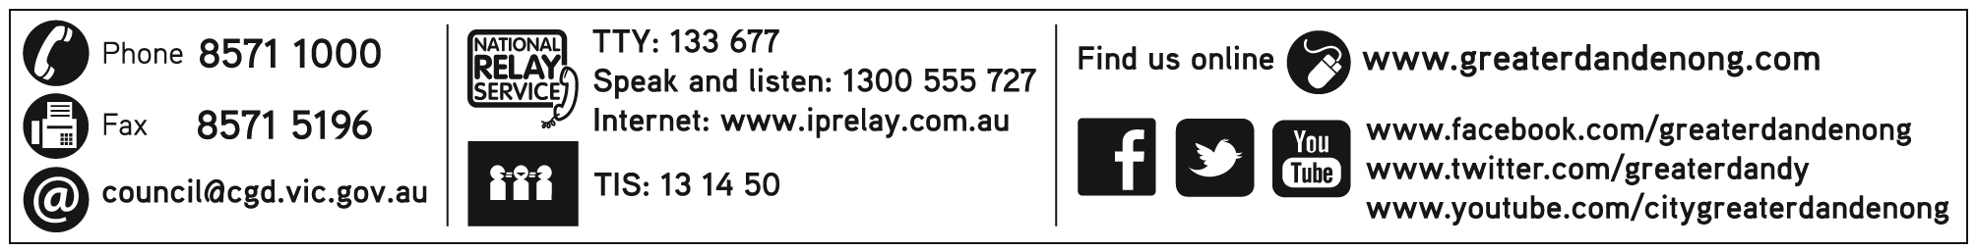
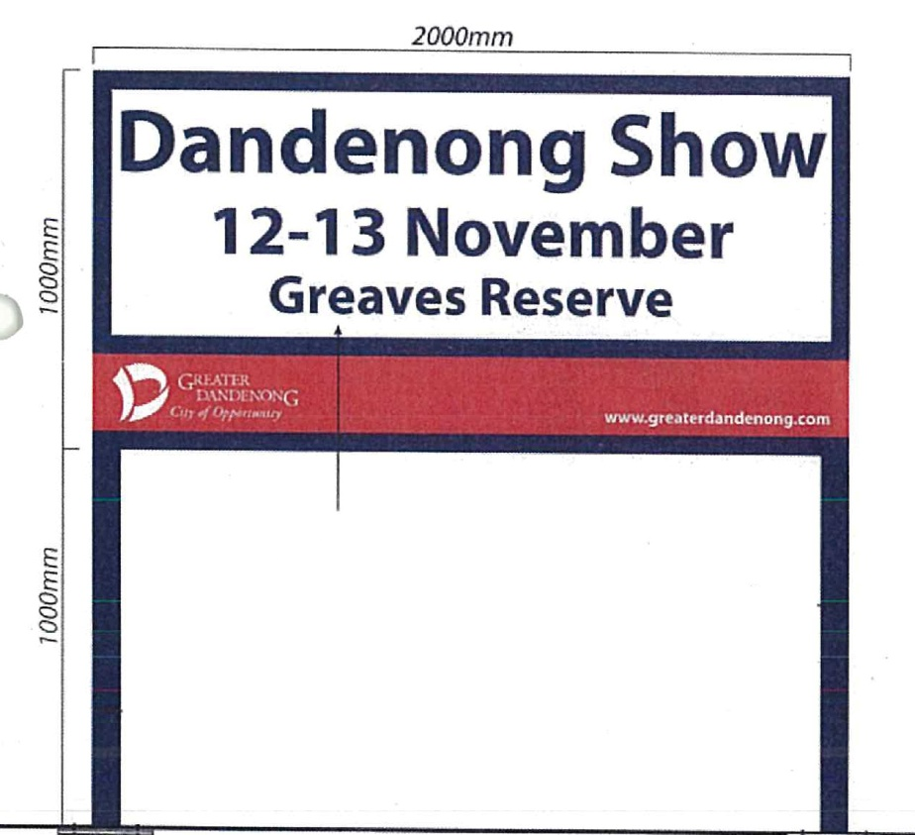
Once complete please return this form to events@cgd.vic.gov.au with the words Community signs in the subject line or by mail to:
Festivals and Events
City of Greater Dandenong
PO Box 200
Dandenong VIC 3175
Please note: Filling out this form does not guarantee your booking. Council will let you know once this booking is approved.

Signs must be printed in Arial font in navy blue:
Event Name
Date
Location

Please note this is the only text to be included. Phone numbers and web addresses are not permitted.

Signs need to be: 1980mm x700mm

We respect your privacy. We will not sell or give away your personal information, unless required by law. Occasionally, we may use your details for our own research purposes or to let you know about other council information. If you want to see your personal data, modify your details, or if you receive information from us you do not want in the future please contact Council on 8571 1000
APPROVED SIGN FORMAT

