Educational Outcomes

Young people in Greater Dandenong experience less favorable early school development, leave school earlier, less often attend university, are more often disengaged from employment and education, and are more likely to be unemployed later in life, than those throughout Melbourne.

Early Childhood Progress
The Australian Early Development Census (AEDC) measures the progress of all pupils in their first year of school across Australia, in five domains of development: physical, social, emotional, language and cognitive, and communication and general knowledge.
The 2018 AEDC findings revealed that 28% of prep pupils in Greater Dandenong were ‘developmentally vulnerable’ in one or more of these fields of development –substantially more than the Victorian level of 20%, and the second highest rate in Melbourne.
For each metropolitan municipality, the percentage of prep pupils who are considered ‘developmentally vulnerable’ in one or more domains, is illustrated in the diagram below.

Percent Prep. Pupils Developmentally Vulnerable in one or more Domains by metropolitan Municipality, 2018
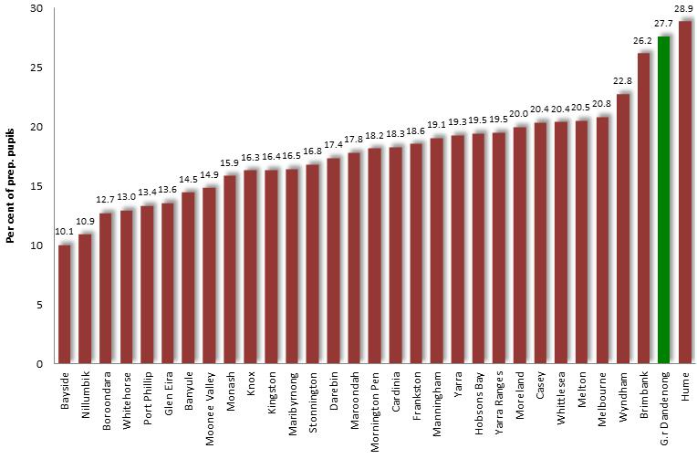

Locally, the proportion of prep pupils who are ‘developmentally vulnerable’ ranged from 34% in Springvale, to 30% in Dandenong and Springvale South, 27% in Noble Park and Dandenong North, 22% in Keysborough and 20% in Noble Park North.
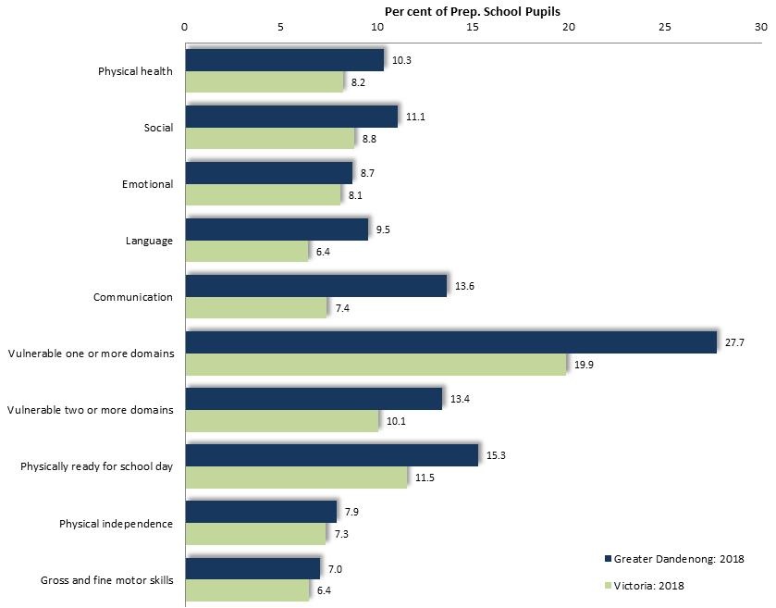
Percent Prep. Pupils Developmentally Vulnerable, by Domain: Greater Dandenong, 2012 and 2015

Notably however, the proportion of children in Greater Dandenong who were recorded as developmentally vulnerable in one or more domains had declined from 37% in 2012 to 28% by 2018. Results from Greater Dandenong for each of the domains of personal development among prepl. pupils is illustrated above.

Pre-School and Kindergarten Participation
The 2018 Australian Early Development Indicators recorded 18.5% of prep. pupils in Greater Dandenong schools had not participated in a pre-school program in the preceding year –compared with 11% across Victoria and the fourth highest level in Melbourne.

Percentage of Prep. Grade Pupils who did not attend a Pre-school Program: metropolitan Municipalities, 2018
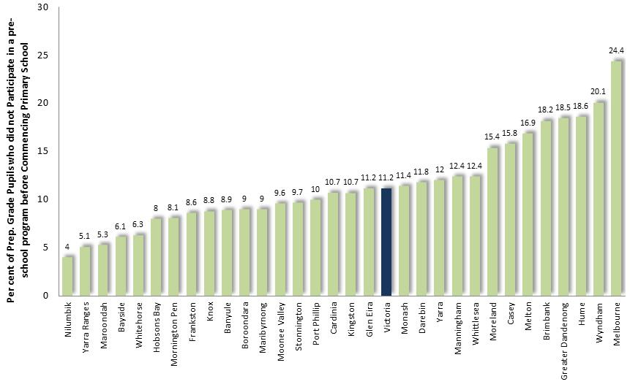
Literacy and Numeracy in Primary and Secondary School
Each year, primary and secondary students throughout Victoria in years 3, 5, 7 and 9, are tested for literacy and numeracy by the State Government. Results for 2017 show differences between results for pupils in Greater Dandenong and the Victorian average.

Literacy
The proportion of Greater Dandenong pupils in years 3, 5, 7 and 9 who did not meet the national literacy benchmarks in 2017, were approximately twice the Victorian average in these year levels. Among local pupils in year 9, the proportion whose test results were below the national benchmark was the third highest in the state.
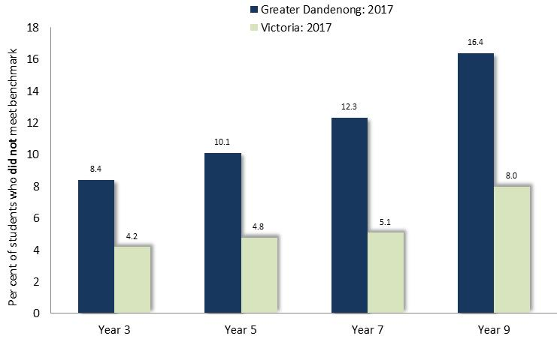
Per cent of pupils below the national literacy benchmark by year level: Greater Dandenong and Victoria, 2017

Numeracy
The proportion of Greater Dandenong pupils who did not meet numeracy benchmarks was also approximately twice the Victorian level. Among year 9 pupils, the proportion from Greater Dandenong who did not meet the benchmark was the highest in the state.
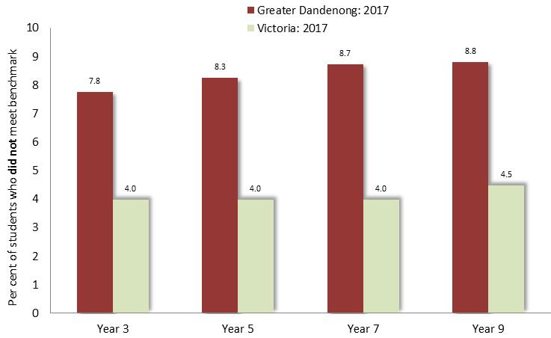

Per cent of pupils below the national numeracy benchmark by year level: Greater Dandenong and Victoria, 2017

Early School Leaving
Current Conditions
The 2016 Census found that 13% of young adults aged 20-24 in Greater Dandenong had left school before completing year eleven – including 15.3% of males and 10.2% of females - compared with 8.3% across Melbourne.
The map below illustrates the prevalence of early school leaving among 20-24 year-olds, showing high rates in portions of the middle and outer municipalities, including Melton, Werribee and Broadmeadows in the northwest as well as Dandenong, Cranbourne, Pakenham and Frankston North to the south.
Percentage of Persons who had left School before Completing Year 11, metropolitan Melbourne, 2016
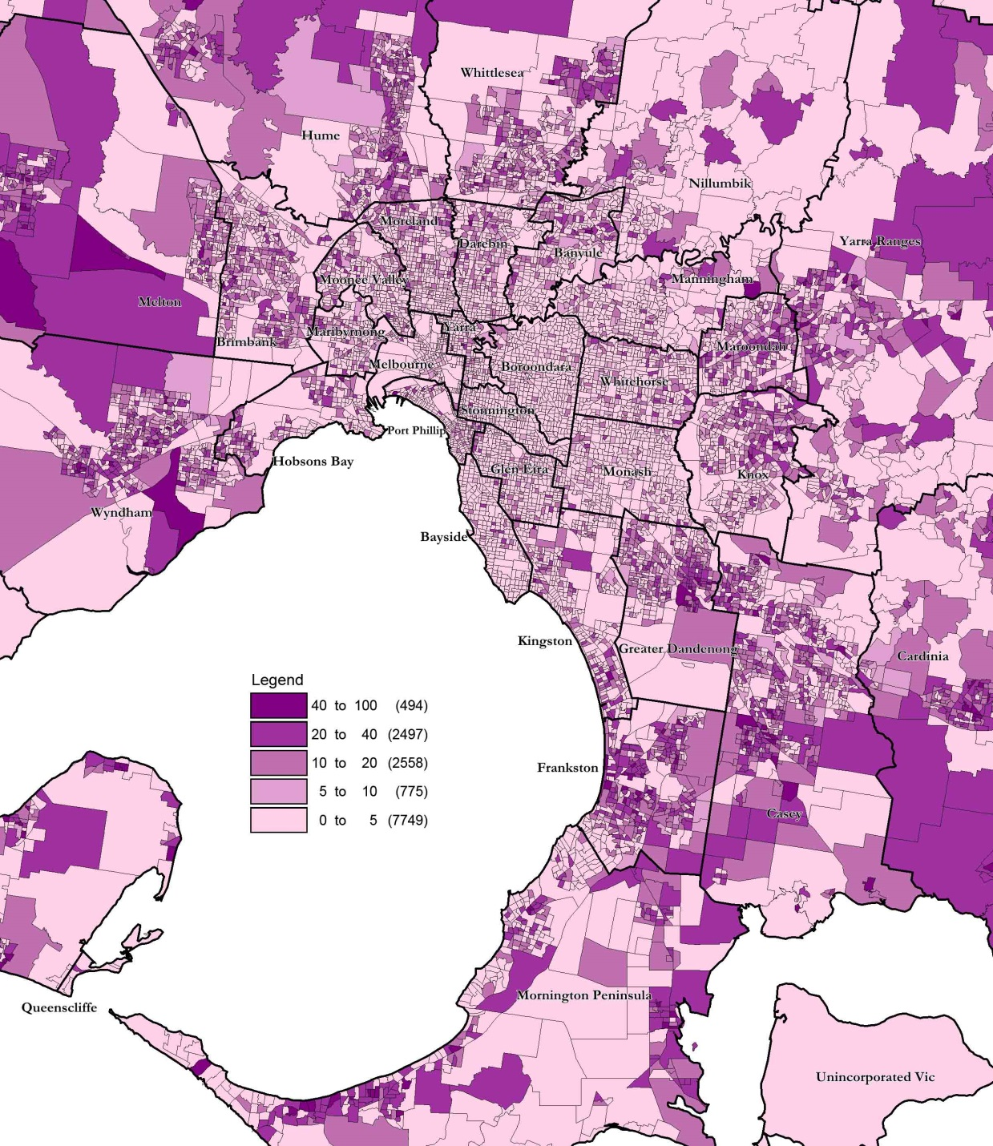
Rates of early school leaving among young people within Greater Dandenong, range from 25% in Dandenong, 14% in Dandenong North, approximately 10% in Noble Park and Springvale, and lower in Noble Park North ((8.6%), Springvale South (7.4%) and Keysborough (5.8%).
Among residents aged 15 years or more in Greater Dandenong, 32% had left school early, compared with 27% of those across Victoria.
Historic Trends Early School Leaving by Age: Greater Dandenong, 2016
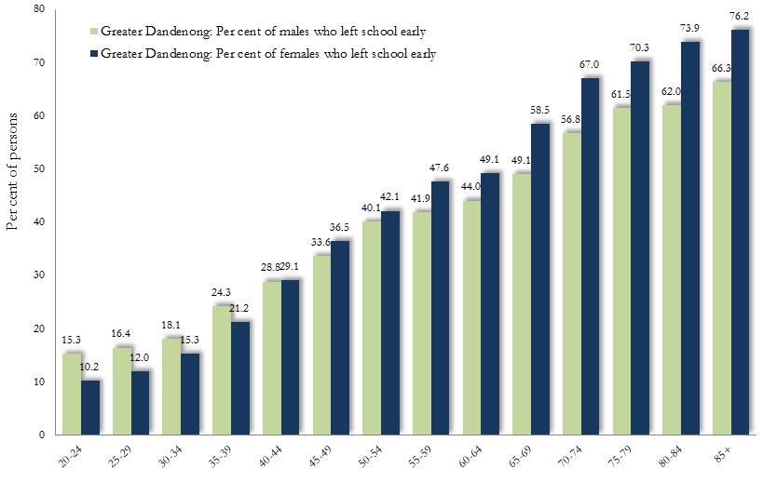
Since education levels have increased over the past few generations, it is scarcely surprising that the rate of early school leaving among residents of Greater Dandenong is highest among older people, rising from 13% among those aged 20-24, to one-third of residents aged 60-64 and more than three-quarters of those over 85.
Notably, among younger people aged 20-24 years old, the rate of early school leaving among males is substantially higher than the corresponding rate among females (15.3% compared with 10.2%). Among older residents though, this trend is reversed, with a higher proportion of females than males having left school early.

Early School Leaving and Birthplaces Rates of Early School Leaving by Birthplace: Greater Dandenong, 2016
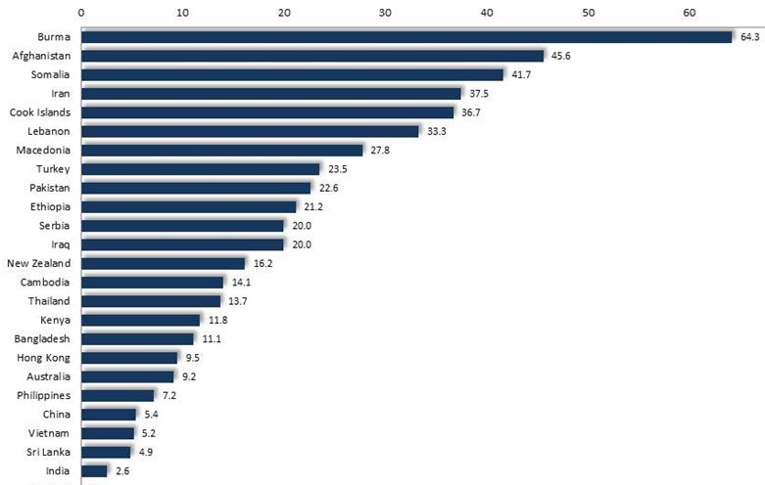
In 2016, 69% of 20-24 year-old residents who had left school before completing year 11 were born overseas.
The proportion of young adults from selected birthplaces who had left school early, is illustrated in the accompanying diagram and ranges from over 40% among young people from Afghanistan, Burma and Somalia, to fewer than 6% of those from India, Sri Lanka, Vietnam and China.

TAFE and University Attendance: 20-24 year olds, Tertiary Participation Rates
Greater Dandenong, 2017
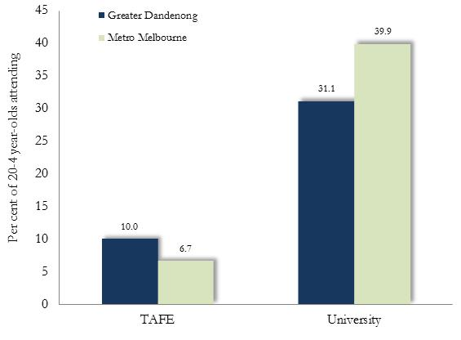
Levels of attendance at university among young adults in Greater Dandenong are lower than the metropolitan average, with 31% of local 20-24 year-olds attending university or other tertiary institutions (up from 23% in 2011), compared with 40% across Melbourne.
Rates of attendance at TAFE though, are relatively high, with 10% of 20-24 year-olds in Greater Dandenong attending TAFE, compared with 6.7% of Victorian residents that age.
Qualifications: Greater Dandenong and Victoria, 2016
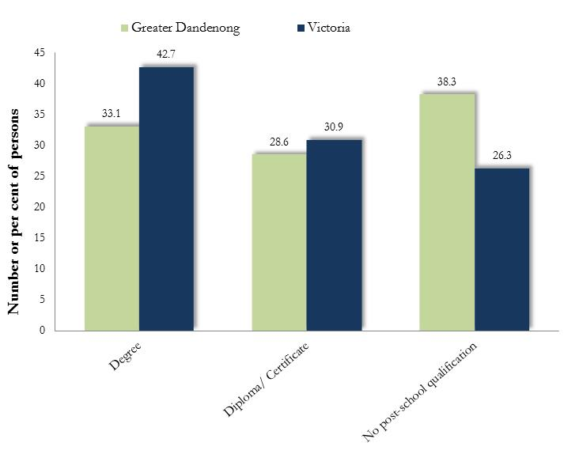
Qualifications
Consideration of qualifications holds particular relevance for residents aged 25 to 44 years, among whom employment levels are relatively high.
Within Greater Dandenong, nearly two-fifths (38%) of residents in this age range held no post-school qualification in 2016. Their range of qualifications is illustrated in the accompanying chart.

Education & Employment Prospects
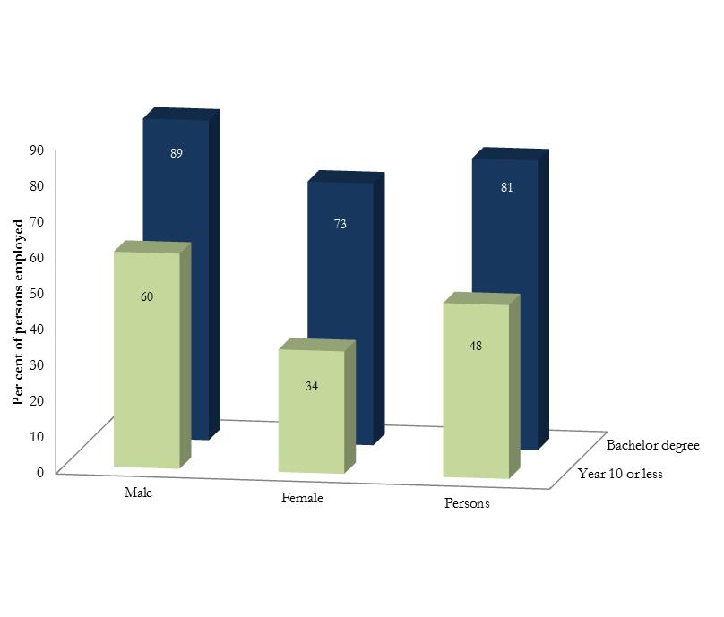
The 2016 Census found that, among Greater Dandenong residents aged 30-39 years, 81% of those with a degree were employed, compared with 48% of people who had left school before completing year 11.

Employment Rates by Educational Attainment: Persons 30-39 years of age, Greater Dandenong, 2016

Among women the same age, this contrast is more striking, with 73% of females with a degree employed, compared with just 34% of early school leavers.

