Gender Differences in Social Conditions and Outcomes

Early Child Birth
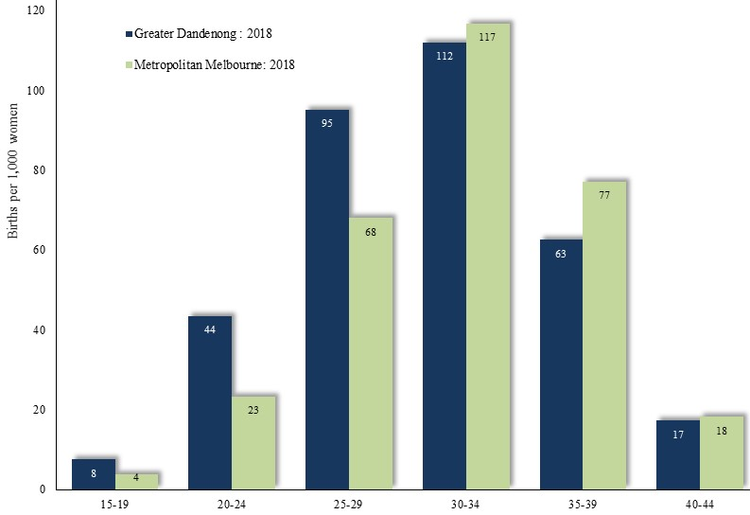
Birth Rates (births per 1,000 women) by Age:
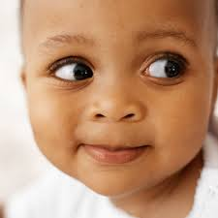
Metropolitan Melbourne and Greater Dandenong, 2018

Birth rates among younger women are higher in Greater Dandenong than in Melbourne.
For some young women, early child birth is either a consequence or a cause of limited educational and vocational opportunities.

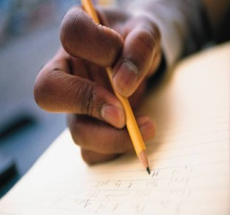

Early School Leaving

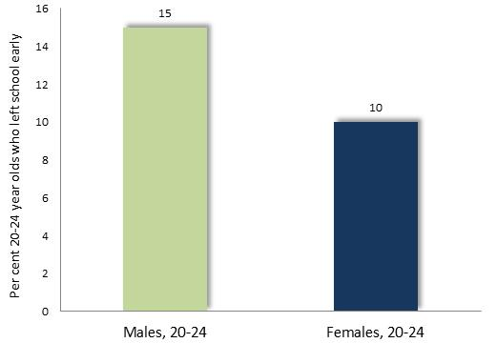
Per cent of persons aged 20 to 24 years, who had left school before completing year 11, by gender: Greater Dandenong, 2016
Young men in Greater Dandenong are more likely to leave school early than women of the same age.
Early school leaving rates in Greater Dandenong vary widely with birthplace, with women from Somalia, Macedonia, Turkey, Afghanistan and Cambodia recording early leaving rates in excess of 80% in 2016.

English Literacy
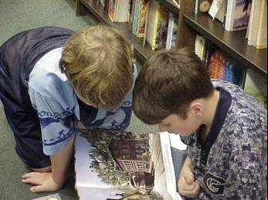
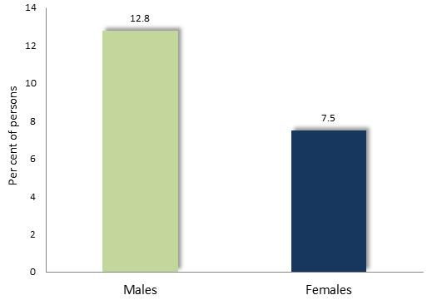

Per cent of persons aged 20 to 24 years, with limited English literacy: Australia, 2011
The 2011–12 Programme for the International Assessment of Adult Competencies, found that among Australians aged 20-24 years, 12.8% of males and 7.5% of females were rated as having an English literacy level of or below Level One Literacy, the lowest levels on the scale of literacy

Tertiary Qualifications
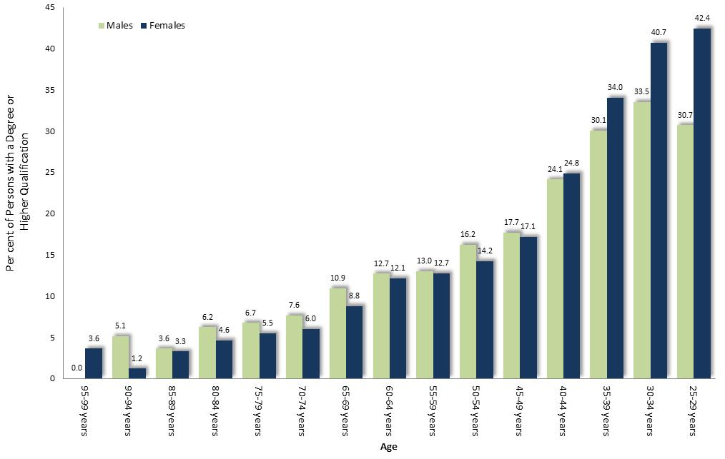
The 2016 Census found that, among 25-44 year-old residents, 30% of men and 37% of women had attained a university degree.

Per cent of persons who hold a tertiary qualification, by gender and age: Greater Dandenong, 2016
The 2016 Census revealed that younger women were more likely than older women to hold a tertiary qualification. For example, women aged 25-29 years were more than ten times more likely to hold a tertiary qualification than those born sixty years earlier. These younger women were also decisively more likely to hold such qualifications than their male contemporaries.

.

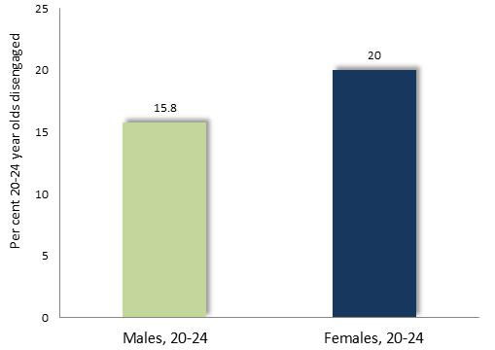
Youth Disengagement

Per cent of persons aged 20-24 years, who were neither in paid employment nor enrolled in education or job training, by gender: Greater Dandenong, 2016
Despite their higher school retention levels, disengagement levels among young women in Greater Dandenong are substantially higher than for males, due to the fact that most young women with children are not in paid employment or enrolled in education.

Paid Employment
The 2016 Census found that among persons aged 15-64 years in Greater Dandenong, 68% of men were in paid employment, compared with 53% of women. In December 2020, 67% of Victorian males aged 15-64 held paid employment, compared with 56% of females. Notably though, the proportion of females who were in paid work has risen from 40% since 1978.
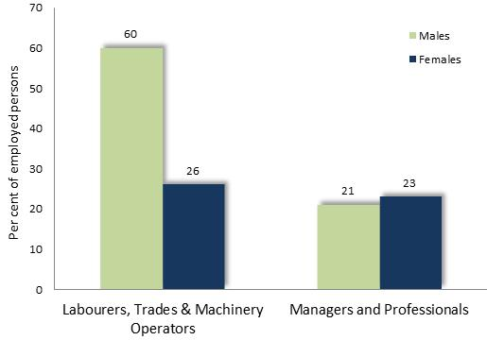
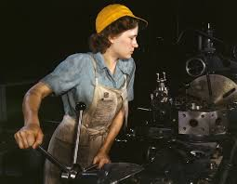
Per cent of persons in paid employment who were employed as managers or professionals, by gender: Greater Dandenong, 2016

The 2016 Census also revealed that, in Greater Dandenong, 60% of men in paid employment worked as tradespersons, labourers or machinery operators, compared with 26% of women.
Conversely, 23% of women in paid work were employed as managers or professionals, compared with 21% of employed men. (accompanying diagram)

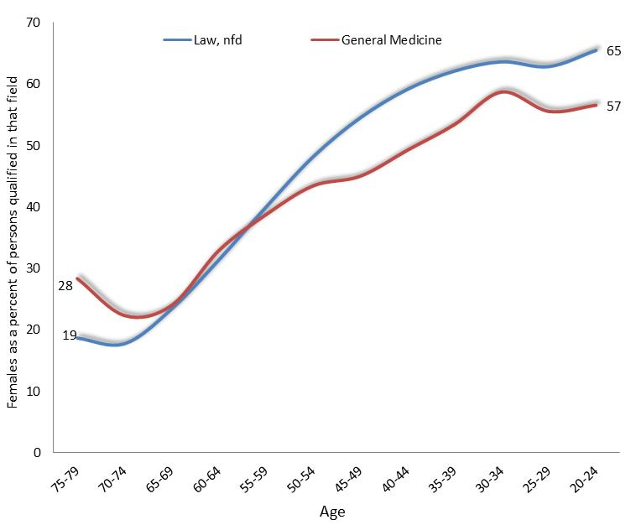
Fields of Qualification

Women as a percentage of persons with tertiary qualifications in medicine and law, by age: Victoria, 2016
The rising proportion of women with tertiary medical and legal qualifications, with decreasing age, reflects changing trends, during the previous half-century.
Similar increases, though less pronounced, have occurred in the representation of women in scientific, engineering, accounting, management and other fields.

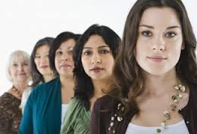

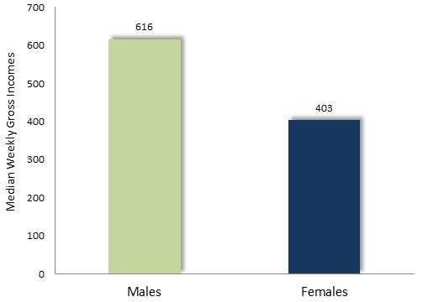
Incomes
Median weekly gross individual income among persons aged 15 years or more, by gender: Greater Dandenong, 2016

In 2016, median weekly individual gross incomes stood at $616 among males - 53% higher than the corresponding level among women, of $403 p.w.

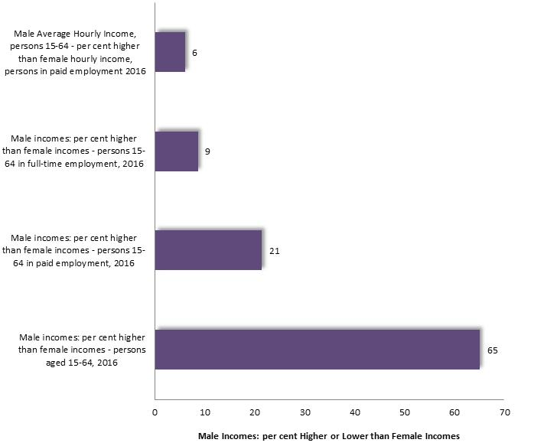

Median income levels by employment status and level, by gender: Greater Dandenong, 2016

The income gap between women and men was lower among those in paid employment, and less among those in full-time work. The difference between women’s and men’s hourly income was smaller still, at 6%.
These findings confirm that income differences between women and men are due largely to the lesser proportion of women who hold paid employment, and the lower percentage of those in paid work who are employed full-time.

.

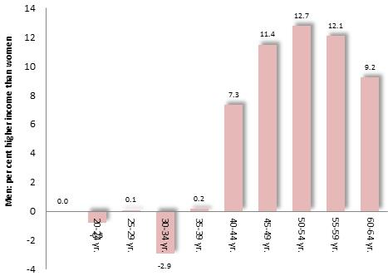

Disparity between men’s and women’s hourly incomes, Victoria, 2016

The 2016 Census also showed that the disparity in hourly income between women and men is higher older women and lowest among young women – suggesting a trend towards increased pay equity.

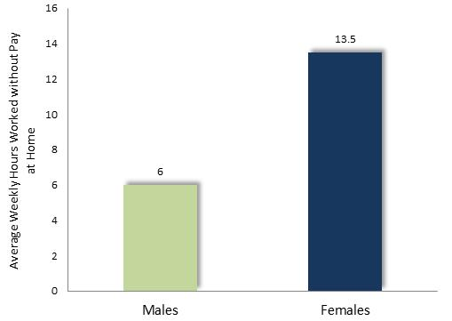
Unpaid Work at Home
In 2016, the average number of hours unpaid work performed at home by males aged 20-79 years in Greater Dandenong, was 6 hours, less than half the corresponding average among women of the same age, of 13.5 hours.

Average hours of unpaid work performed each week, by gender: Greater Dandenong, 2016

Disability
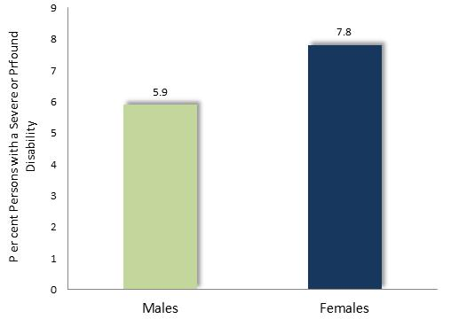
The 2016 Census recorded that 5.9% of males in Greater Dandenong, and 7.8% of females, had a severe or profound disability, requiring them to obtain daily assistance in communications, mobility or self-care.

Per cent of persons with a severe or profound disability, by gender: Greater Dandenong, 2016

When these figures are adjusted to compensate for age differences between women and men, this disparity declines to 6.7% among men and 7.6% for women.

Unpaid Assistance to Persons with Disability
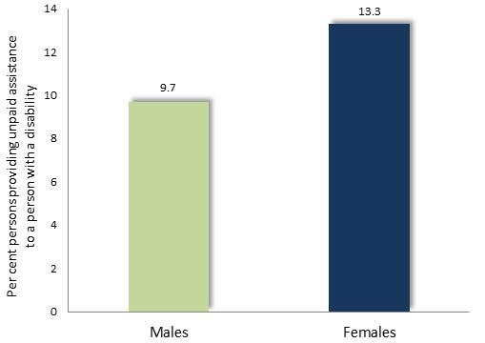
The 2016 Census also showed that 9.7% of males and 13.3% of females in Greater Dandenong, provided unpaid care for a person with a disability.

Per cent of persons who provide unpaid care for a person with a disability, by gender: Greater Dandenong, 2016

Personal Stress
The 2017 Victorian Population Health Survey found that 43.9% of women were experiencing ‘high’ or ‘very high’ levels of psychological distress, compared with 36.3% of men.
The survey also reported that 33.6% of women and 21.0% of men were experiencing doctor-diagnosed anxiety or depression.
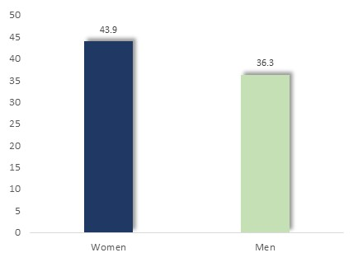

Per cent of persons with ‘high’ or ‘very high’ levels of psychological distress: Victoria, 2017

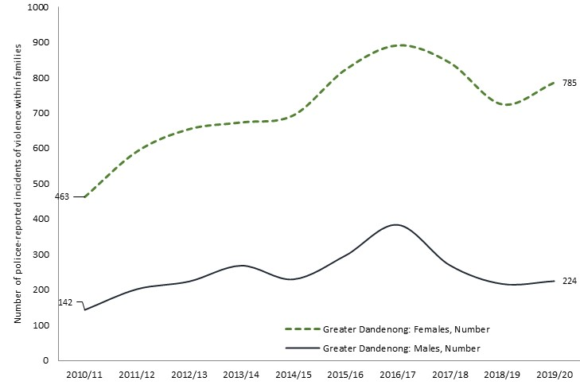
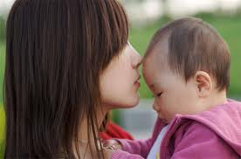
Family Violence
Women accounted for 785 victims of alleged family violence incidents recorded by police in Greater Dandenong in 2019/20, representing 78% of recorded victims of such crimes.

Number of recorded victims of alleged family violence incidents, by gender: Greater Dandenong, 2019/20

Attitudes to Gender Equity
The 2015 VicHealth Indicators Survey sought to measure support for gender equality, recording the level of agreement among respondents to two statements:
- Men should take control in relationships and be head of the household
- Women prefer a man to be in charge in a relationship
The result was a score representing the percentage of respondents with a low support for gender equity, which ranged from 18% in Indigo Shire to 58% in Greater Dandenong, averaging 36% across Melbourne.

Percentage of people who express low support for gender equality, by selected characteristics: Victoria, 2015
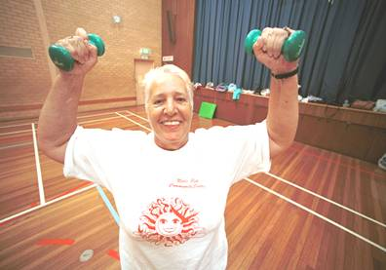
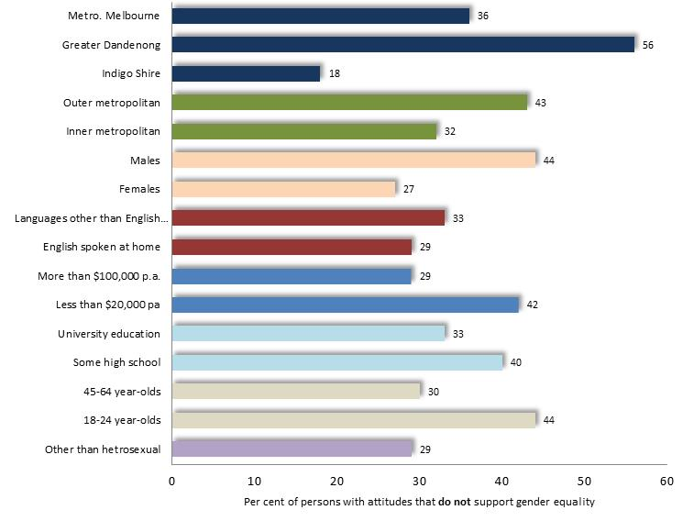
Segments of the community which expressed the lowest support for gender equality included younger people, men, people with limited education, unemployed residents, those from non-English-speaking countries and people living in outer-metropolitan localities.

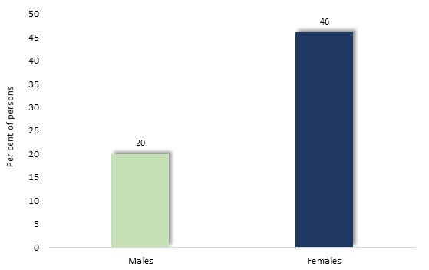
Perceptions of Personal Safety
A 2015 survey conducted by the State Government found that nearly half (46%) of females and a fifth (20%) of males in Greater Dandenong felt unsafe while walking alone at night in their neighbourhoods.

Per cent of women and men who feel unsafe walking alone in their neighbourhoods at night: Greater Dandenong 2015

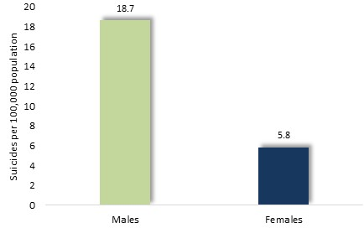
Mental Health & Suicide
In 2018, the suicide rate among Australians was 18.5 per 10,000 persons among males and 5.8 per 10,000 among females – reflecting a long-standing disparity between male and female rates.

Suicide rate (per, 10,000) by gender: Aus, 2018
The National Survey of Mental Health and Wellbeing found that the prevalence of post-traumatic stress disorder is almost twice as high among Australian women (15.8%) as for men (8.6%), while depression (at 14.5% among women and 8.6% among men), social phobia (12.8% and 8.4% respectively) and generalised anxiety disorder (7.3% vs. 4.4%) are also more widespread among women.

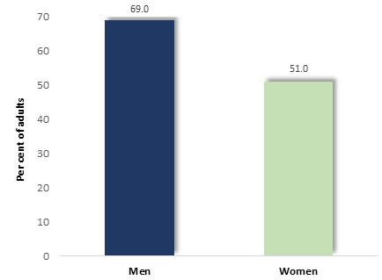
Alcohol Consumption
The 2019 National Drug Strategy Household Survey found that 26% of Australian male adults, and 10% of females, consumed alcohol to levels which placed them at lifetime risk.

Per cent of adults at lifetime risk of alcohol-related harm
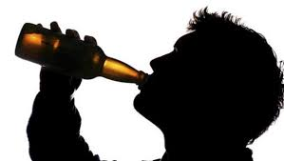

Mortality
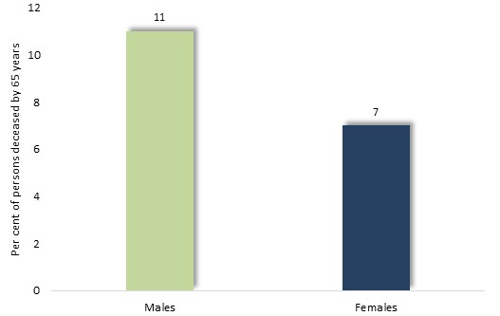
Mortality rates among males tend to be higher than among females throughout the lifespan. In 2018, the probability of death by 60 years was 8% for males and 5% for females.

Percent of persons deceased by age 65: Australia, 2016-18 age-specific mortality rates

