Incomes and Financial Disadvantage
Median Incomes: Greater Dandenong & metro Melbourne, 2006 & 2016
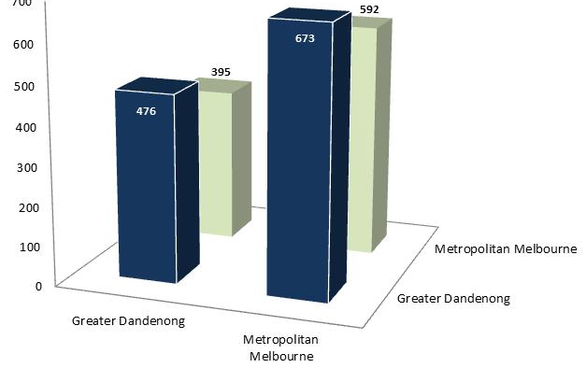
In 2016, the median individual weekly gross income in Greater Dandenong stood at $476 – the lowest level in Melbourne. In the decade to 2016, individual incomes in Greater Dandenong have remained at approximately 70% of metropolitan levels.

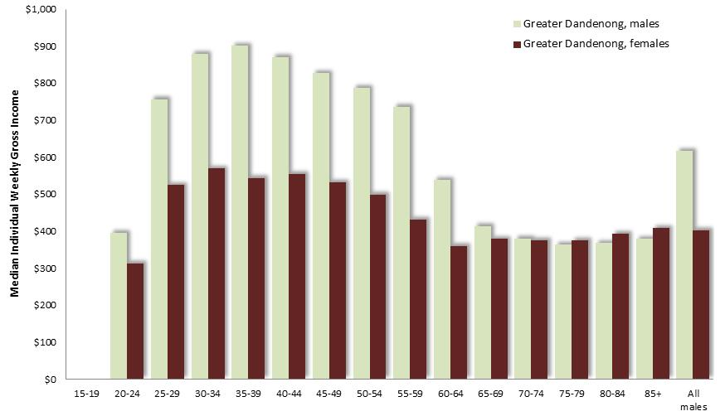
Median Incomes by Sex: Greater Dandenong, 2016
At $616 per week, incomes among males aged 15-64 years in Greater Dandenong were 53% higher than those for females, at $403. The disparity between female and male income levels in Greater Dandenong was most prominent among residents of working age (diagram, left).

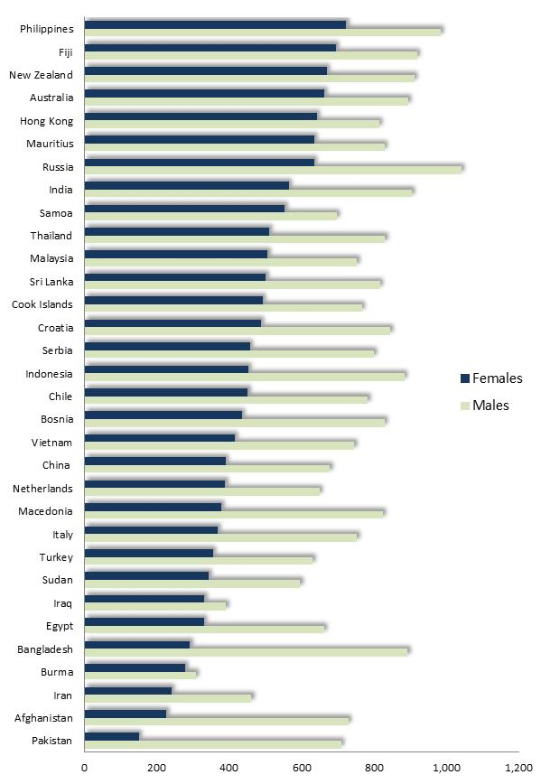

Median Income by Gender and Selected Birthplaces: Persons aged 25-64, Greater Dandenong, 2016

Income levels also vary widely by birthplace. Among residents aged 25 to 64, incomes ranged from $786 among those born in Australia, to $298 among those from Burma.
Notable disparities between female and male incomes were present also. Among residents from Pakistan, Afghanistan and Bangladesh, male incomes were over three times the female levels, while among residents from Iraq and Burma female and male incomes were similar – perhaps due to the high rates of unemployment among these residents.
Geographic Distribution of Incomes
The distribution of incomes is illustrated in the map, below. Regions with the lower median individual income levels – illustrated in the pale shades – are largely situated in the north, west and southeast of Melbourne, including Greater Dandenong and adjoining portions of neighboring Frankston, Casey and Monash.

Median Weekly Individual Incomes: metropolitan Melbourne, 2016
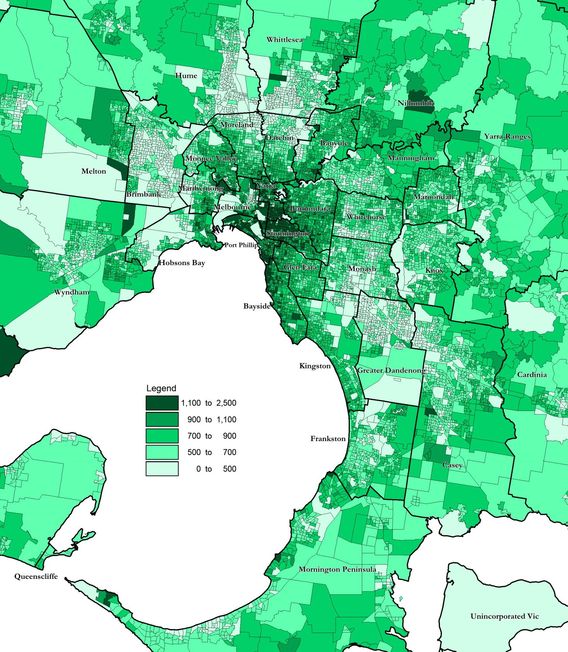

Centrelink Support
In June 2020, 12% of Greater Dandenong residents held a Health Care Card – the third highest dependency upon such support in metropolitan Melbourne and substantially more than the metropolitan level of 7.9%, reflecting extensive financial hardship.
More than one-fifth (22%) of occupied dwellings in Greater Dandenong attract rental assistance payments, the highest level in Melbourne and substantially more than the metropolitan average of 14%.
The 2020 Centrelink payments also revealed a high level of dependency of older local residents upon the aged pension, with the number of residents relying on this payment equal to 69% of the number of residents aged 65 years or more – the highest level in Melbourne and higher than the metropolitan ratio of 55%.
The table below sets out a selection of ratios between the relevant population and the number of Centrelink beneficiaries in mid-2020, confirming the level of dependence of various segments of the local population upon pensions and benefits, including older, disabled and unemployed people, and families facing financial difficulties.

 | Greater Dandenong |  | Metro. Melbourne
RATIOS
Jobseeker Payment / Population 18-64 (%) | 10.9 |  | 7.9
Parenting Payment Single / Population Females 20-44 (%) | 3.9 |  | 3.2
Parenting Payment - partnered / Population Female 20-45 (%) | 3.4 |  | 1.8
Disability Pension / Total population (%) | 3.7 |  | 2.3
Aged Pension/ Population 65+ (%) | 69 |  | 55.0
Health Care Card / Total population (%) | 12.0 |  | 9.5
Rent Assistance/Occupied Dwellings (%) | 22.4 |  | 13.9

Notably, in 2016, 31% of families with children in Greater Dandenong had no parent in paid employment – the highest level in metropolitan Melbourne and substantially more than the State level of 19%.

Findings of the 2009-10 ABS Household Expenditure Survey documented some of the financial difficulties experienced by households with low incomes. Across Australia, members of households whose main source of income was government pensions and benefits, were:
- four times more likely than others to have had to go without meals than others
- five times more likely to have been unable to heat their home
- three times more likely to have been unable to afford to have friends over for a meal once a month
- three times more likely to have been unable to afford hobby activities, than others.

The 2016 Index of Relative Socio-economic Disadvantage
Greater Dandenong is ranked as the second most disadvantaged municipality in Victoria, on the Commonwealth Government Index of Relative Socio-economic Disadvantage.

This index, was released by the Australian Bureau of Statistics recently, and based on 2016 Census findings about income levels, education, English fluency, home ownership and others.

- Greater Dandenong is ranked as the second most socio-economically disadvantaged municipality in Victoria (after Central Goldfields) – the same as its ranking 20 years ago, in 1996.

- By contrast, the least disadvantaged locality in Victoria is Nilumbik, as it was in 2011.

- Within Greater Dandenong, the suburbs of Dandenong and Springvale are the most disadvantaged on this index, and are among the most disadvantaged 2% in Victoria. Keysborough is the least disadvantaged suburb in Greater Dandenong, though still among the 27% most disadvantaged in the State
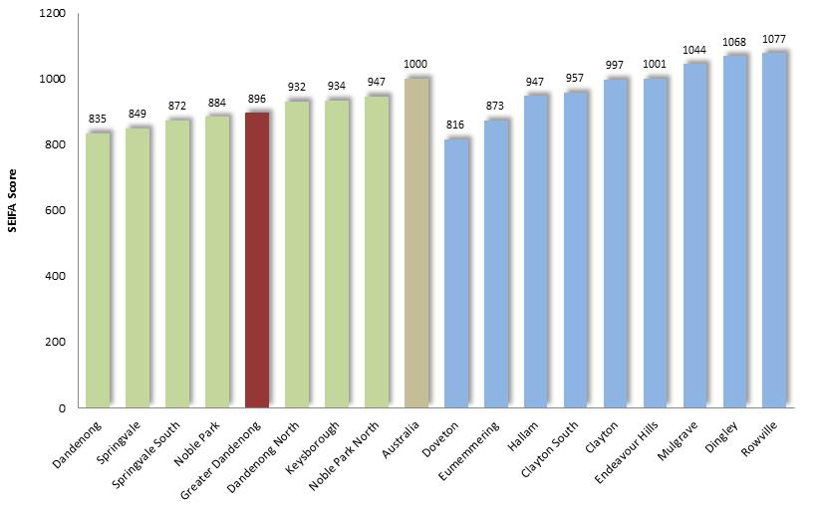

Index of Relative Socio-economic Disadvantage, 2016: Suburbs of Greater Dandenong and Neighbouring Suburbs

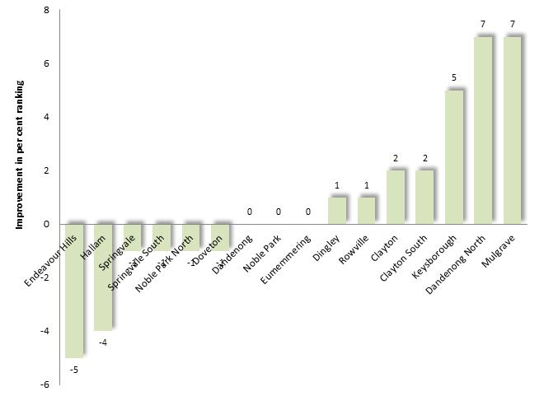
Changes over time

The accompanying chart illustrates the change in ranking among suburbs within and neighbouring Greater Dandenong, in the period 2011 to 2016.
A rise in ranking reflects a reduction in socio-economic disadvantage or improvement in conditions.

Change in Index of Relative Socio-economic Disadvantage, 2016: Suburbs of and around Greater Dandenong: 2011 to 2016

The chart below, illustrates changes in ranking on the Index of Relative Socio-economic Disadvantage, among Victorian municipalities, in the 20-year period 1996 to 2016.
Notably, overall increases in ranking on the index, signifying improvements in general socio-economic conditions, were registered in Nillumbik, Moreland, Darebin and other ‘gentrifying’ municipalities, while declines in ranking were recorded in a selection of smaller rural municipalities including Yarriambiak, Buloke and Corangamite. The ranking on this index for Greater Dandenong has not changed in this period.

Numeric Change in Ranking from 2011 to 2016: Municipalities of Victoria
Increase in relative disadvantage Decline in relative disadvantage
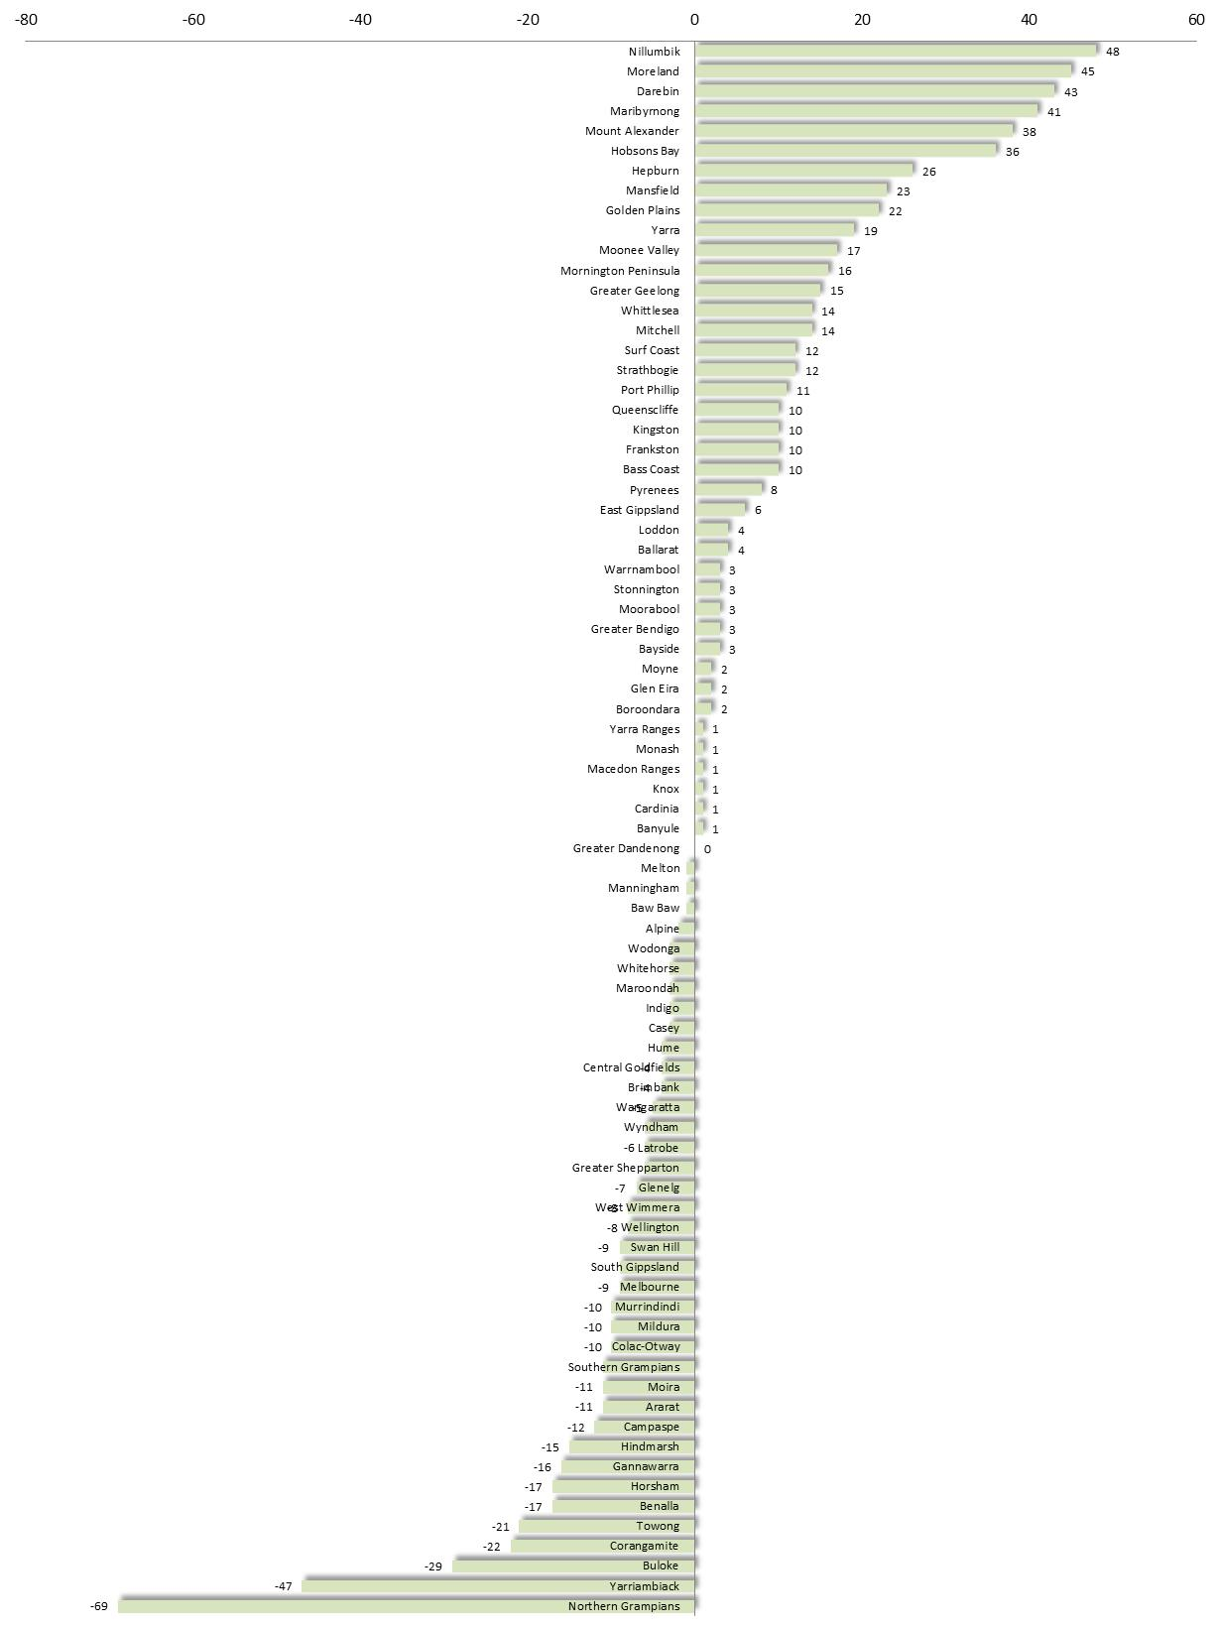
Geographic Distribution of Disadvantage

The accompanying map illustrates the geographic distribution of scores on the 2016 index, with lighter areas most disadvantaged, and the darker shaded areas least disadvantaged.

Index of Relative Socio-economic Disadvantage across metropolitan Melbourne, 2016

