Older Residents

Population: In 2021, approximately 18,000 people in Greater Dandenong – or one in ten residents – were aged 70 years or more. In the decade to 2031, this number may increase by 4,560, or 25%, to 22,700. Meantime, the population aged 85+ is forecast to swell by 1,460 – a rise of 40%.
Persons aged 70 years or more, by selected birthplaces, 2016
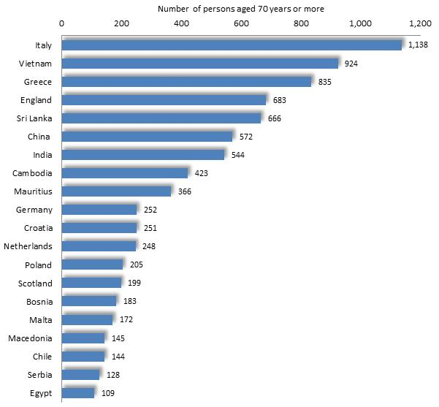
Cultural Diversity
In 2016, nearly three-quarters (73%) of residents in Greater Dandenong aged 70 or more were born overseas – higher than the metropolitan level of 51%, and the largest proportion in Victoria.
Their birthplaces include Italy, Vietnam, Greece, England, Sri Lanka and China.

Change in population aged 70+, by selected birthplaces, 2006 to 2016
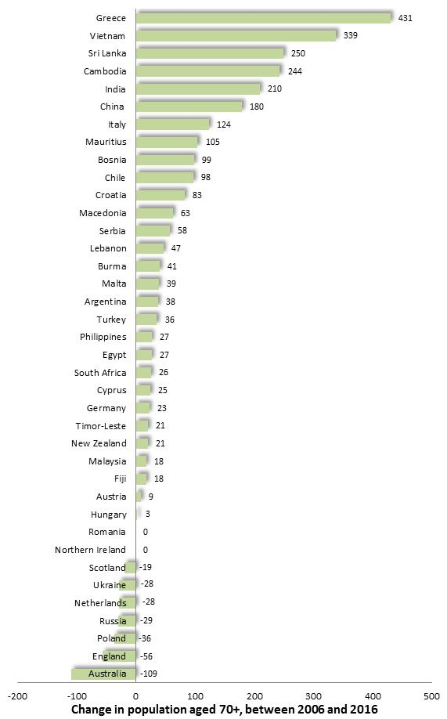

The 2016 Census recorded that 27 residents were Aboriginal or Torres Strait Islanders aged 70 or more.
The number of older residents from many European sources of migration has declined in recent years, resulting in fewer from Britain, Poland and elsewhere. Meantime, many residents from Vietnam, Cambodia, India and China are passing into their older age. These two trends have caused a steady rise in the number of older residents in our municipality, coupled with a gradual change in their blend of birthplaces.
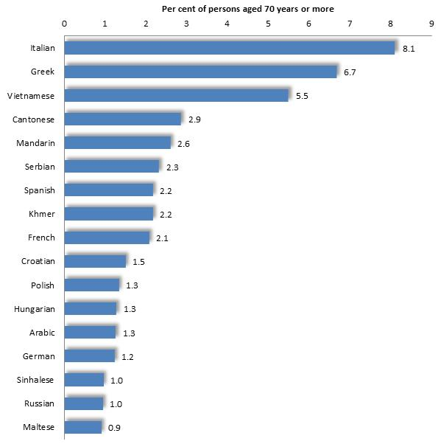
Persons aged 70 years or more, by selected languages, 2016 Spoken Languages
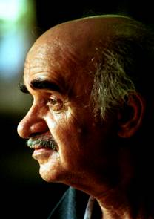
Reflecting the cultural diversity of residents aged 70 or more, over half (54%) speak languages other than English at home, including Italian (spoken by 8.1% of older residents), Greek (6.7%), Vietnamese (5.5%), Cantonese (2.9%), Mandarin (2.6%), Serbian, Spanish, Khmer and French (a little over 2% each). The percentage of residents aged 70 or more who speak each of a selection of non-English languages, is illustrated in the accompanying diagram.

English Fluency
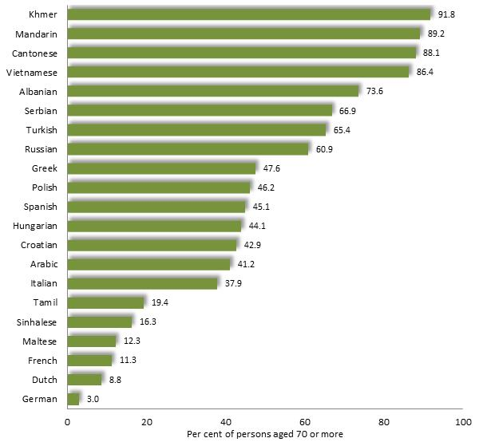
Over one-quarter (29%) of residents aged 70 or more has limited fluency in the use of spoken English, the highest proportion in Victoria. These include over four-fifths of those who speak Cantonese, Khmer, Mandarin and Vietnamese.

Per cent of residents aged 70 years or more, who have limited English fluency, by age, 2016

Household Types
Household Types, Persons aged 70+ and living in a private dwelling, 2016
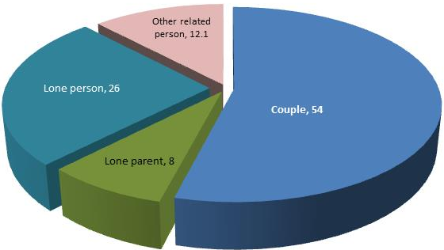

More than half (54%) of older residents aged 70 or more, live with a partner and just over a quarter (26%) alone. Others reside with their children or other relatives.
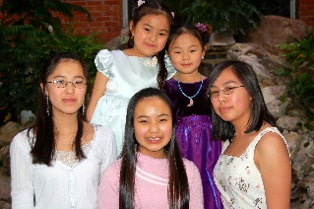

Incomes, Employment and Welfare Dependence

Incomes and employment
At $554, the median income among Greater Dandenong residents aged 55-59, and therefore approaching retirement, was the lowest in Melbourne in 2016, and substantially less than the corresponding Victorian median of $819. Among people aged 55 to 59 years in Greater Dandenong, 54% were in paid employment in 2016, compared with a metropolitan level of 69%. Consequently a substantial proportion of residents reach older age with limited savings, exposing them to the risk of financial hardship in retirement.
Pensions
In June 2020, the ratio of Aged Pension recipients to persons aged 65 years or more in Greater Dandenong (expressed as a percentage) was 69% - the third highest in Melbourne. By contrast the ratio of Aged Pension recipients to older persons in metropolitan Melbourne was 55% and in Boroondara 29%, reflecting a lower dependency upon the pension for income support among these residents.

Geographic Distribution of Older Residents
The map presented below, illustrates the distribution of older residents across metropolitan Melbourne. Areas of Frankston and Mornington, as well as a selection of inner and eastern regions, have a high proportion of older residents (darker shades). By contrast, the municipality of Melbourne itself, as well as portions of Yarra, Maribyrnong, Port Phillip and recently-established growth suburbs in the outer municipalities have lesser proportions of older people among their populations (shaded light blue)

Per cent Population who are aged 65 years or more: metropolitan Melbourne, 2016
