Spoken Languages
Nearly two-thirds of the residents of Greater Dandenong speak languages other than English in their homes, while one in seven has limited fluency in the use of spoken English.
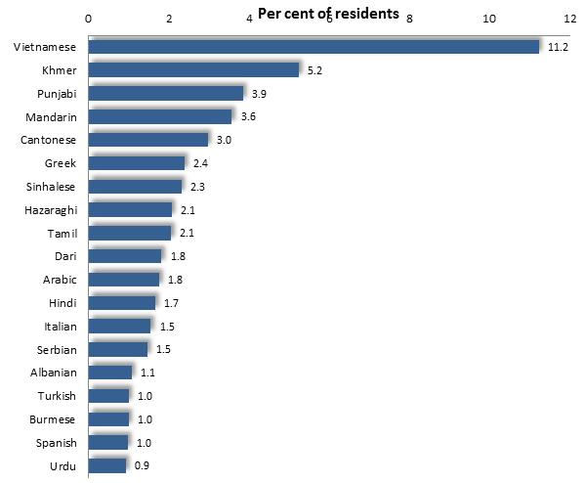
Spoken Languages: Greater Dandenong, 2016
Spoken Languages
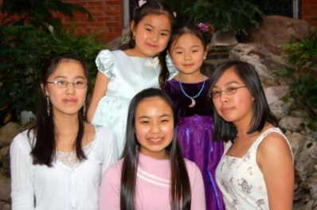
In 2016, over 70% of residents spoke languages other than English in their homes – the largest proportion in Victoria and more than twice the metropolitan level of 31%. Among the more than 130 different languages spoken are Vietnamese, Khmer, Chinese, Greek, Punjabi and Sinhalese.
Greater Dandenong has the greatest diversity of languages in Victoria and the second highest in Australia.

The diagrams below present the major languages spoken by residents among key age groups.
Persons aged 0 to 14 years: number by selected spoken language, 2016
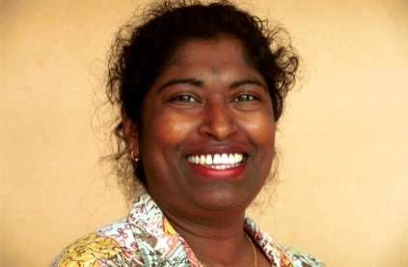
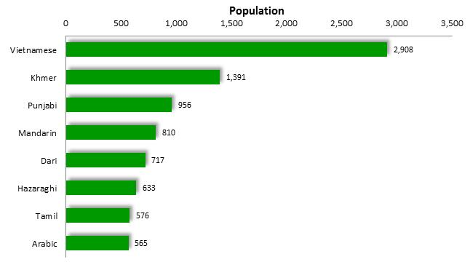

Persons aged 15 to 24 years: by selected spoken language, 2016
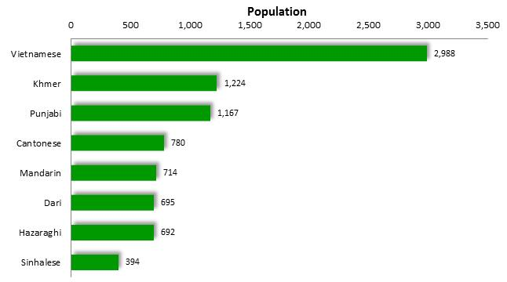
Persons aged 25 to 64 years: number by selected spoken language, 2016
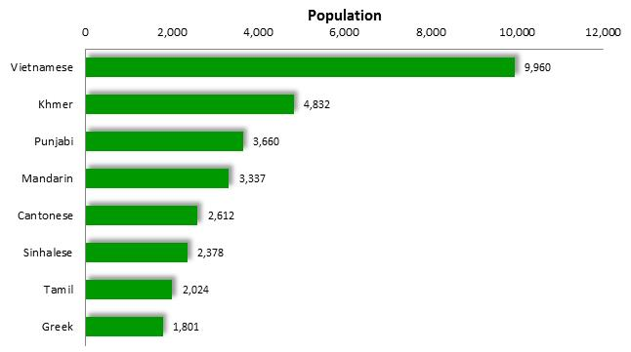
Persons aged 65 years or more: by selected spoken language, 2016
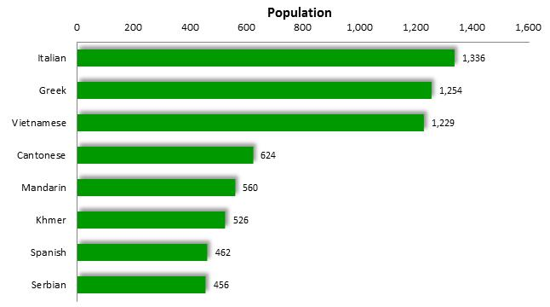

Spoken languages among recently-arrived residents reflect current patterns of birthplace among recent settlers. The 2016 Census found that major spoken languages among residents who had arrived in Australia during the previous 18 months included Punjabi, Vietnamese, Khmer, Mandarin, Sinhalese and Hazaraghi. (diagram below)

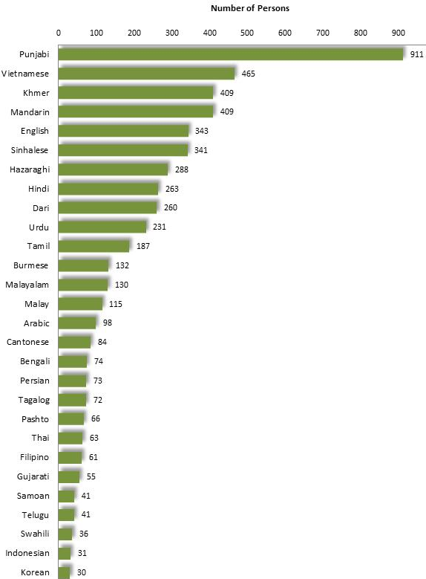

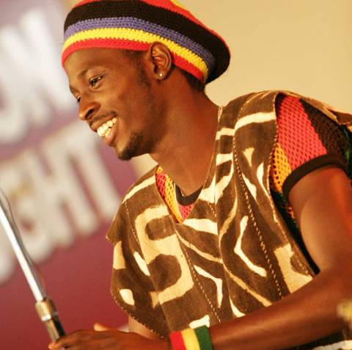
Spoken Languages among Residents who had arrived in Australia during the previous 18 months: Greater Dandenong, 2016

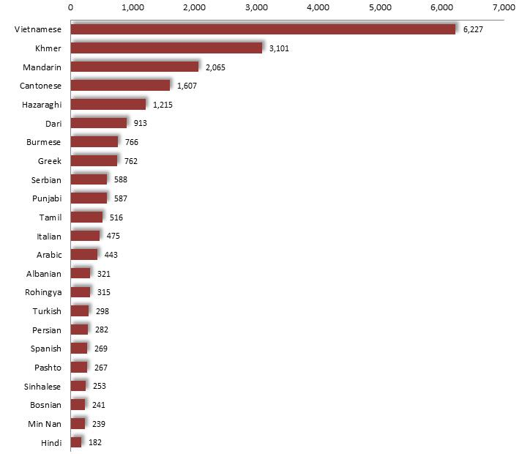
English Fluency Limited English fluency by Spoken Language: Greater Dandenong, 2016
About one in five residents - accounting for 25,500 people at the time of the 2016 Census, or 18% of the population - has limited fluency in the use of spoken English – four times the metropolitan level of 4%.
Substantial numbers of residents who speak Vietnamese, Khmer, Chinese languages, Afghani languages and Greek have limited English fluency (above right).
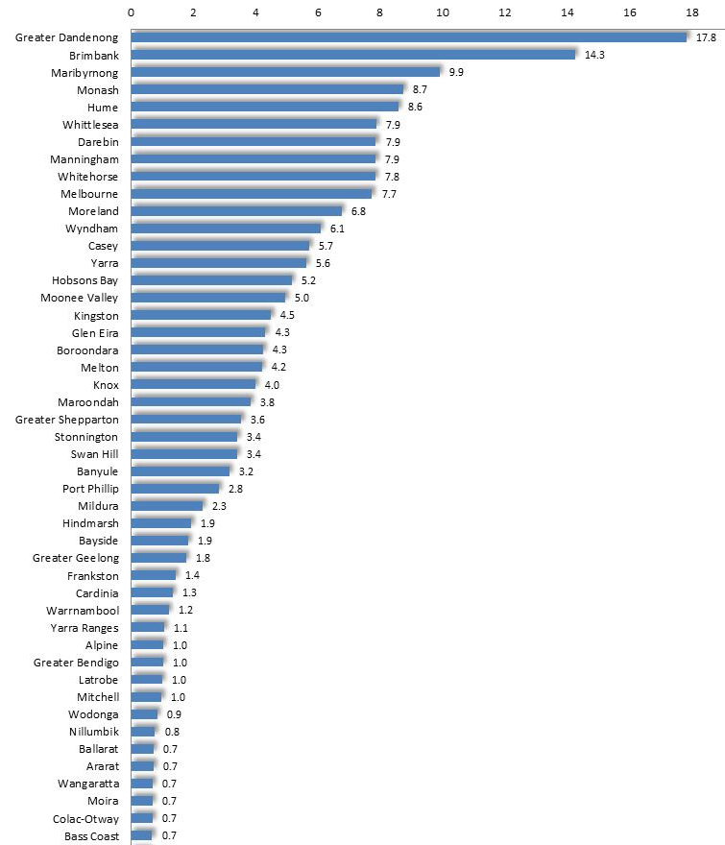

Limited English fluency: Selected Victorian municipalities, 2016

The prevalence of limited fluency in the use of spoken English, varies widely among the municipalities of Victoria and is highest in Greater Dandenong.

(Municipalities where the prevalence of limited English fluency was less than 0.5% are omitted from the accompanying diagram)

The accompanying map illustrates variations in the prevalence of limited English fluency across Melbourne, with higher rates evident in a variety of middle and outer municipalities, including Greater Dandenong. Within the metropolitan area, the proportion of residents with limited English fluency ranges from 18% in Greater Dandenong, to less than 1% in Nillumbik.
Per cent of Residents with Limited English Fluency: Metropolitan Melbourne, 2016
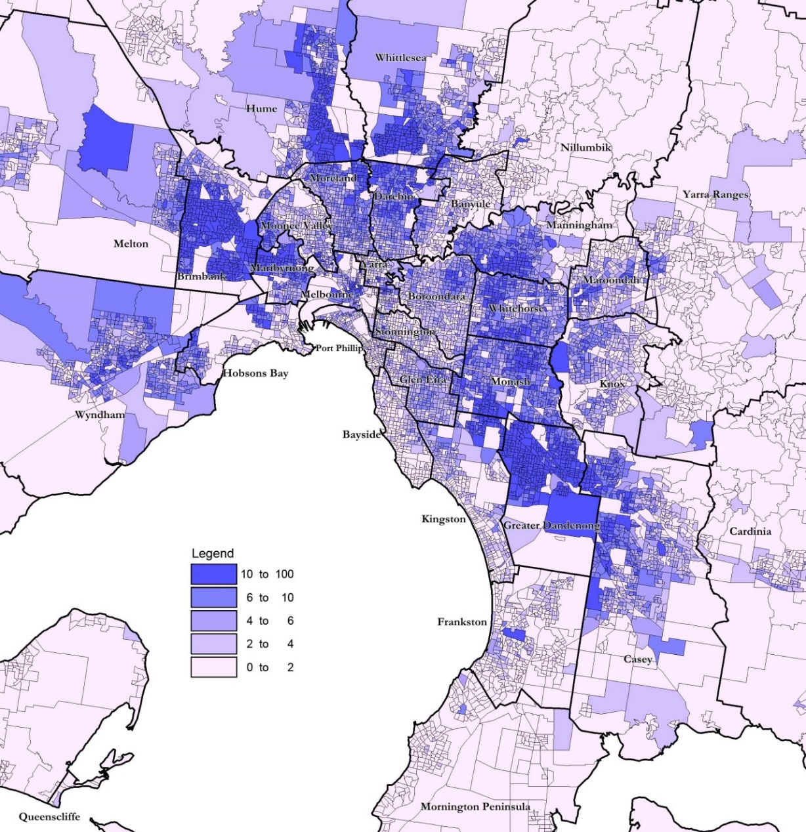
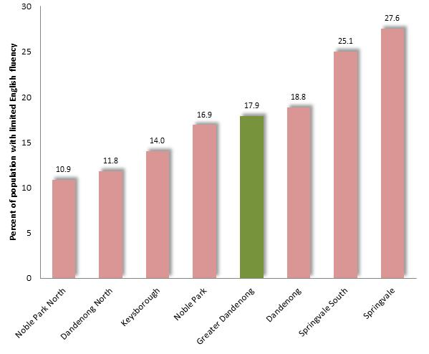
The prevalence of limited English fluency varies among the suburbs of Greater Dandenong, from 11% in Dandenong North, to 28% in Springvale.

Prevalence of Limited English Fluency: Suburbs of Greater Dandenong, 2016

