
Population and Social Conditions in Dandenong

In 2021, Dandenong had an estimated population of 37,600 residents. This suburb features higher levels of migrant settlement and cultural diversity than Greater Dandenong, lower median incomes, rates of early school leaving almost twice those of the municipality, twice its proportion of flats and high levels of crime.
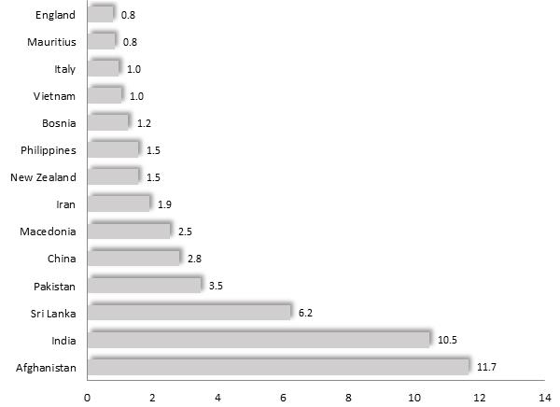
Selected Birthplaces: Dandenong, 2016 The 2016 Census found that 72% of Dandenong residents were born overseas, slightly higher than for Greater Dandenong (64%) and nearly twice the corresponding metropolitan proportion (40.5%). Dandenong is the third most culturally diverse locality in Victoria – after Melbourne and Clayton. Among the 124 birthplaces of its residents were Afghanistan, accounting for 11.7%, India (10.5%), Sri Lanka (6.2%), Pakistan (3.5%) and China (2.8%). A selection of birthplaces is illustrated at left.
Rates of migrant settlement are correspondingly high, with 5% of Dandenong residents having arrived in Australia within the previous 18 months – higher than for Greater Dandenong, at 3.9%.
Languages other than English are spoken by 77% of residents – compared with 70% for Greater Dandenong. Reflecting this diversity of culture, 19% of its population have limited fluency in the use of spoken English, similar to the municipal level of 18%, and over three times the metropolitan level of 6%.
Aside from Christianity, major religious faiths include Islam, adhered to by 34% of residents, Hinduism (10%) and Buddhism (5%).
Contemporary educational outcomes are relatively unfavourable, with 25% of young adults (aged 20-24 years) having left school before completing year 11 – nearly double the municipal average of 13% and three times the metropolitan level of 8.3%
Median individual gross incomes, of $461 p.w., recorded in the 2016 Census, were lower than the Greater Dandenong of $476 and just 68% of the metropolitan median income.
Over one-fifth (22%) of the 11,000 homes in Dandenong are flats, double the proportion across Greater Dandenong (11%) and substantially more than the metropolitan percentage of 16%. Over two-fifths (42%) of homes in the suburb are owned or being purchased by their occupants – fewer than the corresponding metropolitan level of 57%.
The annual rate of violent crime in Dandenong/Dandenong North in 2016/17 was the highest in the municipality, and nearly three times the State level.
 | Dandenong | Greater Dandenong | Metropolitan Melbourne
% Born overseas | 72.0 | 61.7 | 40.5
% Speak languages other than English at home | 77.0 | 70.2 | 38.4
% Population with limited English fluency | 18.8 | 17.8 | 6
% 20-24 year-olds who completed year 10 or less | 24.9 | 13.0 | 8.3
Median weekly individual income | $461 | $476 | $673
% Private dwellings that are flats | 21.9 | 11.4 | 16.3
Population and Social Conditions in Dandenong North

In 2021, Dandenong North had an estimated population of 24,200 residents. The residents of this suburb have slightly lower levels of cultural and language diversity, and crime, than Greater Dandenong, and similar rates of early school leaving and incomes. There is a lower proportion of flats in Dandenong North than for Greater Dandenong and higher levels of home ownership.
Selected Birthplaces: Dandenong North, 2016
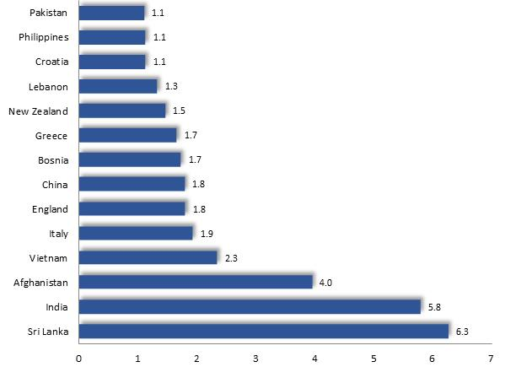
The 2016 Census found that 58% of Dandenong North residents were born overseas, slightly lower than for Greater Dandenong (64%) though more than the corresponding metropolitan proportion (40.5%). Among the 112 birthplaces of its residents were Sri Lanka (accounting for 6.3%), India (5.8%), Afghanistan (4%), Vietnam and Italy.
A selection of birthplaces is illustrated in the accompanying diagram.
2.4% of Dandenong North residents had arrived in Australia within the previous 18 months – less than the figure for Greater Dandenong, of 3.9%.
Languages other than English are spoken by 62% of its residents – compared with 70% for Greater Dandenong. Twelve per cent of Dandenong North residents have limited fluency in the use of spoken English, less than the municipal level of 18%, though twice the metropolitan proportion, of 6%.
Among the major religious faiths, aside from Christianity, are Islam, adhered to by 13% of Dandenong North residents, Buddhism (7%) and Hinduism (7%).
Fourteen per cent of young adults (20-24 years) had left school before completing year 11 – similar to the municipal average of 13% and higher than the metropolitan level, of 8.3%
At $487 p.w., median individual gross incomes recorded in the Census were similar to those for Greater Dandenong and 83 % of metropolitan levels.
Of the 8,200 homes in Dandenong North, just 3.6% are flats, less than one-third of the proportion across Greater Dandenong of 11.4%, and quarter the metropolitan level of 16%. Nearly three-quarters (71%) of homes in the suburb are owned or being purchased by their occupants – higher than the corresponding metropolitan level of 57%.
The annual rate of violent crime in Dandenong/Dandenong North in 2016/17 was the highest in the municipality, and nearly three times the State level.
 | Dandenong North | Greater Dandenong | Metropolitan Melbourne
% Born overseas | 57.7 | 61.7 | 40.5
% Speak languages other than English at home | 61.6 | 70.2 | 38.4
% Population with limited English fluency | 11.8 | 17.8 | 6
% 20-24 year-olds who completed year 10 or less | 14.0 | 13.0 | 8.3
Median weekly individual income | $487 | $476 | $673
% Private dwellings that are flats | 3.6 | 11.4 | 16.3
Population and Social Conditions in Keysborough

In 2021, Keysborough had a population of 30,000 residents. This suburb features lower levels of migrant settlement and cultural diversity than Greater Dandenong, as well as higher levels of English proficiency, substantially greater incomes and levels of home ownership, fewer flats and lower rates of early school leaving.
The 2016 Census found that 57% of Keysborough residents were born overseas, slightly lower than for Greater Dandenong (64%) though more than the metropolitan percentage (40.5%). Among the 105 birthplaces of its residents were Vietnam (accounting for 9.1%), Cambodia (7.3%), India (6.1%) and China (4.4%).
Selected Birthplaces: Keysborough, 2016
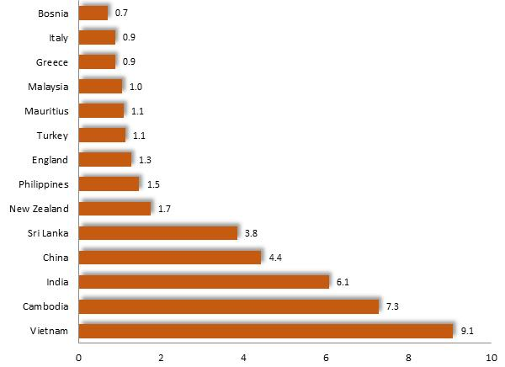
A selection of birthplaces is illustrated in the diagram at left.
Rates of migrant settlement are relatively low, with 2.1% of Keysborough residents having arrived in Australia within the previous 18 months – about half the figure for Greater Dandenong, of 3.9%.
Languages other than English are spoken by 63% of residents – compared with 70% for Greater Dandenong. Fourteen per cent of Keysborough residents have limited fluency in the use of spoken English, more than the municipal level of 18% and over twice the metropolitan level of 6%.
Among the religious faiths, aside from Christianity, are Buddhism, adhered to by 20% of residents, Islam (5%) and Hinduism (5%).
Six per cent of young adults (20-24 years) had left school before completing year 11 – lower than the municipal average of 13% and the metropolitan level, of 8.3%
Median individual gross incomes of $581 p.w. recorded in the Census, are the highest in Greater Dandenong and over four-fifths (86%) of metropolitan levels.
Of the 8,500 homes in Keysborough, just 2.2% are flats, far less than the proportion across Greater Dandenong of 11.4%, or the metropolitan level of 16%. Eighty-two per cent of homes in the suburb are owned or being purchased by their occupants – substantially higher than the metropolitan level of 57%.
The annual rate of violent crime in Keysborough in 2016/17 was less than half the Victorian level.
 | Keysborough | Greater Dandenong | Metropolitan Melbourne
% Born overseas | 56.6 | 61.7 | 40.5
% Speak languages other than English at home | 62.7 | 70.2 | 38.4
% Population with limited English fluency | 14.0 | 17.8 | 6
% 20-24 year-olds who completed year 10 or less | 5.8 | 13.0 | 8.3
Median weekly individual income | $581 | $476 | $673
% Private dwellings that are flats | 2.2 | 11.4 | 16.3

Population and Social Conditions in Noble Park

In 2021, Noble Park had an estimated population of 34,400 residents. The suburb is characterised by similar social conditions to those across Greater Dandenong, including high levels of cultural diversity, relatively low incomes, elevated rates of early school leaving, substantial crime rates and a high density of flats. Rates of migrant settlement however, are twice municipal levels.
Selected Birthplaces: Noble Park, 2016
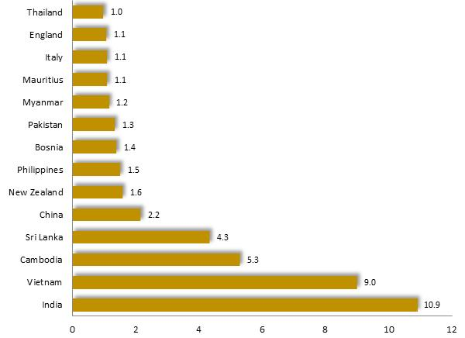
The 2016 Census recorded that 65% of Noble Park residents were born overseas, similar to Greater Dandenong (64%) and more than the metropolitan percentage (40.5%). The 84 birthplaces of its residents include India, accounting for 10.9% of residents, Vietnam (9%) as well as Cambodia, Sri Lanka and China.
A selection of birthplaces is illustrated in the accompanying diagram.
Rates of migrant settlement are correspondingly high, with 4.4% of residents having arrived in Australia within the previous 18 months – slightly higher than the Greater Dandenong figure of 3.9%.
Languages other than English are spoken by about two-thirds of residents (69%) – nearly twice the metropolitan average of 38%. Reflecting this diversity of languages, 17% of Noble Park residents have limited fluency in the use of spoken English, similar to the municipal level of 18%, and nearly three times the metropolitan level of 6%. Patterns of religious faith are similar to those seen across the municipality, with 18% of residents adhering to Buddhism, 5% following Hinduism, and 11% Islam.
Contemporary educational outcomes are marked by a high rate of early school leaving, with 10.4% of young adults (20-24 years) having left school before completing year 11 – lower than the municipal average, but higher than the metropolitan level, of 8.3%
Median individual gross incomes, recorded in the Census, stood at $484 - 72% of the metropolitan median and slightly higher than the municipal level.
Among the 12,000 homes in Noble Park, nearly one-fifth (19%) are flats – slightly higher than the corresponding proportion of 16% across metropolitan Melbourne. Fifty-seven per cent of homes in the suburb are owned or being purchased by their occupants – the same as for metropolitan Melbourne.
The violent crime rate in Noble Park/Noble Park North in 2016/17 was substantially higher than the Victorian level, but slightly less than for Greater Dandenong.
 | Noble Park | Greater Dandenong | Metropolitan Melbourne
% Born overseas | 65.3 | 61.7 | 40.5
% Speak languages other than English at home | 69.1 | 70.2 | 38.4
% Population with limited English fluency | 16.9 | 17.8 | 6
% 20-24 year-olds who completed year 10 or less | 10.4 | 13.0 | 8.3
Median weekly individual income | $484 | $476 | $673
% Private dwellings that are flats | 18.8 | 11.4 | 16.3
Population and Social Conditions in Noble Park North

In 2020, Noble Park North had an estimated population of 7,900 residents. This community is characterised by lower levels of migrant settlement, cultural and language diversity, and limited English proficiency than Greater Dandenong. Incomes are higher than municipal levels and rates of early school leaving lower than for Greater Dandenong. Noble Park North also features higher rates of home ownership than Greater Dandenong or Melbourne and fewer flats.
Selected Birthplaces: Noble Park North, 2016
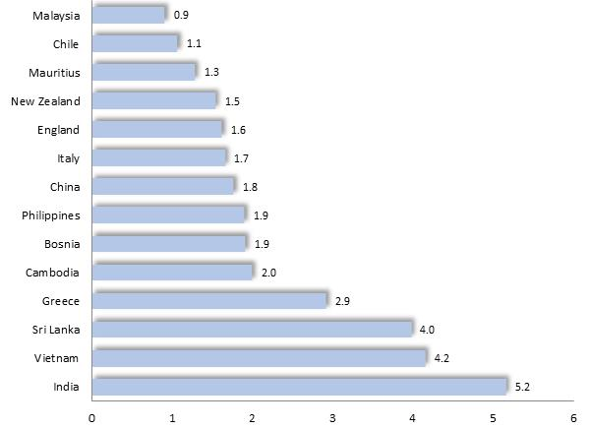
The 2016 Census found that 55% of Noble Park North residents were born overseas, slightly lower than for Greater Dandenong (64%) though more than the corresponding metropolitan proportion (40.5%). Among the 119 birthplaces of its residents were India (5.2%), Vietnam (4.2%), Sri Lanka (4%), Greece and Cambodia.
A selection of birthplaces is illustrated in the accompanying diagram.
Rates of migrant settlement are relatively low, with 2.1% of residents having arrived in Australia within the previous 18 months – little more than half the Greater Dandenong figure, of 3.9%.
Languages other than English are spoken by 58% of residents – compared with 70% for Greater Dandenong. Eleven per cent of Noble Park North residents have limited fluency in the use of spoken English, less than the municipal level of 18% though nearly double the metropolitan level of 6%.
Among the major religious faiths, aside from Christianity, are Buddhism, adhered to by 10% of residents, Islam (8%) and Hinduism (3%).
8.6% of young adults (20-24 years) had left school before completing year 11 – lower than the municipal average of 13% and similar the metropolitan level of 8.3%
At $499 p.w., median individual gross incomes, recorded in the 2016 Census were higher than for Greater Dandenong of $476, and nearly three-quarters of metropolitan levels.
Of the 2,850 homes in Noble Park North, just 8% are flats, less than the municipal level of 11.4% and half the metropolitan level, of 16%. Nearly three-quarters (72%) of homes in the suburb are owned or being purchased by their occupants – substantially more than the metropolitan level of 57%.
The violent crime rate in Noble Park/Noble Park North in 2016/17 was substantially higher than the Victorian level, but slightly less than for Greater Dandenong.
 | Noble Park North | Greater Dandenong | Metropolitan Melbourne
% Born overseas | 55.2 | 61.7 | 40.5
% Speak languages other than English at home | 58.4 | 70.2 | 38.4
% Population with limited English fluency | 10.9 | 17.8 | 6
% 20-24 year-olds who completed year 10 or less | 8.6 | 13.0 | 8.3
Median weekly individual income | $499 | $476 | $673
% Private dwellings that are flats | 8.3 | 11.4 | 16.3

Population and Social Conditions in Springvale

In 2021, Springvale had an estimated population of 25,000 residents. The suburb features higher levels of migrant settlement, cultural and language diversity, and limited English proficiency than Greater Dandenong, while incomes and rates of early school leaving are lower than the municipal average.
Selected Birthplaces: Springvale, 2016
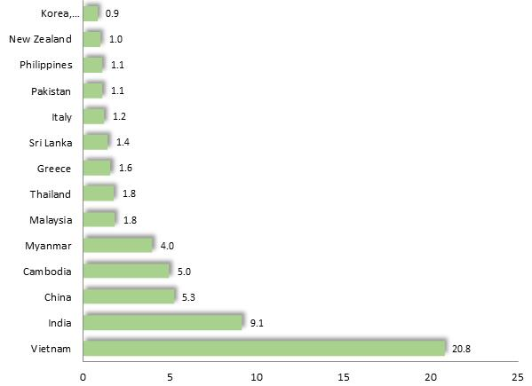
The 2016 Census found that 72% of Springvale residents were born overseas, higher than for Greater Dandenong (64%) and substantially more than the corresponding metropolitan proportion (40.5%). Among the 89 birthplaces of its residents were Vietnam (20.8%), India (9.1%), China (5.3%) and Cambodia (5%).
A selection of birthplaces is illustrated in the chart at right.
Rates of migrant settlement are substantial, with 5.6% of residents having arrived in Australia within the previous 18 months – higher than the Greater Dandenong rate of 3.9%.
Languages other than English are spoken by 82% of Springvale residents – compared with 70% for Greater Dandenong. Twenty-eight per cent have limited fluency in the use of spoken English, higher than the municipal level of 18% and over four times the metropolitan level of 6%.
Among the major religious faiths, aside from Christianity, are Buddhism, adhered to by 25% of residents, Islam (10%) and Hinduism (4%).
Ten per cent of young adults (20-24 years) had left school before completing year 11 – lower than the municipal average of 13% and higher than the metropolitan level, of 8.3%.
Median individual gross incomes of $410 p.w., recorded in the Census, are the lowest in Greater Dandenong and equivalent to 61% of metropolitan levels.
Of the 7,500 homes in Springvale, 10% are flats, less than the proportion across Greater Dandenong of 11.4% and metropolitan level of 16%. Fifty-nine per cent of homes are owned or being purchased by their occupants – similar to the metropolitan level of 57%.
The annual rate of violent crime in Springvale in 2016/17 was similar to the Greater Dandenong level and substantially higher than the Victorian rate.
 | Springvale | Greater Dandenong | Metropolitan Melbourne
% Born overseas | 71.8 | 61.7 | 40.5
% Speak languages other than English at home | 82.4 | 70.2 | 38.4
% Population with limited English fluency | 27.6 | 17.8 | 6
% 20-24 year-olds who completed year 10 or less | 10.2 | 13.0 | 8.3
Median weekly individual income | $410 | $476 | $673
% Private dwellings that are flats | 10 | 11.4 | 16.3

Population and Social Conditions in Springvale South

In 2021, Springvale South had an estimated population of 14,000 residents. These residents have similar levels of cultural diversity and rates of migrant settlement to Greater Dandenong, coupled with lower levels of early school leaving and incomes than Greater Dandenong and a high proportion of Buddhist residents. There is a lesser proportion of flats in Springvale South than for Greater Dandenong and higher levels of home ownership.
Selected Birthplaces: Springvale South, 2016
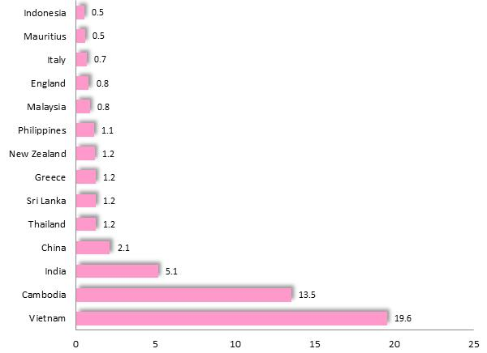
The 2016 Census found that 64% of Springvale South residents were born overseas, the same as for Greater Dandenong and substantially more than the metropolitan level of 40.5%. Among the 82 birthplaces of its residents were Vietnam (19.6%), Cambodia (13.5%), India (5.1%) and China (2.1%).
A selection of birthplaces is illustrated in the accompanying diagram.
Rates of migrant settlement are relatively low, with 2.4% of residents having arrived in Australia within the previous 18 months – less than the corresponding figure for Greater Dandenong, of 3.9%.
Languages other than English are spoken by 77% of residents – compared with 70% for Greater Dandenong. Twenty-five per cent of Springvale South residents have limited fluency in the use of spoken English, more than the municipal level of 18% and over four times the metropolitan level, of 6%.
Among the major religious faiths, aside from Christianity, are Buddhism, adhered to by 36% of residents, Islam (3%) and Hinduism (2%).
Seven per cent of young adults (20-24 years) had left school before completing year 11 – lower than either the municipal average of 13% and the metropolitan level of 8.3%
Median individual gross incomes of $449 p.w., recorded in the 2016 Census, are lower than the Greater Dandenong figure of $476 and about two-thirds (67%) of metropolitan levels.
Of the 4,100 homes in Springvale South, just 3% are flats, less than the Greater Dandenong level of 11.4%, and metropolitan level of 16%. Nearly three-quarters (73%) of homes in the suburb are owned or being purchased by their occupants – higher than the metropolitan proportion of 57%.
In 2016/17, the rate of violent crime in Springvale South was half the Victorian level and a third of the municipal rate.
 | Springvale South | Greater Dandenong | Metropolitan Melbourne
% Born overseas | 63.6 | 61.7 | 40.5
% Speak languages other than English at home | 76.8 | 70.2 | 38.4
% Population with limited English fluency | 25.1 | 17.8 | 6
% 20-24 year-olds who completed year 10 or less | 7.4 | 13.0 | 8.3
Median weekly individual income | $449 | $476 | $673
% Private dwellings that are flats | 2.9 | 11.4 | 16.3

