

City of Greater Dandenong
Sustainable Design Assessment in the Planning Process (SDAPP)

Sustainable Management Plan (SMP)
Example Report

January 2017

Table of Contents

About this document 3
Introduction 4
1.0 Indoor Environment Quality 6
2.0 Energy Efficiency 7
3.0 Water Resources 10
4.0 Stormwater Treatment 11
5.0 Building Materials 12
6.0 Transport 13
7.0 Waste Management 14
8.0 Urban Ecology 15
9.0 Innovation and ESD Excellence 16
10.0 Construction and Building Management 16
11.0 Implementation and Commissioning 17
APPENDIX A – Built Environment Sustainability Scorecard (BESS) Report 19

About this document
This document provides an example of an ESD Report for large-scale applicants seeking a planning permit within the City of Greater Dandenong. Large-scale applicants participating in the Sustainable Design Assessment in the Planning Process (SDAPP) program within Greater Dandenong should submit a Sustainable Management Plan (SMP) that responds to each of the following 10 Key Sustainability Criteria:
Indoor Environment Quality  Energy Efficiency  Water Efficiency  Stormwater Management  Building Materials | Transport  Waste Management  Urban Ecology  Innovation  Construction and Building Management

This document is not designed to set a minimum standard or to provide a definitive list of environmentally sustainable design (ESD) initiatives to be included in a development. ESD should be integrated into the design of a new building from the earliest stage. The best ESD response will depend on many site-specific factors.

Introduction
This Sustainable Management Plan has been prepared for the proposed development at 225 Lonsdale Street, Dandenong, VIC 3175

The City of Greater Dandenong uses the Sustainable Design Assessment in the Planning Process (SDAPP) framework, under which this proposal is classified as ‘large-scale’ development.
SDAPP refers to:

“the consistent inclusion of key environmental performance considerations into the planning permit approvals process in order to achieve more sustainable outcomes for the long-term benefit of the wider community”.

This report demonstrates how this development incorporates environmentally sustainable design initiatives.

The Site
The site is located at 225 Lonsdale Street, Dandenong. The proposed mixed-use development is 4 storeys over 1 basement level for car parking. It comprises 20 apartments (10 one bedroom apartments and 10 two bedroom apartments) and five retail shops.

The total site area is 1000m².
Gross floor area is 2500m2 (Non-Residential 500m2, Residential 1750m2, and Common 250m2).
Residential conditioned floor area 1500m2.

Floor | Details
Basement | 20 Car Parking Space  40 Secure Bicycle Parking Space  50kL Rainwater Tank  55m2 Waste and Recycling Storage Area
Ground floor | 5 Retail Shops
1st floor | 8 Apartements
2nd floor | 8 Apartements
3rd floor | 4 Apartements
Roof | Roof Garden + 5kW Solar PV System

Built Environment Sustainability Scorecard (BESS) Results  The development has been assessed using the BESS assessment tool (www.bess.net.au).  A summary of the results is shown in the table below. For the full BESS Report please see APPENDIX A. | 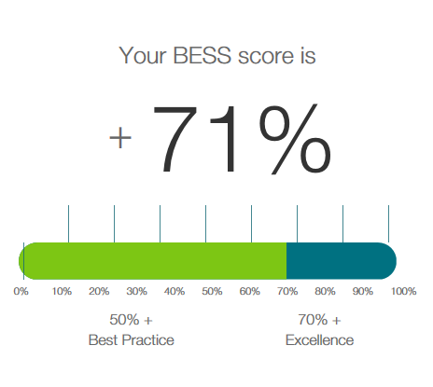

% of Total | Category | Score | Pass
4% | Management | 100% | NA
5% | Water | 62% | YES
17% | Energy | 63% | YES
13% | Stormwater | 100% | YES
12% | IEQ | 74% | YES
7% | Transport | 86% | NA
5% | Waste | 100% | NA
4% | Urban Ecology | 88% | NA
0% | Innovation | 0% | NA

1.0 Indoor Environment Quality
Indoor environment quality is about creating healthy living spaces for building occupants, including rooms that are designed for optimal daylight access, to promote natural ventilation and are comfortable with minimal need for mechanical heating and cooling. The use of low toxicity materials and finishes also supports a health indoor air quality as off-gassing of volatile organic compounds is minimised.

Actions to maximise indoor environment quality
Actions | Potential Impact | Strategies and innovations
Maximise daylighting | Access to daylight has physical and mental health benefit for occupants. Daylighting is particularly important for living spaces. | - 60 % of apartments include north facing windows to habitable rooms.  - No borrowed light to bedrooms – each bedroom has an openable window.  - Common area corridors include windows to improve light penetration.
Maximise opportunities for natural ventilation | Natural ventilation reduces demand for mechanical cooling and prevents build-up of indoor pollutants. | - 70% of apartments achieve natural cross ventilation through openable areas on opposite/adjacent orientations.  - Common area corridors have openable windows to facilitate airflow  - Single aspect apartments include security doors to help ventilation.
Thermal comfort | Reduced demand for mechanical heating and cooling. | - Apartments achieve an average 6.5 NatHERS star rating  - Ceiling fans to be installed in apartment bedrooms as a low energy alternative to mechanical cooling.
Low VOC materials | Reduction in ‘off-gassing’ and associated health issues from products with high levels of VOCs. | - Low VOC paints  - Low VOC flooring  - Low VOC adhesives and sealants  Products chosen will meet the maximum VOC levels as defined in the Green Star credit IEQ-8 Volatile Organic Compounds.

2.0 Energy Efficiency
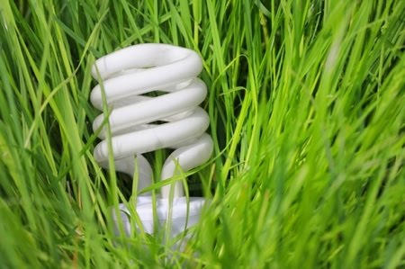
Buildings contribute approximately 20% of global greenhouse gas emissions (Stern Review, 2006), and therefore represent a huge potential for energy and greenhouse gas emission reduction. The highest energy consumption usually comes from heating and cooling, therefore decisions that are made in the early design phase can lock in poor building performance and high energy costs for 50 years or more. Conversely, good design decisions can ensure that a building is future-proofed against rising energy prices.

Actions to maximise energy efficiency

Actions | Potential Impact | Strategies and innovations
Maximise thermal performance | Seven star houses use on average 45% less heating and cooling compared with a 5 star house. | - Apartments will achieve an average 6.5 star energy rating which is a 10% improvement on min. standards (see below for sample energy rating).  - North facing balconies and adjustable shading to east and west facing glazing.  - Common corridors will be naturally ventilated.
Minimise standby power consumption | Standby power can account for up to 10% of a household’s energy consumption | - Dwelling shutdown switches will be installed at apartment entrance doors, so that non-essential appliances can be switched off on leaving the property.
Use energy efficient heating & cooling systems | Heating and cooling systems can account for up to 40% of a household’s energy use | - Passive design initiatives reduce demand on mechanical heating and cooling, but where heating & cooling is needed, reverse cycle air conditioners are specified (within 1 star of best available for both the heating and cooling cycle).  - Reversible ceiling fans will be installed in all apartment bedrooms as a low energy cooling alternative.
Use energy efficient hot water system | Hot water can account for up to 25% of a household’s energy use. | - A centralised solar-gas hot water system with a minimum 50% solar contribution and a minimum gas system efficiency of 86%.
Use energy efficient appliances | While many appliances are supplier by the owner/occupier, some fixed appliances will be provided, including dishwashers and washing machines. | - Dishwashers specified with an energy star rating of within 1 star of best available.  - Washing machines specified with an energy star rating of within 1 star of best available.
Natural clothes drying | Mechanical clothes dryers are energy intensive – this impact can be eliminated by providing options for outdoor clothes drying. | - Foldaway clotheslines (6m of line) to be provided to apartment balconies.
Energy efficient lighting | Common area lighting often runs 24/7, 365 days per year. This can add up to significant energy use for the building. | - Occupancy and daylight sensors to be provided for common area lighting.  - Common area lighting will be compact fluorescent or LED.  - Carpark lighting to be T5 fluorescent, a portion of this on occupancy sensor.  - Apartment lighting to meet 5W/m² under BCA 2011.
Green Roofs | Green roof help to displace the urban heat island effect, which can increase localised temperatures by up to 7ºC. Green roofs can also provide additional insulation to the building. | - Rooftop garden provided, leading to some offset of the urban heat island effect.
Building Management System | An optimised BMS extends equipment life and maximises energy efficiency by ensuring energy is only used where necessary. | - All apartments & retail tenancies will be fitted with a ‘shutdown switch’, allowing all non-critical appliances to be easily switched off when leaving the building.  - Building services will be fine-tuned quarterly during first 12 months of occupation, in line with the best practice requirements in the Green Star rating tool.

On-site energy generation
Actions | Potential Impact | Strategies and innovations
Photovoltaic panels | Reduce emissions from common area lighting & services. Distributed systems reduce the need for upgraded grid infrastructure. | - A 5kW grid connected photovoltaic system will be installed to service common area lighting and other building services.
Solar water heating | Hot water can account for up to 25% of a household’s energy use. | - A centralised solar-gas hot water system with a minimum 50% solar contribution and a minimum gas system efficiency of 86%.

Sample FirstRate Assessments
A representative sample of 10 apartments was modelled using the FirstRate software. This included a range of apartment layouts and orientations and also the apartments likely to have the poorest thermal performance rating. This is a useful check that the development will meet the energy rating requirements of the Building Code of Australia (BCA). A minimum average of 6 stars (138 MJ/m² in Tullamarine climate zone 60) is required to comply with the BCA (2011), with no apartment rating less than 5 stars.

FirstRate calculates the required energy to maintain the dwelling at a comfortable temperature, using the building fabric (floors, walls/windows, roof) information as its input, plus the relevant climate zone (in this case Tullamarine, climate zone 60).

The following star ratings were achieved:

Apartment | Star Rating | Conditioned Floor Area | Total Energy Use (MJ/m2) | Heating Energy Use (MJ/m2) | Cooling Energy Use (MJ/m2)
1.02 | 6.0 | 73 | 116.2 | 92.1 | 24.1
1.06 | 6.2 | 67 | 108.1 | 82.0 | 26.1
1.07 | 7.2 | 67 | 82.8 | 74.5 | 8.3
2.03 | 6.0 | 55 | 112.8 | 90.6 | 22.2
2.06 | 6.3 | 67 | 100.6 | 75.9 | 24.7
2.09 | 6.4 | 54 | 98.6 | 75.9 | 22.7
3.01 | 6.1 | 58 | 110.1 | 83.0 | 27.1
3.09 | 6.0 | 70 | 112.2 | 89.1 | 23.1
4.05 | 7.6 | 65 | 82.8 | 74.5 | 8.3
4.06 | 6.8 | 62 | 100.6 | 75.9 | 24.7
Average | 6.5 | 63.8 | 110.4 | 86.1 | 24.3

Based on this sample, the development is likely to achieve an average 6.5 star rating. Note these ratings depend on the following assumptions:
- All gaps around windows, doors are to be sealed.
- All exhaust fans are to be self-closing
- Roof insulation R4.0 (additional R-value)
- External wall insulation R2.5 (additional R-value)
- Window systems – U-value = 4.95, SHGC = 0.7 (standard aluminium frame, 6mm air gap, double glazed units)

3.0 Water Resources
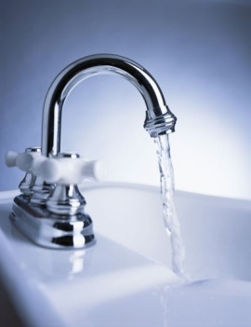
In order to conserve our precious water resources, our cities and our buildings need to carefully plan for water efficiency, and for water use that is ‘fit-for-purpose’. Potable water is treated to drinking water standard and this water quality level is not needed for every application.

Water Efficiency
Water fittings and appliances are rated under the Water Efficiency Labelling and Standards (WELS) scheme. Choosing high WELS rated fittings and appliances (where specified) are a key way to reduce water consumption within a development. Landscaping with low water use species reduces outdoor water use while maintaining attractive outdoor communal spaces.

Actions to maximise water efficiency
Actions | Potential Impact | Strategies and innovations
Water efficient fittings | High efficiency fittings can reduce water use by 50% or more. | - Toilets: 4 star WELS rated (4.5/3)  - Showerheads: 5 star WELS rated (7L/minute)  - Taps: 5 star WELS rated (5L/minute)
Water efficient appliances | High efficiency appliances can reduce water use by 50% or more. | - Dishwashers: WELS rating within 1 star of best available.
Re-use fire system test water | Fire systems need to be tested regularly – this water can be re-used rather than wasted. | - Fire system test water will be fed back to the rainwater tank and used on-site.
Water efficient landscaping & gardens | No potable water used for garden irrigation means that potable water is not wasted but is fit for purpose | - The roof garden will incorporate drought tolerant species where possible (other areas of the roof garden will be used for food production).  - All garden areas will be irrigated using collected rainwater.

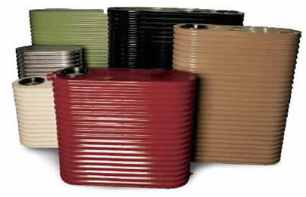
Rainwater Harvesting
A 50,000 litre rainwater tank will be installed in the basement of this development. This tank will collect rainwater from 75% of the roof area (750m²). See plans for location.
Ground Floor retail toilets, first and second floor apartment toilets will be connected to the rainwater storage system.

4.0 Stormwater Treatment
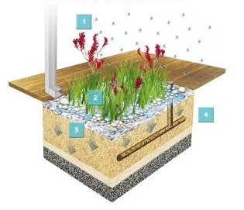
Stormwater quality is a significant issue in urban areas as the high levels of impervious surfaces transport stormwater quickly into the drainage system along with sediment and pollutants from the urban environment. Strategies for improving stormwater include reducing volume entering the stormwater system, either by on-site re-use or by maximising on-site penetration, and also providing treatment measures so that the quality of any stormwater leaving the site is improved.
This development achieves a score of 107% using Melbourne Water’s STORM tool.

Actions | Potential Impact | Strategies and innovations
Rainwater harvesting | Reduction in volume of stormwater to the stormwater system means integrity of stormwater infrastructure is protected.  Mains consumption is reduced by on-site reuse. | - 50,000L rainwater tank connected to 50% of the roof area (750m2). Ground floor retail toilets and toilets to apartments on Floors 1 & 2 will be connected to the tank.
Water Sensitive Urban Design | Increased infiltration means that groundwater flows are improved.  Treatment via raingardens means quality of stormwater entering the mains system is improved. | - 10m² raingarden to treat rainwater tank overflow before it enters the stormwater system.

5.0 Building Materials
A building’s life cycle impact is largely influenced by material selection, including embodied energy of the material, longevity/durability, source, ability to be reused / recycled and the toxicity of material components.

Standard and certification schemes for sustainable materials, such as EcoSpecifier’s Green Tag program and Good Environmental Choice Australia (GECA), provide an independent assessment and are the best starting point for material selection for sustainability.

Actions for sustainable material selection
Actions | Potential Impact | Strategies and innovations
Re-use of existing materials | Avoids sending waste to landfill as well as the higher embodied in new materials. | - Bricks from existing building will be retained and re-used in the new structure  - 80% of construction waste will be recycled (see Waste section)
Recycled content materials | Reduced embodied energy of material by using recycled content rather than virgin materials. | - All concrete used in the project will have a minimum 20% recycled aggregate content.  - All plasterboard will be specified as having a recycled content of not less than 10%.
PVC Minimisation | Human health implications of PVC are related to chemical components used in manufacture, which are known carcinogens, mutagens and teratogens. | - The use of PVC will be minimised. HDPE water pipes will be specified as an alternative.
Sustainable Timber | Avoid timber that may be illegally logged, from old growth forests, or from plantations that are poorly managed | - All timber used in the project will be from a sustainable source – either FSC or AFS certified.
Dematerialisation | Using less material where possible reduces the overall embodied energy of the building. | - Finishes will be raw and exposed where possible to reduce the embodied energy of the building.

6.0 Transport
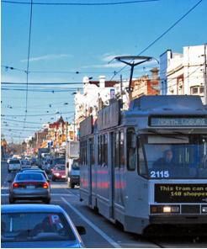
Many transport impacts are inherent to a building’s location, such as the distance from employment, shops, services, schools and recreation. However, sustainable transport options can be facilitated through a building design that promotes convenient use of bicycles and reduced dependence on private vehicle use.
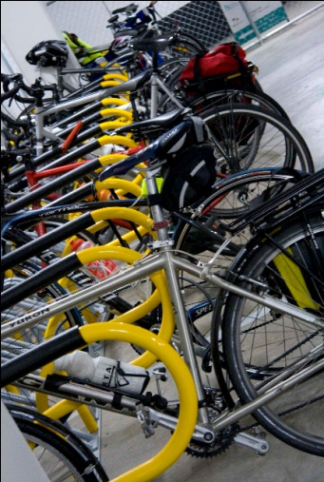
This development is located close to Dandenong Railway Station, and Thomas Street and Walker Street bus services, thereby providing a range of public transport options with close proximity. The Dandenong Plaza, the Dandenong Market, plus shopping areas are within walking distance.
The development is also ideally located for bicycle commuters, being close to the foreshore bike path, one of Melbourne’s major bicycle transport routes. To facilitate sustainable transport choices, a bicycle storage room is provided in the the apartment basement, with 40 bicycle parking spaces (1 per 1 bedroom apartment, 2 per 2 bedroom apartment, plus 2 per retail tenancy). End of trip facilities are also provided within each retail tenancy.

Actions for sustainable transport
Actions | Potential Impact | Strategies and innovations
Bicycle parking on-site | Reduced demand on car transport, reduced demand on public transport. Active & cost effective transport option. | - Bicycle parking provided at the rate of 1 per dwelling for 1 bedroom apartments and 2 per dwelling for 2+ bedroom apartments.  - For retail tenancies, and additional 2 bicycle parking spaces per tenancy
Public transport access | Provides an alternative to private vehicle use. | - This development is well located for public transport. The following services are within 250m walk:  - Dandenong station 10 min interval between services at peak times.  - Walker St and Thomas St bus (3 bus services). 10 min interval between services at peak times.
Pedestrian access | Health and environmental benefits. | - The site is well located for local shopping on foot being located in the heart of Dandenong.
Car sharing schemes | Has the potential to reduce private vehicle ownership. | - No car sharing schemes are currently located nearby. The developer will seek to work with Council and with car-sharing companies to establish an on-street location close by.

7.0 Waste Management

Actions for waste avoidance and recycling
Actions | Potential Impact | Strategies and innovations
Construction Waste Management Plan | Construction and demolition waste makes up approximately one third of waste to landfill in Victoria (Sustainability Victoria). Most of this waste is inert & can be easily recycled for other purposes. | - Before construction commences, a Construction Management Plan will be submitted. This plan will include a commitment to recycle 80% of waste during the construction phase of the project.
Operational Waste Management Infrastructure | Convenient infrastructure can significant improve recovery rates for recyclable materials | - Kitchens are designed for in-built separated bins for recyclables and waste  - Dedicated bin storage area in the basement will be easy to access and have appropriate signage.  - The following space requirements will be provided for bins:  Recycling: 42.5m²  Rubbish: 12.5m²  Green Waste: 1 bin

8.0 Urban Ecology
Urban ecology is about promoting and protecting ecosystems and biodiversity. Urban and agricultural development has caused displacement of species and degradation of natural environments – therefore in many established urban areas the aim is to increase biodiversity. Biodiversity provides a number of services that have traditionally been, and continue to be, undervalued, such as:
- Protection of water resources
- Soil formation & protection
- Nutrient storage & recycling
- Pollution breakdown
- Ecosystem maintenance
As well as all the products we harvest and use, such as food, medicine and building products.
This development is a redevelopment of an old retail shop site within an existing Central Dandenong area. Opportunities for protecting biodiversity are limited; however there are still initiatives that can be incorporated into the development in order to enhance biodiversity and urban ecology.

Actions for urban ecology
Actions | Potential Impact | Strategies and innovations
Re-use of land | Development in existing urban areas helps reduce the need for greenfield development and the associated environmental impacts, such as car dependency, increased need for infrastructure and displacement of agricultural land. | - This development is a redevelopment of an existing building, thereby increasing density in already established urban areas and reducing urban sprawl.
Topsoil retention | Retaining topsoil conserves the valuable resource it provides and reduces unnecessary waste to landfill. | - The small amount of topsoil from the existing site will be separated and protected during construction, and then used on the roof garden of the new building.
Outdoor communal facilities | On average, people spend 90% of their lives indoors. There is a growing body of evidence that demonstrates how communal green spaces can offer lasting economic, environmental and social benefits. | - A large outdoor communal space (250m²) is provided with the rooftop garden, including seating, shaded areas and a bbq area. This will promote outdoor activities and a sense of community amongst the building’s residents.
Biodiversity |  | - Landscaping will incorporate indigenous plants to encourage local insects and birds.

9.0 Innovation and ESD Excellence
Innovation and ESD Excellence is a category designed to recognise new or outstanding ESD initiatives not recognised elsewhere (such as in the Green Star tools). This development is not claiming any initiatives under this category.

10.0 Construction and Building Management

Actions for ongoing building performance
Actions | Potential Impact | Strategies and innovations
Building fine-tuning | Ensures the building services operate as designed, throughout various climatic conditions and with realistic occupancy profiles. | - Building services will be fine-tuned each quarter for the first 12 months of occupation, in line with the best practice requirements in the Green Star rating tool.
Building User’s Guide | Provides educational information to the building occupants as to how to operate the building most effectively. | - A building user’s guide will be supplied to each apartment and information will be displayed in the building’s entrance foyer. The user’s guide will outline the buildings sustainability features and educate residents and tenants on how to operate the building most effectively

11.0 Implementation and Commissioning
Implementation of the ESD initiatives in this report requires the following process:
- Full integration with architectural plans & specifications
- Full integration with building services design drawings & specifications
- Endorsement of the ESD report with town planning drawings
- ESD initiatives to be included in plans and specifications for building approval
The following implementation schedule is provided.
Actions | Requirement | Responsibility | Date Completed
FirstRate Assessments | Full FirstRate ratings for each dwelling, based on recommendation of sample ratings | ESD Consultant, Architect
Window glazing | To be specified according to energy ratings & BCA | Architect, Builder
Insulation & sealing | To be specified according to energy ratings | Architect, Builder
Air-conditioning systems | Reverse cycle split systems, 5 star heating cycle and 5 star cooling cycle | Services Engineer, Builder
Hot water heating | Centralised solar-gas hot water system with a minimum 50% solar contribution and a minimum gas system efficiency of 86% | Services Engineer, Builder
Lighting | To meet 5W/m² as per BCA 2011 | Architect, Builder
Security Doors | Security doors on all apartment entrance doors. | Architect, Builder
Motion / time switch controls | Common area lighting (including carpark lighting) to be controlled by motion sensors or timers as appropriate. | Services Engineer, Builder
Bike storage | 60 bicycle parking spaces to be installed in basement storage room. | Architect, Builder
Clothes drying | Foldaway clotheslines to be installed to apartment balconies | Architect, Builder
Metering | Install separate water and electricity meters to each apartment | Services Engineer, Builder
VSD pumps/fans | Specify and install pumps and fans with variable speed drives | Services Engineer, Builder
Energy efficient lifts | Specify and install energy efficient lifts | Services Engineer, Builder
Apartment shutdown switches | Each apartment to have a ‘shutdown switch’ located inside entrance doors for all non-essential appliances. | Services Engineer, Builder
Rainwater tank | Specify and install 50,000 L rainwater with plumbing to all ground, first and second floor toilets. | Services Engineer, Builder
Water efficient toilets | Specify and install minimum 4 star toilets | Architect, Builder
Water efficient taps | Specify and install minimum 5 star taps | Architect, Builder
Water efficient showers | Specify and install minimum 3 star showerheads | Architect, Builder
Water efficient appliances | Specify and install dishwashers with WELS star rating within 1 star of best available | Architect, Builder
Fire system test water capture | Specify and install fire system with ability to capture and reuse water. | Builder, Services Engineer
Concrete | Concrete to have minimum 20% recycled aggregate content. | Builder
Plasterboard | Plasterboard to have minimum 10% recycled content. | Builder
Timber | All timber to be FSC or AFS certified | Builder
Material Re-use | Bricks and other material to be salvaged from demolition of existing building and reused in new building. | Architect, Builder
Topsoil | Topsoil on existing site to be retained and used in landscaping for new building. | Builder
Construction Management Plan | Prepare Construction Waste Management Plan to maximise recycling of construction waste (80% min). | Builder
Low VOC paints, sealants, adhesives | Specify and use low VOC paints, sealants and adhesives | Architect, Builder
Building Users Guide | Prepare Building Users Guide and distribute to occupants. Display in prominent location at apartment entrance | Owner’s Corporation, ESD Consultant, Building Services
Building tuning | Undertake building services fine-tuning each quarter for the first 12 months of occupation. | Owner’s Corporation, Building Services

APPENDIX A – Built Environment Sustainability Scorecard (BESS) Report

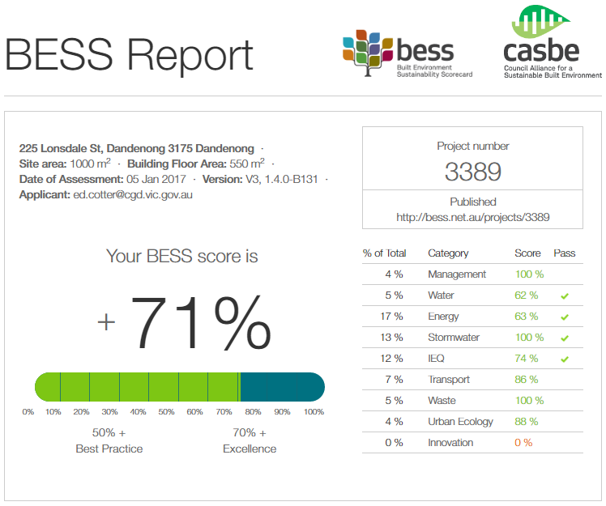

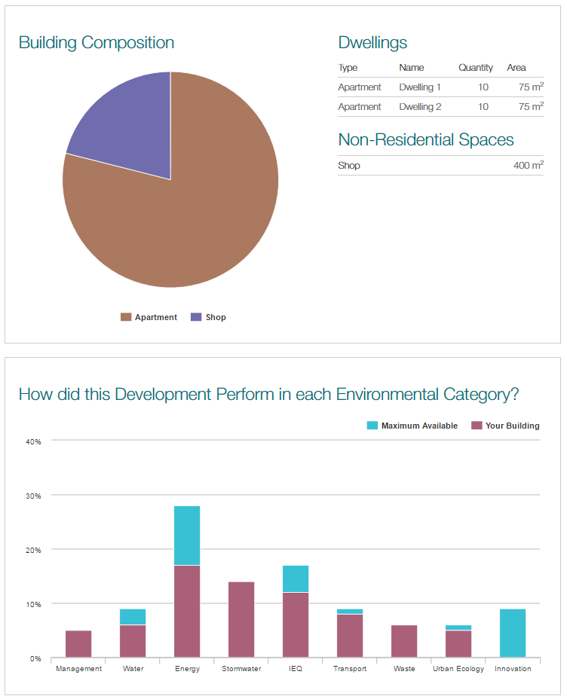

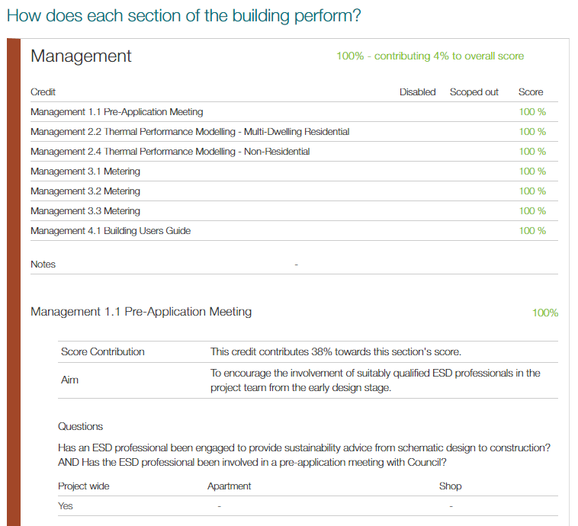

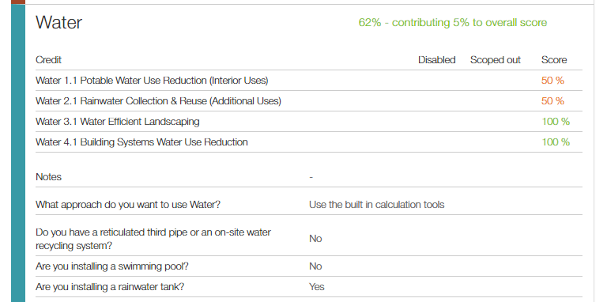

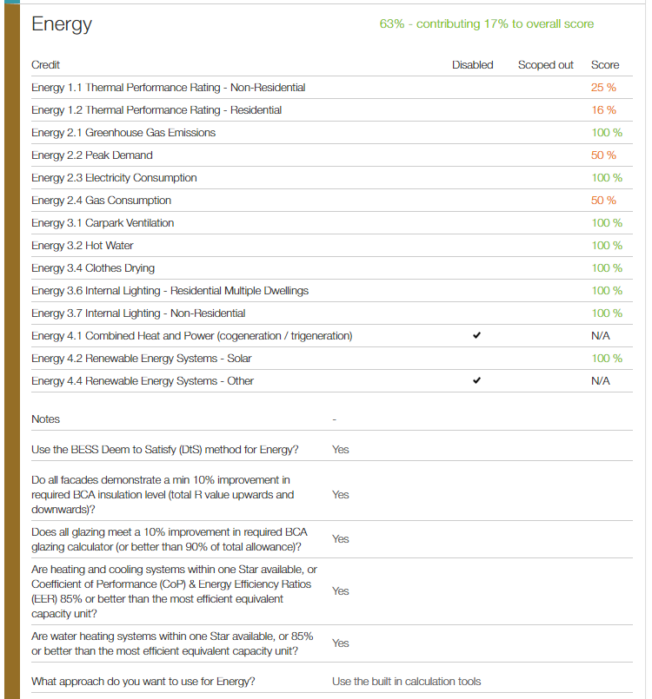

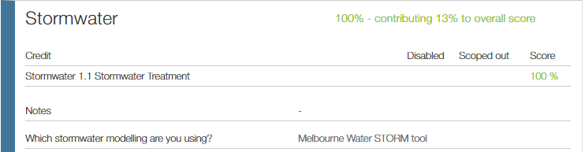

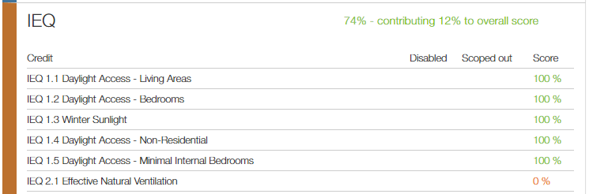

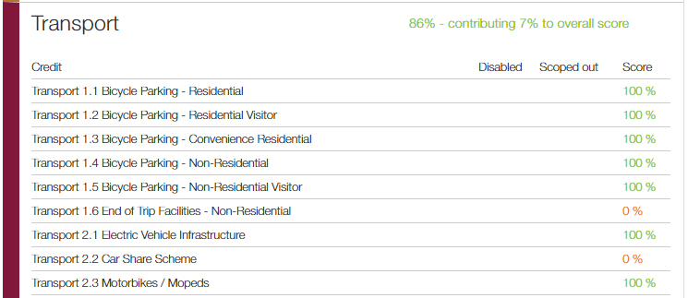

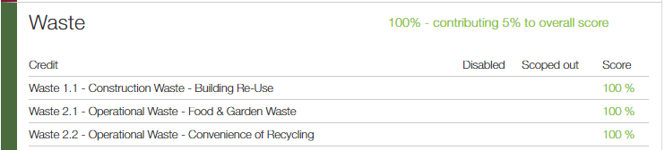

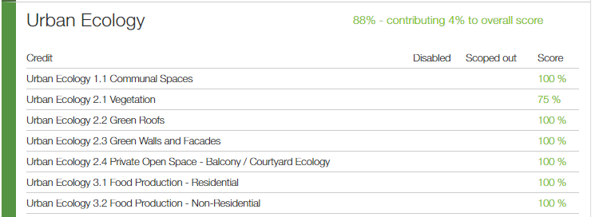

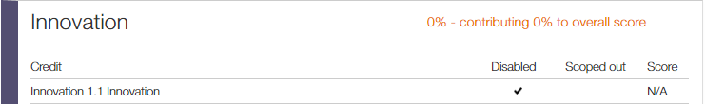

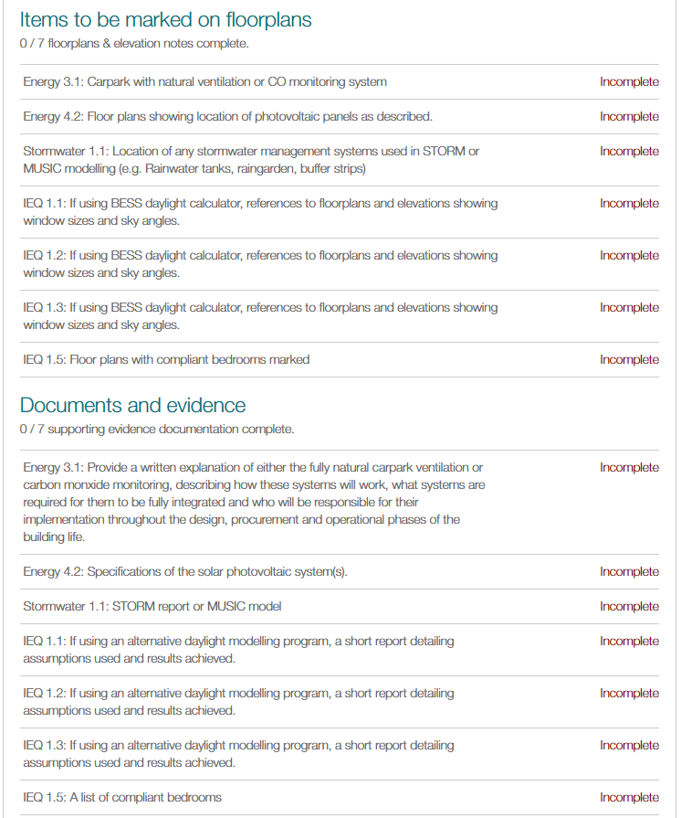

Note: Applicants are expected to ensure key ESD commitments are marked up on the relevant plans and drawings, and in addition, supporting documentation should be provided as evidence, where applicable.

