2020 Key Advocacy Issues

Table of Contents

Greater Dandenong: An Overview 4
Mayor and Councillors 5
Executive 6
Dandenong Wellbeing Centre 7
Community Revitalisation 10
Dandenong Sports and Events Centre (DSEC) 11
Shepley Regional Multipurpose Centre 14
Social and Affordable Housing in Greater Dandenong 18
Transport Infrastructure 21

Greater Dandenong: An Overview
The City of Greater Dandenong is a dynamic and progressive Council located approximately 35km south east of Melbourne’s central business district. Financial backing from the State Government to support its Victoria-wide planning strategy marks the region as a key activity centre, and Central Dandenong is fast becoming a residential city of national significance offering a flexible approach to development and providing high quality urban landscape.
Greater Dandenong’s role in providing the employment, business, transport and education infrastructure for the south-east region of Melbourne will become even more important as the population of Melbourne’s south-east expands significantly over the next 20 years.
The municipality has recently undergone a significant transition with a number of major projects either completed or underway. It boasts welcoming neighbourhoods and enjoyable leisure environments, based on strong partnerships and supported by well planned, integrated and sustainable service networks.
The population is currently over 160,000, serving a regional catchment area with a projected growth of 21 per cent by 2030. Greater Dandenong is now the most multicultural municipality in Australia. Over half the city’s residents were born overseas, 56 per cent from non-English speaking countries and representing 157 different nations. The city is a shining example of how harmony can exist in diversity and how that harmony, diversity and multi-culturalism are celebrated.
Council is working closely with all stakeholders, including the State and Federal Governments, local businesses, organisations and various government departments based in our city. Greater Dandenong is a great place to live, work, invest and raise a family; truly a City of Opportunity.

Mayor and Councillors
Cr Tim Dark
Keysborough Ward
0466 403 914
tim.dark@cgd.vic.gov.au
Cr Lana Formoso
Noble Park North Ward
0435 530 536
lana.formoso@cgd.vic.gov.au
Cr SophieTan (Deputy Mayor)
Noble Park Ward
0466 793 727
sophie.tan@cgd.vic.gov.au

Cr Richard Lim
Springvale Central Ward
0435 627 164
richard.lim@cgd.vic.gov.au
Cr Angela Long (Mayor)
Cleeland Ward
0466 004 616
angela.long@cgd.vic.gov.au
Cr Bob Milkovic
Dandenong North Ward
0435 237 051
bob.milkovic@cgd.vic.gov.au
Cr Jim Memeti
Dandenong Ward
0434 560 239
jim.memeti@cgd.vic.gov.au
Cr Rhonda Garad
Keysborough South Ward
0435 107 584
rhonda.garad@cgd.vic.gov.au

Cr Sean O’Reilly
Springvale North Ward
0422 523 258
sean.oreilly@cgd.vic.gov.au
Cr Loi Truong
Springvale South Ward
0466 004 618
loi.truong@cgd.vic.gov.au
Cr Eden Foster
Yarraman Ward
0435 202 645
eden.foster@cgd.vic.gov.au

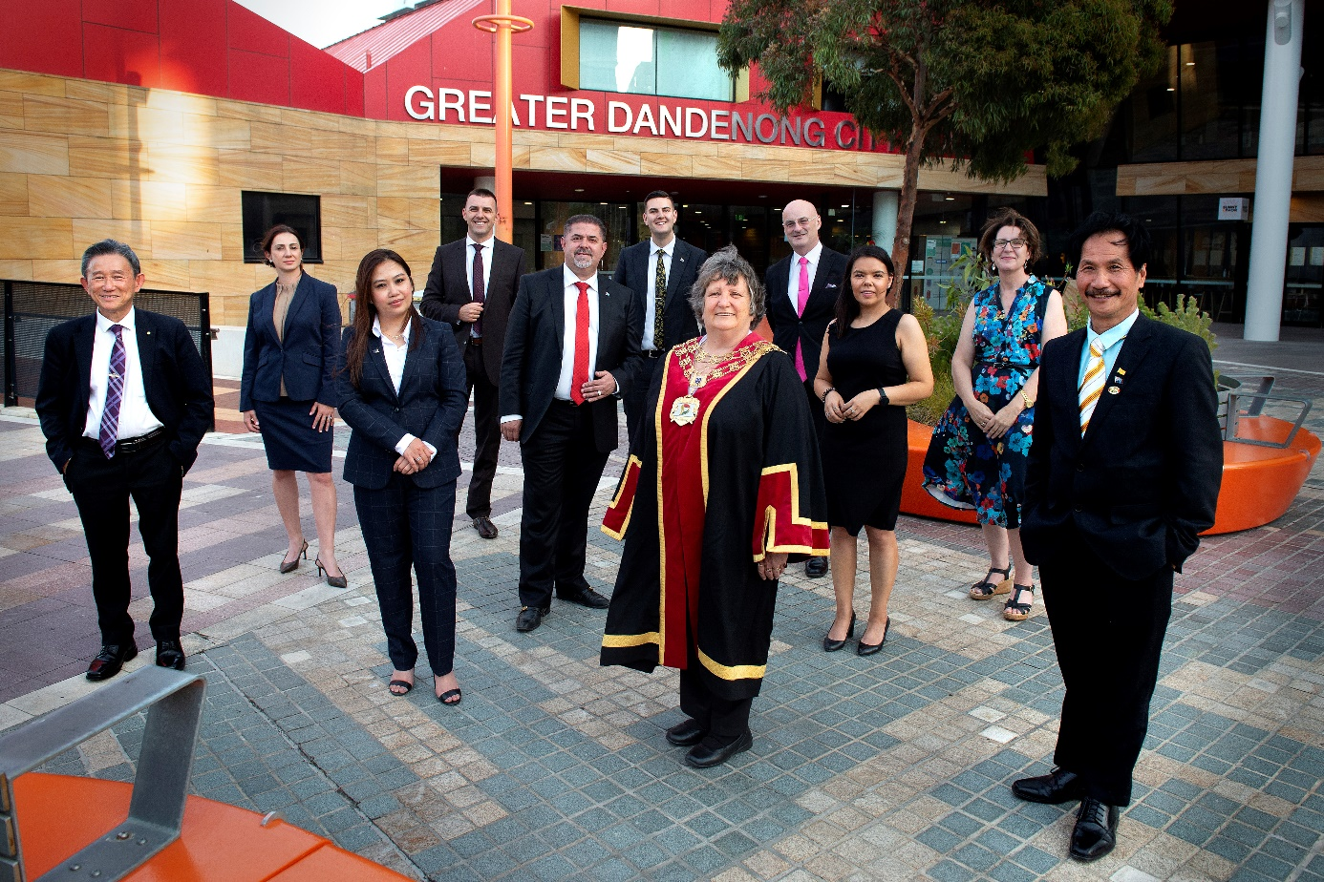
Executive

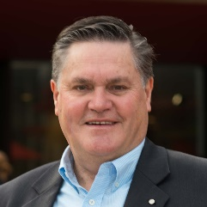
John Bennie PSM
Chief Executive Officer
8571 5220
john.bennie@cgd.vic.gov.au

Jody Bosman
Director City Planning, Design and Amenity
8571 1468
jody.bosman@cgd.vic.gov.au
Martin Fidler
Director Community Services
8571 5211
martin.fidler@cgd.vic.gov.au
Paul Kearsley
Director Business, Engineering and Major Projects
8571 1571
paul.kearsley@cgd.vic.gov.au

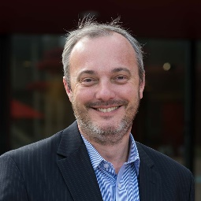
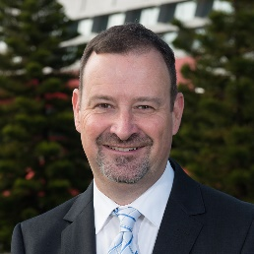
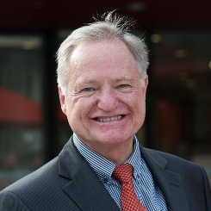

Dandenong Wellbeing Centre
The Dandenong Wellbeing Centre is a contemporary multipurpose aquatic centre with an enhanced focus on health and wellbeing, that is proposed to replace the existing ‘Dandenong Oasis’ and tailored to meet the needs of Greater Dandenong’s unique community.

Background
‘Dandenong Oasis’ is Greater Dandenong’s premier indoor aquatic centre that is over 40 years old and nearing the end of its service life.
The Centre has aging infrastructure with a limited range of facilities and is no longer meeting the needs of the community. This is evident from declining attendances and participation levels and escalating operational and maintenance costs.
The City’s Aquatic Strategy (2019) recommends that Dandenong Oasis be replaced with a new aquatic centre that seeks to maximise community health and wellbeing benefits, in response to the high level of need within the Greater Dandenong community and broader south east region.
The proposed Centre will have a targeted focus on health and wellbeing and will complement the nearby Noble Park Aquatic Centre (NPAC) providing a municipal solution to aquatics provision.
Located within a Health Precinct
The new Centre will be developed in Mills Reserve, located on the corner Heatherton Rd and Cleeland St in Dandenong, and adjacent to the existing Dandenong Oasis (to be demolished).
Mills Reserve is perfectly situated within a medical, health and education precinct with the Dandenong Hospital and Chisholm Institute both located in close proximity.
This location, together with the Centre’s targeted focus on health and wellness presents an exciting opportunity to partner with specialist organisation/s that can ‘add value’ to the facility and associated programs and services.
Project scope
The new multi-purpose aquatic and wellbeing centre is proposed to include:
- Two warm water pools
- 50m pool with moveable boom
- Learn to swim pool
- Leisure pool / water play
- Spa and sauna / steam
- Health and wellness gymnasium
- Program / group fitness rooms
- Allied health suites
- Café, creche and meeting room
- Administration, amenities etc.
Project Status
A detailed business case has been prepared for the new aquatic and wellbeing centre that is compliant with DTF guidelines and demonstrates significant health, social, economic and environmental benefits.
The detailed design process for the new centre is currently underway and expected to be completed by mid-2022.
Project cost: Approximately $62.5 million
Contact details for further information:
Paul Kearsley
Director Business, Engineering and Major Projects
Ph: 8571 1571
Paul.kearsley@cgd.vic.gov.au

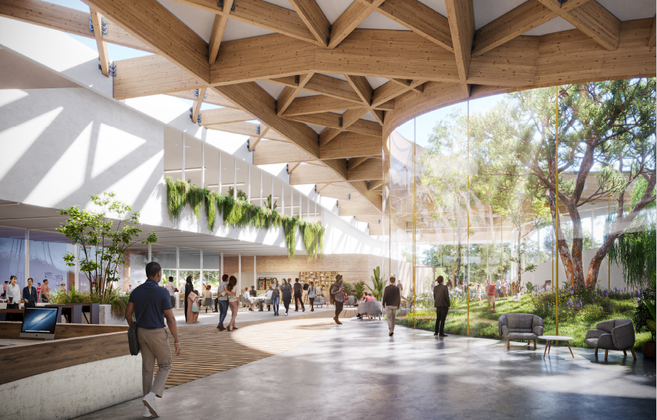

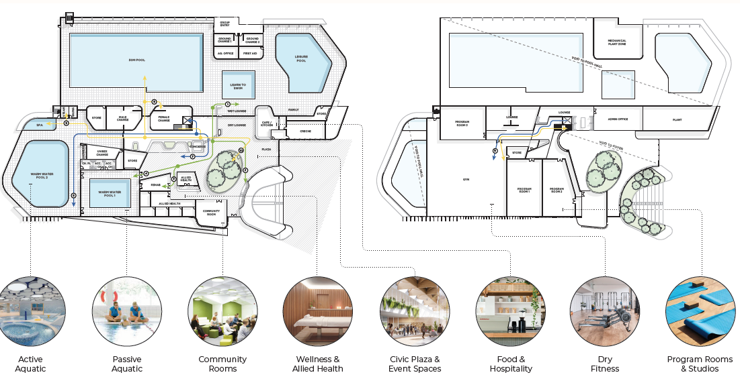
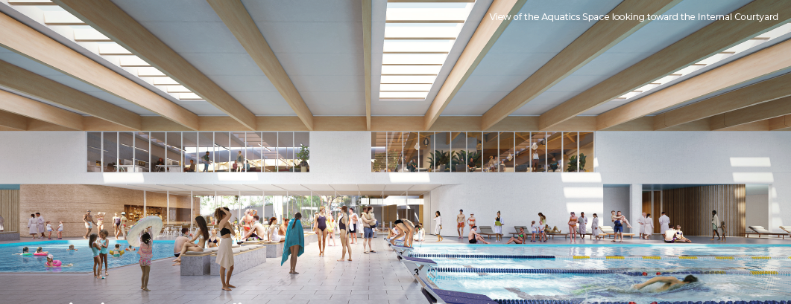
Indicative plans and images of the Dandenong Wellbeing Centre for illustrative purposes only.

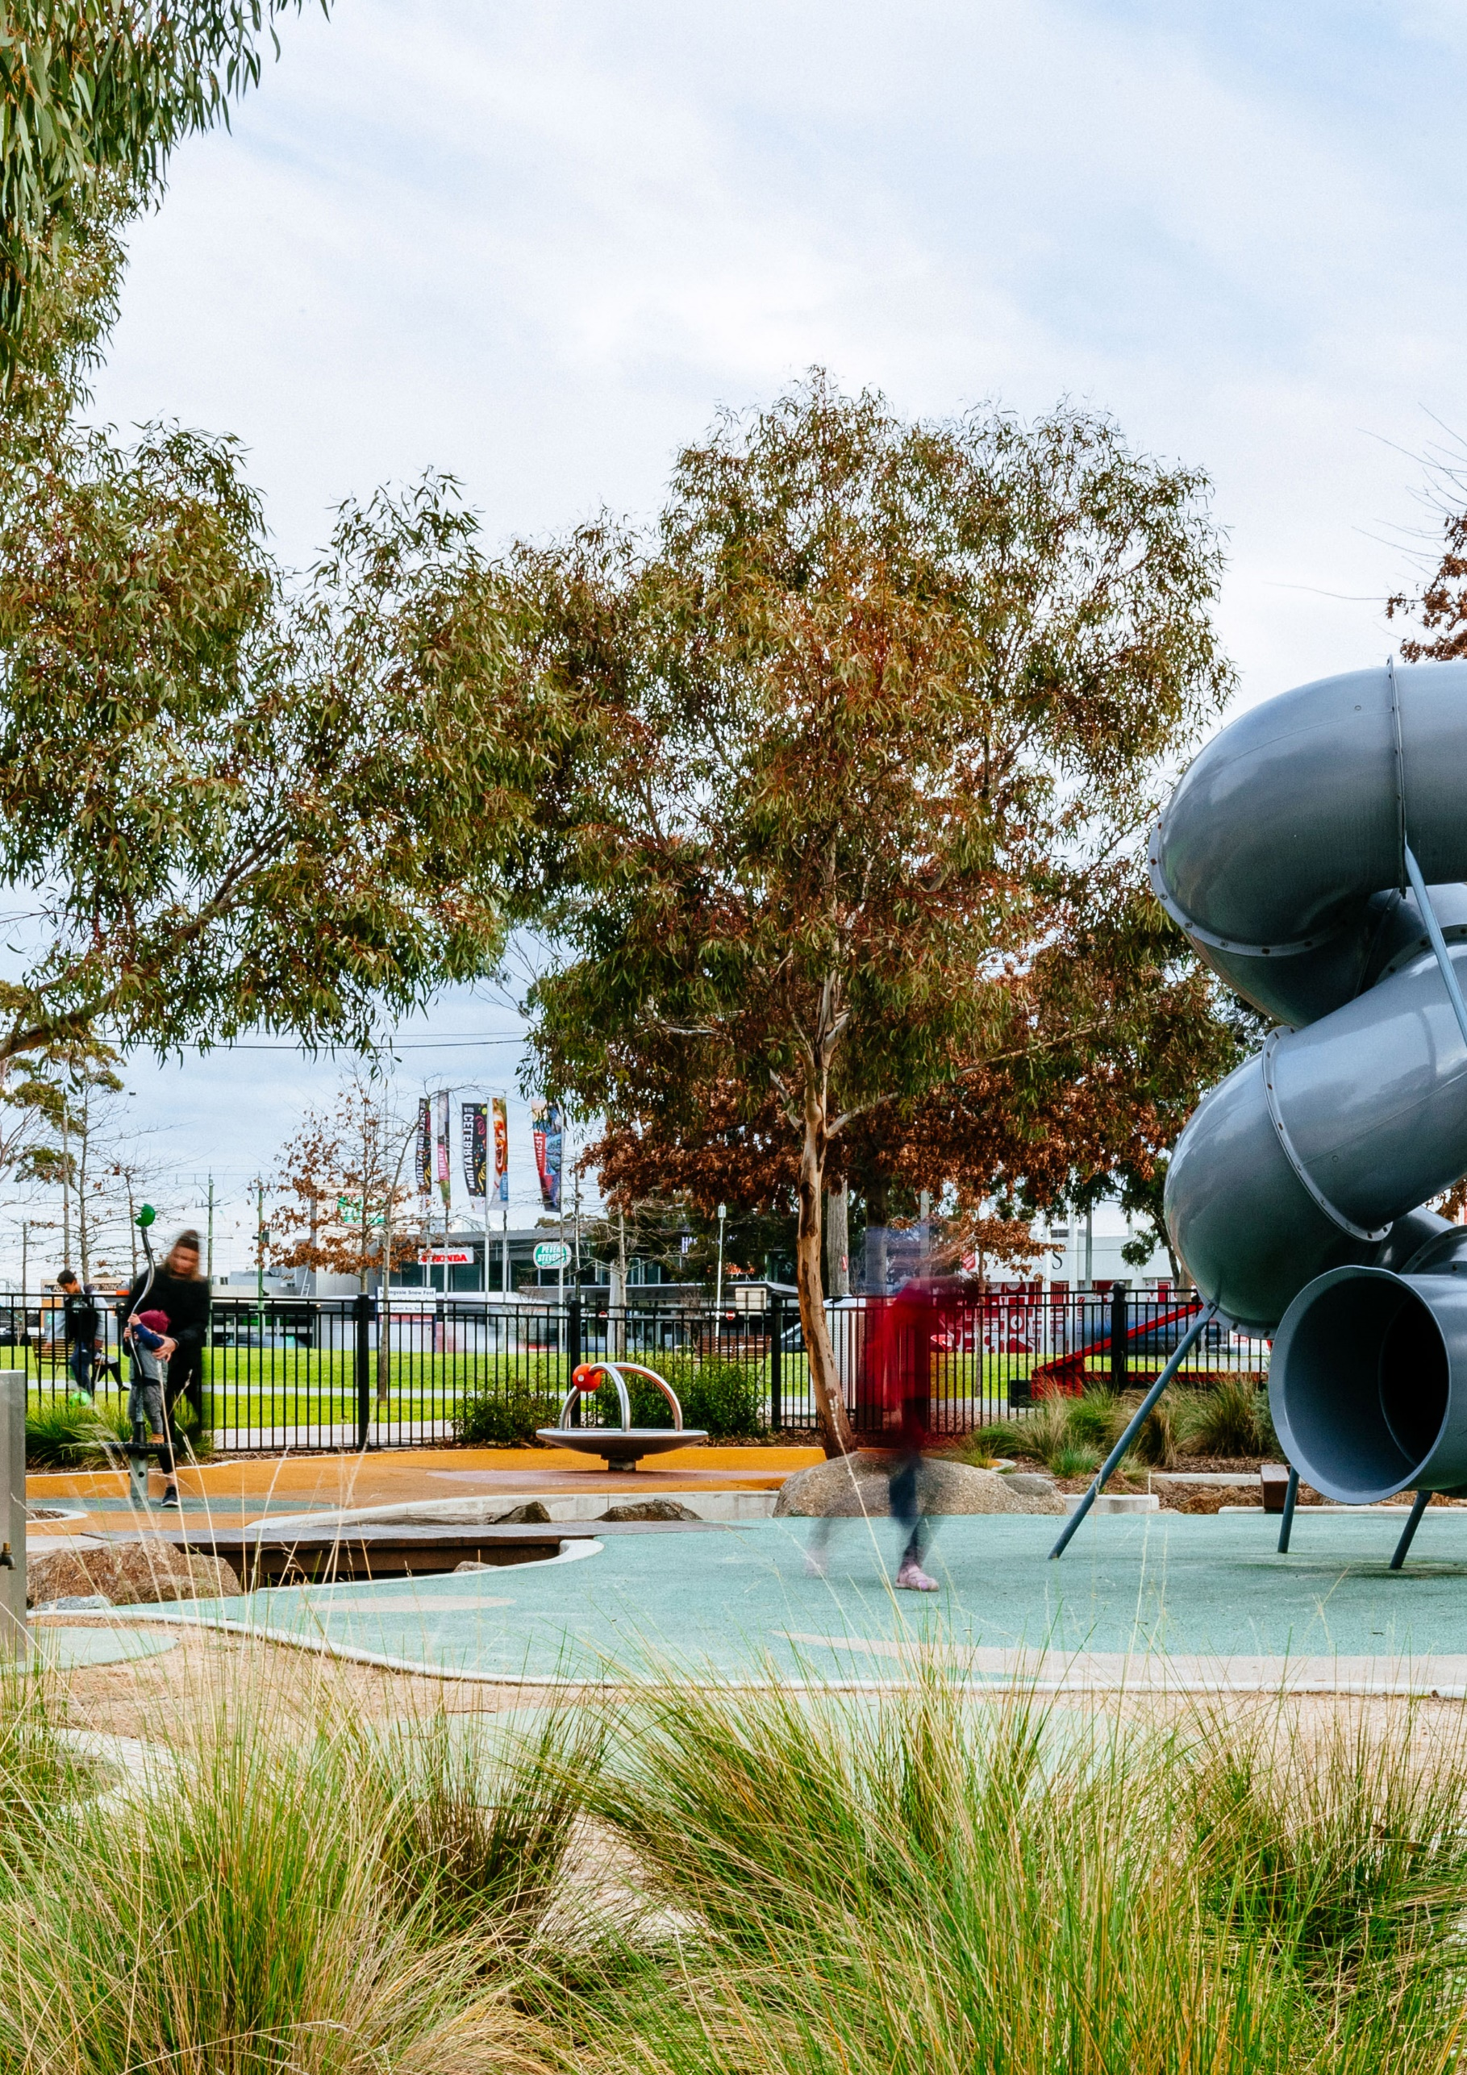

Community Revitalisation

Introduction
Council has been funded by the State Government (through DJPR) over the past three years to undertake the Community Revitalisation (CR) Project, with Council also contributing over the past year.
Taking a place-based approach, the aim of the project has been to assist our most disadvantaged jobseekers to take advantage of the jobs-rich community in which they live.
The project has undertaken a range of innovative approaches to building the employment capability of the jobseekers and the awareness of the employers of the untapped potential of this cohort.

Background
The project was informed by the research conducted by TACSI for the RDA Southern Region looking at the factors that contribute to the level of disadvantaged in the south east region of Melbourne. Council’s One Percent project also provided an evidence base for the need to take a new and different approach to addressing the high level of unemployment in this region.

Evidence for continuance
Both the research and the live data obtained during the course of this project indicate that to have a long-term impact, there is a need for not only a place-based approach, but also a highly individualised tailored service to ensure optimum outcomes are achieved. Our data clearly demonstrates that the degree of engagement and intervention correlates to the employment outcomes.

Having undertaken a number of initiatives in the first two years of the project, we have continued to leverage the learnings and embed the implementation of those most effective – both with jobseekers and with employers – and inform other stakeholders for their development. With a plethora of services and organisations to support jobseekers in the region, there is a need for an independent body to act as the connector to programs / organisations providing work preparation and referral to support agencies, as well as providing opportunities for jobseekers to address identified gaps in work readiness beyond resumes and interview training. Council has played this role through the Greater Dandenong Regional Employment Taskforce throughout the course of this project.
Implementing learnings over the past year has not only resulted in an increase in the uptake of selected initiatives as anticipated, but has also informed new initiatives to be developed. With the significant increase in unemployment for the foreseeable future which will impact considerably on those already experiencing disadvantage, it is essential that we continue with this project to both enable ‘best practice’ activities to become embedded across a number of organisations – and scalable across regions. Minimising the impact on our most vulnerable and changing the employment landscape is the primary aim.

Timeline
The current funding agreement with the State Government is due to expire on 30 June 2020.

Contact details for further information:
Paul Kearsley
Director Business, Engineering and Major Projects
8571 1571
Paul.kearsley@cgd.vic.gov.au

Contact details for further information:
Paul Kearsley
Group Manager Greater Dandenong Business
Ph: 8571 1571
Paul.kearsley@cgd.vic.gov.au

Dandenong Sports and Events Centre (DSEC)
What we are seeking:
- Grant funding of $500,000 over a two year period.

In partnership with other regional stakeholders, the City of Greater Dandenong has been advocating for the development of a multipurpose sport, community and entertainment venue adjacent to Dandenong Train Station since 2017. The facility would address a gap in the provision of major stadia in Greater South East Melbourne and cater for elite sporting competition, concerts, festivals and community events. A considered indoor layout would also provide spaces for large-scale functions and conferences, office workers, education, training and outreach programs for our rapidly-growing, cosmopolitan community.

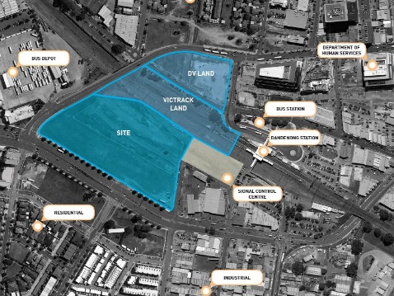
The Site
Cheltenham Road, Dandenong, adjacent to Dandenong Train Station. This provides direct public transport links to and from Melbourne along the heavily-populated Cranbourne, Pakenham and Traralgon train lines, as well as 23 metro and five regional bus routes.

Opportunities

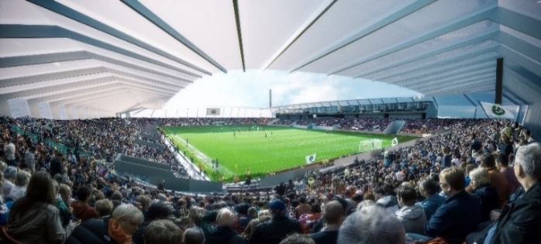
OUTDOOR
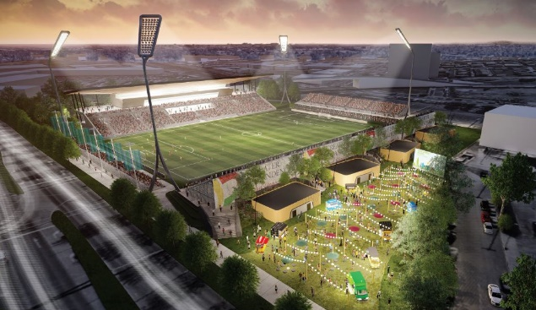
- A 15,000-capacity (approx.) home ground for
Melbourne City FC A-League and W-League
matches. The Club announced in December
2020 it was relocating to South East Melbourne
with the establishment of a new City Football
Academy at Casey Fields. Football (soccer) is
the No.1 grassroots sport in South East
Melbourne, with more than 23,000 participants
across more than 100 clubs.
- Professional men’s and women’s Rugby League
and Rugby Union matches.
- Marquee community sporting events.
- Concerts, multicultural festivals, community events.

INDOOR
- Large function space/s for major conferences,
exhibitions, jobs fares, community events,
weddings and school functions.
- Multipurpose meeting spaces.
- Integration of education and training programs.
- Commercial or government office space.
- Exploration of eSports potential.

Revitalising Central Dandenong (RCD)

A 2019 University of Melbourne / Australian National University study revealed the need for a “catalyst project” or projects to re-energise the State Government-backed RCD concept. With its close proximity to the Dandenong CBD and train station, as well as several significant Development Victoria land parcels, the DSEC would have a transformative effect on Dandenong, sparking a fresh wave of private investment into the city as well as providing a boon for existing businesses, particularly hospitality and retail. The DSEC would create a Docklands-style precinct development opportunity for Dandenong.

Regional Benefit
For more than 1.6 million residents of Greater South East Melbourne, access to the DSEC would be quicker and more convenient than travel to major stadia concentrated around Melbourne’s CBD. The central location of the DSEC provides an easily accessible venue for local residents to attend elite sporting matches, major entertainment events and functions, removing a major travel (and cost) burden that currently exists for Melbourne-based venues. The facility is expected to generate up to 1028 construction jobs and support more than 350 ongoing jobs (direct and tourism-related), while adding $114 million of annual economic output generated from increased visitor activity in the region (Source: REMPLAN).

Project Status
The City of Greater Dandenong, together with Sport and Recreation Victoria and with the support and participation of Melbourne City FC, is currently working with Deloitte to develop a business case for the proposed DSEC. The report will pull together and build upon extensive planning already undertaken. It is due for completion in November 2021.
What we are seeking:
Capital funding assistance to go towards a total project cost of approximately $110 million for Stage 1 of the Dandenong Sports and Events Centre, in conjunction with other funding partners.

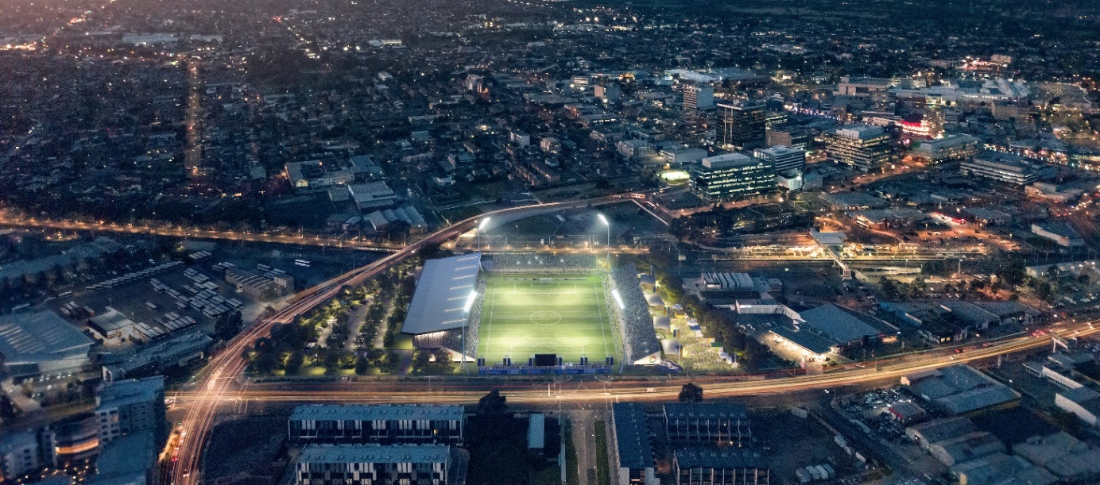

Contact details for further information:
Paul Kearsley
Director Business, Engineering and Major Projects
Ph: 8571 1571. Paul.kearsley@cgd.vic.gov.au

Shepley Regional Multipurpose Centre

Introduction

Shepley Oval is a regional sports facility located in Dandenong – a destination suburb in Melbourne’s south east. The oval is currently used for Cricket and Australian Rules Football. To ensure Shepley Oval’s relevance and future longevity Council is currently advocating for funding to build a Regional Multipurpose Centre on the site. The centre will cater for hosting business forums and promoting local employment opportunities as well as support to sporting clubs to access the south-east region of Melbourne, while continuing to provide an operating base for Cricket Victoria, Dandenong District Cricket Association, Dandenong Cricket Club and the Dandenong Southern Stingrays Football Club.

Key Features of the Centre include:
- Multipurpose indoor training space, which can be converted into a six lane cricket net facility.
- Multipurpose space for community use.
- Multipurpose space to host industry forums to promote local employment and to profile the region’s manufacturing and industrial sectors
- Six unisex change rooms with adjoining showers and toilets.
- Referees unisex change room with adjoining showers and toilets.
- Kiosk.
- Male, female and accessible public toilets.
- Administration ‘hot desk’ space for State, sporting and community group use.
- Two meeting rooms.
- New accessible grandstand for Shepley Oval.
- Environmental standard design
5-star or equivalent.

Background
The perceived need for a community accessible multipurpose indoor training centre (MPITC) at Shepley Oval, Dandenong Park was first identified by
Dandenong Cricket Club and Dandenong District Cricket Association in 2009.
Need and demand for the new facility has been assessed through consultation with a broad range of regional community sporting clubs, relevant community groups, Victorian peak sporting bodies and Sport and Recreation Victoria.
The Make Your Move Greater Dandenong Physical Activity Strategy identified that the level in participation in physical activity by residents is significantly lower than the Victorian average with 49% and 73% respectively. In addition, the prevalence of diabetes (type 2) is 36% higher in the municipality than the Victorian average of 9%. This facility will provide much needed infrastructure for residents to participate in physical activity opportunities to improve these statistics.
Targeted stakeholder consultation has been undertaken with over 27 sporting clubs and State Sporting Associations who identified demand for the new facilities. An online survey was undertaken with community sporting clubs in Greater Dandenong and 17 clubs with over 2000 current participants responded.
Meetings and workshops were held with Cricket Victoria, AFL Victoria Southern Metro, Dandenong Premier Men’s and Women’s Cricket Club, Dandenong Stingrays Football Club, St Kilda Football Club, Australian Futsal and Hockey Victoria.
Cricket Victoria is strongly interested in utilising the facility and view the facility as a regional/metropolitan hub. They have indicated that they would like to conduct various participation and sports development programs, including multicultural (Harmony) programs, school and community offerings, and conduct training and coaching seminars from the facility.
AFL Victoria has indicated they would like to deliver school and community programs, sports development and training seminars from the facility. They have also advised that the St Kilda Football Club will be interested in delivering programs from the venue.
Council’s Make Your Move Greater Dandenong Physical Activity Strategy 2020-2030 also identifies the need for a regional indoor training facility.

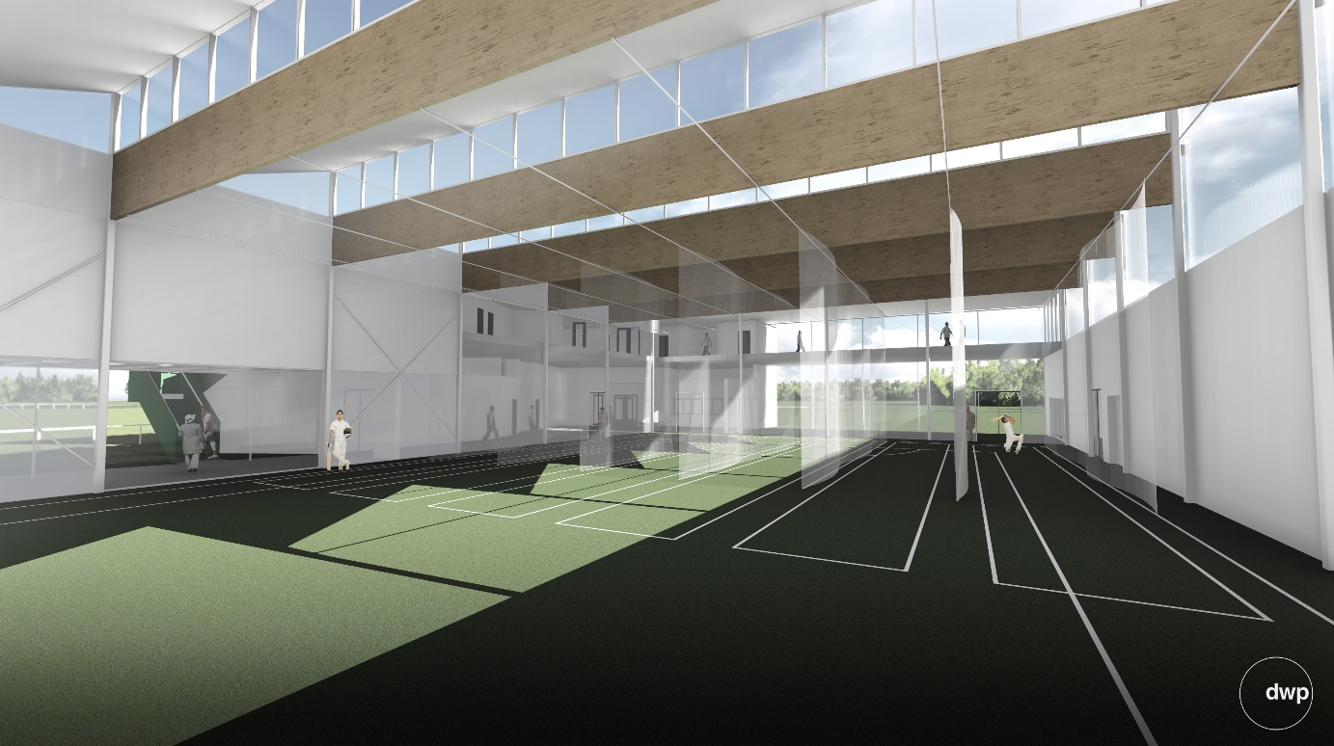

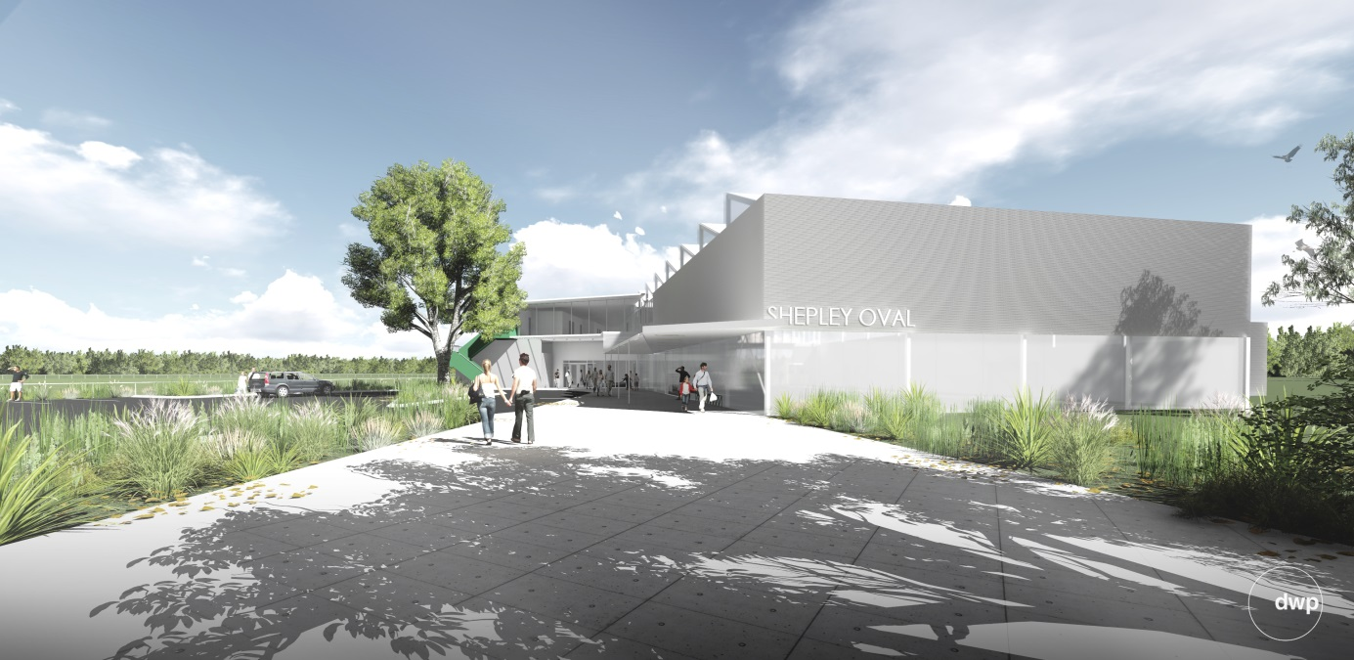
Current demand for indoor multi-purpose space

An assessment of need and demand established the following:

- Regional and community sporting clubs have indicated that the provision of appropriate new training facilities will play a key role in enabling sports participation growth in Greater Dandenong by providing greater access to all weather day and night facilities.
- The availability of the facility on a year round basis will maximise opportunities to increase participation across a number of sports.
- Dandenong Cricket Club (Men’s and Women’s), both of which have Premier teams competing at the top level of Victorian cricket, have demonstrated a strong interest in the development of an indoor facility to enable year round training and expanded delivery of development programs that have high potential to increase participation in the region from junior levels upwards.
- The lack of access to indoor training facilities is currently restricting program delivery by one of the region’s largest sporting entities, the Dandenong Stingrays Football Club, whose extensive activities include development and inclusion programs from junior to elite levels and encompassing girl’s and women’s, multicultural and indigenous football development.
- Melbourne Football Club has partnered with the Stingrays for the delivery of multicultural participation and talent development programs and have indicated their need and desire to use the new facility. The Centre will also assist in facility provision for a female AFL academy, state level events and programs with the potential for significant visitor economy benefit.
- The multipurpose facility will be designed to provide use by futsal, hockey and other community sports. It will also provide administrative offices for the Dandenong District Cricket Association and Indoor Sports Victoria.
- Greater Dandenong has a significant sub-continent community with a strong interest in cricket. This facility will provide further opportunity to deliver structured programs and cricketing opportunities, which will help satisfy the current year round demand from Sri Lankan, Indian and Pakistani residents of the city.
Additional programming opportunities for schools and for the large refugee and asylum seeker community in the area may be afforded by the new facility.
Schematic and detailed design and documentation has been completed, with construction proposed to commence dependent on funding. An option to stage the construction of the new Centre is also being considered subject to available funding.
What we are seeking:
- Capital grant funding assistance with a total project cost of $22 million for the development of the Shepley Regional Multipurpose Centre. Or:
  - Stage 1: Indoor Multi-purpose Centre ($12 million)
  - Stage 2: Grandstand and Shepley Oval amenities ($10 million)
Contact details for further information:
Jim Davine
Acting Director Community Services
8571 5160
jim.davine@cgd.vic.gov.au
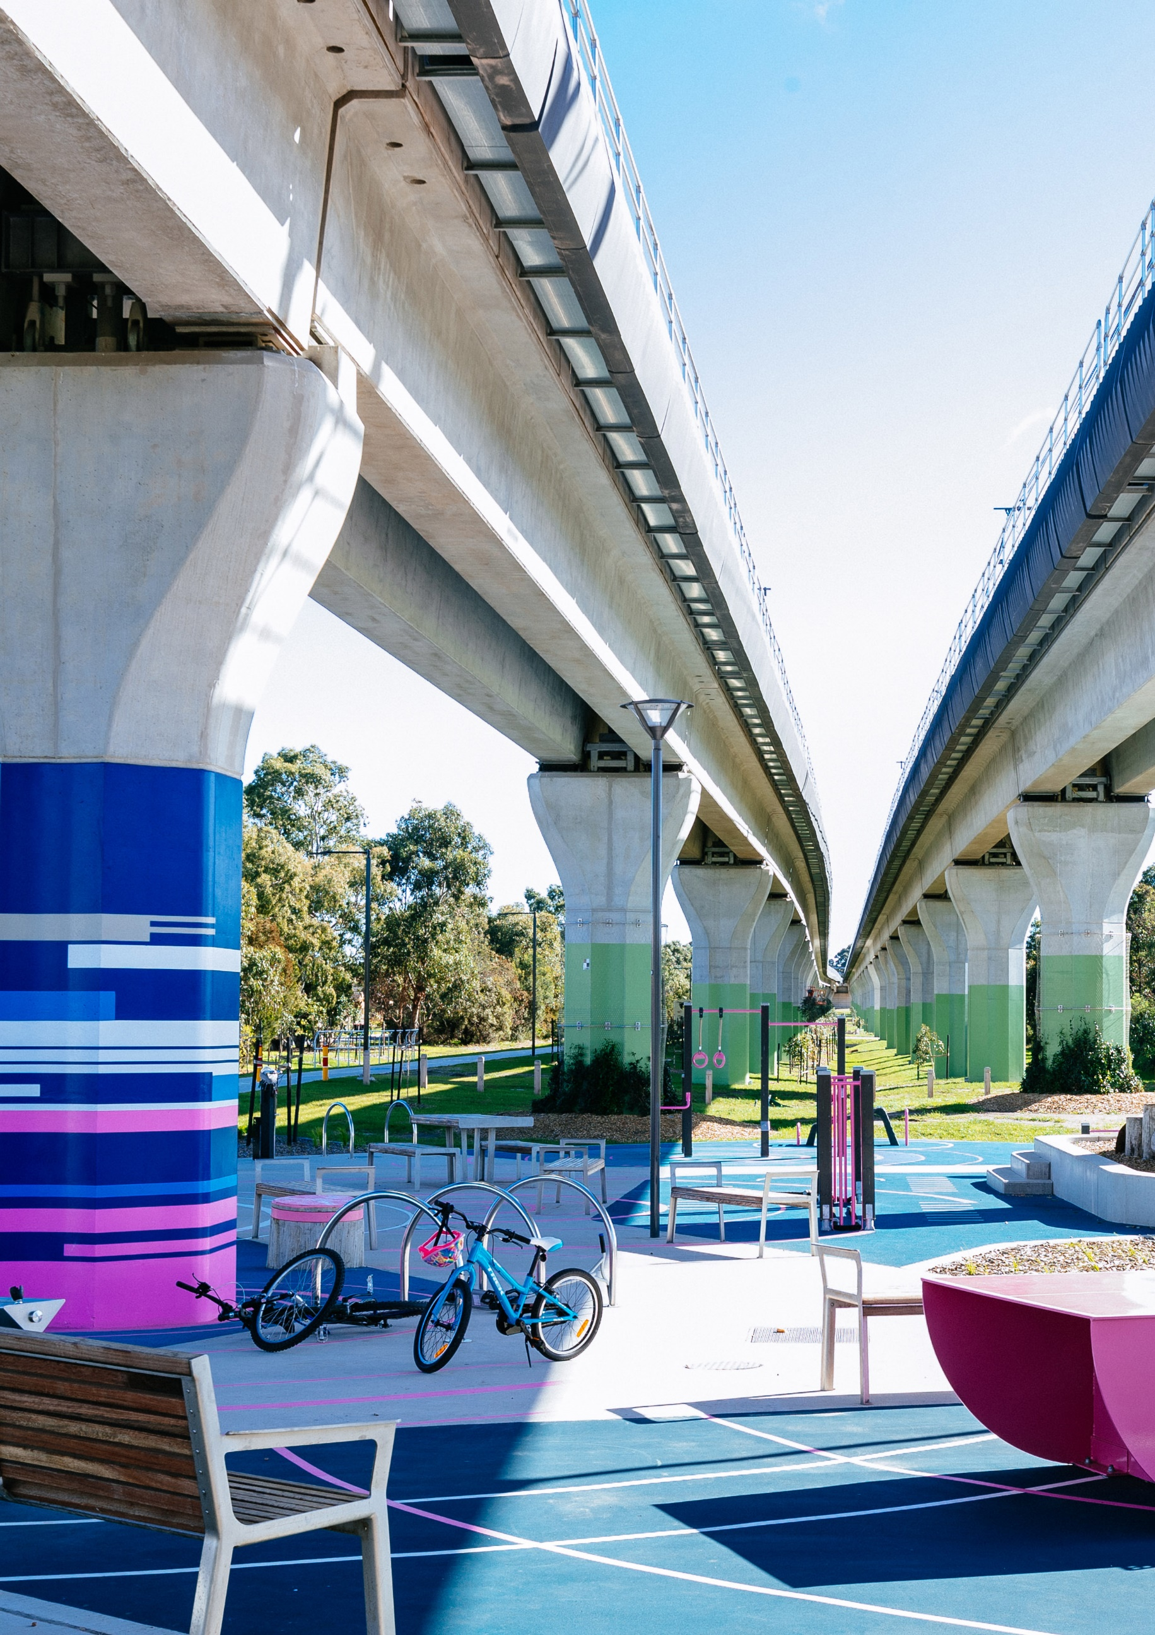

Social and Affordable Housing in
Greater Dandenong

Introduction

The City of Greater Dandenong is the most multicultural and diverse municipality in Australia with residents from 157 birthplaces and 64 per cent of its 169,000 population born overseas. Over 200 languages and dialects are spoken within the municipality with languages other than English spoken by over two-thirds (70 per cent) of its residents – the highest level in Victoria. A significant portion of the residents are recent migrants, refugees and people seeking asylum.
Homelessness in Greater Dandenong is different to the homelessness witnessed in Melbourne’s Central Business District (CBD), inner cities or along coastal suburbs. This is because Greater Dandenong is a community of marked cultural diversity and ongoing migrant settlement which faces the challenges of low-income levels, high unemployment, unfavourable educational outcomes, a substantial rate of refugee settlement, lower levels of mental and physical health than the Victorian average, and elevated crime rates.
The population cohorts most at risk of homelessness in Australia have been identified as disengaged youth, recent migrants including refugees and people seeking asylum, single-parent households, people living in rent-related poverty, Aboriginal and Torres Strait Islander people, women over the age of 55, unemployed residents and low-income households, women and children escaping family violence, LGBTIQ young people, people with disabilities, people with mental health problems, and older people living on a pension.
These population cohorts, with or without intersectional disadvantages, account for approximately two-fifths of Greater Dandenong’s population. With 1,200 people seeking asylum living within Greater Dandenong as of 2021, many find themselves living in low quality housing, with highly precarious tenures, and inadequate physical standards.

Background
Greater Dandenong has the highest rate of homelessness in Victoria. On Census night in 2016, 1942 people were found to be sleeping rough or in temporary accommodations - nearly three times the Victorian average of 0.42 per cent.

In 2016, nearly a third (32 per cent) of local households were living in acute financial stress – among the highest prevalence of rental stress in the state, and well in excess of the metropolitan level of 26 per cent. The proportion of local, available rented properties that are affordable to a family on Centrelink payments has declined from 83 per cent in 2001, to 9 per cent by 2020.

In the past 20 years, median housing prices in Greater Dandenong have more than trebled in real terms. Local house purchase prices rose by 37 per cent (after inflation) in the decade to 2020, compared with 14 per cent across metropolitan Melbourne.

Of the 3000 requests for assistance from specialist homelessness services in Greater Dandenong in 2018-19, 57 per cent involved females, of whom, nearly half (43 per cent) cited family violence as their reason for seeking assistance. Currently there is only one option within the Greater Dandenong area for women and children escaping family violence.

What we are seeking:
- Increase funding of the National Housing and Homelessness Agreement (NHHA) - for affordable housing, social housing, encouraging growth and supporting the viability of the community housing sector, and for NHHA homelessness priorities and initiatives that reduce the incidence of homelessness and contribute to improved data collection and reporting.

- Increase to Commonwealth Rent Assistance (CRA) - CRA payments to low-income renters are no longer sufficient in achieving rental affordability, because the value of CRA has fallen behind rent. An increase in CRA is necessary so that families and individuals are not pushed out of the private rental market or forced into overcrowded living conditions.

- Increase to JobSeeker - boosted by at least $100 per week and tied to wages, so to relieve housing stress amongst households.

- Liveable income made available to people seeking asylum - many families and individuals having been denied access to a safety-net and liveable income (Status Resolution Support Services Program, JobSeeker, Commonwealth Rent Assistance) and their ability to remain within private rentals has become harder to achieve.

- Funding to construct a bespoke crisis accommodation facility in Greater Dandenong for women and children experiencing family violence - developed by Greater Dandenong Council in partnership with local Housing provider, WAYSS.

Contact details for further information:
Martin Fidler
Director Community Services
8571 5211
martin.fidler@cgd.vic.gov.au

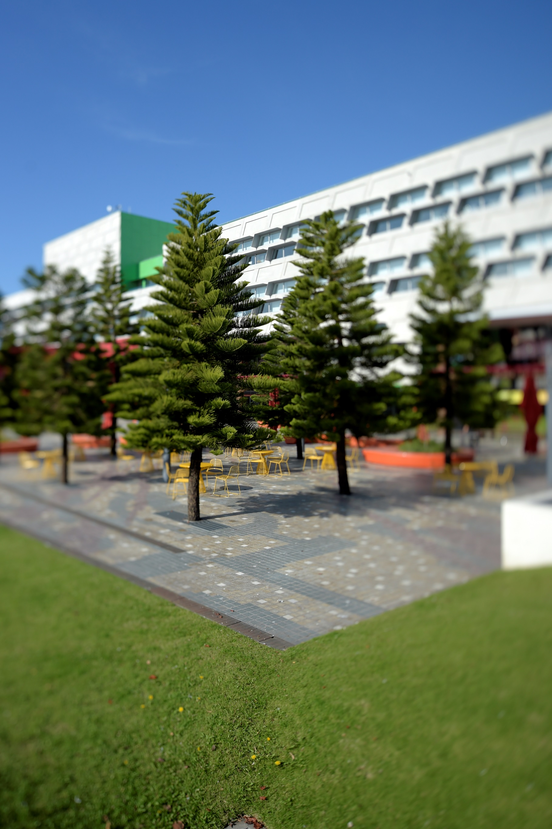

Transport Infrastructure

Addressing shortfalls in transport infrastructure impacting the regional economy and community
The following projects fall under three themes:
- Supporting the role of Greater Dandenong as a major employment hub, manufacturing centre, generator of exports and distribution hub
- Improving public transport facilities that are not compliant with DDA (Disability Discrimination Act) standards
- Extending and upgrading shared user path networks to improve access to employment and recreation

Theme 1 - Dandenong as a major employment hub
Greater Dandenong is home to the Dandenong National Employment and Innovation Cluster (NEIC) which includes the Dandenong Metropolitan Activity Centre and Dandenong South State Significant Industrial Precinct (SSIP).
Dandenong South has major manufacturing, warehousing /distribution and is an employment powerhouse in providing a vital source of jobs for the abutting and fast-growing south-east growth area. These include very large industries such as Bombardier, Volgren, Iveco, Visy, Nissan, Kraft, Pilkington and Jayco as well as numerous warehousing/distribution companies such as Woolworths, Aldi, Amazon and Bunnings.
While Dandenong South has a surrounding freeway and arterial road network that provides access to the Port of Melbourne and the broader metropolitan area, it is constrained by a range of “last mile” transport infrastructure shortfalls. These include:
- Poor internal east west access which restricts economic activity and access to jobs and services.
- Poor access to the adjoining residential growth areas which have a net shortage of jobs. This adversely impacts outcomes for the region’s liveability and social inclusion, effectively locking out a proportion of the potential workforce.
- Increasing peak-hour congestion caused by gaps in the surrounding arterial road network.
Council’s Transport Plan proposes a range of infrastructure projects to address existing problems and build for the future. Many of these are critical to ensure the NEIC SSIP fulfils its ongoing role as an employment and economic powerhouse however are well beyond Council’ capacity to fund.
The following four transport projects have potential to unlock the productivity and increase the resilience of this area and the liveability of the adjoining residential growth area by moving people and freight around more quickly, more safely and more efficiently.

Project 1 – Complete the Dandenong Bypass
This completed arterial will connect the eastern end of the existing Dandenong Bypass at the South Gippsland Highway with the South Gippsland Freeway. It will:
- provide a direct east west link between the South Gippsland Freeway/Western Port Highway easing pressure on the congested South Gippsland Highway and surrounding access roads
- help separate traffic which does not have a destination in the NEIC from that which does
- finalise the Bypass of the Dandenong Activity Centre
- support the development of Noble Park and Springvale Activity Centres as 20-minute neighbourhoods.
When in combination with a right-hand turn interchange between the South Gippsland Freeway and Monash Freeway, this project will provide an overall high capacity network capable of moving all forms of traffic across this part of the region.
Indicative Cost: $265 million.

Project 2 – Complete the missing internal ‘last mile’ east west route
This project comprises principally a bridge over the Eumemmerring Creek, construction of a short extension of Bangholme Road and intersection treatment at Dandenong-Frankston Road.
It completes a continuous link through the heart of the industrial precinct to provide swift access for freight and the local workforce. It accesses the South Gippsland Freeway through a chain of arterial roads with potential for a longer-term connection with EastLink.
Key lengths of this route have already been completed or have been committed to be built within two years. The accompanying figure shows those parts of the link that have been completed, committed and yet to be constructed. Completion of the outstanding components will:
- significantly improve connectivity and access to existing businesses
- lift productivity and help drive economic growth
- increase the legibility of the precinct for those accessing the area
- increase transport network resilience.
Indicative Cost: $38 million (one lane in each direction – does not include EastLink ramps)

Project 3 – Build Glasscocks Road
Glasscocks Road is planned as a major east west arterial linking the Casey growth area to employment and other opportunities. It also directly serves the developing areas in Lyndhurst which are part of the NEIC. It is a vital component of the South East Growth Area Plan.
Funding will eventually be available to develop parts of this road abutting the NEIC through a Development Contributions Plan. At this point in time there are only limited funds available to construct Glasscocks Road.
Construction of Glasscocks Road will have the following benefits:
- substantially upgrade east west access for residents and workers with a destination in Dandenong South and beyond
- significantly improve freight access to the NEIC from the surrounding arterial and freeway network and help encourage investment, productivity and drive economic growth
- significantly improve network resilience by reducing length of large detours during arterial network disturbances.
Indicative Cost: $220 million (Linking across Casey)

Project 4 – South East Freight Hub
The Dandenong NEIC is the largest destination in Victoria for imported containers, all of which now arrive by road. It also receives large amounts of other road freight that has been broken down into smaller consignments closer to the port. Its growing role as a huge logistics, warehousing and distribution centre underpins the need for improved efficient freight links and a reason to transfer a proportion of freight to rail.
A freight hub will support thousands of jobs and make exports more competitive by ensuring it is cheaper and faster to move goods overseas. The South East Freight Hub is part of the Melbourne-wide Port Rail Shuttle Network scheme, with freight hubs planned in the southeast, north and west.
Benefits are estimated as follows:
- 6,100 new jobs when operational - 2,800 FTE jobs during construction.
- Exports: Moving freight by rail will cut export freight costs by 25 per cent
- Imports: Moving freight by rail will save importers 23 per cent
- Congestion: Freight rail would take 3500 trucks a day off Melbourne’s road network.
- Environment: 66 per cent drop in carbon emissions per container moved by rail, 63 per cent drop in fuel use per container.
Provision has been made for freight trains to access the proposed hub from this line paving the way for an intermodal freight terminal as part of the planned and committed duplication of the Cranbourne railway line.
As the next step we need a commitment to undertake a business case investigating public / private delivery of the rail freight connection.
Indicative Cost: $100,000 (business case)

Theme 2- Upgrade public transport facilities that are not DDA compliant and support bicycle use
Greater Dandenong is home to five railway stations on the busy Dandenong rail line. Upgraded services are being progressively implemented along this line with newer high capacity trains planned to be rolled out this year along with increased services. While Springvale, Noble Park and Dandenong stations have seen upgrades in recent years, Yarraman and Sandown Park are much older style stations that lack many of the modern facilities enjoyed by other stations.
In particular, Yarraman is not DDA compliant.
The platforms at Yarraman Station, can only be accessed via pedestrian footbridges that cross over the station. These footbridges are not DDA compliant as they have steep ramp grades without intermittent level landings. This makes their use unsafe, particularly for individuals with a disability. This station must be made DDA compliant by 31 December 2022.
In addition to these shortfalls there is currently no secure bicycle parking at Yarraman Station. This discourages cycling and increases reliance on the limited car parking at Yarraman and other nearby stations.
The Victoria Cycling Strategy 2018-28 identifies the need to integrate cycling and public transport.
Indicative Cost: $10k for cycle parking and $1.8 million for DDA compliant ramps
What we are seeking:
- Support to help fund the transport infrastructure as outlined above i.e.
  - Upgrade ramps at Yarraman Station so that they are DDA compliant.
  - Provide secure bicycle parking & Parkiteer at Yarraman Station.

Theme 3 - Extending and upgrading shared user networks
The City of Greater Dandenong has a bicycle network of 98 kilometres of off and on-road cycling paths including the EastLink and Dandenong Creek trails.
This bicycle network provides a number of benefits to the community and the region including:
- an alternate and very affordable form of transport for commuters
- reduced reliance on access to a private vehicle
- links between neighbourhoods, suburbs and destinations of interest including jobs and services
- an opportunity to create a healthier lifestyle through physical exercise
- opportunities to access and enjoy a range of natural environments
- increased transport resilience.
Despite this extensive network there are a number of locations where there are major deficiencies or where opportunities exist to extend and upgrade facilities.
Three significant network upgrades are proposed.

Project 1 - Continuation of the Djerring Trail shared user path to Dandenong
As part of the level crossing removal project along the Dandenong railway line the Victorian Government has completed a premium-grade shared user path between Caulfield and Yarraman stations. The shared user path caters for both commuter and recreation cyclists as well as pedestrians.
However, the 2km leg from Yarraman Station to the Dandenong Station and Dandenong Metropolitan Activity Centre has not been constructed. Consequently, this relatively short section of the extensive Djerring Trail is a missing link between Caulfield and the south eastern suburbs.
Council has developed a design plan that demonstrates how this link can be developed in a practical manner.
Indicative Cost: $3.8 million

Project 2 - Construction of a strategic cycling corridor as part of the Cranbourne rail duplication project
The Victorian Government is currently duplicating eight kilometres of single track from Dandenong to Cranbourne paving the way for trains every ten minutes on the Cranbourne Line.
Track duplication works will kick off in 2020 and finish in 2022.
As part of this project funds from the Growth Areas Infrastructure Contribution (GAIC) Fund have been allocated to construct a share user path (SUP) alongside the upgraded rail line in the City of Casey between Western Port Highway and Cranbourne. This forms a section of the state Strategic Cycling Corridor between Dandenong and Cranbourne activity centres.
Despite “in principle” funding support for the SUP by the Victorian Government, the terms of the GAIC funding does not extend into Greater Dandenong (which is outside the Growth Area). Consequently, there is a shortfall in funding to build this strategic cycling corridor shared user path beyond the Growth Area (Western Port Highway) and Dandenong Activity Centre, a distance of around 7 kilometres.
Construction of the Greater Dandenong component would provide the opportunity to connect nearby residential areas with the significant employment locations available within the Dandenong South Industrial Precinct and Dandenong Activity Centre as well as providing recreational opportunities.
Not delivering this SUP during the Cranbourne Line Upgrade works will result in significant direct and indirect costs due to additional rail disruptions.
The section of trail between Greens Road and National Drive could be undertaken as part of the Cranbourne Line Upgrade if funding was available. This would immediately leverage off the Pound Road West upgrade (by 2022) connecting residents to the employment area from Hampton Park, Narre Warren and Berwick via Pound Road SUP and the Hallam Valley Trail. It would also allow for municipal paths to be considered for construction to further distribute commuters via active transport throughout the greater employment area.
The remaining sections along this corridor require further consideration and design. With funding, this could also be undertaken within 12 months, minimising construction costs and rail disruptions.
Upgrade Indicative Cost: $6.7 million to construct SUP between Greens Road and National Drive and $1 million to design remainder of the SUP.

Project 3- EastLink Trail bridge over the rail line
The EastLink Trail is a popular recreational strategic cycling corridor which connects Carrum to Ringwood and beyond. The trail is severely interrupted by the Dandenong rail line at Railway Parade and Greaves Reserve, Noble Park and presents a major inconvenience to users. As a consequence:
- cyclists must tackle a circuitous 400m detour via a non-DDA compliant route across the rail corridor
- there is conflict between trail users and rail passengers within the station using the same route.
To overcome these barriers there is a need to construct a new dedicated bridge over the rail line adjacent to EastLink to make the trail more direct, convenient and safer for trail users, whilst reducing barriers to walking and cycling.
Indicative Cost: $3.1 million
What we are seeking:
- Support to help fund the extension of planned shared user paths that have a benefit for commuters and recreational users i.e.
  - Extension of the Djerring Trail between Yarraman and Dandenong
  - Continuance of the planned Cranbourne rail corridor path between the growth area, Dandenong South Industrial Area and Dandenong Activity Centre.
  - EastLink Trail bridge

Contact details for further information:
Paul Kearsley
Director Business, Engineering and Major Projects
8571 1571
Paul.kearsley@cgd.vic.gov.au

Contact details for further information:
Paul Kearsley
Group Manager Greater Dandenong Business
Ph: 8571 1571
Paul.kearsley@cgd.vic.gov.au

