National Elder Abuse Prevalence Study

The National Elder Abuse Prevalence Study, commissioned by the Commonwealth Government and conducted in 2020, was the first large-scale Australian study of the prevalence of elder abuse. Previous investigations have generally drawn from administrative data or unrepresentative surveys, or featured qualitative inquiries.
Two surveys were conducted in the course of this research:
- Phone interviews of 7,000 Australians aged 65 years or more and living in the community, to determine the prevalence and nature of abuse, characteristics of victims and perpetrators, and the assistance sought by older people who experienced abuse.
- Phone interviews of 3,400 Australians aged 18 to 64, about attitudes to older people, awareness of abuse, responses to suspected abuse and care arrangements with older people.
The survey of older people excluded those without access to a phone, people whose health limitations precluded them from participating, and those with no-one to care for them.
The authors of the study also caution that some older people living with an abusive carer may have been reluctant to participate or respond candidly, or prevented from doing so, while others may not perceive abusive behavior as such. As a consequence, they concede that the prevalence of abuse measured in this study probably underestimates its actual pervasiveness in the Australian community.

Prevalence – in the past 12 months
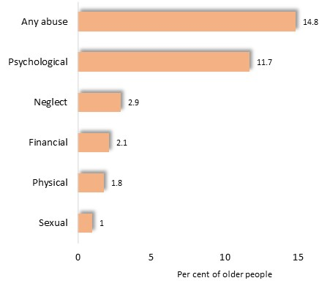
Approximately one in seven (14.8%) of older people who participated in the survey stated that they had experienced abuse in the past year, including 15.9% of women and 13.6% of men - the equivalent to approximately 600,000 Australians.
Psychological abuse was by far the most common type of mistreatment experienced by older people.

Prevalence of abuse by type of abuse
(As some experienced more than one type of abuse, percentages exceed 100)

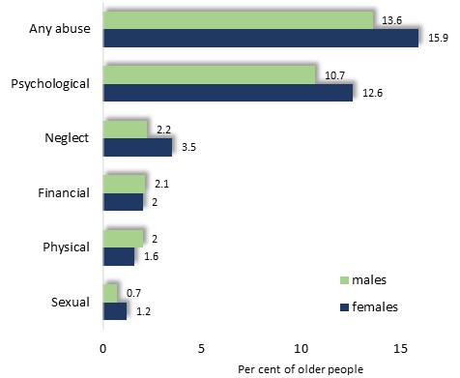

Prevalence of abuse by gender and type of abuse

The overall prevalence of abuse was slightly higher among older women than men, and higher for psychological and sexual abuse, as well as neglect.

Nature of Abuse
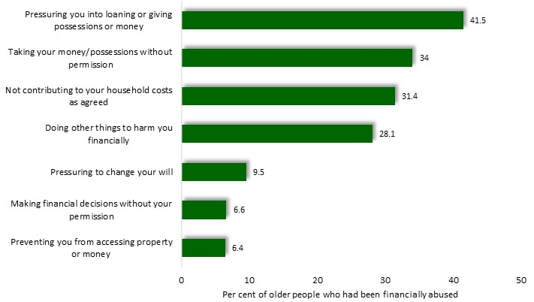
The survey explored the types of abusive behavior experienced by older people. For each category of abuse, the principal types of behavior, and the proportion of older people who experienced them, are illustrated below.

Types of financial abuse
(Since some people experienced more than one type of financial abuse, percentages exceed 100)

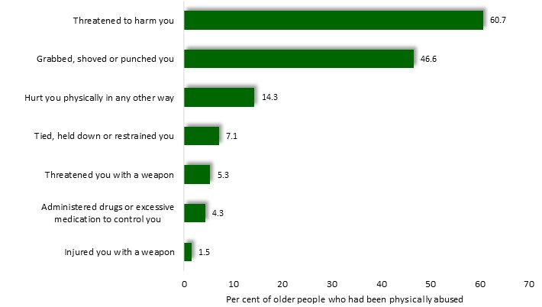

Types of physical abuse
(Since some people experienced more than one type of physical abuse, percentages exceed 100)

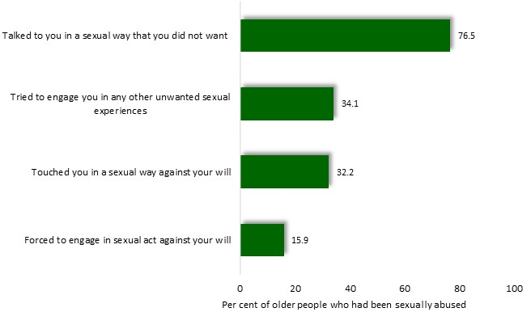

Types of sexual abuse
(Since some people experienced more than one type of sexual abuse, percentages exceed 100)

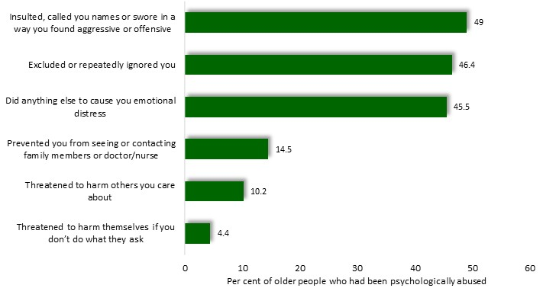

Types of psychological abuse
(Since some people experienced more than one type of psychological abuse, percentages exceed 100)

Neglect
The experience of neglect was recorded among 2.9% of the older people surveyed. Neglect included failure to perform housework (reported by 80% of survey participants who had experienced neglect), to assist with transport (69%) or to help with any other day-to-day activity (58%), as well as omissions in medical preparation or personal care, or inadequate assistance with getting in and out of bed, eating, toileting or shopping for groceries.

About a third (35%) of the survey participants experienced two or more kinds of abuse, with psychological abuse most often accompanying other types of abuse.
Among CALD participants, 4% reported abuse relating to their language and culture, including being disrespected for their culture, mistranslations when dealing with financial or legal matters, denial of important information in their preferred language, limited access to people of the same cultural background or to cultural activities.

Vulnerable Groups
Sex: 15.9% of older women and 13.6% of men stated that they had been abused. It has also been noted that the prevalence of psychological and sexual abuse, as well as neglect, was slightly higher among women.
Age: The recorded prevalence of abuse declined with increasing age, from 20.3% of people aged 65 to 69, to 9.4% of those aged 85 or more.
However, authors of the report caution that the fall in recorded prevalence of abuse with age may not accurately portray the true state of affairs, since more infirm people – who tend to be older – may be less well represented in the survey due to practical difficulties in contacting them or enlisting their participation; a lesser tendency to recognize or perceive behavior as abusive; and, as older, more dependent, people, a greater reluctance to disclose abuse by a person who is a source of indispensable support.
If it were supposed that indeed, the proportion of older Australians who had experienced abuse during the previous 12 months actually does not decline with age, but is similar to the rate recorded among 65 to 69 year-olds, then the estimated rate of abuse would rise to 20.3%. If, on the other hand, the true prevalence of abuse actually rises with age, then this actual prevalence of elder abuse would be higher.
The study found that an elevated risk of abuse was associated with a range of conditions:
- Limited formal education: chiefly in relation to sexual or psychological abuse
- Low income and socioeconomic status: at 17% among most disadvantaged and 12% among the least
- Renting accommodation
- Being divorced
- Poor health: with a prevalence of 20.8% among those with ‘poor’ or ‘fair’ health, compared with 11.3% among those with ‘excellent’ or ‘very good’ health
- Disability: 20.6% of those with a disability or long-term health condition and 9.8% of others
- Limited social support or contact with family and friends: 17.8% among those who see family less often than once a week, compared with 13.7% of those who have face-to-face contact at least a few times a week.

Following an analysis of these factors, the authors of the report concluded that disability, marital status, housing tenure and education among older people were most strongly associated with the likelihood of abuse. It may be mentioned that the range of conditions considered here is limited to those documented in the survey of older people.

Perpetrators of Abuse
Friends, children (including in-laws) and partners accounted for nearly half of the perpetrators of abuse.
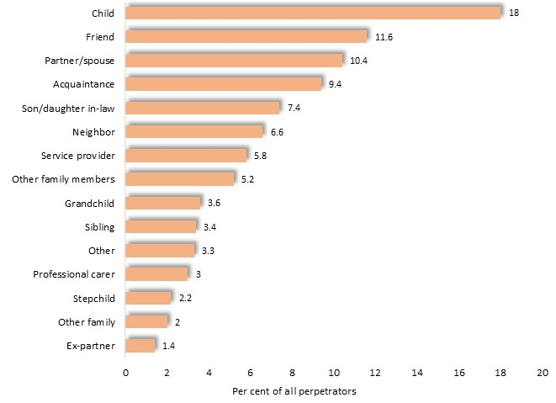

Relationship of older person to perpetrator

For neglect and physical abuse, partners and children were the main perpetrators; for financial abuse the son or daughter; and for sexual abuse friends were the largest category of perpetrator.

Characteristics of Perpetrators
Perpetrators were largely middle-aged, not employed, living with the older person, and often had serious personal problems. Their main characteristics included:
- similar proportions of males (55%) and females (45%)
- over half (52%) aged 35 to 64 years
- more than half (53%) not employed
- over three-quarters (77%) living with the older person; and
- nearly half (46%) had mental or physical health concerns, issues relating to alcohol or other drugs, finances, family or gambling, or other personal problems, according to the survey participants.
Seeking Help
Overall, approximately a third (36%) of the older people who had experienced abuse, sought help. The proportion who sought assistance ranged from 50% among those enduring physical abuse, to 20% of those experiencing neglect. Most requests for assistance were directed to family or friends.

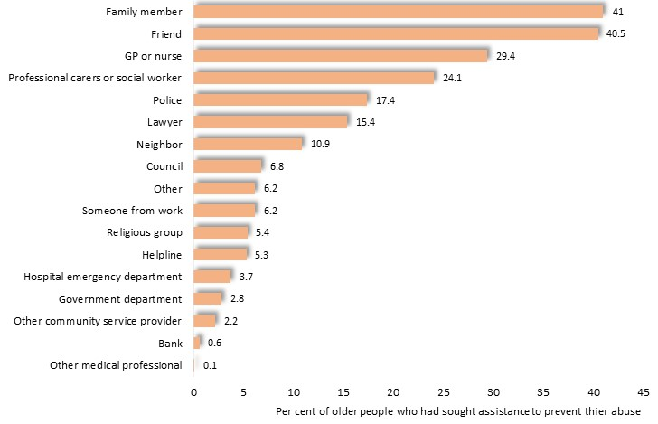

People or agencies approached for assistance to prevent abuse
(Some people approached more than one person or agency, with the result that these percentages exceed 100)

It has been seen that about a third of the older people who participated in the survey sought help from an external individual or agency in relation to their experience of abuse. However, over four-fifths (82%) took some kind of action to stop the abuse, including speaking to the perpetrator (53%), breaking contact with them (42%), having a family member or friend speak to the person on their behalf (20%), withdrawing from social life (13%), seeking mediation or counselling (9.9%), obtaining legal advice (8.9%), having a medical professional speak to the person on their behalf (9.4%) and imposition of a restraining order (3.8%).
Most older people reported that their efforts were effective in ending the abuse, often finding that discussions with the perpetrator provided them with the means to resolve their concerns.
In about a third of instances though, the abuse was not curtailed, with the perpetrator unreceptive or unsympathetic to their concerns, inflexible, or afflicted with mental health, drug or other conditions.

Faced with these circumstances, many older people found that suspending their involvement with the perpetrator seemed a more feasible option. For some older people though, this did not end the abuse or else resulted in their estrangement from family members.

The full report of the National Elder Abuse Prevalence Study is available here, or at https://aifs.gov.au/publications/national-elder-abuse-prevalence-study-final-report

